SD-15
Defense Standardization Program


Performance Specification Guide

June 29, 1995 SDMP

Office of the Assistant Secretary of Defense
for Economic Security
Washington D.C. 20301-3300

FOREWORD

On June 29, 1994, the Secretary of Defense directed sweeping reform of military specifications and standards. The Secretary directed the Department of Defense to make greater use of performance and commercial requirements in the acquisition process. Performance specifications are preferred over detail specifications.

This document offers guidance on how to write performance specifications. The information is applicable to all types of materiel: systems, subsystems, assemblies, components, and parts. It is not meant to be a “cookbook” approach to developing performance specifications, but a guidance tool to provide direction and to shape the overall thought process.

The SD-15 is intended to be a “living document” that will undergo changes as required. If you have any recommendations on improving this document, please send your comments to:

Office of the Assistant Secretary of Defense (Economic Security)
Standardization Program Division
5203 Leesburg Pike, Suite 1403
Falls Church, VA 22041-3466

/signed/

Walter B. Bergmann, II
Chairman
Defense Standards Improvement
Council

TABLE OF CONTENTS

PREFACE 1
SECTION ONE: WRITING PERFORMANCE REQUIREMENTS 3
INTRODUCTION 3
WHY WE NEED PERFORMANCE SPECIFICATIONS 4
MARKET ANALYSIS 5
PERFORMANCE VERSUS DETAIL SPECIFICATIONS 6
REQUIREMENTS CONSIDERATIONS 9
CONFIGURATION CONTROL 11
LOGISTICS SUPPORT 12
REPROCUREMENT 13
VERIFICATION 14
WARRANTIES AND CERTIFICATES OF CONFORMANCE 15
HAZARDOUS, TOXIC AND RECYCLED MATERIALS, AND OZONE 16
DEPLETING CHEMICALS
FORMAT 16

SECTION TWO: STANDARD PERFORMANCE SPECIFICATIONS 17
INTRODUCTION 17
REQUIREMENTS CONSIDERATIONS 17
SECTION THREE: GUIDE SPECIFICATIONS 19
REQUIREMENTS CONSIDERATIONS 19
CONTENT 20
SECTION FOUR: PROGRAM-UNIQUE SPECIFICATIONS 23
REQUIREMENTS CONSIDERATIONS 23
REQUIREMENTS DEVELOPMENT 24
PERFORMANCE BASED TECHNICAL DATA PACKAGES 26
Appendix A References 29
APPENDIX B COMPARISON OF PERFORMANCE AND 31
DETAIL SPECIFICATIONS

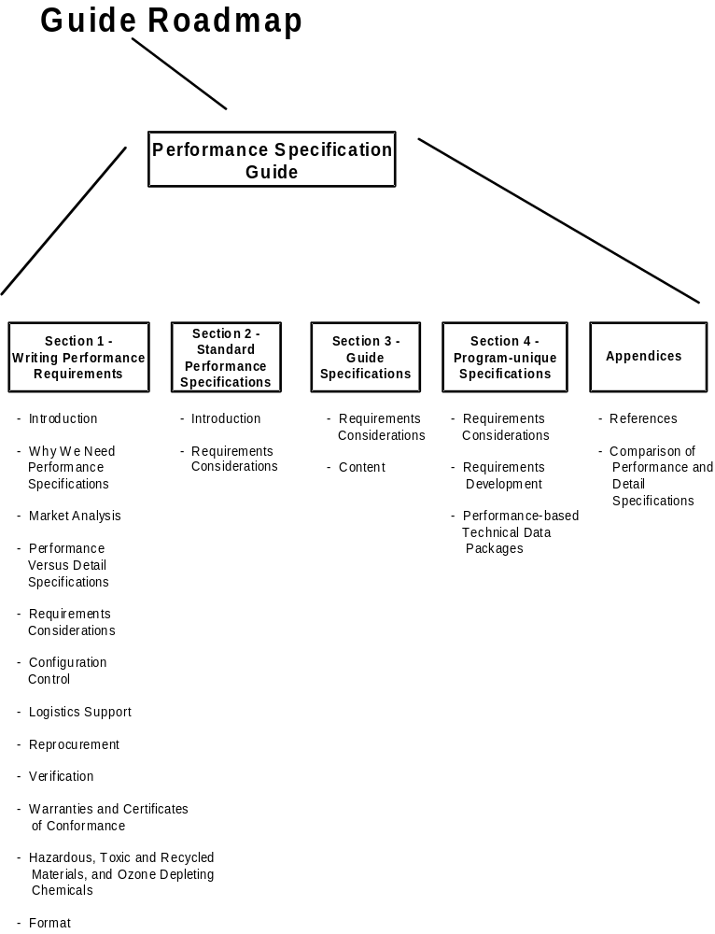

PERFORMANCE
SPECIFICATION
GUIDE

PREFACE

This guidance is approved for use by all Departments and Agencies of the Department of Defense.
Comments (recommendations, additions, deletions) and any pertinent data that may be of use in improving this document should be addressed to: Chief, Standardization Program Division, 5203 Leesburg Pike, Suite 1403, Falls Church, VA 22041-3466.

On June 29, 1994, the Secretary of Defense directed sweeping reform of military specifications and standards. Most of the changes the Secretary directed focused on making greater use of performance and commercial requirements in the acquisition process. His intent was to ensure that the Department of Defense (DoD) can:
- Integrate the military and commercial industrial production bases
- Reduce costs.
- Increase access to commercial state-of-the-art technology.

This guide is intended to assist in the implementation of these reforms.

SECTION ONE

WRITING PERFORMANCE REQUIREMENTS

INTRODUCTION

Purpose

This document offers guidance on how to write performance specifications. It is intended to serve as a guide for those personnel who write or review specifications. In addition, it supplements existing guidance on writing commercial item descriptions. Finally, it is expected to assist DoD personnel who provide input to non-Government standards bodies.
The information is applicable to all types of materiel: systems, subsystems, assemblies, parts, and components. This section applies to all materiel in general. Section 2 deals with all item specifications (non-Government standards, commercial item descriptions, and standard performance specifications) but focuses on standard performance specifications. Section 3 addresses guide specifications, and Section 4 offers additional guidance for those writing program-unique specifications.

Background

As stated in the preface, current DoD policy is to move to greater use of performance and commercial specifications and standards. This will increase DoD’s access to commercial, state-of-the-art technology. As a result, DoD will gain direct access to the existing commercial industrial base for defense applications. To that end, the order of precedence for the use of specifications in acquisition is that performance specifications are always preferred over detail specifications. The table on the next page provides a more detailed breakdown of the overall order of precedence:

Order of Precedence in Specifications

GROUP | TYPE OF SPECIFICATION/STANDARD | EXAMPLES
I | Documents mandated by law or regulation pursuant to law. | OSHA or EPA regulations
II | Performance documents  - Non-Government standards*  - Commercial item descriptions**  - Federal specifications  - Standard performance specifications | ASTM or SAE standards  A-A- documents (see the DoD Index of Specifications and Standards (DoDISS))  MIL-PRF- documents (see DoDISS)
III | Detail documents  - Non-Government standards*  - Federal specifications  - Detail specifications*** | ASTM or SAE standards  MIL-DTL- documents (see DoDISS)
IV | Standards, specifications, and related publications issued by the Government outside the military or federal series for the non-repetitive acquisition of developmental items | Purchase descriptions  Product descriptions  Program-peculiar or system specifications

* Non-Government standards are not necessarily performance-based. They should be examined individually to determine if they are performance documents.
** By definition a CID is a performance specification
*** The application of detail specifications and military standards requires a waiver.

WHY WE NEED PERFORMANCE SPECIFICATIONS

In general, specifications communicate the user’s requirements to the manufacturer. They translate operational requirements into more technical language that tells the manufacturer: 1) what we will consider an acceptable product, and 2) how we will determine if the product is acceptable. To the extent that any specification does these two things, it is good. The problem arises when we use specifications to tell the manufacturer how to make the product.
Sometimes we think we know exactly how a needed product should be manufactured, and we know that the manufacturer does not know how to manufacture it. If we can communicate that knowledge clearly, then we have done little harm. If all goes well, we will get a product that will meet our needs. On the other hand, if the manufacturer knows how to make the product, we may be missing an opportunity. By using a detail specification we have automatically limited the possibility of obtaining an improved, less costly, or more reliable product because we have constrained the ability of the manufacturer to be innovative. Consider the manufacture of common tools. Hand saws have not changed for generations, and they are still used in many applications. They’re not circular saws, or band saws, or jig saws, but they are still useful. It would be shortsighted, however, to constrain manufacturers to produce hand saws when they may have a better item to propose.
The problem becomes more acute when we are not absolutely sure how to make a product, or we communicate our knowledge poorly, or we truly need improved products. In these cases, then we may have done serious harm by including “how to” information in our specification. That is why we need performance specifications. Performance specifications leave out unnecessary “how to” or detail and give the manufacturer latitude to determine how to best meet our stated needs. The word “unnecessary” is emphasized because some detail requirements are necessary in a performance specification. Almost always the need for detail is generated by interface requirements.

MARKET ANALYSIS

In order to write effective performance requirements, we must understand the user’s actual need and the technical characteristics of the products that might meet that need. The best way to achieve both of these ends is through a market analysis that involves the user in the process. A market analysis examines all available documentation to identify existing civilian technology that will fulfill the requirements.
The first course of action to meet a new materiel requirement (after product improvement) is to look at the feasibility of acquiring a commercial product. Likewise the first course of action in looking for replacements for existing military specifications is to look for equivalent non-Government performance standards. In both situations a market analysis should be the first step in the process. A market analysis should precede every requirements definition effort, ranging from a new-start acquisition program to the preparation or revision of a specification.
Data collected during the analysis can be used to understand the technologies involved, the alternatives available, and the feasibility of meeting the requirement with a commercial product. In addition, involving users in the analysis automatically improves communication between the user and the specification writer, enhancing everyone’s understanding of the operational requirement. Standardization Document 5 (SD-5), Market Analysis for Nondevelopmental Items, provides detailed guidance on conducting a market analysis.
Finally, early involvement of the user, or the user’s representative, helps to determine the degree of flexibility possible in the requirement, allowing consideration of a broader range of alternatives (such as nondevelopmental items). The requirements document should reflect the user's flexibility by stating requirements in terms of acceptable ranges or thresholds to be met rather than precise points. A market analysis will determine what ranges of performance are currently possible.

PERFORMANCE VERSUS DETAIL SPECIFICATIONS

A performance specification states requirements in terms of the required results and provides criteria for verifying compliance, but it does not state methods for achieving results. It defines the functional requirements for the product, the environment in which it must operate, and the interface and interchangeability requirements.
The following tables give examples of performance and detail requirements:

Examples of Performance Requirements | Reason
The circuit breaker shall not trip when subjected to the class 1, type A, shock test specified in MIL-S-901. | States required results.
The biocular eyepiece shall operate at altitudes up to 10,000 feet above sea level. | Defines the operational environment.
The detector shall not contain foreign matter—such as dust, dirt, fingerprints, or moisture—that can be detected by visual examination. | Provides criteria for verifying compliance. (Assuming that foreign matter affects detector performance)
The tank shall traverse the Aberdeen Proving Ground Terrain Profile Course at all speeds up to 30 MPH. | Provides criteria for verifying compliance
Fluid seals and bearings shall provide no less than 5 years use without replacement. | States required results.
The molybdenum disulfide content shall not be greater than 5 percent. | States required result.
The shoes shall be of the following standard men's sizes: 9, 9-1/2, 10, 10-1/2, 11, 11-1/2, 12, 12-1/2, 13 | Provides interface requirement.
The equipment shall withstand, without damage, temperatures ranging from -46°C to +71°C. | Defines operational environment.
During the accuracy check conducted 18 hours into the second cycle of the humidity test, the accuracy of the indicator shall be within plus or minus 2 percent of each pre-cycle reference measurement point. | Provides criteria for verifying compliance.
The tractor shall be capable of utilizing contractor supplied attachments for standard category 1, 3 points mounting, front and rear. | Provides interface requirement
Examples of Performance Requirements (cont.) | Reason
All parts shall be capable of passing the solderability tests in accordance with MIL-STD-883, test method 2003, on delivery. | Provides criteria for verifying compliance.
The Standard Evaluation Circuit (SEC) shall demonstrate the operating temperature range (case, ambient, or junction) capability of the technology being offered. | Defines the operational environment.
Parts shall be marked with the following information:  a. Manufacturer's name.  b. Source control number.  c. Inspection lot identification.  The marking shall remain legible when subjected to the resistance to solvents testing of MIL-STD-883, method 2015. | States required results.
Packaging shall prevent mechanical damage of the devices during shipping and handling and shall not be detrimental to the devices. | States required results.

Examples of Unnecessary Detail | Reason
The reinforcement shall consist of corrosion-resistant steel wires. Hose under 16Z shall have a single layer of braid, and hose 16Z and above shall have 2 layers of braid. The wires shall be arranged over the inner tube to provide sufficient strength to ensure conformance with the requirements specified herein. | Steel wires and layers of braid may not be the best way to reinforce the hose. The functional requirement is for the hose to withstand a specified amount of pressure.
The cloth shall be made from cotton that has been carded and spun into single yarn for both the warp and filling. The weave shall be a 5-harness sateen. The filling effect side shall be finished and identified as the “face” side. | This tells the manufacturer how to make the cloth, not what type and quality of cloth the user desires.

Types of Performance Specifications

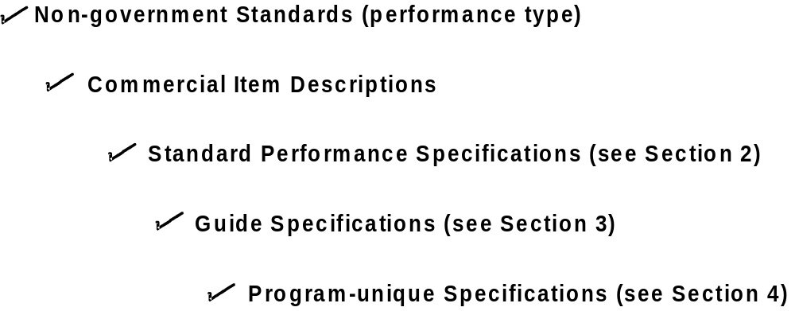

Definitions

Commercial Item Description. An indexed, simplified product description prepared by the Government that describes, by performance characteristics, an available, acceptable commercial product that will satisfy the Government’s needs. The content and format requirements for this specification are provided in the GSA Standardization Manual (Chapter 6), DoD 4120.3-M, and DoD 5000.37-H.

Detail Specification. A specification that specifies design requirements such as materials to be used, how a requirement is to be achieved, or how an item is to be fabricated or constructed. A specification that contains both performance and detail requirements is still considered a detail specification. The content and format requirements for this specification are covered by MIL-STD-961.

Guide Specification. This type of specification identifies standard, recurring requirements that must be addressed when developing new systems, subsystems, equipments, and assemblies. Its structure forces appropriate tailoring to meet user needs. The content and format requirements for this specification are covered by DoD 4120.3-M, “Defense Standardization Program Policies and Procedures.” It is a type of performance specification.

Interchangeability. A condition which exists when two or more items possess such functional and physical characteristics as to be equivalent in performance and durability, are capable of being exchanged one for the other without alteration of the items themselves or of adjoining items, except for adjustment, and without selection for fit and performance.
Interoperability. 1. (DoD, NATO) The ability of systems, units or forces to provide services to and accept services from other systems, units or forces and to use the services so exchanged to enable them to operate effectively together. 2. (DoD) The condition achieved among communications-electronic equipment when information or services can be exchanged directly and satisfactorily between them and/or their users.
Non-Government Standard. A standardization document developed by a private sector association, organization, or technical society that plans, develops, establishes, or coordinates standard specifications, handbooks, or related documents. This term does not include standards of individual companies.

Program-unique Specification. This type of specification, also called a system specification, establishes requirements for items used for a particular weapon system or program. Little potential exists for the use of the document in other programs or applications. It should be written as a performance specification, but it may include a blend of performance and detail design type requirements.

Requirement. Any condition, characteristic, or capability that must be achieved and is essential to the end item’s ability to perform its mission in the environment in which it must operate is a requirement. Requirements must be verifiable.

Standard Performance Specification. This type of specification establishes requirements for military-unique items used in multiple programs or applications. The content and format requirements for this specification are covered by MIL-STD-961.

REQUIREMENTS CONSIDERATIONS

This section reviews general points to consider in writing performance specifications. Specifications must clearly articulate the user’s requirements. However, remember that other needs must also be met. The specification allows prospective offerors to propose, the Government to evaluate the proposals, and the Government to accept the delivered article. Finally, the preparation of technical requirements should involve an integrated team process, including the user and representatives from all functional areas which may be affected by the requirement.
The first step in writing technical requirements is to understand the operational requirement thoroughly:
- Which requirements are minimum or threshold requirements?
- What is each threshold? The best way to gain this understanding is to be sure that the user is fully involved in developing the requirement.
- What constraints will apply? All constraints governing operation or use—natural and induced environments, interface with other systems, operator and maintainer limits—must be addressed.

Characteristics
In general, performance requirements should have the following characteristics:
- Requirements should be quantitative rather than qualitative. The specification must ensure that parties submitting proposals or bids—and those evaluating them—are equally clear on exactly what the Government requirements are. Government requirements that are not based on quantitative data are extremely sensitive to varying interpretations and misunderstanding. If the performance parameters are not spelled out clearly in the specification, evaluating proposals against a common standard and enforcing performance after contract award are very difficult.

EXAMPLE
Overall length of the tractor shall be 150 inches or less. Overall width shall not exceed 52 inches. Overall height shall be 85 inches or less.

- Requirements should be verifiable. The Government must be able to determine through analysis, test or demonstration if a product will perform as required. Verifiable requirements also assist the manufacturer. If the Government verifies the ruggedness of a device by requiring that it survive a 15 foot fall onto a steel deck, then prospective bidders will have a better idea of what the Government meant by “rugged” and whether their product will meet the requirement.

EXAMPLE
The mandrel shall have a hardness of not less than 60 and not more than 65 on the Rockwell “C” scale.

- Performance requirements should describe interfaces in sufficient detail to allow interchangeability with parts of different design. Interface considerations should be addressed carefully when using performance specifications. For example, the specification must enumerate the interface requirements necessary to allow maintenance at the appropriate level, but it must not impose a design solution beyond that necessary to ensure a proper interface.

EXAMPLE
Provision shall be made for installation mounting of the Position and Azimuth Determining System, AN/USQ-70 (PADS), with a control and display unit in the Type A utility truck (Litton Industries' installation kit drawings 880512, 880515, 875267, 880510, 880511, and 880513). Provision shall be made for installation of 24 volt DC power cable access to the equipment. The size of the PADS unit is approximately 26x31x20 inches. The weight of the unit is 317 pounds.

- Requirements should be material and process independent. It should be possible to change material and processes without changing the performance specifications.

EXAMPLE
All mowers shall be treated with the manufacturer’s commercial standard rust-proofing treatment.
Not:
All mowers shall be rust-proofed in accordance with MIL-SPEC-xxxx.

Performance specifications define the complete performance required of the product, the intended use, service environmental conditions, maintainability, and necessary interface and interchangeability characteristics. They cover form, fit, function, and interface. The offerors are free to meet the requirements in any way they can. They can offer materiel conforming to the specification, either an-off-the-shelf commercial product or something entirely new, as long as the products they offer meet the performance criteria established in the specification. The crucial issue is that both offerors and acquisition managers be able to determine whether the product meets those criteria precisely.
A danger in writing specifications is including unnecessary information. Choosing what to exclude is as important as choosing what to include. Acquisition managers must scrutinize all requirements and eliminate any requirement that adds no value to the product being acquired. Performance and data requirements, verification methods, and Government oversight must reflect the Government’s minimum essential needs.

ENVIRONMENTAL EXAMPLE:
The processes used for the tractors shall not rely on hazardous or toxic materials, or Class I Ozone Depleting Chemicals IAW the 1990 Clean Air Act Amendments, whenever feasible. Recycled Materials shall be used to the maximum extent possible provided there is no adverse impact on the operational and maintenance requirements.

CONFIGURATION CONTROL

Performance specifications allow contractor control and maintenance of the design solution to the specified performance requirements. This is true not only at the system or end item level but also at lower levels of replaceable components and spares. In any development program the degree of control of the configuration that is retained by the Government is dependent on the planned maintenance strategy. If the Government intends to repair the system at the piece-part level, then the Government should include requirements for interchangeability and interoperability to the replacement part level in its performance specifications for such parts. If the Government is planning total contractor logistics support then the contractor should retain control of, and responsibility for, the design configuration through the production and operational life of the system, while the Government retains system level configuration control through the performance specification.
For development programs, approval of major changes at the system or end item level—those that affect performance, form, fit, function, interchangeablity, and interface—always remains with the Government. Since final authority on such requirements will continue to rest with the Government, the acquisition plan should not establish the limits on the contractor’s control authority, other than for changes that affect the performance requirement, regardless of maintenance strategy. Government performance specifications for a system’s lower level items that are to be separately procured must be developed around contractor defined interchangeability and interoperability criteria for such items that are included in the Government’s product baseline.

EXAMPLE
Interchangeability:
All splice parts having the same military part number shall be physically and functionally interchangeable without the need for modification of such items or of the splicing equipment.

While delegation of configuration control responsibility encourages the contractor to improve the system, the Government must ensure that systems produced earlier and still in use can be supported. Interchangeability and interoperability criteria must be key elements of the Government’s requirements, and they must be clearly spelled out in the solicitation and in the performance specification down to the lowest level of the system being maintained.
For example, recently-awarded contracts to dual sources specifically require that the two new products be interchangeable and interoperable with each other as well as with the previous product. The key is to require interchangeability at the level at which the system will be supported in the field—by the contractor or by DoD.



LOGISTICS SUPPORT

Changing from a detailed design procurement to one based on performance specifications may strongly affect logistics support. For example, consider the following issues:
1. If the Government is now buying piece parts to support a system or subsystem in the field and still needs to support the system at the piece part level, how does the customer continue to buy these parts when a higher-level performance specification is selected?

2. How can the Government ensure that the piece parts will continue to work, and not become obsolete due to lower-level contractor changes, if the customer no longer controls their design?

3. How will the Government verify the functionality of items procured from new contractors before they are installed in higher-level assemblies?

Resolution of these issues must recognize that the Government will determine the degree of configuration control it wishes to exercise based on its maintenance strategy. So one possible solution to issue 1 could be to list piece parts in the contract that the contractor will be required to purchase. Likewise, issue 2 might be resolved by constraining the contractor's lower-level design changes to be compatible in form, fit and function with the systems the Government has previously purchased. (The LAV 25 Buy-back Plan required that the Government would be compensated for all spares, repair parts, and special tools rendered obsolete as a result of contractor design changes.) Issue 3 could be addressed by requiring that bid samples be submitted before procurement and checking them out on the higher-level assemblies.
Acquisition managers must understand how essential it is to ensure that the mechanism for these remedies is in place before the contract is signed. The Government must be able to control the form, fit, function, interface(s), and interchangeability of an item in the field.
Because the requirement for interoperability and interchangeability is driven by logistics support needs, each change to the performance specification must be carefully considered by the customer. Changes may have significant impact on the entire logistics environment, including spare and repair parts, training, manuals, maintenance operations, diagnostic tools, ground support equipment, and maintenance operations.
Obviously, any such change to the performance specification brings the Government back into the approval loop, whether the proposed change is surfaced by the contractor or the Government. The Government controls the performance specification, and the ramifications of such changes must be carefully considered by the Government before their implementation is authorized.

REPROCUREMENT

When a performance-based specification results in contract award, competitive reprocurement will follow the same process. The technical data package or drawing (if there is one) resulting from the previous buy will be provided “for information only.” The performance specification remains the baseline. Areas for best value consideration will be drawn from this new baseline.
Responses to a reprocurement based on a performance specification may propose materiel different in some respects from the initial procurement. An off-the-shelf cable assembly may require a new lubricant, or a different shaped mount may require smaller bolts. Changes which affect logistics support must be identified and carefully weighed. Interchangeability to the spare part level may be required to ensure that logistics support is not critically degraded. Conversely, if a good operational level of repair analysis is performed early in the program, it may be determined that the part(s) in question shouldn’t be procured as spares. If this repair analysis was not made early, a “mid-product-life analysis” to establish a baseline may be useful.
A performance-based reprocurement strategy follows these steps:
- Identify the essential performance requirements to be included in the solicitation before issuing the request for proposal (RFP), or request for quote (RFQ).

- Seek input from potential offerors through requests for information, draft requests for proposal, and advanced planning briefings for industry. Use these venues to ensure that all interested parties understand the Government’s requirements and the offerors’ range of capabilities. This dialogue—which should include the user, the procuring activity, and potential offerors—should focus on ensuring that the required performance is precisely defined.

- Limit the amount of information to be submitted by offerors. Information to help the Government determine which offeror will provide best value and that necessary to demonstrate compliance with the requirements of the solicitation should be included. The RFP should reference the current specification and technical data package (TDP) for the item, if one is available, but state explicitly that the TDP is provided for information only. This limitation encourages innovation and production improvements.

An Industry Response to a Draft Solicitation:

“The solicitation package is overwhelming. The voluminous requirements for information and data is very discouraging for a small business....In our opinion, the [Government] objective should be to buy hardware that meets requirements. In this solicitation, it appears to us that the [Government] is more interested in a paper writing contest, where document submittals are more important than the product.”

A performance specification approach to acquisition represents a shift from the “build-to-print” environment of the past. It requires the user to identify essential requirements for the item and areas in which improvements would be desirable. It requires the offeror to identify specific improvements, including any design and development effort. It clearly states that such improvements will be evaluated as part of the best value source selection, that is, selection will be based upon the best overall value to the Government in terms of performance, schedule and cost rather than cost alone.
The performance-based acquisition does not encourage the continuing reprocurement of the same item. It expects the Government to capitalize on the technical expertise and ability of the industrial community in order to procure products at continually improving levels of performance and reliability.

VERIFICATION

The Government uses various verification techniques (e.g., test and evaluation, simulation and modeling, examination) to ensure that the systems or items being acquired meet their performance requirements and will perform effectively and can be supported in the intended operational environment. The type of verification requirements the Government imposes on the contractor should match the type of performance specification it uses with the contract. For example, if the performance specification requires the contractor to deliver a biocular eyepiece that operates at altitudes up to 10,000 feet above sea level, the contractor should be required to verify achievement in his test and evaluation program.

EXAMPLE
Seat Leakage. Each valve shall be tested for seat tightness. Permissible seat leakage is 10 cubic centimeters (cm³) per hour of water or condensate per inch of hps.

In addition, the specification must enable the Government and the contractor to measure compliance with the specification requirements. For example, if the user states that the item “must fit securely,” the contractor needs to know how a secure fit will be verified. The acquisition manager must define in advance a finite means by which the secureness of fit will be measured.
Verification beyond contract compliance, such as verification of system effectiveness in the intended environment, is usually the responsibility of the Government.
The contractor’s verification program should ensure that, as applicable, (1) pass-fail criteria, (2) interdependency of tests, (3) test analysis methodologies, and (4) procedures for reporting test results are planned and documented in advance of actual testing. If the Government is conducting follow-on verification of the product, the extent to which it wants contractor participation, as well as the contractor’s liability for correction of problems identified during the follow-on verification, should be identified in the contract.

WARRANTIES AND CERTIFICATES OF CONFORMANCE

Since performance specifications give the contractor more overall control of the product, a warranty program is a potential additional Government safeguard. For some items a warranty can offset the loss of Government control and provide protection against defective products. The contractor can be required to warrant the performance of the item to specific requirements identified in the performance specification.
However, in other circumstances warranties should be avoided. For some items they are of limited value. They offer little recourse in combat situations, for example. A warranty is of limited comfort when a combat unit does not accomplish its mission because its weapons jammed. Ensuring that mission essential equipment will perform properly beforehand is the better course. Over-insistence on warranting performance in unrealistically harsh environments may drive away vendors of acceptable commercial products. Finally, the value of a warranty is heavily dependent on the offering company.
The value of requiring warranties should be carefully considered in preparing each performance specification. Warranties have benefit, but they are not a substitute for proper performance and verification requirements.

HAZARDOUS, TOXIC AND RECYCLED MATERIALS, AND OZONE DEPLETING CHEMICALS

As the emphasis on performance requirements represents a shift in the way the acquisition community does business, a similar shift has been experienced in the environmental arena. In the past the emphasis has been on controlling pollution. It is now on preventing it at the source. The new approach is to influence the design, manufacture, operations and maintenance processes. It requires the use of less hazardous and toxic materials and processes -- using recycled materials where feasible and reducing or eliminating the reliance on ozone depleting chemicals (ODCs).
The hazardous and toxic materials, and the ODCs to avoid are listed in SD-14. If a material listed in SD-14 must be specified, it shall be listed as a key word in the specification.

FORMAT

The formats for performance specifications can be found in the following documents:

Non-Government Standards | Style Guides
Commercial Item Descriptions | GSA Standardization Manual  DoD 4120.3-M
Standard Performance Specifications | MIL-STD-961D
Guide Specifications | DoD 4120.3-M
Program-unique Specifications | MIL-STD-961D



SECTION TWO

STANDARD PERFORMANCE SPECIFICATIONS

INTRODUCTION

Standard performance specifications, commercial item descriptions, and some non-Government standards are generally grouped into the category of “item specifications.” This section focuses on the writing of standard performance specifications. However, the approaches identified here can be applied to other item specifications as well.
While this guide distinguishes between standard performance specifications, guide specifications, and program-unique or system specifications, the language and concepts of performance requirements apply to each of them equally. The difference is that as we come across the spectrum from large system specifications to item specifications, the level of detail involved increases. This shift complicates the task of keeping unnecessary detail out of the specification.

REQUIREMENTS CONSIDERATIONS

A standard performance specification is intended to facilitate standardization and interchangeability of common equipment in the DoD. These specifications typically cover items—fasteners and electronic components, for example—used on a number of different systems and subsystems. The Defense Logistics Agency is usually the inventory control point and manager for these items.
Since the items covered by standard performance specifications are used in a variety of different applications, this type of document usually specifies product characteristics and dimensions. In order to achieve standardization and interchangeability, matters relating to form, fit, and function must be clearly identified. This type of specification should be performance oriented to the maximum extent possible.

Item specifications have the following characteristics:
- End item characteristics are specified in such a manner that the contractor has flexibility in developing and applying design, construction, materiel, and quality control solutions to meet the performance requirements.

EXAMPLES
The capacitor shall have a capacitance value of 0.1 microfarads ± 10 percent.
The relay shall have a contact resistance of 0.10 ohms maximum.
The resistor shall have a resistance value of 100 ohms ±1 percent.

- Performance of the item is specified in terms of the environment in which it must operate (e.g., operating temperature range, vibration, shock, etc.). The acceptable range or threshold is usually given.

EXAMPLE
Operating Temperature Range. The capacitor shall have an operating temperature range of -55°C to +125°.

- Form, fit, and function are controlled only to the degree necessary to achieve standardization and interchangeability. Control of critical interface dimension should be considered performance requirements as long as specific “how to” design solutions are not prescribed.

EXAMPLES
Lead Spacing. The lead spacing for the device shall be 0.200 ±0.015 inches.
Case Height. The case height for the device shall be 0.336 inches maximum.

- Verifications for quality and reliability are based on the performance characteristics of the product. Quality assurance and verification systems may include qualification requirements for Qualified Products Lists, Qualified Manufacturers Lists, and market acceptance criteria, as well as first article and other quality control inspections.

EXAMPLE
Market Acceptance Criteria
The company offering the item must have produced at least 1000 identical or similar models to that being tendered.

SECTION THREE

GUIDE SPECIFICATIONS

REQUIREMENTS CONSIDERATIONS

Guide specifications identify all the essential performance parameters normally associated with the development of a class of like end items. Generic guide specifications are intended to assist in preparing development specifications for specific end items. A generic specification provides a general description and does not specify specific performance capabilities.
The specification is then tailored to the program-specific requirements by filling in the blanks with the needed performance capabilities. Some blanks will be filled in by members of the Government team and others by members of the contractor team. The Government portion, completed before publication of the RFP, presents design independent requirements. The remaining blanks will be filled in by the offeror as part of the proposal.
Explicit directions on how the blanks are to be filled in must be provided to the offeror or bidder. These directions may require supplemental information, such as user requirements documents, to be included. In some instances, it may not be feasible to fill in all the blanks for all the contractual specifications. In this case, the solicitation must provide specific direction for how the remainder of the blanks will be filled in as part of the Government-defined achievement criteria for program milestones. Such directions are usually provided in a non-contractual appendix attached to the guide specification.
For the top level program specification, normally a system specification, the Government is responsible for finalizing the required performance parameters. However, the contractor can provide input to the system specification. The top level specification will state the required performance parameters, those derived from stated user needs, in terms that are measurable and verifiable within the scope of the development program. Contractor inputs may come from activities accomplished as part of previous program phases; from requirements trade study contracts; responses to a request for information; or from the draft request for proposal process.
Lower level specifications are normally much more dependent upon the design solution proposed by the contractor. In these, the contractor sets the required performance parameters. In some situations, however, the Government team may find it necessary to specify design independent requirements even for lower level specifications. This would be especially true for modification or update programs that are replacing existing items. In this case, the Government may need to provide design specific requirements that ensure compatibility with other components of the system. Alternatively the Government could provide the complete set of existing specifications for guidance, as a baseline, and allow the contractor to determine how to ensure compatibility.

EXAMPLE
3.2.1 Landing gear System
3.2.1.1 General
With stated exceptions, the service life of the landing gear components shall be ________________.
..........................................................................................................................
4.2.1 Landing gear system
4.2.1.1 General.
The landing gear component service life shall be evaluated by ______________. The ground flotation characteristics shall be evaluated by ____________. Performance during and after operation on surfaces of specified roughness shall be evaluated by _________.

CONTENT

See AFGS-87253 on use of guide specifications for additional information on the intent of design-specific performance parameters.
Because they are used in development, guide specifications should also include the verification requirements for each performance parameter. The verification requirements generally provide a range of options which may be selected for a specific application. The preferred form for the statement of performance parameters is in terms of required end results and not in terms of “how to” achieve the end result. It may be necessary or desirable to include design specific performance parameters for contractual tracking of technical performance measurements. In this case, alternative sets of language would normally be included to address the alternative design approaches or use of alternative technologies.
The guide specification will include performance parameters for the end item (product), and its associated production and support processes. The purpose of any military acquisition program is to procure systems which satisfy user needs. These top level requirements are stated in terms of operational capability to achieve specific military objectives. Since the intent is to avoid requirements which are design solutions, guide specifications will contain both firm, design-independent performance requirements and blanks which must be filled in by each offeror to represent his or her design solution.

An essential attribute of the generic guide specification is the inclusion of a handbook that provides guidance for filling in the blanks when preparing an end item development specification. The handbook provides guidance for definition of performance parameters and selection of the verification requirements. It provides a rationale for requirements, lessons learned, and general and/or specific guidance. The guidance varies in level of detail: it may discuss the preferred form, suggest language for design specific requirements, or recommend detailed analytical techniques for derivation of numerical requirements.
Technical requirements for elements below the system level are defined through a process of decomposition which produces derived and allocated requirements common for like systems, subsystems, equipment, and assemblies. The format of a guide specification requires the user to tailor the document to the specific application.
Guide specifications are standardization documents that identify recurring essential requirements that must be tailored for each acquisition or contractor selection. Unlike military specifications, which standardize fixed form, fit, and function requirements for reprocurement of like items, guide specifications standardize functional or performance requirements that are used in the development of new systems, subsystems, equipments, and assemblies. Guide specifications should not be used for reprocurement purposes, and generally, should not be used for acquisition of components, parts, and materials.
Guide specifications offer a methodology for standardizing the essential requirements that must be determined for each acquisition without imposing restrictive, single-solution requirements.

SECTION FOUR

PROGRAM-UNIQUE SPECIFICATIONS

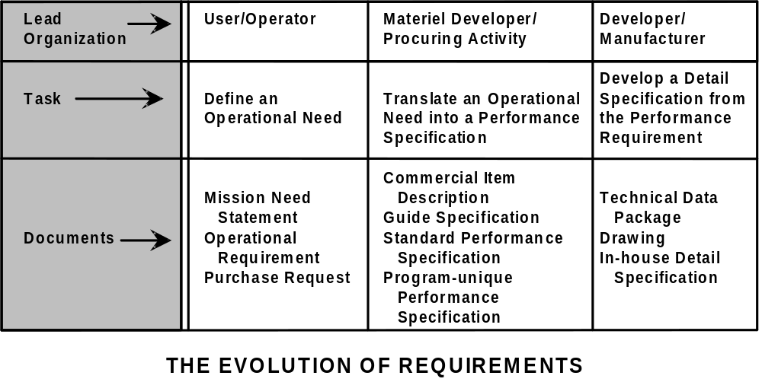

REQUIREMENTS CONSIDERATIONS

For a system acquisition, the Government must develop a top level specification, usually referred to as a program-unique or systems specification. It should be developed by an integrated product team. The specification must be based on the operational requirement and might also be based on existing guide specifications. The specification must allow offerors maximum flexibility in proposing solutions. Therefore, the specification may be released with blanks or incomplete information. In this case, offerors will be required to complete the necessary information to describe their designs.
Each offeror must develop a detail specification. Offerors should be encouraged to propose improvements above the minimum requirements to enhance their competitive position. The statement of work should include information necessary to demonstrate compliance with the specification requirements. The system

specification must contain sufficient detail, or blanks requiring the offeror to propose detail, to suffice for source selection and for eventual acceptance of the delivered article.
After a source has been selected, the specification of the winning offeror then becomes the Government’s specification.

REQUIREMENTS DEVELOPMENT

Even though program-unique documents are used for development programs, they should encourage the use of nondevelopmental piece parts, components, equipments, and subsystems wherever possible (i.e., standard performance specifications). Program-unique documents should use performance terms whenever practical.
Breaking down a systems requirement into its components and sub-requirements allows better definition of the requirement in terms of function and performance. Defining the requirement in terms of the lowest level functions that must be incorporated will help identify conflicts and inconsistencies. Alternative solutions may also be revealed in the process.
In developing the specification, only those aspects of the requirement essential to providing the customer with a viable and practical solution should be specifically identified. In other words, the amount of detail in the definition of requirements should be kept to the minimum essential to adequately describe the user’s need. Optional “extras” which are desirable or “nice to have,” should also be kept to a minimum, and if included, should be identified as precisely that. The evaluation of the system should recognize this condition.
Program-unique performance specifications become the top level item specification and take precedence over drawings. They can, of course, be supplemented with drawings and process control specifications, but the drawings should be for guidance only.
While the system requirements are being developed and the performance specification is being prepared, acquisition management may identify additional features they wish to incorporate. As long as the technical characteristics which evolve are the best way to define the user’s true needs, it is appropriate to make these amendments. However, once the requirement has been defined in technical terms, it may be difficult to modify.
In addition to performance specifications for the end-item hardware or system, similar requirements are necessary for system support activities. These could include such elements as system software, system support hardware and software, all elements of logistics support, training, and training equipment. These requirements must reflect the user’s needs, as well as DoD’s long-term concept for employment and support of the item, since they have direct bearing on an offeror’s approach to meeting the customer’s needs.
In cases of reprocurement of hardware for fielded systems when a performance specification will be used for the first time, the current technical data package is the starting point for potential offerors. The data package is provided for information only; the procuring activity must clearly enunciate the user’s needs in the requirements documents and eliminate all requirements which do not add value.
In many cases, a non-development item may be procured to meet a user’s defined need. While minor engineering effort clearly may exist in this instance, its cost is borne by the potential contractor. This approach is little different from that of a commercial endeavor. In that sense, minimizing data requirements in the solicitation becomes even more important because commercial manufacturers do not expect extensive data requirements.
One of the largest areas of uncertainty on the part of specification writers revolves around the question “How low should I go?” in the development of performance specifications. In other words, “To what level do I control the hardware?” Two answers are useful. First, the writer should not specify below the lowest replaceable unit. It makes little sense to specify below the level at which we will remove and replace parts. Second, the writer should specify to the level necessary to ensure that the item will meet the user’s need and can be supported cost efficiently.
For example, a performance specification can describe an engine that powers a tank or a helicopter, and a performance specification can also describe the shaft that connects the engine to the rest of the vehicle, since the shaft can be defined in terms of dimensional envelope, power transmission requirements, endurance or fatigue life, interfaces, and so forth.

Many of these characteristics are easily identified since the prime contractor today is buying the item to a performance specification. Examples of this latter category would include landing gear or an auxiliary power unit for a helicopter. The helicopter manufacturer defines what is needed to meet the system performance requirements, and the subcontractor with the specific landing gear or auxiliary power unit expertise designs and develops the item. In fact, DoD could be in the same situation (although its engine contractor is not), because the engine may be provided as Government furnished equipment (GFE) to the vehicle contractor against a defined interface—a performance specification as far as the system contractor is concerned.

PERFORMANCE BASED TECHNICAL DATA PACKAGES

Technical data packages (TDPs) play an additional role in a performance-based solicitation because the purpose of a performance-based solicitation should be not only to increase DoD’s access to the existing commercial industrial base but to acquire products on a “best value” basis.
“Best value to the Government” is a combination of competitive pricing and improved performance. Offerors should be encouraged to propose improvements above the minimum requirements and to propose lower cost alternatives that meet the performance criteria. As a part of this process, they must identify changes their proposed approach would make to the current system if one exists. They must also identify the impact of their approach on logistic support, reliability, environmental concerns, and similar issues.
Typical improvements might consist of deleting obsolete requirements or providing direct operating benefit to the user. Proposed changes will, of course, be subject to user review during the source selection process, to determine if they do actually enhance the intrinsic value.
If the Government expects to use the offeror’s system specifications in subsequent procurements, then the specification must be even more carefully constructed.
The solicitation should require offerors to show how their product and their proposed approach satisfies the requirements defined by the Government, with technical details submitted as substantiating data. This approach avoids inclusion of “how to” information in the specification, and avoids identification of proprietary processes which could tend to drive the specification to sole source. The goal is for the selected contractor’s specification to become the Government’s specification as well, but it must be suitable for competitive reprocurement at a later date.
The contractor will maintain and warrant the TDP. The Government may have the opportunity to exercise options to acquire the TDP, if necessary, and/or to procure spares and repair parts against the same criteria under which the contractor is procuring or producing hardware.

APPENDICES

Appendix A

References

MIL-STD-961 -- Defense Specification Practices

AFGS-87253 -- Air Force Guide Specification, System Specification

SD-2 -- Buying NDI

SD-5 -- Market Analysis for Nondevelopmental Items

SD-14 -- Listings of Toxic Chemicals, Hazardous Substances, and Ozone-Depleting Chemicals

DoD 4120.3-M -- Defense Standardization Program Policies and Procedures

General Services Administration Federal Standardization Manual

AMC-P 715-17 -- Guide for the Preparation and Use of Performance Specifications

Copies of federal and military specifications, standards, and handbooks are available from the Department of Defense Single Stock Point, Subscription Service Desk, 700 Robbins Avenue, Building 4D, Philadelphia, PA 19111-5094.

APPENDIX B

COMPARISON OF PERFORMANCE AND DETAIL SPECIFICATIONS

SPECIFICATION REQUIREMENTS | PERFORMANCE SPECIFICATION | DETAIL SPECIFICATION
Section 1 - Scope | No difference. | No difference.
Section 2 - Applicable Documents | As a rule, performance specifications have fewer references. They refer to test method standards; interface drawings, standards, and specifications; and other performance specifications. | Design specifications use materials and part and component specifications; manufacturing process documents; and other detail specifications as references.
Section 3 - Requirements | Biggest differences between performance and design are in Section 3.
1. General | States what is required, but not how to do it. Should not limit a contractor to specific materials, processes, parts, etc., but can prohibit certain materials, processes, or parts when Government has quality, reliability, or safety concerns. | Includes “how to” and specific design requirements. Should include as many performance requirements as possible, but they must not conflict with detail requirements.
2. Performance | States what the item or system shall do in terms of capacity or function of operation. Upper and/or lower performance characteristics are stated as requirements, not as goals or best efforts. | States how to achieve the performance.
SPECIFICATION REQUIREMENTS | PERFORMANCE SPECIFICATION | DETAIL SPECIFICATION
3. Design | Does not apply “how to” or specific design requirements. | Includes “how to” and specific design requirements. Often specifies exact parts and components. Routinely states requirements in accordance
 |  | with specific drawings, showing detail design of a housing, for example.
4. Physical Characteristics | Gives specifics only to the extent necessary for interface, interoperability, environment in which item must operate, or human factors. Includes the following as applicable: overall weight and envelope dimension limits; and physical, | Details weight, size, dimensions, etc. for item and component parts. Design-specific detail often exceeds what is needed for interface, etc.
 | federal, or industry design standards that must be applied to the design or production of the item. Such requirements should be unique, absolutely necessary for the proper manufacture of the item, and used sparingly. An example would be the need to meet Federal Aviation Administration design and production requirements for aircraft components.
5. Interface Requirements | Similar for both design and performance specifications. Form and fit requirements are acceptable to ensure interoperability and interchangeability.
SPECIFICATION REQUIREMENTS | PERFORMANCE SPECIFICATION | DETAIL SPECIFICATION
6. Materiel | Leaves specifics to contractor, but may require some materiel characteristic; e.g., corrosion resistance. Does not state detail requirements except shall specify any item-unique requirements governing the use of materiel in the design of the item. Such requirements should be unique, critical to the successful use of the item, and kept to a minimum. An example would be the mandated use of an existing military inventory item as a component in this new design. | May require specific materiel, usually in accordance with a specification or standard.
.
7. Processes | Few, if any, requirements. | Often specifies the exact processes and procedures to follow—temperature, time, and other conditions—to achieve a result; for example, tempering, annealing, machining and finishing, welding, and soldering procedures.
8. Parts | Does not require specific parts. | States which fasteners, electronic piece parts, cables, sheet stock, etc. will be used.
9. Construction, Fabrication,  and Assembly | Very few requirements. | Describes the steps involved or references procedures which must be followed; also describes how individual components are assembled.
10. Operating  Characteristics | Omits, except very general descriptions in some cases. | Specifies in detail how the item shall work.
11. Workmanship | Very few requirements. | Specifies steps or procedures in some cases.
SPECIFICATION REQUIREMENTS | PERFORMANCE SPECIFICATION | DETAIL SPECIFICATION
12. Reliability | States reliability in quantitative terms. Must also define the conditions under which the requirements must be met. Minimum values should be stated for each requirement, e.g., mean time between failure, mean time between replacement, etc. | Often achieves reliability by requiring a known reliable design.
13. Maintainability | Specifies quantitative maintainability requirements such as mean and maximum downtime, mean and maximum repair time, mean time between maintenance actions, the ratio of maintenance hours to hours of operation, limits on the number of people and level of skill required for maintenance actions, or maintenance cost per hour of operation. Additionally, existing Government and commercial test equipment used in conjunction with the item must be identified. Compatibility between the item and the test equipment must be specified. | Specifies how preventive maintainability requirements shall be met; e.g., specific lubrication procedures to follow in addition to those stated under Performance. Also, often specifies exact designs to accomplish maintenance efforts.
14. Environmental  Requirements | Establishes requirements for humidity, temperature, shock, vibration, etc. and requirement to obtain evidence of failure or mechanical damage. | Similar to performance specifications.
SPECIFICATION REQUIREMENTS | PERFORMANCE SPECIFICATION | DETAIL SPECIFICATION
Section 4 - Verification | Must provide both the Government and the contractor (manufacturer) with a means for assuring compliance with the specification requirements | Same as for performance specifications.
1. General | Very similar for both performance and design. More emphasis on functional. Comparatively more testing for performance in some cases. | Very similar for both performance and design. Additional emphasis on visual inspection for design in some cases.
2. First Article | Very similar for both performance and detail. However, often greater need for first article inspection because of greater likelihood of “innovative” approaches. | Very similar for both performance and detail. Possibly less need for first article inspection.
3. Inspection Conditions | Same for both.
4. Qualification | Same for both.
Section 5 - Packaging
Packaging information is usually contained in contracts, thus virtually no difference between performance and detail specifications. | (All detailed packaging requirements should be eliminated from both performance and design specifications.)
Section 6
Data Requirements | Often requires more data from the contractor since the TDP may be needed as baseline for reprocurements. Contractor has prepared the TDP. | In design approach, the Government has prepared much of the TDP.

