COURSE TITLE: OPERATING SYSTEM
COURSE CODE: SWD 311
LECTURER : Mr Oladimeji
BY
AKINWUNMI OLADIMEJI OLUWATOBI
21/69/0004

SWD 311(P) INDIVIDUAL ASSIGNMENT QUESTIONS

- Open the Command Prompt or PowerShell as an administrator. Type notepad.exe and press Enter to create a new process. Use the tasklist command to view the list of running processes. Identify the process you just created (Notepad) and note its Process ID (PID).

- Open the Task Manager (Ctrl + Shift + Esc). Click on the "Processes" tab. Observe the list of running processes and their corresponding CPU usage. Identify the process with the highest CPU usage and note its PID. Use the tasklist command to view the priority of the process.

- Open Notepad and type some text. Select the text and copy it to the Clipboard (Ctrl + C). Open Microsoft Word and paste the text from the Clipboard (Ctrl + V). Observe how the text is transferred from Notepad to Word.

- Open the Task Manager (Ctrl + Shift + Esc). Click on the "Processes" tab. Identify a process that is not responding or is using excessive resources. Right-click on the process and select "End Task". Confirm that the process has been terminated.

- Create a new C++ program using a compiler like Visual Studio. Write a program that creates two threads, each performing a different task (e.g., printing numbers and letters). Compile and run the program. Observe how the two threads run concurrently, demonstrating multithreading.

- Open the Task Manager (Ctrl + Shift + Esc). Click on the "Processes" tab. Identify a process that you want to adjust the priority for (e.g., Notepad). Right-click on the process and select "Set priority". Choose a new priority level (e.g., High). Observe how the process's CPU usage changes. (7) Choose a programming language (e.g., C++, Java). Write a program that creates a new thread. Compile and run the program. Use the Task Manager to observe the new thread.

- Open the Resource Monitor (resmon.exe). Observe the system resources (CPU, memory, disk, network). Identify a process that is using excessive resources. Right-click on the process and select "End Process".
- Open the Task Manager (Ctrl + Shift + Esc). Click on the "Processes" tab. Identify a process that you want to configure security for (e.g., Notepad). Right-click on the process and select "Properties". Configure security settings (e.g., run as administrator). Observe how the process's security changes. Be my guide

Above are your class practical assignments. Submit the following for each assignment after attempts:
⦁ Aim & Objectives
⦁ Tools
⦁ Procedure
⦁ Observation
⦁ Lessons learnt

1. Creating a Process Using Notepad
This task demonstrates how to initiate a process through the Windows Command Prompt by executing the notepad.exe command. Upon launching, the process appears in the system's task list, and its Process ID (PID) can be retrieved using the tasklist command. This practical activity highlights how the operating system tracks and manages active processes.
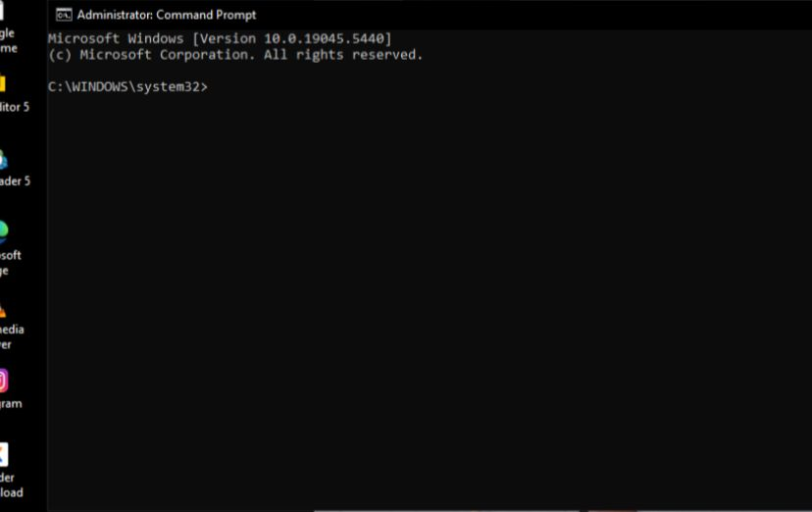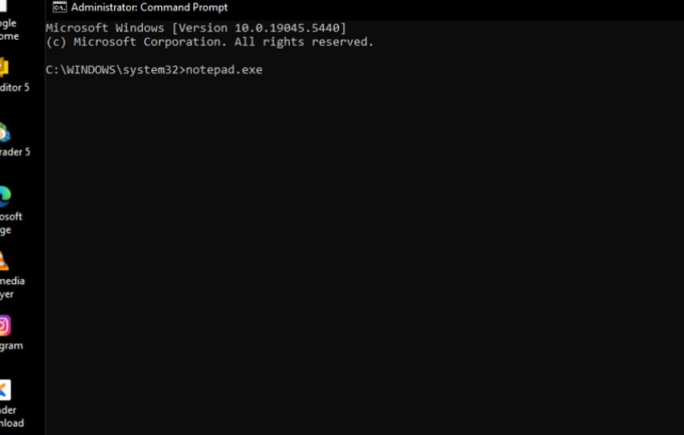
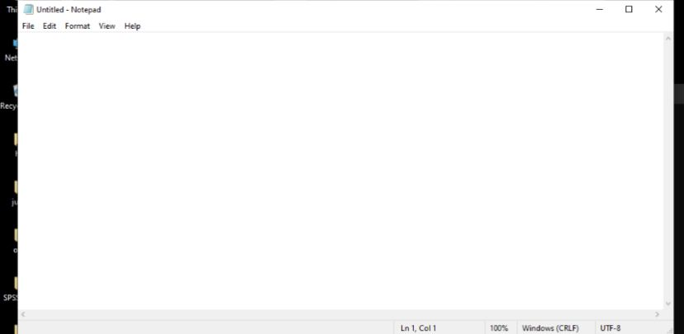
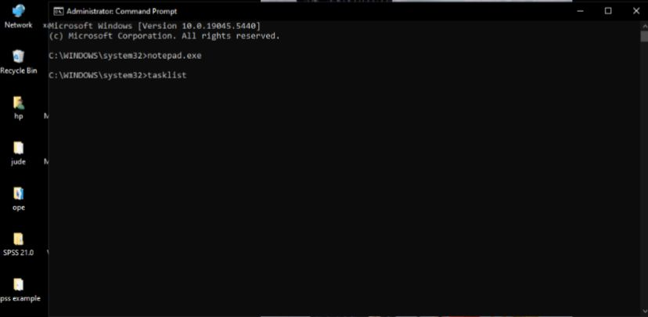
2. Monitoring CPU Usage and Process Priority
In this exercise, the Task Manager is used to observe CPU usage among active processes. The most resource-intensive process is identified, and its priority level is examined. Understanding process priority is essential in managing system performance and resource allocation efficiently.
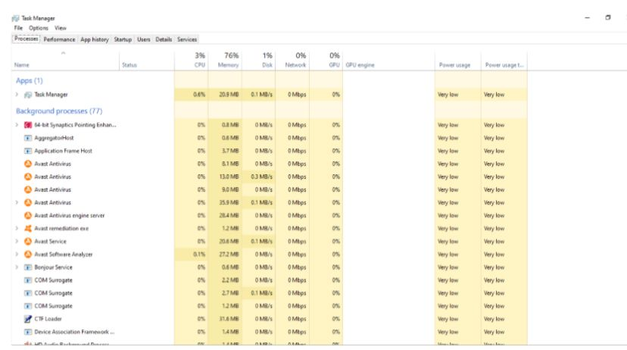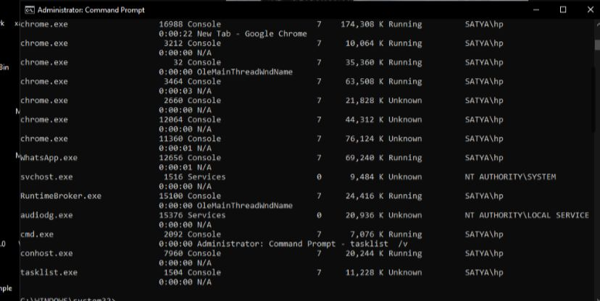
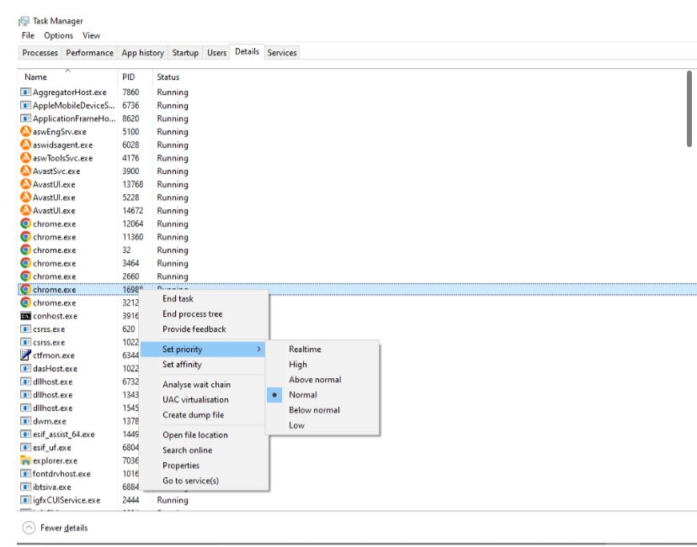
3. Clipboard Data Transfer Between Notepad and Word
This task illustrates inter-process communication through the clipboard. Text typed in Notepad is copied and successfully pasted into Microsoft Word. The exercise reinforces the concept of data sharing between applications via the operating system's clipboard mechanism.
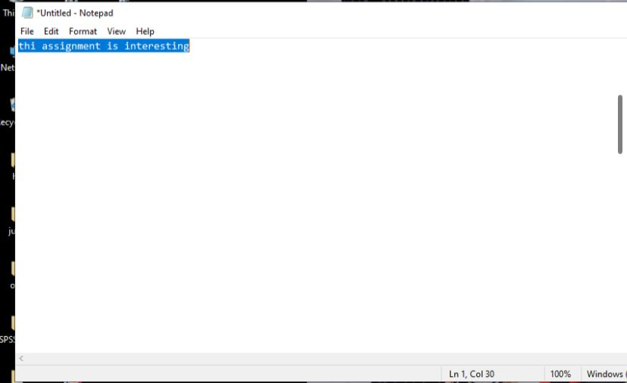
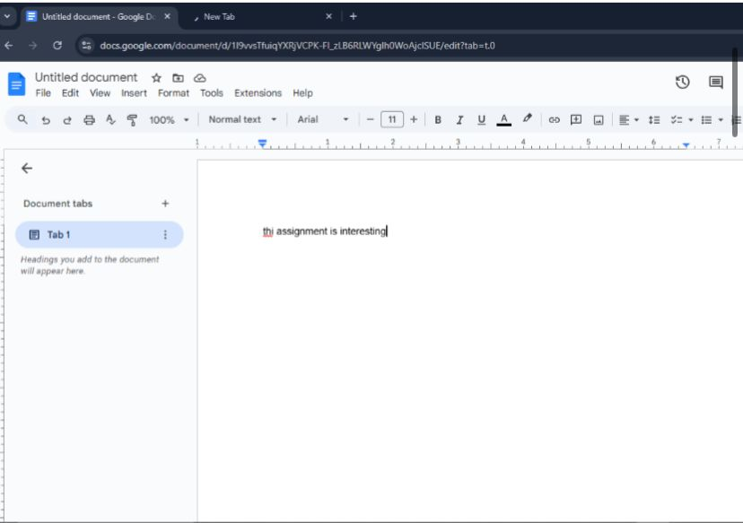
4. Terminating a Non-Responsive Process
This activity focuses on handling unresponsive applications. Using Task Manager, a non-responding process is located and terminated using the “End Task” function. The task underscores the importance of process control in system stability and user experience.

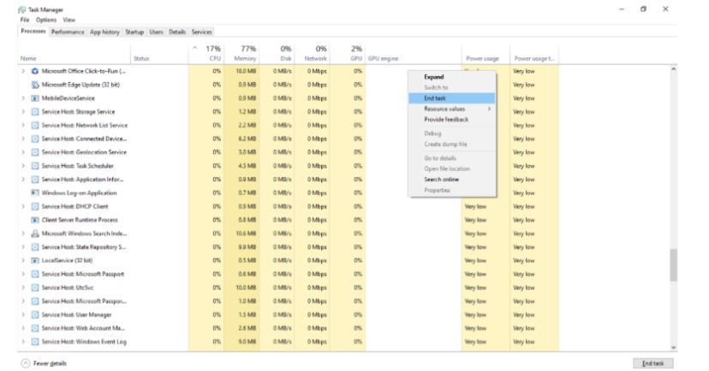
5. Creating and Executing a C++ Multithreaded Program
Here, a multithreaded C++ program is developed to demonstrate concurrent execution. The program spawns multiple threads to print letters and numbers simultaneously. The task provides a practical understanding of how operating systems support parallel processing and manage multiple threads within a single process.
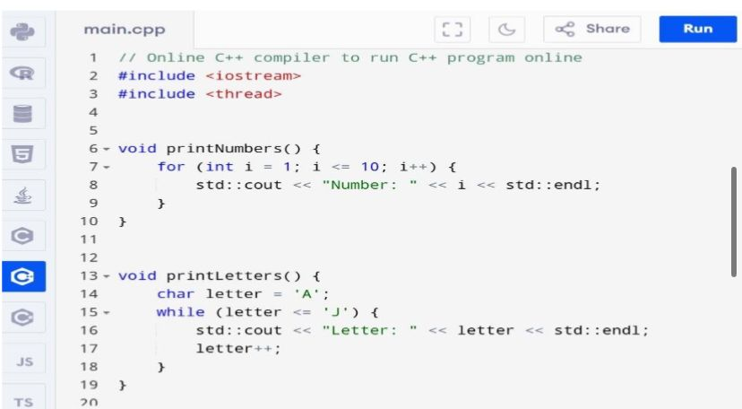
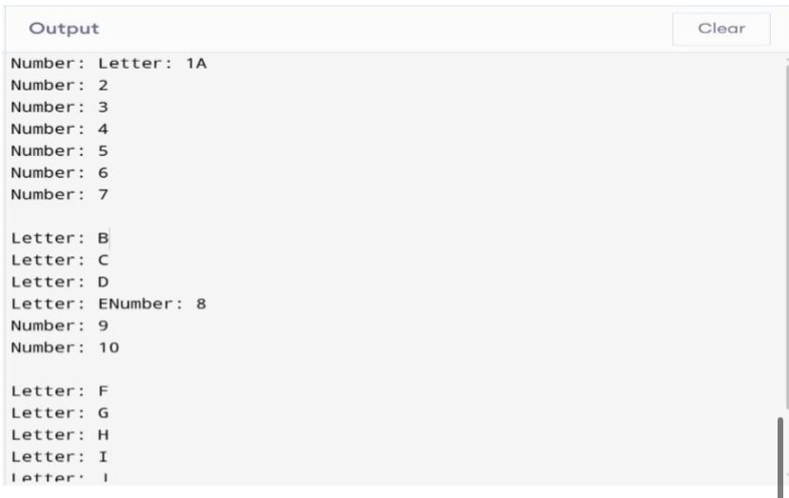

6. Modifying Process Priority via Task Manager
This task involves altering the priority of a running process (e.g., Notepad) from its default to a higher level. The modification is done through Task Manager by selecting the desired priority setting. This enhances comprehension of how priority levels influence CPU scheduling.
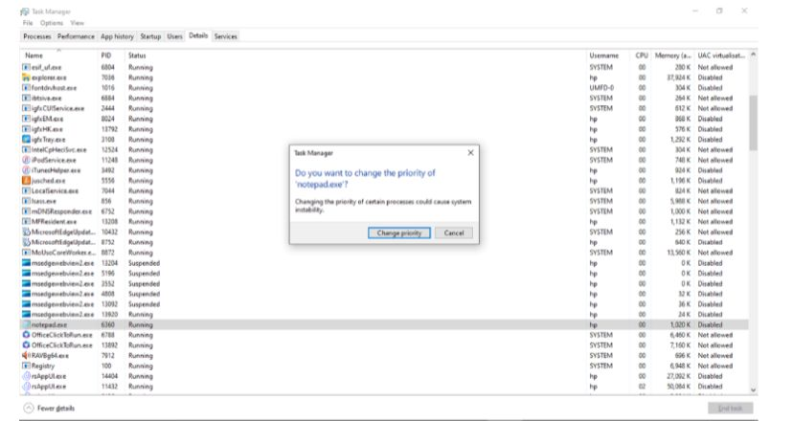

7. Creating and Monitoring Threads in a Program
In this section, a new thread is created using either C++ or Java programming. Upon execution, the thread performs a simple task and is observable via the Task Manager. The activity reinforces thread management concepts and the role of threads within a parent process.
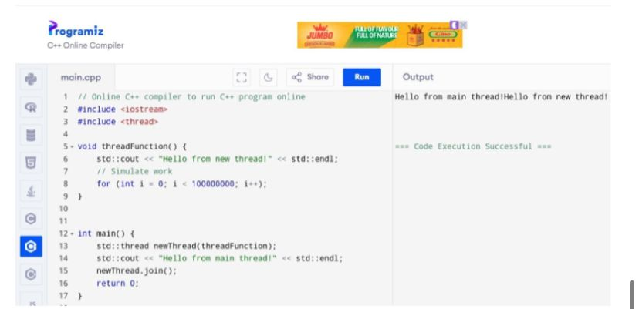

8. Terminating a High-Resource Process Using Resource Monitor
The Resource Monitor tool is employed to identify processes consuming excessive system resources. Once located, such a process is safely terminated. This task teaches how to use advanced system utilities for monitoring and maintaining performance.

9. Configuring Process Security in Task Manager
This final activity demonstrates how to modify the execution settings of a process for elevated privileges. By adjusting the security properties (e.g., running Notepad as Administrator), the task emphasizes how operating systems enforce access control and user-level execution permissions.

1. Create a Process Using Notepad
Aim & Objectives: To learn how to create a new process using the Command Prompt and observe system processes, to identify processes and learn how to retrieve their Process ID (PID).

Tools: Command Prompt or PowerShell, Tasklist command

Procedure:
- Open Command Prompt or PowerShell as an administrator.
- Type notepad.exe and press Enter to create the process.
- Run the tasklist command to view running processes.
- Locate Notepad and note its PID.

Observation:
The Notepad process was successfully created and listed under the running processes, and the PID for Notepad was easily identifiable in the task list.

Lessons Learnt: Learned how to create processes via the command line and list running processes using tasklist.

Task 2: Monitor CPU Usage and Priority
Aim & Objectives:
To understand how to monitor CPU usage and process priority, and to learn how to check the priority level of a running process.
Tools:
Task Manager, Tasklist command.
Procedure:
- Open Task Manager using Ctrl + Shift + Esc.
- Navigate to the “Processes” tab and identify the process with the highest CPU usage.
Note the Process ID (PID).
- Open Command Prompt and use the tasklist command to check the process priority.
Observation:
The process with the highest CPU usage was successfully identified. The tasklist command provided its corresponding priority level.
Lessons Learnt:
Gained experience in monitoring CPU usage and understanding how process priorities affect performance.

Task 3: Clipboard Transfer Between Notepad and Word
Aim & Objectives:
To observe how the clipboard is used to transfer data between applications and understand operating system-level inter-process communication.
Tools:
Notepad, Microsoft Word.
Procedure:
- Type a sample text in Notepad.
- Copy the text using Ctrl + C.
- Open Microsoft Word and paste the text using Ctrl + V.
Observation: The text was successfully copied from Notepad and pasted into Word without errors.
Lessons Learnt: Developed an understanding of how the clipboard allows data transfer between applications.

Task 4: End a Non-Responsive Process
Aim & Objectives: To learn how to terminate non-responsive processes and understand their impact on system stability.
Tools: Task Manager.
Procedure:
- Open Task Manager and identify a non-responsive application.
- Right-click on the process and select “End Task.”
- Confirm the action to terminate the process.
Observation:The selected non-responsive process was successfully terminated using Task Manager.
Lessons Learnt: Understood how to manage and terminate unresponsive processes effectively.

Create and Run a C++ Multithreading Program
Aim & Objectives: To understand the concept of multithreading and how to create and run a multithreaded program in C++.
Tools: C++ Compiler (e.g., Visual Studio).
Procedure:
- Write a C++ program that creates two threads.
- Each thread performs a different task (e.g., printing numbers and letters).
- Compile and execute the program to observe concurrent execution.
Observation: Both threads ran concurrently and independently, demonstrating multithreaded behavior.
Lessons Learnt:
Learned how to implement and manage multiple threads in a C++ environment.

Task 6: Change Process Priority in Task Manager
Aim & Objectives: To explore process priority levels in Task Manager and understand how changing priorities affects CPU scheduling.
Tools: Task Manager.
Procedure:
- Open Task Manager and locate a process such as Notepad.
- Right-click the process and select “Set Priority.”
- Choose a higher priority level (e.g., High) and observe CPU behavior.
Observation: After changing the process priority, there was a noticeable increase in CPU attention to that process.
Lessons Learnt: Understood how adjusting process priorities can impact system performance and resource allocation.

Task 7: Create a Thread in Another Program
Aim & Objectives: To create a new thread in a C++ or Java program and observe how the operating system handles it.
Tools:
C++ Compiler or Java IDE.
Procedure:
- Write a basic program that creates and runs a separate thread.
- Compile and execute the program.
- Open Task Manager to observe the thread’s activity.
Observation: The thread was created successfully and executed without conflict. Its presence was observable via Task Manager.
Lessons Learnt: Learned how threads operate within a parent process and how they can be monitored.

Task 8: End a Resource-Heavy Process Using Resource Monitor
Aim & Objectives: To monitor system resources and terminate processes that consume excessive CPU or memory.
Tools: Resource Monitor (resmon.exe).
Procedure:
- Launch Resource Monitor.
- Identify a process using high resources.
- Right-click and select “End Process.”
Observation: The selected resource-heavy process was terminated, resulting in immediate improvement in system responsiveness.
Lessons Learnt: Gained practical experience in using Resource Monitor to manage system efficiency.

Task 9: Configure Security for a Process in Task Manager
Aim & Objectives: To learn how to adjust security settings for processes and run them with different privilege levels.
Tools: Task Manager.
Procedure:
- Open Task Manager and find a process (e.g., Notepad).
- Right-click and select “Properties.”
- Modify settings to “Run as Administrator.”
Observation: The process launched with administrator privileges, confirming the applied security configuration.
Lessons Learnt: Understood how to control process permissions and how administrative access affects process execution.

