EXECUTIVE MEMO
Marketplace Analytics
Growth, Concentration Risk, and Seller Performance
Reporting Period January 2023 – December 2024
Document Version 1.0
Date Prepared April 2026
Classification Internal — Leadership
Prepared ByData & Analytics Team

DISTRIBUTION
Head of Growth · Head of Seller Operations · Head of Data · Executive Leadership Team

PREPARED BY | REVIEWED BY | APPROVED BY
_________________________  Signature / Date | _________________________  Signature / Date | _________________________  Signature / Date

1. Executive Summary
The Marketplace grew revenue from ₦155M in 2023 to ₦871M in 2024 — a 462% increase driven by order volume scaling from 479 to 2,517 paid orders. The growth is real, but it masks two structural problems: revenue is dangerously concentrated in a single product category, and nearly a third of new customers in key states never make a first purchase.

Headline Metrics
Metric | 2023 | 2024 | Δ Abs. | Δ %
Total revenue (₦) | 155,000,000 | 871,000,000 | +716,000,000 | +462%
Paid orders (delivered) | 479 | 2,517 | +2,038 | +426%
Active sellers | ; | 90 | ; | —
Active buyers (made a purchase) | — | 677 | — | —
Bonus-qualifying sellers | — | 10 | — | 11% of base
Table 1. Year-over-year headline metrics, 2023 to 2024.

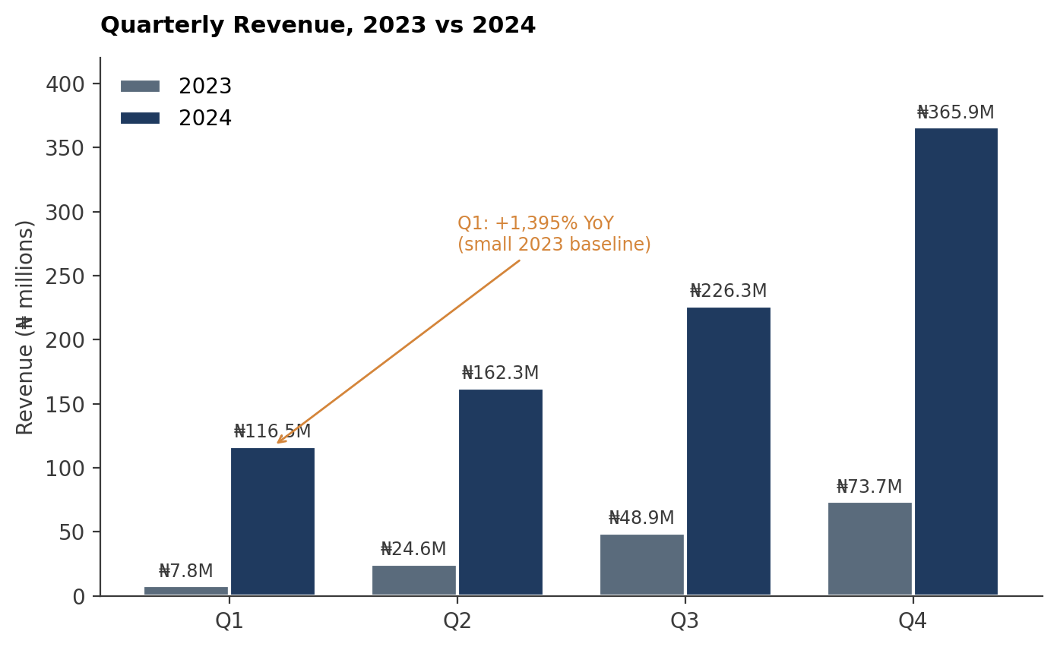
Figure 1. Quarterly revenue. Q1 2024 grew 1,395% off a small Q1 2023 baseline of ₦7.8M / 22 orders; Q4 2024 reached ₦365.9M, the largest quarter in the period.
STRATEGIC TENSION
Underlying the headline growth: the platform is structurally exposed to a single product category, and the new-customer pipeline leaks first-purchase intent in two of the top five sign-up states. These are addressable, but they require deliberate action — they will not self-correct as volume grows.

2. Key Findings
Finding 1: Revenue depends almost entirely on Electronics
All ten of the highest-grossing products in 2024 are Electronics, led by the top SKU at ₦26.7M (see Appendix A, Q2). The top 10 alone account for over ₦215M in 2024 revenue. Meanwhile, the platform sells across seven categories — Fashion, Beauty & Personal Care, Home & Garden, Food & Beverages, Sports & Fitness, and Books & Stationery — none of which placed a single product in the top revenue tier.
A supply disruption, pricing shift, or demand change in Electronics would disproportionately hit overall platform revenue. The remaining six categories are underperforming relative to catalogue size — each has 40 products listed, yet their combined top-line contribution is dwarfed by Electronics.
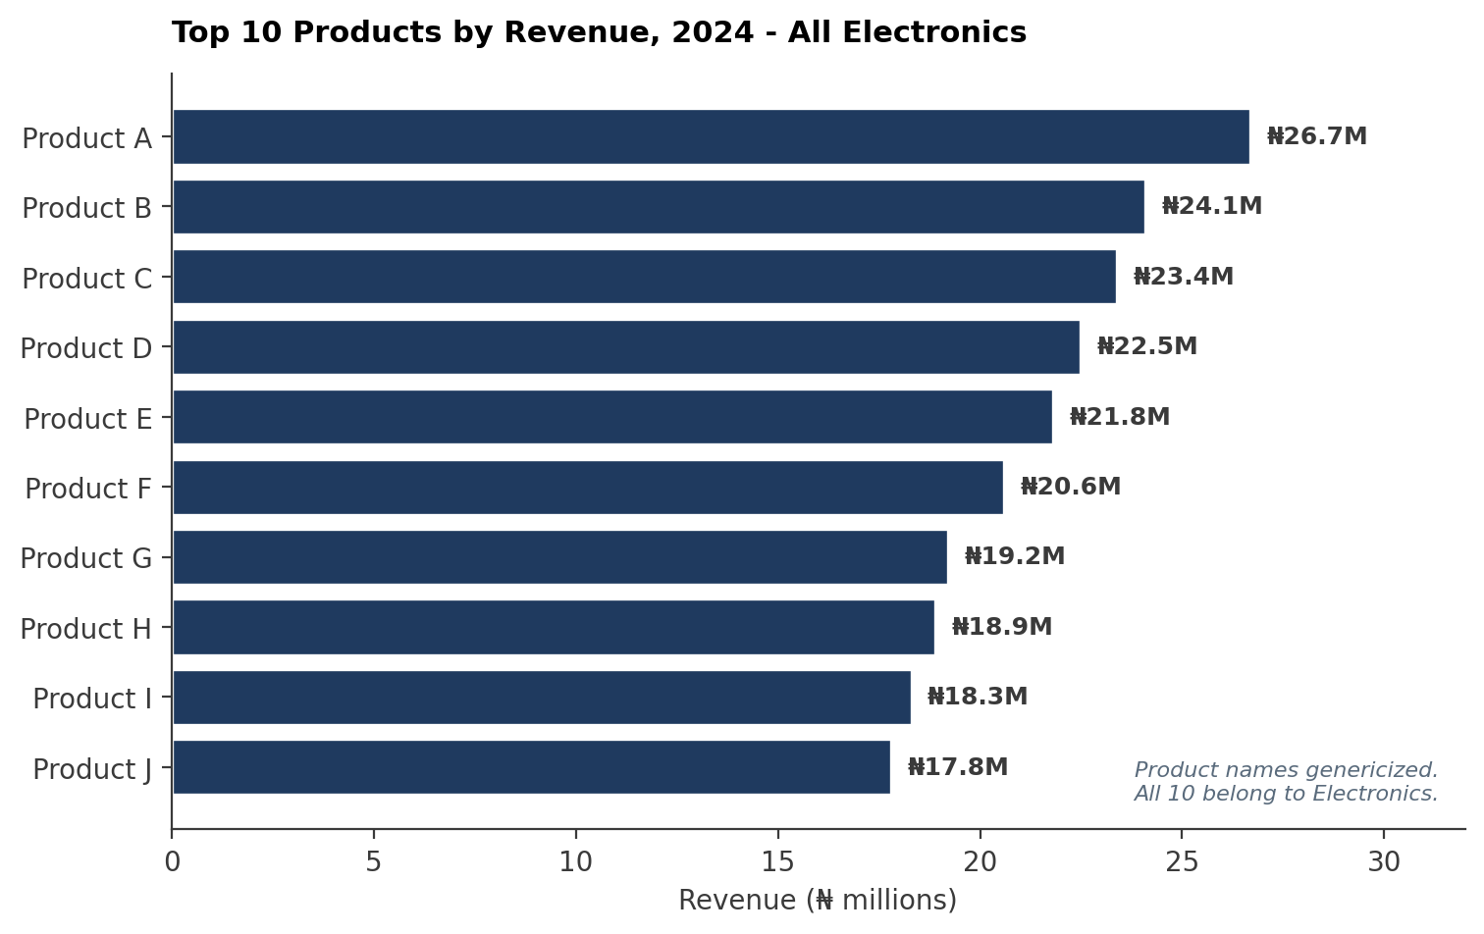
Figure 2. Top 10 products by revenue, 2024. All Electronics; no non-Electronics SKU placed in the top tier.

Finding 2: Customer conversion varies sharply by state, with Kano and Oyo lagging
Lagos converts 49.3% of new sign-ups within 30 days. Kano converts 31.0%, and Oyo 33.3% (see Appendix A, Q1). That gap represents real lost revenue: Kano had 58 new sign-ups in 2024, meaning 40 people created accounts and never bought. Oyo tells a similar story with 42 unconverted out of 63.
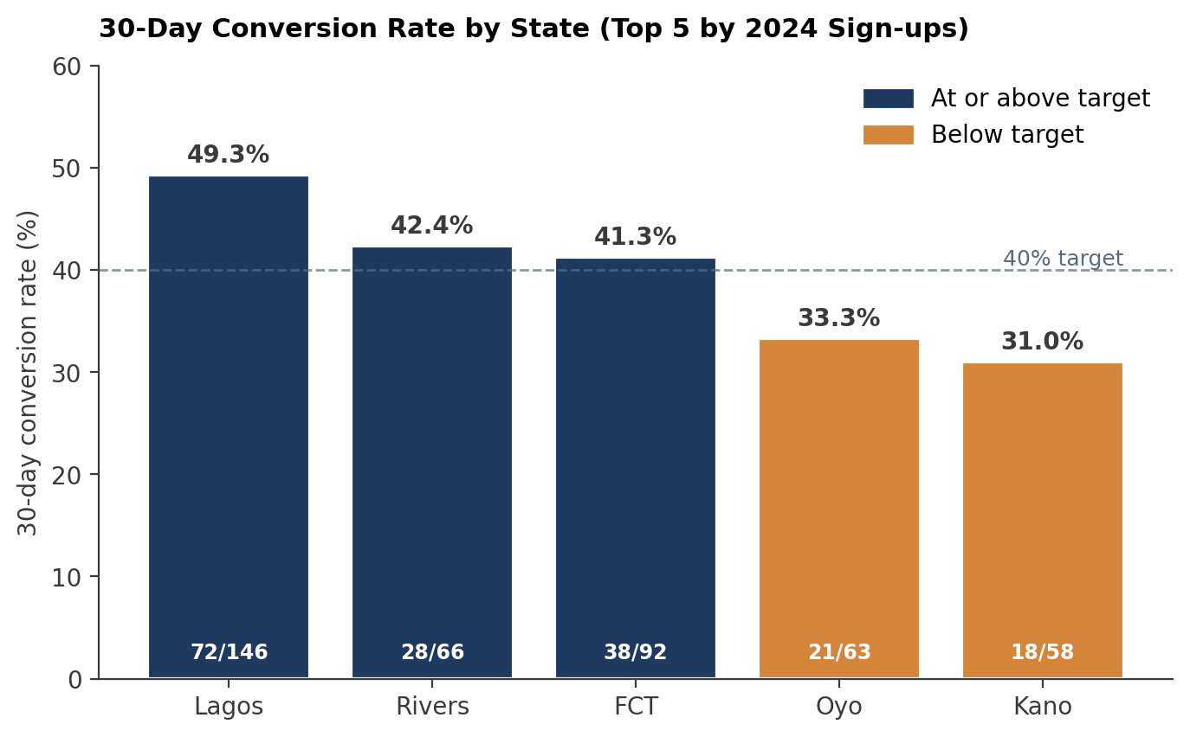
Figure 3. 30-day conversion rate by top 5 sign-up states. Two states fall below the 40% target line.
The payment data offers a possible explanation. Kano and Oyo are the only two states where Cash on Delivery is the most popular payment method. Card-dominant states — Lagos, FCT, Rivers — all convert above 41%. There may be a friction problem: customers in COD-heavy states may hesitate to commit to a first order when they cannot pay digitally.
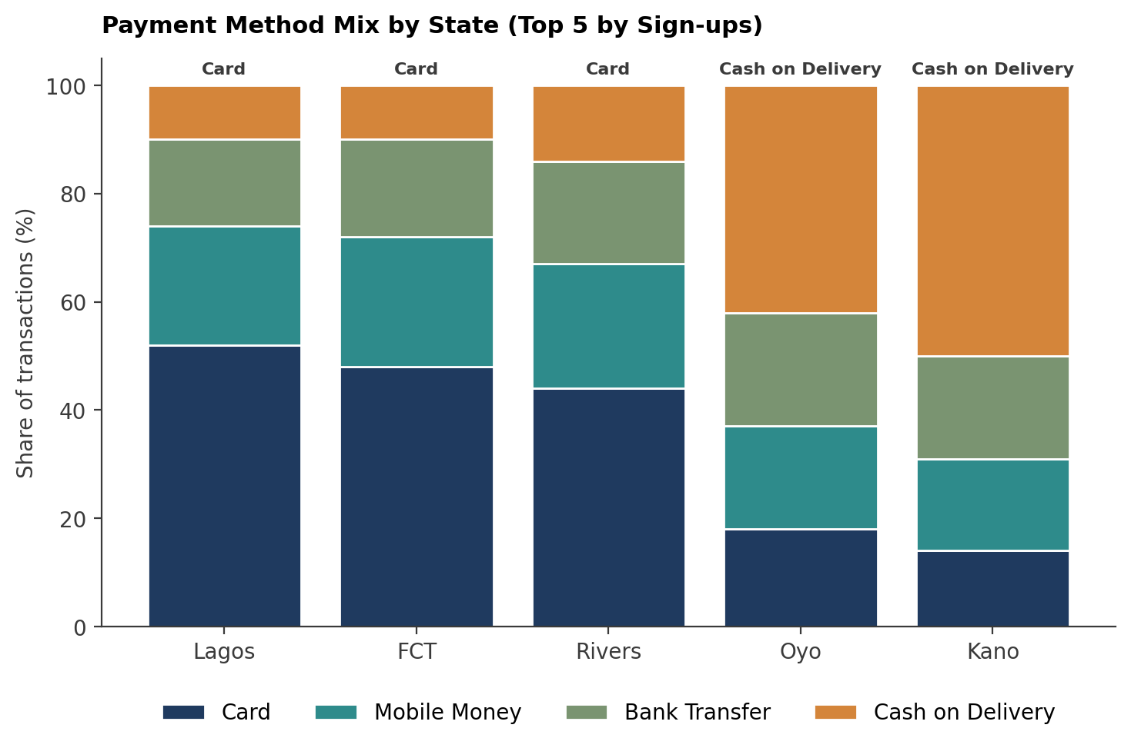
Figure 4. Payment method composition. The two states where Cash on Delivery dominates also have the lowest conversion rates.
Finding 3: Only 10 sellers meet the quality bar for a performance bonus
Out of 90 active sellers, just 10 qualified under the bonus criteria. The top qualifier (Seller A) earned ₦10.98M in revenue. Among fast-fulfilling sellers, Seller B ships in 91 hours but carries a 3.25 average rating — fast, but not satisfying customers. Speed alone is not translating to customer satisfaction.
The seller base has a quality distribution problem: most sellers either lack volume or lack ratings to qualify for any performance incentive. This concentrates outsized rewards on a small group while the long tail operates without performance feedback loops.
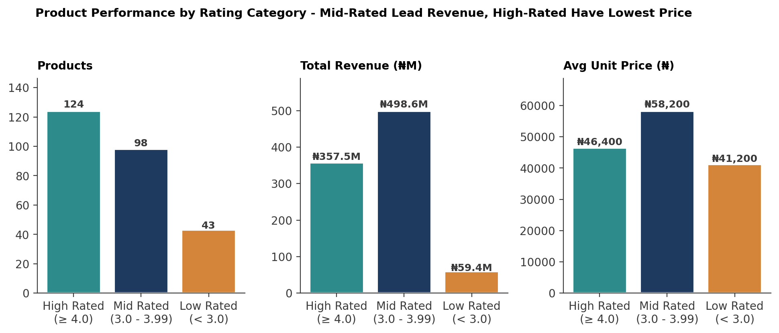
Figure 5. Mid-rated products generate ₦141M more revenue than high-rated ones. High-rated products carry the lowest average unit price (₦46,400).
COUNTER-INTUITIVE FINDING
Mid-rated products (3.0–3.99 stars) produce ₦498.6M in revenue — ₦141M more than High-rated products (≥ 4.0 stars).
High-rated products have the lowest average unit price (₦46.4K), below mid-rated (₦58.2K). Customers may be rating cheaper, simpler products favourably while spending on more expensive mid-rated SKUs.
Investing in lifting Mid-rated SKUs to High-rated may yield more incremental revenue than chasing the already-saturated High-rated tier.

3. Recommendations
Recommendation 1: Launch a category growth pilot for the three largest non-Electronics categories
Element | Detail
Action | Select Fashion, Beauty & Personal Care, and Home & Garden — the three categories with the most listed products after Electronics — and run a 90-day promotional push: homepage placement, targeted discounts, and bundled recommendations alongside Electronics purchases.
Owner | Head of Growth, in coordination with the Category Management team.
Expected Outcome | Within 90 days, at least one non-Electronics product appears in the top 20 by revenue. Demand exists for moderately-reviewed products at higher price points; the issue is visibility, not product quality.
Evidence | Q2 (category concentration in top revenue tier); Q7 (Mid-rated products generate more revenue than High-rated).
KPIs | Non-Electronics share of top-20 revenue (target: ≥5% by day 90); click-through rate on bundled recommendations; conversion rate on promoted categories.
Risks | Cannibalisation of Electronics conversions during bundle promotion; promotional discounts compressing margin if not capped.
Table 2. Recommendation 1 specification.

Recommendation 2: Implement a 'first-purchase' conversion programme targeting Kano and Oyo
Element | Detail
Action | For new sign-ups in Kano and Oyo, trigger a time-limited first-purchase incentive within 7 days of registration: a small discount or free delivery on the first order. Also prioritise expanding Mobile Money acceptance in these states as a bridge between COD hesitation and full card adoption.
Owner | Head of Growth, supported by the Payments and Operations teams.
Expected Outcome | Raise 30-day conversion in Kano from 31% to at least 40%, and in Oyo from 33% to 40%, within 60 days. If converted customers follow the platform's average spend pattern, this could recover an estimated ₦30M – ₦50M in currently lost first-year revenue from these two states.
Evidence | Q1 (state conversion rates); Q6 (Cash on Delivery dominance correlates with low conversion).
KPIs | 30-day conversion rate by state (weekly); Mobile Money share of first-time orders; first-purchase incentive redemption rate.
Risks | Discount-driven conversions may not retain at the same rate as organic ones; Mobile Money rollout depends on partner readiness.
Table 3. Recommendation 2 specification.

4. Data Quality Notes
Two material data quality issues were identified during analysis. Both were resolved using documented decision rules, but the underlying patterns affect interpretation of the revenue figures and are worth calling out explicitly. The full audit is in Document 3.
Issue 1: Order total amount discrepancies
124 orders had total_amount values that did not match the sum of their line items, with discrepancies ranging from ₦99 to ₦326,748. An additional 131 orders had NULL total amounts but valid line items.
Decision: All 255 orders were corrected by replacing total_amount with the calculated sum from order_items. If these original totals reflected legitimate adjustments — manual discounts, refunds, or promotional credits not captured in the line items — then revenue figures throughout this memo may be overstated by the cumulative difference.
Issue 2: Unrecoverable product prices
Four products (PROD0088, PROD0104, PROD0205, PROD0245) have NULL unit prices in both the products table and all 97 of their order_items. Total impact: 19 orders with completely unrecoverable revenue data.
Decision: These records were excluded from revenue-based queries. If prices were recoverable from an external source, total platform revenue would increase and these products might affect rankings in Q2 or the segmentation in Q7.
5. What the Data Cannot Tell Us
Leadership is likely to ask: “why are customers in Kano and Oyo not converting?” The data shows the gap exists and correlates with payment method preference, but it cannot establish causation. We do not know whether customers abandoned carts, never browsed after signing up, or attempted purchases that failed.
To answer the underlying question, session-level behavioural data is required: page views, cart additions, checkout attempts, and drop-off points tied to customer IDs. A funnel analysis with this data would pinpoint exactly where the conversion breaks down and whether payment method is the bottleneck or a symptom of a deeper UX or product-market fit issue in those regions.
RECOMMENDED NEXT STEP
Instrument event tracking on the registration-to-first-purchase funnel for Kano and Oyo specifically. A 30-day data collection window would supply the missing layer needed to design a precise intervention.

Appendix A — Query Catalogue
The following queries underpin the analysis in this memo. Full annotated SQL is in the Query Documentation Pack (Document 4) and Technical Methodology Report (Document 2).
Ref | Business Question | Used In
Q1 | Which states have the highest new-customer sign-ups in 2024, and what share converted within 30 days? | Finding 2; Recommendation 2
Q2 | Which products generated the most revenue in 2024? | Finding 1; Recommendation 1
Q3 | Which sellers fulfil orders fastest, and how does fulfilment speed correlate with customer rating? | Finding 3
Q4 | How did quarterly revenue change from 2023 to 2024? | Executive Summary; Figure 1
Q5 | How is customer spend distributed across high, medium, and low spender segments? | Supporting context
Q6 | Which payment methods dominate by state, and where is Cash on Delivery most prevalent? | Finding 2; Recommendation 2
Q7 | How does product rating correlate with revenue and unit price? | Finding 1; Recommendation 1
Q8 | Which sellers qualify for the 2024 performance bonus? | Finding 3
Table 4. Query reference index. Full documentation in the Query Documentation Pack (Document 4).

Appendix B — Definitions
Term | Definition
Delivered order | An order with order_status = 'Delivered' and a non-NULL delivery_date. Used as the basis for all revenue calculations.
30-day conversion | A customer who placed at least one order within 30 calendar days of their signup_date. Measured against new sign-ups in 2024.
Bonus-qualifying seller | A seller with at least 10 delivered orders in 2024 and an average customer rating of 4.0 or above across all reviews tied to that seller's orders.
High Spender | Customer with total 2024 spend ≥ ₦100,000.
Medium Spender | Customer with total 2024 spend between ₦50,000 and ₦99,999.
Low Spender | Customer with total 2024 spend < ₦50,000.
High Rated product | Average customer rating ≥ 4.0 across all reviews.
Mid Rated product | Average customer rating between 3.0 and 3.99.
Low Rated product | Average customer rating < 3.0.
Average fulfilment hours | AVG(EXTRACT(EPOCH FROM (delivery_date - order_date)) / 3600) across delivered orders for a given seller.
Table 5. Working definitions used throughout this memo.

Document Control
Version | Date | Change Summary | Author
0.1 | 2026-03-12 | Initial draft — findings only | Data Team
0.5 | 2026-03-28 | Added recommendations and data quality section | Data Team
0.9 | 2026-04-04 | Internal review; added Appendix A & B | Data Team
1.0 | 2026-04-15 | Approved for distribution to leadership | Data Team
Table 6. Revision history.

Revenue figures derive from delivered orders only. Cancelled, returned, processing, and shipped-but-undelivered orders are excluded from revenue calculations.
Conversion is the share of new sign-ups in 2024 who placed at least one order within 30 calendar days of registration. Customers who signed up in late December had less than 30 days to convert before the data period ended.
Of 280 catalogued products, 15 had no reviews and were excluded from rating-based grouping. Four products had unrecoverable unit prices and were excluded from revenue calculations. See §6, Issue 2.
Bonus criteria: a minimum of 10 delivered orders in 2024 and an average customer rating of 4.0 or above across all reviews tied to that seller's orders.
Correlation, not causation. The pattern is suggestive but session-level behavioural data is required to confirm payment friction as the driver. See §5.

