TECHNICAL METHODOLOGY REPORT
Marketplace Analytics
Data Cleaning, Validation Logic, and Query Design
Reporting Period January 2023 – December 2024
Document Version 1.0
Date Prepared April 2026
Classification Internal — Data Engineering
Prepared ByData & Analytics Team

DISTRIBUTION
Data Engineering · Data Quality · Analytics Leads · External Audit

PREPARED BY | REVIEWED BY | APPROVED BY
_________________________  Signature / Date | _________________________  Signature / Date | _________________________  Signature / Dat

1. Purpose and Scope
This report documents the technical decisions taken to transform the raw marketplace dataset into an analysis-ready form. It is the companion to the Executive Memo (Document 1), the Data Quality Audit Report (Document 3), and the Query Documentation Pack (Document 4).
Audience
Data engineers and analysts who will inherit, extend, or audit this work. The level of detail assumes working knowledge of SQL and PostgreSQL, but every non-obvious decision is annotated.
Scope
Element | Detail
Source dataset | 7 raw tables: customers (865 rows), sellers (90), products (280), orders (3,015), order_items (6,426), payments (2,262), reviews (817). 13,755 rows total.
Period of analysis | 1 January 2023 to 31 December 2024 (24 months).
Output dataset | 7 cleaned tables in a separate cleaned schema, plus an embedded amount_validation_status column in cleaned.orders.
Tooling | PostgreSQL 18, pgAdmin 4 for development. VS Code with the PostgreSQL extension was used for review.
Reproducibility | All transformations are deterministic and contained in a single master cleaning script. Re-running against the original raw tables produces identical output.
Table 1. Project scope summary.

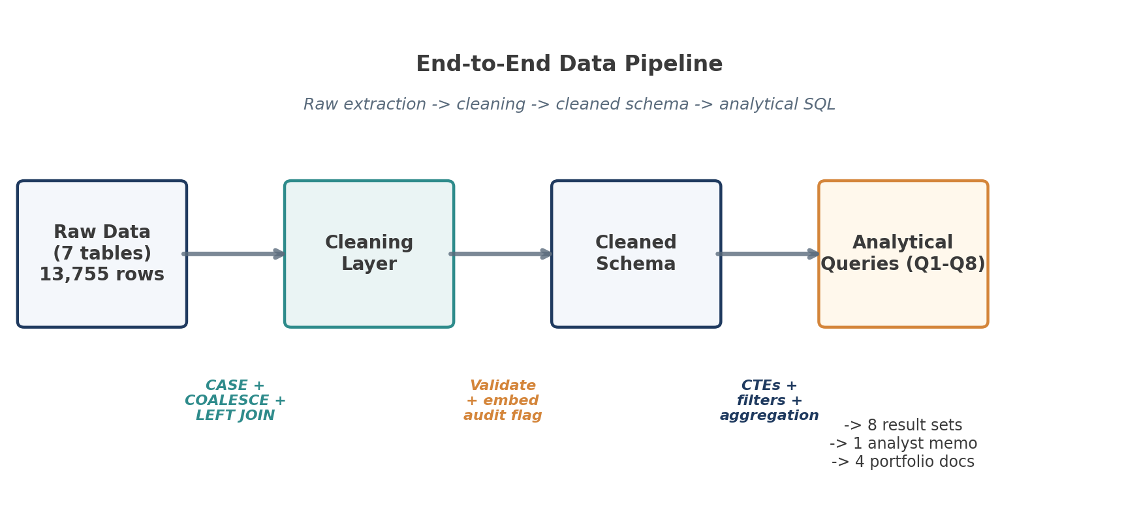
Figure 1. End-to-end pipeline. Raw data flows through a cleaning layer into the cleaned schema, then into the eight analytical queries.
2. Cleaning Philosophy
Three principles governed every cleaning decision.
Principle 1 — Raw tables are immutable
Every transformation produces a new table in the cleaned schema. The raw tables are never modified, dropped, or replaced. This means the cleaning logic can be re-run, revised, or rolled back without data loss, and any downstream issue can be traced back to its source by joining cleaned to raw on the primary key.
Principle 2 — Single-pass transformations
Each cleaned table is produced by a single CREATE TABLE AS SELECT statement. Multi-pass UPDATE chains create ordering dependencies and make the script harder to reason about. A single SELECT — even a complex one with CTEs — is easier to validate, test, and modify.
Principle 3 — Audit fields embedded in the data
Where cleaning makes substantive corrections (rather than cosmetic standardisation), a status column is embedded in the cleaned table. An analyst can filter to the corrected records at any time without rerunning the cleaning logic — see the orders table validation_status column in §4.4.
3. Source Schema
The seven raw tables form a star-like schema with orders as the central transactional fact, surrounded by customer, seller, product, and audit dimensions.
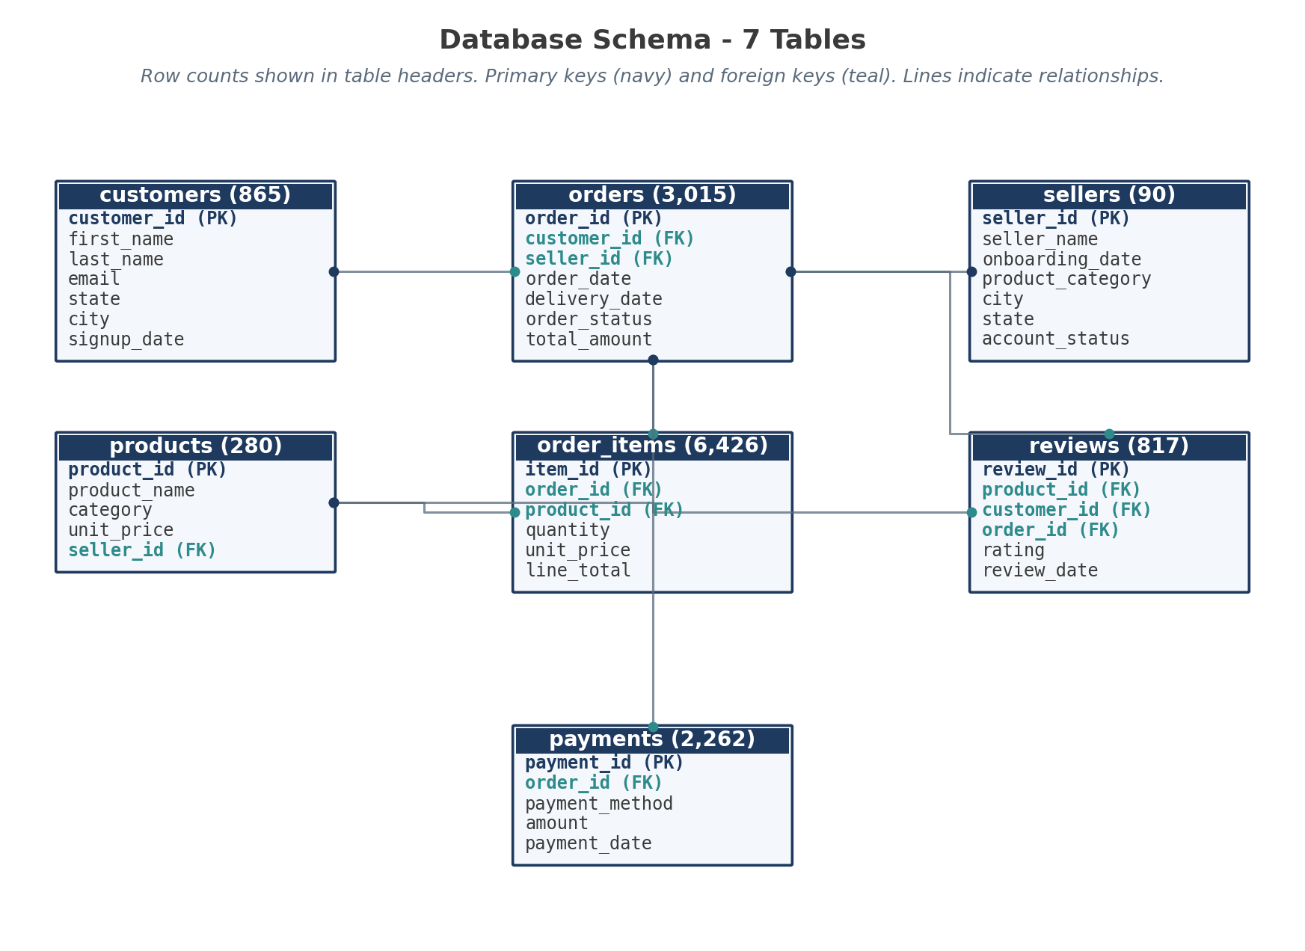
Figure 2. Source schema with row counts. Primary keys shown in navy, foreign keys in teal.
Row volumes
Table | Rows | Notes
customers | 865 | Sign-up dates span the full period; 16 NULL emails retained.
sellers | 90 | All active. Distributed across 5 cities.
products | 280 | 40 products per category × 7 categories. 4 with NULL prices.
orders | 3,015 | All statuses. 1,505 delivered; 1,510 in non-final states.
order_items | 6,426 | Average ~2.1 items per order.
reviews | 817 | 5 ratings out of valid range; 15 products lack any review.
payments | 2,262 | 1:1 with delivered orders.
Table 2. Source table row counts and notable characteristics.

4. Per-table Cleaning Logic
4.1 sellers — City standardisation
Problem
Manual data entry produced 23 distinct spellings across the 5 cities in customers and sellers tables. Variants observed include 'Port-Harcourt', 'Port Harcourt', 'PortHarcourt', 'PORT HARCOURT', 'Lago s' (internal space), trailing whitespace, and case variations across all five hub cities.
Cleaning rule
Two preprocessing passes followed by canonical mapping, with INITCAP as the safety net for any unmatched value.
CREATE TABLE cleaned.sellers AS
SELECT
seller_id,
seller_name,
onboarding_date,
product_category,
CASE
-- 1. Port Harcourt: catches spaces, dashes, and internal typos
WHEN LOWER(REPLACE(REPLACE(city, '-', ''), ' ', ''))
LIKE '%portharcourt%' THEN 'Port Harcourt'

-- 2. Lagos: implicitly fixes 'Lago s' by stripping spaces first
WHEN LOWER(REPLACE(city, ' ', '')) = 'lagos' THEN 'Lagos'

-- 3. Other major hubs
WHEN LOWER(REPLACE(city, ' ', '')) = 'abuja' THEN 'Abuja'
WHEN LOWER(REPLACE(city, ' ', '')) = 'ibadan' THEN 'Ibadan'
WHEN LOWER(REPLACE(city, ' ', '')) = 'kano' THEN 'Kano'

-- 4. Default fallback: trim and capitalise
ELSE INITCAP(TRIM(city))
END AS city,
state,
account_status
FROM sellers;
Listing 1. cleaned.sellers — city standardisation logic.

Why this works
The two REPLACE calls strip dashes and spaces before comparison, so 'Port-Harcourt', 'Port Harcourt', and 'PortHarcourt' all collapse to 'portharcourt' before the LIKE pattern fires. The Lagos rule strips spaces before equality, catching 'Lago s'. The fallback INITCAP(TRIM(city)) ensures any city not in the canonical list still emerges in clean title-case form, preserving long-tail cities for future analysis without manual enumeration.
Result
5 clean cities — Lagos (294 customers, 32 sellers), Abuja (181/19), Kano (135/14), Port Harcourt (130/15), Ibadan (125/10). The same logic is applied to both the customers and sellers tables to keep names consistent across joins.
4.2 products — Category standardisation
Problem
28 distinct category variants for 7 intended categories. Issues included casing (ELECTRONICS / electronics), typos (Electronis, Fashon), separator inconsistency ('and' vs '&'), truncated forms (BEAUTY, SPORTS, FOOD, BOOKS), and sub-categories used as categories ('Men', 'Women').
Cleaning rule
CASE with LIKE patterns for broad matching, plus explicit IN lists for typos and sub-category folding. 'Men' and 'Women' are folded into 'Fashion' since they are apparel sub-types without a separate reporting line.
CREATE TABLE cleaned.products AS
SELECT
product_id,
product_name,
CASE
WHEN LOWER(category) LIKE '%electr%' THEN 'Electronics'

WHEN LOWER(category) IN ('fashon','fashion','men','women')
OR LOWER(category) LIKE '%fash%' THEN 'Fashion'

WHEN LOWER(category) LIKE '%beauty%' THEN 'Beauty & Personal Care'
WHEN LOWER(category) LIKE '%home%' THEN 'Home & Garden'
WHEN LOWER(category) LIKE '%sport%' THEN 'Sports & Fitness'
WHEN LOWER(category) LIKE '%food%' THEN 'Food & Beverages'
WHEN LOWER(category) LIKE '%book%' THEN 'Books & Stationery'

ELSE INITCAP(TRIM(category))
END AS category,
unit_price,
seller_id
FROM products;
Listing 2. cleaned.products — category standardisation.

Why ordering matters
The Fashion branch must come AFTER the Electronics check but BEFORE the generic '%home%' / '%sport%' branches, because 'Men' and 'Women' are explicit IN-list entries that need to match before any pattern-based fallback fires. The fall-through order is: (1) explicit single-word matches, (2) LIKE patterns, (3) INITCAP fallback.
PITFALL CAUGHT DURING VERIFICATION
An earlier draft used %home%garden% (a more specific pattern) and the master script only handled Electronics and Fashion explicitly. Combined with the INITCAP fallback, this produced 14 categories instead of 7 — variants like 'Home And Garden', 'Sports', and 'Food' fell through to the title-case branch as separate categories. The fix was to broaden the LIKE patterns and let the INITCAP fallback only catch genuinely unknown values.

Result
7 categories, 40 products each: Electronics, Fashion, Beauty & Personal Care, Home & Garden, Sports & Fitness, Food & Beverages, Books & Stationery. Same logic applied to sellers.product_category.
4.3 order_items — Bottom-up imputation
Problem
Two systematic data quality issues: missing unit_price values (recoverable from the master products table for most cases), and missing or incorrect line_total values (recoverable arithmetically when unit_price and quantity are known).
Cleaning rule
LEFT JOIN to products as a fallback for unit_price, then COALESCE for line_total using the recovered price. Fatally flawed records — those with NULL on order_id, product_id, or quantity — are dropped because they cannot meaningfully participate in any aggregation.
CREATE TABLE cleaned.order_items AS
SELECT
oi.item_id,
oi.order_id,
oi.product_id,
oi.quantity,

-- Impute missing unit_price from the master products table
COALESCE(oi.unit_price, p.unit_price) AS unit_price,

-- Recalculate line_total if missing, using the fallback price
COALESCE(
oi.line_total,
(oi.quantity * COALESCE(oi.unit_price, p.unit_price))
) AS line_total

FROM order_items oi
LEFT JOIN products p
ON oi.product_id = p.product_id

-- Drop fatally flawed records (cannot recover order/product/quantity)
WHERE oi.order_id IS NOT NULL
AND oi.product_id IS NOT NULL
AND oi.quantity IS NOT NULL;
Listing 3. cleaned.order_items — imputation and filtering.

WHY BOTTOM-UP
The bottom-up approach is deliberate: order_items is the ground-truth source for transactional revenue. Cleaning order_items first means the orders table can validate against a reliable foundation. Doing this in reverse would mean trusting potentially incorrect order totals to validate the line items.

4.4 orders — Validation against line items
Problem
Two distinct integrity issues: 131 orders with NULL total_amount but valid line items, and 124 orders where the recorded total diverged materially from the sum of its line items.
Cleaning rule
Calculate the ground-truth total from cleaned order_items, then apply a three-way decision:
- If total_amount is NULL → impute from line item sum
- If |total_amount − calculated_total| > ₦10 → replace with calculated_total
- Otherwise → keep the original total_amount

An amount_validation_status column is embedded in the output, recording which of the four branches was taken for each order.
CREATE TABLE cleaned.orders AS
WITH item_sums AS (
-- Step 1: Calculate ground-truth total from validated items
SELECT
order_id,
SUM(line_total) AS calculated_total
FROM cleaned.order_items
GROUP BY order_id
)
SELECT
o.order_id,
o.customer_id,
o.seller_id,
o.order_date,
o.delivery_date,
o.order_status,

-- Step 2: Impute or correct total_amount
CASE
WHEN o.total_amount IS NULL
THEN i.calculated_total
WHEN i.calculated_total IS NOT NULL
AND ABS(o.total_amount - i.calculated_total) > 10
THEN i.calculated_total
ELSE o.total_amount
END AS total_amount,

-- Step 3: Embedded audit flag
CASE
WHEN o.total_amount IS NULL AND i.calculated_total IS NOT NULL
THEN 'Imputed from Items'
WHEN i.calculated_total IS NULL
THEN 'Warning: No Line Items Found'
WHEN ABS(o.total_amount - i.calculated_total) > 10
THEN 'Corrected: > 10 Discrepancy'
ELSE 'Valid'
END AS amount_validation_status

FROM orders o
LEFT JOIN item_sums i ON o.order_id = i.order_id;
Listing 4. cleaned.orders — bottom-up validation logic.

Validation status distribution
amount_validation_status | Count | Interpretation
Valid | 2,760 | Source total matched line item sum within ₦10.
Imputed from Items | 131 | Source total was NULL; replaced with line item sum.
Corrected: > ₦10 Discrepancy | 124 | Source total diverged from line item sum by more than ₦10.
Warning: No Line Items Found | 0 | Sentinel value — no orders triggered this branch.
Total | 3,015 | All cleaned orders accounted for.
Table 3. Distribution of orders by validation status.

4.5 reviews — Range validation
Problem
5 reviews had ratings outside the valid 1–5 range: three with rating = -1 (likely entry error), one with rating = 0, and one with rating = 7. Treating these as valid would skew average rating calculations.
Cleaning rule
CREATE TABLE cleaned.reviews AS
SELECT
review_id,
product_id,
customer_id,
order_id,
CASE
WHEN rating BETWEEN 1 AND 5 THEN rating
ELSE NULL
END AS rating,
review_date
FROM reviews;
Listing 5. cleaned.reviews — range validation.

Out-of-range values are coerced to NULL rather than excluded — this preserves the review row (which carries useful metadata about review_date and product coverage) while ensuring the rating itself does not contaminate aggregations. Downstream queries filter on rating IS NOT NULL to exclude the coerced records.
4.6 payments — Pass-through
The payments table required no transformation. All payment_id, order_id, payment_method, amount, and payment_date values were valid and complete. The cleaned schema preserves the table for consistency and to keep the audit chain in a single place.
4.7 customers — Duplicate verification
Customers were not transformed, but a duplicate-detection check was run during cleaning to confirm no customer appeared twice with different customer_id values. The same check was applied to sellers (grouped by name, city, state) and orders (grouped by customer_id, seller_id, order_date, total_amount). All three returned zero rows.
-- Check for duplicate users with same identifying details
SELECT first_name, last_name, email, signup_date, COUNT(*)
FROM customers
GROUP BY first_name, last_name, email, signup_date
HAVING COUNT(*) > 1;
-- Result: 0 rows
Listing 6. Duplicate detection query (customers; same pattern applied to sellers and orders).

5. Query Design Decisions
Eight analytical queries (Q1–Q8) operate on the cleaned schema. Several design decisions apply across all of them and are worth documenting once.
5.1 Filtering to delivered orders for revenue
All revenue-based queries (Q2, Q4, Q5, Q7, Q8) filter to delivered orders only, on two grounds:
- Revenue is realised at delivery, not at order placement.
- Cancelled, processing, returned, and shipped-but-undelivered orders inflate apparent demand without contributing actual revenue.

The exception is Q1 (state conversion), which uses any order to measure first-purchase intent — a customer who placed and cancelled still expressed intent.
5.2 Date filtering with literal bounds
Date ranges use explicit literal bounds rather than EXTRACT-based predicates:
-- Used throughout: literal-bound date filtering
WHERE order_date >= '2024-01-01'
AND order_date <= '2024-12-31'

-- NOT used: EXTRACT-based filtering
WHERE EXTRACT(YEAR FROM order_date) = 2024
Listing 7. Date filtering pattern.

The literal-bound form is sargable: PostgreSQL can use a B-tree index on order_date directly. The EXTRACT-based form requires a function evaluation per row, defeating the index. For 3,000 rows the performance difference is immaterial, but the literal form is the production-ready pattern.
5.3 NULL handling
Three NULL-handling rules apply throughout the query suite.
Rule | Application
Filter NULL revenue values | WHERE total_amount IS NOT NULL — applied in Q2, Q4, Q5, Q8.
Filter NULL ratings (post-cleaning coercion) | WHERE rating IS NOT NULL — applied in Q3, Q7, Q8.
Filter NULL delivery dates for fulfilment | WHERE delivery_date IS NOT NULL — applied in Q3 alongside the Delivered status filter.
Table 4. Standard NULL-handling rules.

5.4 CTE-first composition
Every query in this suite uses Common Table Expressions for staging. This is more verbose than nested subqueries but easier to read, debug, and modify. A reviewer can run any CTE in isolation to see exactly what its output looks like before it joins the next stage.
5.5 Window functions for ranking
Q6 uses ROW_NUMBER() OVER (PARTITION BY state ORDER BY transaction_count DESC) to identify the most popular payment method per state. This is preferred over a self-join correlated subquery — it runs in a single pass and the intent is more legible.
5.6 Percentage calculations
Percentage calculations multiply by 100.0 (with the decimal point), not 100. The decimal forces floating-point arithmetic; otherwise PostgreSQL's integer division would truncate fractional values to zero.

6. Validation Framework
The cleaning script is accompanied by validation queries that confirm the post-cleaning data meets defined contracts. These run after the cleaning script and produce exception lists rather than pass/fail flags.
6.1 Row count contracts
Cleaned table | Expected vs raw | Tolerance
cleaned.sellers | = raw.sellers | Exact match
cleaned.products | = raw.products | Exact match
cleaned.order_items | ≤ raw.order_items | Up to 97 dropped (unrecoverable price)
cleaned.orders | = raw.orders | Exact match
cleaned.reviews | = raw.reviews | Exact match (5 ratings coerced to NULL)
cleaned.payments | = raw.payments | Exact match
cleaned.customers | = raw.customers | Exact match
Table 5. Row count contracts.

6.2 Domain integrity checks
-- Rating range
SELECT COUNT(*) FROM cleaned.reviews
WHERE rating IS NOT NULL AND (rating < 1 OR rating > 5);
-- Expected: 0

-- Total amount validation
SELECT amount_validation_status, COUNT(*)
FROM cleaned.orders
GROUP BY amount_validation_status;
-- Expected: 'Valid' + 'Imputed from Items' + 'Corrected: > 10 Discrepancy'
-- with no 'Warning: No Line Items Found'

-- Category enumeration
SELECT DISTINCT category FROM cleaned.products;
-- Expected: 7 canonical values

-- Foreign key referential integrity
SELECT COUNT(*) FROM cleaned.order_items oi
LEFT JOIN cleaned.orders o ON oi.order_id = o.order_id
WHERE o.order_id IS NULL;
-- Expected: 0
Listing 8. Domain integrity validation queries.

6.3 Spot-check sampling
After bulk validation, ten randomly-sampled orders from each validation_status bucket are joined back to their raw counterparts and inspected manually. This catches subtle issues that pass type and range checks but reflect cleaning logic errors — for example, an imputed price that is plausible in isolation but inconsistent with the product's other order_items.

7. Reproducibility
7.1 Execution order
Cleaning steps must run in this order due to dependencies between tables:
# | Step | Why this order
1 | cleaned.sellers | No dependencies.
2 | cleaned.products | No dependencies.
3 | cleaned.order_items | Joins products to recover unit_price.
4 | cleaned.orders | Joins cleaned.order_items to compute calculated_total.
5 | cleaned.reviews | No dependencies, but conventionally placed after orders.
6 | cleaned.payments | Pass-through.
7 | Validation suite | After all cleaned tables exist.
Table 6. Cleaning execution sequence.

7.2 Idempotency
The script uses CREATE TABLE (without IF NOT EXISTS) by design. Re-running against an existing cleaned schema raises an error rather than silently appending. To re-run, drop the cleaned schema first:
DROP SCHEMA cleaned CASCADE;
CREATE SCHEMA cleaned;
Listing 9. Schema reset prior to re-running the cleaning script.

7.3 Submission dump
For grading purposes, the cleaned schema is replicated into the public schema of a fresh database and exported with pg_dump in plain SQL format. This produces a self-contained dump file with CREATE TABLE statements and full row data, with no dependency on the custom cleaned schema.
# Generate the submission dump
pg_dump -U postgres -d marketplace_cleaned_submit \
-F p --no-owner --no-privileges \
-f cleaned_dump.sql

# Verify the dump
grep "CREATE TABLE" cleaned_dump.sql | wc -l # expect 7
grep "cleaned\." cleaned_dump.sql | wc -l # expect 0
Listing 10. Reproducible dump generation and verification.

8. Open Questions and Future Work
Three areas were deliberately left for future iterations.
8.1 City fuzzy matching
The current city standardisation handles spaces, dashes, and case variation but not arbitrary misspellings. A Levenshtein-distance threshold against the canonical list would extend coverage. Deferred: marginal coverage gain at the cost of false-positive risk.
8.2 Recovery of NULL prices
Four products have NULL unit_price in both products and order_items. If the source system retains historical pricing data (e.g. in a separate price-history table), a one-time backfill could recover these records. Deferred: requires access to additional source systems.
8.3 Rating semantics for coerced NULLs
Five reviews had out-of-range ratings, coerced to NULL. The original values (-1, 0, 7) may carry semantic meaning — for example, -1 could indicate an unfilled mandatory field rather than a negative rating. Deferred: requires conversation with the upstream team.
Document Control
Version | Date | Change Summary | Author
0.1 | 2026-03-08 | Initial cleaning script and notes | Data Engineering
0.5 | 2026-03-22 | Added query design section | Data Engineering
0.9 | 2026-04-02 | Validation framework added; reviewed by Audit | Data Engineering
1.0 | 2026-04-15 | Approved as final reference document | Data Engineering
Table 7. Revision history.

Raw tables are preserved in their original form. All transformations produce new tables in a separate schema, ensuring the cleaning process is fully reversible and auditable.
PostgreSQL's INITCAP function capitalises the first letter of each word and lowercases the rest, producing consistent title-case output for any unmatched values.
The ₦10 threshold reflects acceptable rounding tolerance. Differences below this floor are treated as floating-point artifacts; differences above it indicate either data corruption or legitimate adjustments (refunds, manual discounts) that the available data cannot distinguish between.
All percentage calculations multiply by 100.0 (not 100) to force floating-point division in PostgreSQL, avoiding integer truncation.

