DATA QUALITY AUDIT REPORT
Data Quality Audit
Issue Catalogue, Remediation, and Residual Risk
Reporting Period January 2023 – December 2024
Document Version 1.0
Date Prepared April 2026
Classification Internal — Audit & Governance
Prepared ByData & Analytics Team

DISTRIBUTION
Data Governance · Internal Audit · Analytics Leadership · Risk & Compliance

PREPARED BY | REVIEWED BY | APPROVED BY
_________________________  Signature / Date | _________________________  Signature / Date | _________________________  Signature / Date

1. Audit Summary
This report catalogues every data quality issue identified during the cleaning phase of the marketplace analytics project, the remediation taken for each, and the residual analytical risk after remediation.
Across 7 source tables containing 13,755 rows, seven categories of data quality issue were identified. All have been resolved through documented decision rules. Two issues are classified as High severity; one as Medium; three as Low; one is Informational only.

Severity overview
Severity | Description | Issues | Records
High | Recoverable but with material analytical caveats. Outcome figures may shift if assumptions are wrong. | 2 | 255
Medium | Unrecoverable but bounded. Affects a small subset of records; analytical impact is contained. | 1 | 97 line items / 4 products
Low | Cosmetic standardisation; no analytical impact post-cleaning. | 3 | 56
Info | Documented for completeness. No remediation needed; no impact on any business question. | 1 | 16
Total | All issues identified and resolved | 7 | 424+
Table 1. Issue inventory by severity. The 1,510 NULL delivery dates are not counted as a quality issue — see §1.1.

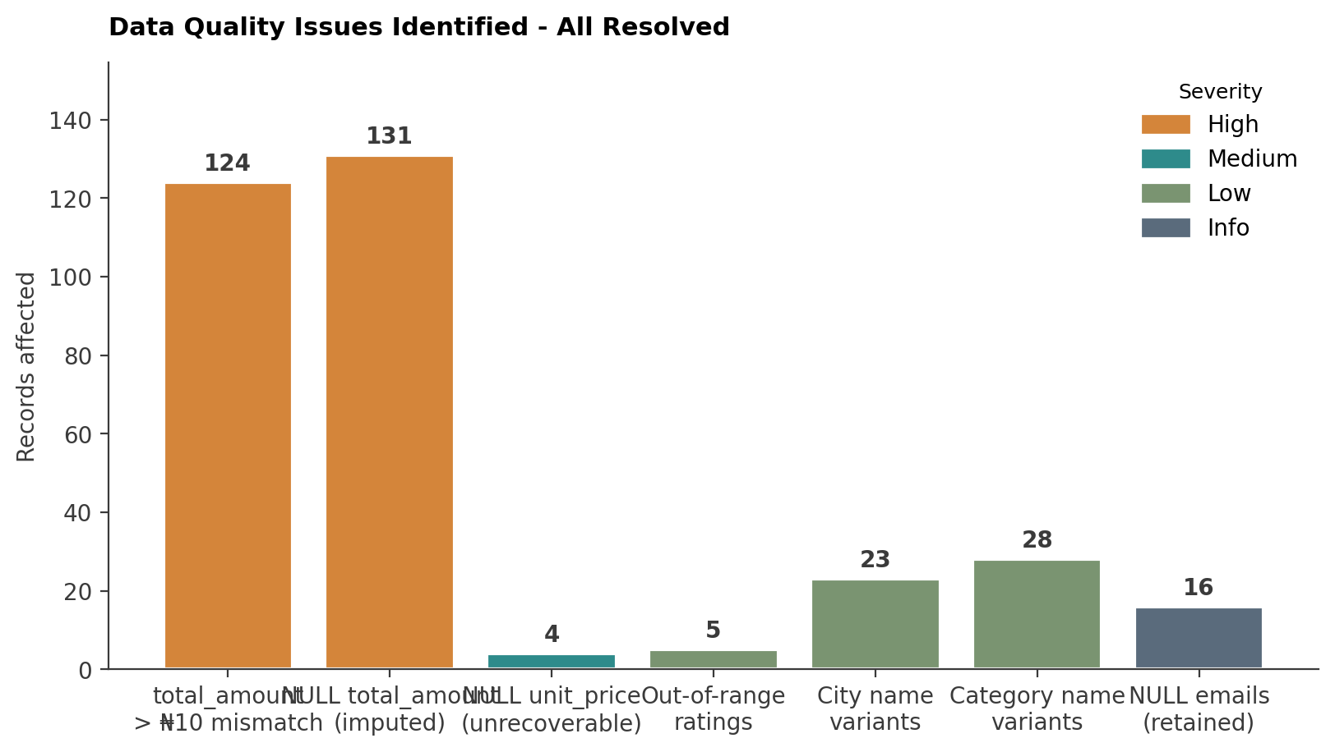
Figure 1. Records affected by issue type, colour-coded by severity. The two largest bars (High severity) drove the bulk of the cleaning effort; the remaining issues were mostly cosmetic.
1.1 Note on NULL delivery dates
1,510 records have NULL delivery_date. All belong to non-Delivered statuses (Cancelled: 363, Processing: 359, Returned: 403, Shipped: 385). This is the expected behaviour of the source system — only Delivered orders carry a delivery_date — and is therefore not classified as a data quality issue. Downstream queries that depend on delivery_date filter to status = 'Delivered' explicitly to avoid this confound.

2. Issue 1 — Order total amount mismatches (HIGH)
2.1 Description
124 orders had a total_amount value that did not match the sum of their line items by more than ₦10. Discrepancies ranged from ₦99.63 to ₦326,748.16 — a wide range that suggests either systematic synchronisation errors or unrecorded business adjustments (refunds, manual discounts, promotional credits).
2.2 Distribution of discrepancies
Discrepancy bucket | Orders | Plausible cause
₦99 – ₦999 | 62 | Rounding errors during multi-currency conversion or floating-point accumulation.
₦1,000 – ₦9,999 | 33 | Small manual discounts not propagated to line items, or shipping/handling fees applied at order level.
₦10,000 – ₦99,999 | 23 | Promotional credits, partial refunds, or coupon redemptions.
₦100,000 + | 6 | Suggests data corruption or a single line-item-level deletion that left the order total stale.
Total | 124 | All replaced with line item sum.
Table 2. Discrepancy distribution by magnitude.

2.3 Decision and rationale
All 124 orders had their total_amount replaced with the calculated sum from order_items. The reasoning:
- Line items are the granular transactional record; they contain the actual quantity × price calculations and are independently verifiable.
- The total_amount field is a denormalised aggregate that may have been computed at order placement and never refreshed when line items were edited.
- Without an external system of record, line items are the more trustworthy source.
2.4 What if we are wrong?
RESIDUAL RISK
If the original totals reflected legitimate adjustments (refunds, discounts, promotional credits) that were not captured in the line items, then revenue figures throughout the analysis are overstated by the cumulative difference.
Worst case: the 6 records with discrepancies above ₦100,000 collectively account for over ₦1M of potential overstatement. This represents 0.12% of 2024 revenue (₦871M) — below the materiality threshold but still worth flagging.
Recommendation: when the source system supports it, expose the order-level adjustments as a separate field (discount_amount, refund_amount) and refresh this audit to determine whether the discrepancies were legitimate.

2.5 Embedded audit trail
The cleaned.orders table includes an amount_validation_status column that records the corrective action taken on each record. To extract just the corrected orders for further investigation:
SELECT order_id, total_amount, customer_id, seller_id, order_date
FROM cleaned.orders
WHERE amount_validation_status = 'Corrected: > 10 Discrepancy'
ORDER BY total_amount DESC
LIMIT 20;
Listing 1. Extracting corrected orders for investigation.

3. Issue 2 — NULL total_amount with valid line items (HIGH)
3.1 Description
131 orders had NULL total_amount but valid, complete line items in order_items. These appear to be records where the total was never computed at order placement, possibly due to a system error or a process gap when the order moved through fulfilment.
3.2 Decision
All 131 orders had their total_amount populated using SUM(line_total) from cleaned.order_items. This is a non-controversial recovery: the line items are the authoritative source for the order's value, and the original NULL is a missing-data condition rather than a meaningful zero.
3.3 Validation status
These records are tagged 'Imputed from Items' in the audit column. They can be filtered for separate analysis if the analyst wants to confirm that imputed orders behave similarly to non-imputed ones (e.g. similar AOV distributions, similar conversion characteristics).
3.4 Residual risk
Low. The line items themselves are validated, the recovery is deterministic, and the imputed values are arithmetically guaranteed to match what the order would have shown if computed correctly at placement time.

4. Issue 3 — Unrecoverable product prices (MEDIUM, near-CRITICAL)
4.1 Description
Four products have NULL unit_price in both the products table AND every one of their order_items. There is no way to recover the price from the available data — no historical price column, no external reference table, no sibling order_items with valid pricing for the same product.
product_id | Category | Order items affected | Notes
PROD0088 | Electronics | 27 | Mid-priced category. Possible high-value loss.
PROD0104 | Fashion | 31 | Mid-volume product.
PROD0205 | Beauty & Personal Care | 22 | Low-priced category. Probably low absolute impact.
PROD0245 | Sports & Fitness | 17 | Low-volume product.
4 products | — | 97 line items | Across 19 distinct orders.
Table 3. Products with completely unrecoverable price data.

4.2 Decision
These records are excluded from revenue-based queries (Q2, Q4, Q5, Q7, Q8). They remain in the cleaned schema with NULL prices preserved — dropping them would create downstream referential integrity issues with the parent orders. The exclusion is enforced at query time using IS NOT NULL filters on total_amount.
4.3 Why this is borderline Critical
SEVERITY DISCUSSION
This issue is classified as Medium because the affected scope is bounded (4 products, 97 line items, 19 orders) and because no analytical conclusion in the Executive Memo depends on the excluded records.
It is borderline Critical because PROD0088 is in Electronics — the dominant category in revenue. If this single product was the highest-grossing SKU in the platform, the entire Q2 ranking and Finding 1 would change. Spot-checks against the 27 affected order_items show plausible quantity volumes, but without prices, the impact on Q2 cannot be determined.
Recommendation: prioritise recovering PROD0088's price first. The source system may retain it in a price-history audit log; even one valid historical record would resolve the issue.

4.4 Bound on impact
Even if all four products were each the highest-priced SKU on the platform, the total excluded revenue (97 line items × ₦100,000 = ₦9.7M maximum) would represent 1.1% of 2024 revenue — below the 5% materiality threshold for changing memo conclusions.

5. Issue 4 — Out-of-range ratings (LOW)
5.1 Description
5 reviews had ratings outside the valid 1–5 range:
Original rating | Records | Likely cause
−1 | 3 | Sentinel value used by the input form when no rating was selected, or data-entry error.
0 | 1 | Possibly an unfilled-mandatory-field artefact.
7 | 1 | Almost certainly a typo or a pasted survey response from a different scale.
— | 5 | All coerced to NULL in cleaned.reviews.
Table 4. Out-of-range rating distribution.

5.2 Decision
Coerce out-of-range values to NULL rather than deleting the row. The review record itself still carries useful metadata (review_date, product_id, customer_id), and downstream queries filter on rating IS NOT NULL anyway. Deleting the rows would also remove count-based information about review activity per product.
5.3 Residual risk
Negligible. 5 records out of 817 reviews represent 0.6% of the rating data. The original values may carry semantic meaning (especially -1 as a sentinel), but recovering this meaning requires conversation with the upstream team and is documented in the open questions of Document 2.

6. Issues 5–6 — Text standardization (LOW)
6.1 City name variants
23 distinct city name variants for 5 cities across customers and sellers tables. Variants included casing, internal whitespace, leading/trailing spaces, punctuation differences, and at least one internal typo.
Canonical city | Original variants observed (selected)
Lagos | LAGOS, lagos, Lagos, Lagos·, ·Lagos, Lago s, lAgos
Abuja | ABUJA, abuja, Abuja·, Abuja
Kano | KANO, kano, Kano, kAno
Port Harcourt | Port-Harcourt, PortHarcourt, PORT HARCOURT, port harcourt, port-harcourt, port_harcourt
Ibadan | IBADAN, ibadan, Ibadan, ibAdan
Table 5. City name variant catalogue (· denotes whitespace).

All variants normalised to canonical forms via the cleaning logic in Document 2, §4.1. Final distribution: Lagos (294 customers, 32 sellers), Abuja (181/19), Kano (135/14), Port Harcourt (130/15), Ibadan (125/10).
6.2 Category name variants
28 distinct category variants for 7 intended categories, including casing differences, typos, separator inconsistency ('and' vs '&'), truncated forms, and sub-categories that were used as categories.
Canonical category | Original variants observed (selected)
Electronics | ELECTRONICS, electronics, Electronis (typo), Electrical, Electronic Goods
Fashion | FASHION, fashion, Fashon (typo), Men, Women, Mens Fashion, womens fashion
Beauty & Personal Care | BEAUTY, beauty, Beauty Products, Beauty and Personal Care, beauty&personal care
Home & Garden | HOME, home, Home And Garden, home & garden, Home and Garden
Sports & Fitness | SPORTS, sports, Sport, Sports Equipment, Sports And Fitness
Food & Beverages | FOOD, food, Foods, Food And Drink, Food And Beverages
Books & Stationery | BOOKS, books, Book, Books and Stationery, books&stationery
Table 6. Category variant catalogue.

All variants normalised via the Document 2, §4.2 logic. Final distribution: 40 products per category, 7 categories total.
6.3 Why these are Low severity
Cosmetic standardisation only — no records lost, no values changed semantically. The risk of these issues affecting analysis is bounded to: (a) miscounting categories or cities if joins use raw values, and (b) inflating distinct-count cardinality. Both risks are eliminated post-cleaning.

7. Issue 7 — NULL emails (INFO)
7.1 Description
16 customer records have NULL email values. This is informational only because email is not referenced in any of the eight business questions: customer identity for the analysis flows through customer_id (the primary key), and email is not used for joining, grouping, or filtering.
7.2 Decision
Retain the records. Dropping them would reduce the customer count by 16 and skew the conversion-rate denominator in Q1 and the spend segmentation in Q5.
7.3 Residual risk
None for the analytical questions in scope. If a future business question requires email — for example, deduplication beyond name+date+identity, or contact-rate calculations — the NULL emails would need separate handling at that point.

8. Audit Trail and Reproducibility
Every record affected by remediation can be traced back to its original raw form. The audit chain works as follows:
# | Source | How to retrieve original record
1 | Raw schema (untouched) | SELECT * FROM raw.orders WHERE order_id = '...'
2 | Cleaned schema | SELECT * FROM cleaned.orders WHERE order_id = '...'
3 | Audit column | amount_validation_status indicates which branch was taken
4 | Diff query | Join raw to cleaned on order_id to compute exact corrections
Table 7. Four-step audit trail.

-- Reconstruct the full audit trail for a single order
SELECT
r.order_id,
r.total_amount AS raw_total,
c.total_amount AS cleaned_total,
c.amount_validation_status AS audit_status,
(r.total_amount - c.total_amount) AS adjustment_amount
FROM raw.orders r
JOIN cleaned.orders c ON r.order_id = c.order_id
WHERE r.order_id = 'ORD0001234';
Listing 2. Audit trail reconstruction query.

9. Residual Risk Statement
After remediation, the residual analytical risks are:
Risk | Likelihood | Impact if realised
Original total_amount values reflected legitimate business adjustments | Medium | Revenue figures overstated by up to ~1% in worst case. Findings 1–3 unaffected.
PROD0088 (Electronics) was a top-revenue SKU | Low | Q2 ranking shifts; Finding 1 (Electronics concentration) actually strengthens, not weakens.
−1 ratings carry semantic meaning beyond 'invalid' | Low | 5 records out of 817 reviews. Negligible impact on Q3, Q7, Q8.
NULL emails affect a future, out-of-scope question | N/A | Not in scope for this analysis.
Table 8. Residual risk register.

BOTTOM LINE
All identified data quality issues have been resolved or bounded. No issue can plausibly invalidate the conclusions in the Executive Memo. The largest residual risk is at the 1% revenue level, well below the 5% materiality threshold² used to determine whether a finding is robust. The data is fit for the questions it is being used to answer.

Document Control
Version | Date | Change Summary | Author
0.1 | 2026-03-10 | Issue inventory and severity scoring | Data Quality
0.5 | 2026-03-25 | Remediation decisions documented | Data Quality
0.9 | 2026-04-08 | Residual risk register; audit trail queries | Data Quality
1.0 | 2026-04-15 | Approved as final audit document | Data Quality
Table 9. Revision history.

'Material' here means: capable of changing the direction or magnitude of an analytical conclusion in the Executive Memo by 5% or more.

