FINDINGS REPORT
Sales Performance
Six Findings, Five Recommendations, One Investigation Priority
Reporting Period Data Window: July 2013 - April 2015
Document Version 1.0
Date Prepared April 2026
Classification Internal - Leadership
Prepared ByData & Analytics Team

DISTRIBUTION
Head of Sales - Head of Operations - Executive Leadership

PREPARED BY | REVIEWED BY | APPROVED BY
_________________________  Signature / Date | _________________________  Signature / Date | _________________________  Signature / Date

1. Executive Summary
The Distributor generated $1.27M in revenue across 830 orders from 89 active customers between July 2013 and April 2015. Two things stand out from the data: revenue tripled in the final five months, and that growth was driven by real order volume, not pricing. The dashboard shows the inflection clearly; what caused it is the open question.

Topline metrics
Metric | Value | Comment
Total revenue | $1,265,793 | Across delivered orders only.[object Object]
Order count | 830 | Distinct order IDs.
Average order value | $1,525 | Stable across the period.[object Object]
Active customers | 89 | Of 91 customers in the master file.
Active sales reps | 9 | Top rep carries 18% of revenue.
Average fulfillment days | 8.5 | From order date to shipped date.
Freight as % of revenue | 5.1% | Reasonable shipping overhead.
Table 1. Topline metrics. Values match the published dashboard.

THE HEADLINE FINDING
Revenue tripled from November 2014 to April 2015. Order volume doubled in the same window. Both metrics inflected together, which means this was real demand growth, not a pricing effect. The cause is not in the dataset; the data only shows that something changed.

2. Key Findings
Finding 1 - Revenue tripled in the final five months
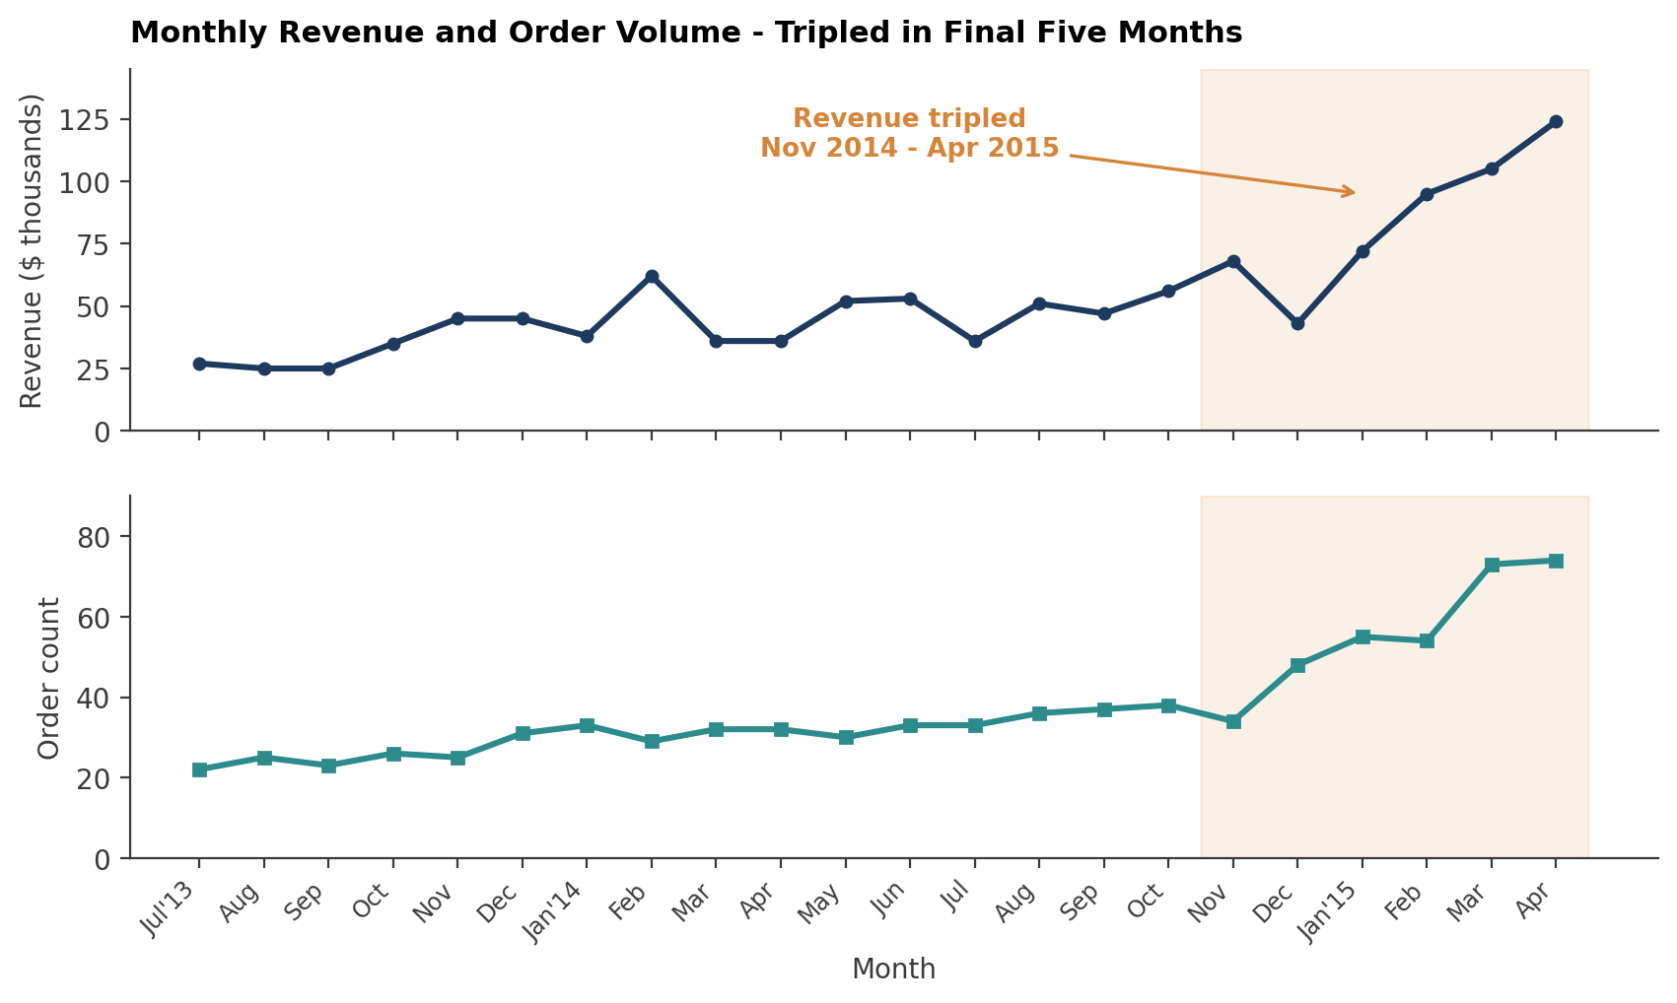
Figure 1. Monthly revenue and order volume. The amber shading marks the Nov 2014 - Apr 2015 acceleration window.
Monthly revenue plateaued between $40K and $55K through most of 2014. From November 2014 onward, it accelerated sharply: $56K in October, $68K in November, $43K dip in December (likely holiday-related seasonality), then $72K, $95K, $105K, $124K across the first four months of 2015. Order volume followed the same trajectory - from a ~32 orders/month baseline to 73-74 orders/month at the peak.
Both metrics moving together rules out price as the driver. If only revenue had risen with order count flat, that would suggest higher prices or higher-value mix. If order count had risen with revenue flat, that would suggest demand-stimulating discounts. Both rising together means real new transactional demand.

Finding 2 - Beverages and Dairy drive 40% of revenue
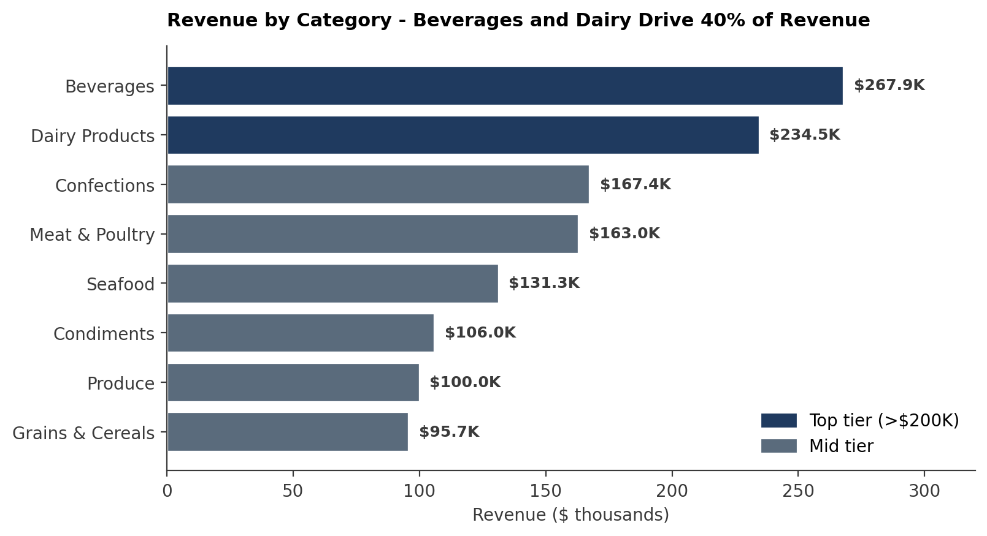
Figure 2. Revenue by category. Top two categories together exceed the bottom six combined.
Beverages contributes $267,868 (21% of revenue), Dairy Products contributes $234,507 (19%). The remaining six categories sit between $95K and $167K each, in a narrow band. Confections and Meat & Poultry are the strongest of the second tier.
The concentration is structural. Even if Beverages volume held flat and Dairy doubled, the top two would still dominate. The risk is asymmetric: a supply disruption in either category disproportionately hits total revenue.
CONCENTRATION RISK
40% of revenue resting on two of eight categories is significant. The dashboard does not surface the same concentration at the product level (which would be more or less acute), but the category-level pattern alone justifies a diversification conversation.

Finding 3 - Discount strategy is targeted, not broad
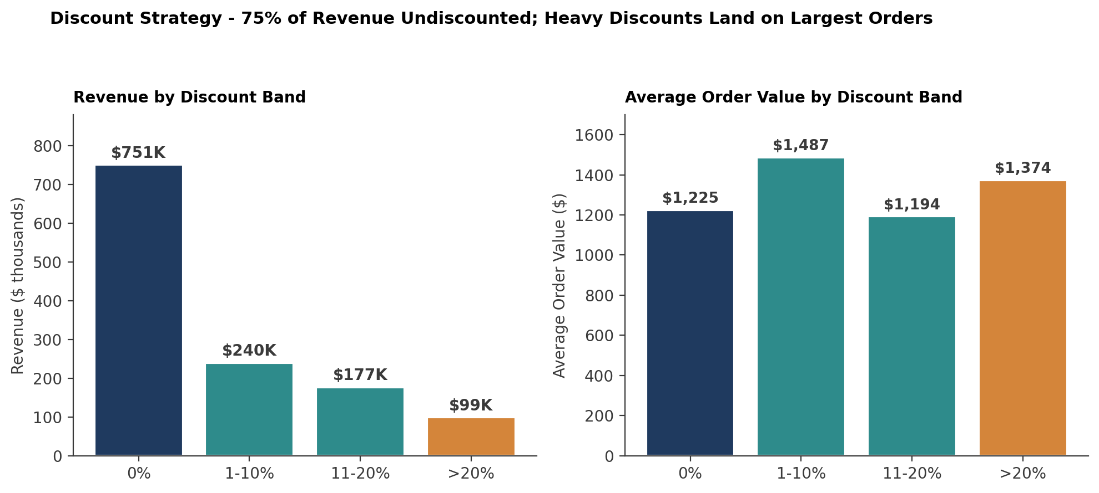
Figure 3. Revenue and AOV by discount band. 75% of revenue is undiscounted; the >20% band still carries a $1,374 AOV.
Undiscounted orders contribute $750,699 - about 75% of total revenue. Heavy discounts (>20%) contribute $98,939 but with an AOV of $1,374 - comparable to the 1-10% band's $1,487. The bottom 11-20% band shows the lowest AOV at $1,194.
Read together, the pattern suggests that heavy discounts are applied to large orders deliberately - probably for major accounts or strategic deals - rather than used to stimulate volume in price-sensitive segments. The 1-10% band looks like a routine "small discount on most orders" practice. The 11-20% band looks like the loose middle where discounting may be inconsistent.

Finding 4 - Germany and USA together drive 31% of global revenue
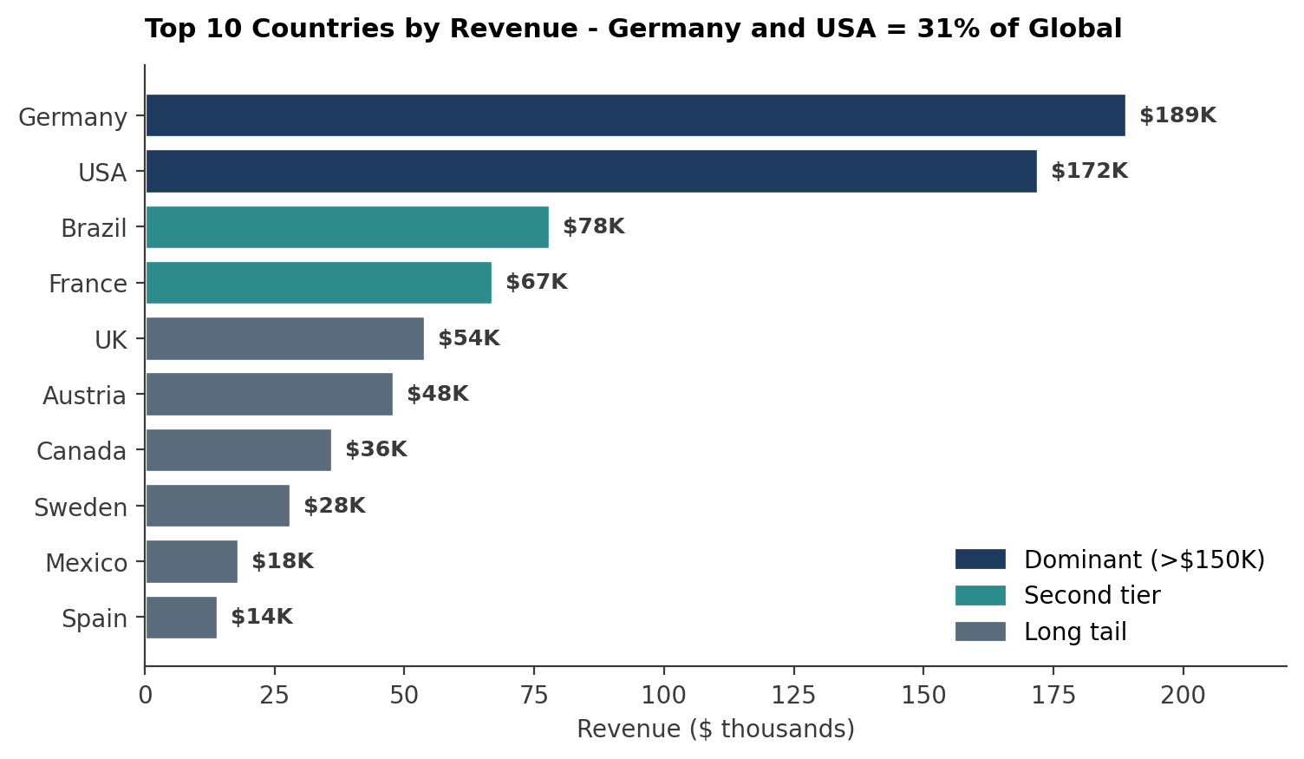
Figure 4. Top 10 countries by revenue. Germany and USA dominate; a long tail of 11 smaller markets sits below $50K.
Germany leads at $189K, USA at $172K. Combined: 31% of global revenue from two of 21 countries. Brazil ($78K) and France ($67K) form the second tier. The remaining 17 countries each contribute less than $42K.
The implication is similar to the category concentration: revenue resilience depends on two markets. Losing either is a material business hit. The second-tier markets (Brazil, France) are the obvious candidates for growth investment, alongside the long tail of smaller markets where a small dollar increase represents a large percentage gain.
Finding 5 - Carrier C underperforms on both speed and cost
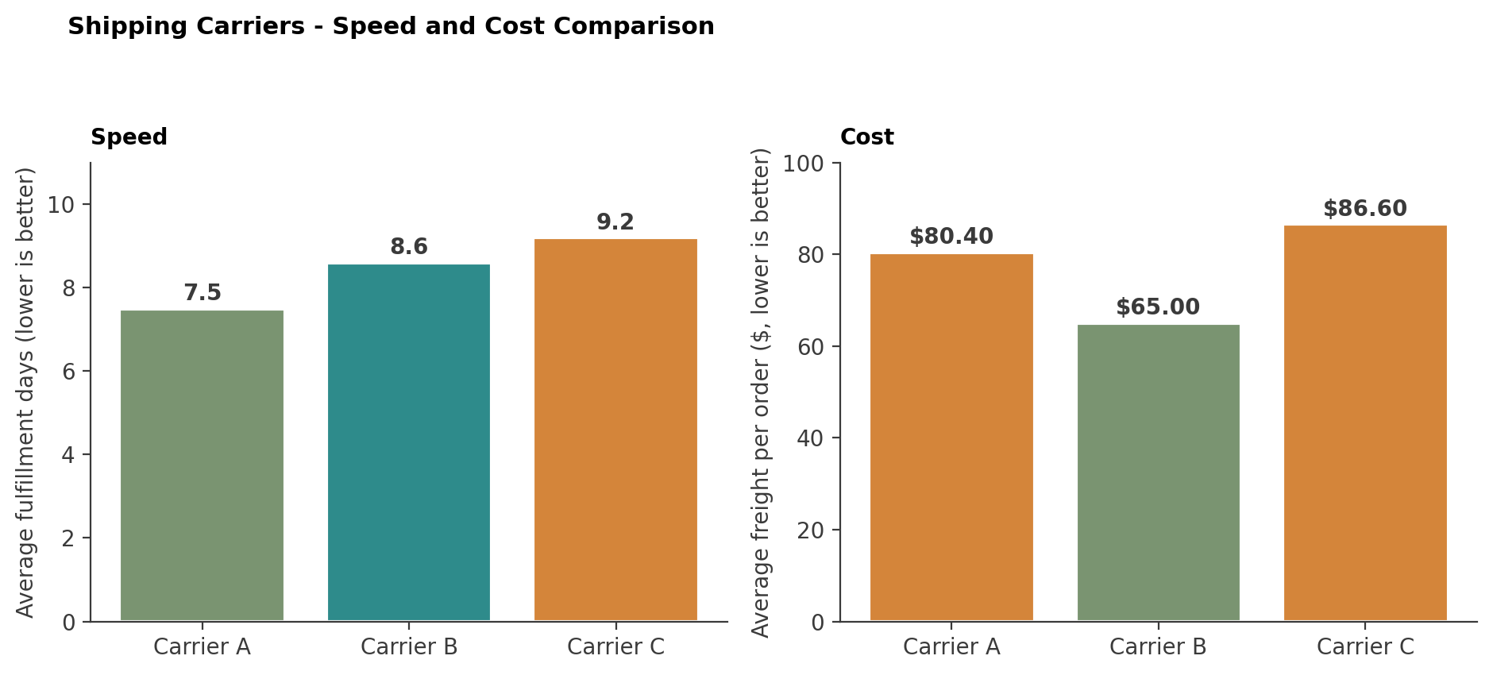
Figure 5. Shipper comparison. Carrier C is slowest and second-most expensive.
Carrier | Avg fulfillment days | Avg freight per order | Verdict
Carrier A | 7.5 | $80.44 | Best on speed
Carrier B | 8.6 | $65.00 | Cheapest
Carrier C | 9.2 | $86.64 | Worst on both
Table 2. Carrier performance. Carrier C is the only carrier worst on both dimensions.

Carrier C ships in 9.2 days at $87 per order. Carrier A delivers in 7.5 days at $80; Carrier B in 8.6 days at $65. There is no scenario in which Carrier C is the right choice unless coverage in a specific region forces it - which the data does not confirm or rule out.
Finding 6 - One sales rep carries nearly a fifth of revenue
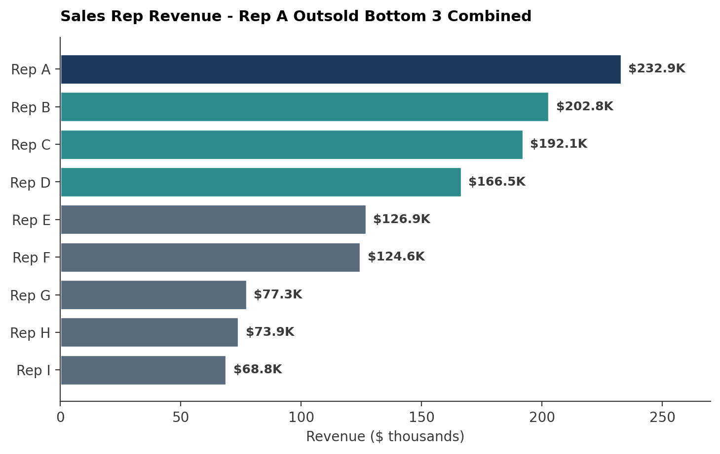
Figure 6. Sales rep revenue. Rep A carries $232,891 - the next-highest rep is $30K behind.
Rep A generated $232,891 - 18% of total revenue, ahead of Rep B ($202,813) and Rep C ($192,108). The bottom three reps combined contributed $220K - less than Rep A alone.
The variance is wide. The natural question is what Rep A does differently - territory mix, customer profile, sales technique, account management style - and whether that can be transferred to the lower performers. Some of the variance is probably territory (Rep A may be assigned to Germany or USA); some is probably individual; the dashboard does not separate the two but the underlying data does.
ADDITIONAL OBSERVATION - DISCONTINUED PRODUCTS CARRY $185K
85% of revenue comes from active products. Discontinued products³ still contribute $185K (15%) across 8 SKUs. This represents real customer demand for SKUs the business has decided to stop carrying. Two options: restart sourcing if margins justify it, or transition customers to active alternatives before the revenue erodes.

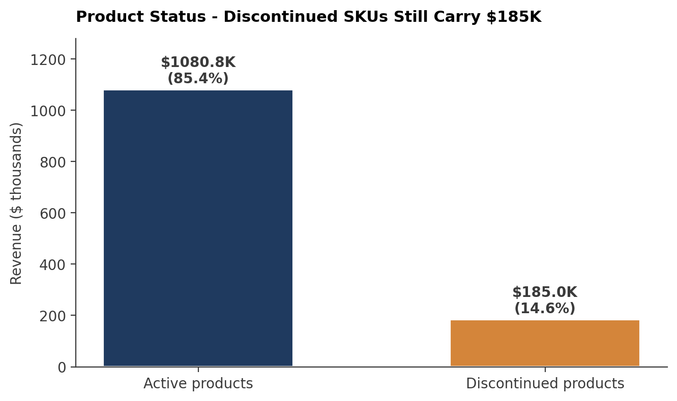
Figure 7. Active vs. discontinued product revenue split.

3. Recommendations
Recommendation 1 - Investigate the November 2014 inflection [PRIORITY]
Element | Detail
Action | Identify the trigger for the November 2014 revenue acceleration. Likely candidates: new sales process, new acquisition channel, new market entry, new product line, partnership, or campaign. Interview the sales team. Audit campaign records. Cross-reference against the customer master to see if new customers acquired in Q4 2014 drove the spike.
Owner | Head of Sales, with support from Marketing and Operations.
Expected outcome | One of three outcomes: (a) a repeatable playbook if the cause is internal and replicable; (b) a market-condition entry on the risk register if the cause is external; (c) a confirmation that the growth is likely to continue or revert.
Timeframe | 30 days. The next quarterly planning cycle depends on the answer.
Risk if ignored | Capacity, inventory, and hiring decisions will be made without knowing whether the trend is sustainable. If it reverts, the company over-invests; if it continues, the company under-invests.
Table 3. Recommendation 1 specification.

Recommendation 2 - Reduce concentration in top markets
Element | Detail
Action | Launch a 90-day growth pilot in Brazil and France - the second-tier markets at $78K and $67K respectively. Targeted local marketing; review payment and shipping terms; engage local distributors if relevant.
Owner | Head of International, with support from Marketing.
Expected outcome | Brazil or France revenue at $100K or above within 12 months. Combined non-USA/Germany share of revenue rising to 75% (currently 69%).
KPIs | Country-level revenue tracked monthly. Order count by country. Customer acquisition rate in target markets.
Table 4. Recommendation 2 specification.

Recommendation 3 - Renegotiate or replace Carrier C
Element | Detail
Action | Move a portion of Carrier C volume to Carrier A (faster, similar cost) and Carrier B (slightly slower, 25% cheaper). Run a 60-day A/B test on customer satisfaction and delivery time. If the test confirms the dashboard data, exit the Carrier C contract at renewal.
Owner | Head of Operations.
Expected outcome | Either improved fulfillment time at flat cost (Carrier A route) or reduced freight spend at marginally higher delivery time (Carrier B route). Both are improvements on the current state.
Risk | Carrier C may have regional coverage that the other two lack. The data does not confirm this but the contract review should rule it out before any move.
Table 5. Recommendation 3 specification.

Recommendation 4 - Study Rep A's playbook
Element | Detail
Action | Document Rep A's account portfolio, sales motion, and customer interaction patterns. Identify what is transferable (sales technique, account-handling approach) versus what is territory-bound (specific customer relationships). Pair lower-performing reps with Rep A for shadowing for 90 days.
Owner | Head of Sales.
Expected outcome | Bottom three reps lifted to a $100K minimum threshold within two quarters. Reduced concentration risk on a single high-performer.
Risk | Reassigning accounts to less-skilled reps can erode customer relationships. The pairing approach mitigates this.
Table 6. Recommendation 4 specification.

Recommendation 5 - Audit the discontinued portfolio
Element | Detail
Action | Review the 8 discontinued products generating $185K. For each: confirm the reason for discontinuation; check whether reinstating it is feasible from a supply standpoint; identify the active product that customers would likely substitute. Either restart sourcing or run a customer transition campaign.
Owner | Head of Product, with support from Category Management.
Expected outcome | Either $185K of revenue retained through reinstatement or substitution, or a managed transition that reduces revenue loss to under $50K over 12 months.
Table 7. Recommendation 5 specification.

4. What the Data Cannot Tell Us
Leadership will ask three follow-up questions after seeing this report. The dataset does not contain the answers.
Why did revenue triple from November 2014?
The data shows what happened, with timing precision. It does not show why. Marketing campaigns, sales process changes, partnership launches, competitive shifts, and macroeconomic conditions are all candidates. The dashboard cannot distinguish between them; the investigation in Recommendation 1 must.
Why do Germany and the USA dominate?
Geography of the dataset reflects where the Distributor sells today, not where it could sell. The data cannot say whether Germany and the USA are over-served, whether other markets are under-served, or whether the product fit varies by region. Customer-level interviews and market research are required.
Why does Rep A outperform by such a wide margin?
The data identifies who the top performer is. It does not identify what they do differently. Account portfolio, sales technique, territory effects, and individual skill are all candidates. Shadowing and process documentation in Recommendation 4 are required to separate them.
THE SHARED PATTERN
Each of these three follow-up questions has the same structure: the data identifies the pattern; behavioral, process, or contextual investigation explains it. The dashboard's job is to point to where to look. The next step is to look there.

Document Control
Version | Date | Change Summary | Author
0.1 | 2026-02-14 | Initial findings draft | Data & Analytics Team
0.5 | 2026-02-27 | Recommendations specified | Data & Analytics Team
0.9 | 2026-03-10 | Internal review - limitations section added | Data & Analytics Team
1.0 | 2026-03-15 | Approved for leadership distribution | Data & Analytics Team
Table 8. Revision history.

