DIMENSIONAL MODEL DESIGN
Banking Transaction Warehouse
Star Schema, SCD Logic, Surrogate Keys, Performance Strategy

Reporting Period Design Window: Q1 2026
Document Version 1.0
Date Prepared April 2026
Classification Internal - Data Engineering
Prepared ByData & Analytics Team

DISTRIBUTION
Data Engineering - Data Quality - Internal Audit - Analytics Leadership

PREPARED BY | REVIEWED BY | APPROVED BY
_________________________  Signature / Date | _________________________  Signature / Date | _________________________  Signature / Date

1. Purpose and Scope
This document specifies the dimensional warehouse for the Bank's retail banking transaction data. The source is a flat transaction file with 15 columns; the output is a star schema implemented in PostgreSQL 18, with full SCD support, an embedded data quality framework, and a monthly aggregate table for reporting performance.
The model answers five business questions:
- Which customer segments generate the most fee income?
- How does transaction behavior vary by branch and channel?
- Are high-value customers reducing their activity?
- Which products drive deposits versus withdrawals?
- How do metrics compare month-over-month, quarter-over-quarter, and year-over-year?
Scope summary
Element | Detail
Source data | Flat transaction file: Txn_ID, Txn_Date, Customer_ID, Customer_Name, Tier, Branch_ID, Branch_Name, State, Product_ID, Product_Name, Product_Type, Txn_Type, Channel, Amount, Balance_After.
Target schema | Star schema with one fact table, six dimensions, one staging table, one monthly aggregate.
Database | PostgreSQL 18 (pgAdmin 4 for development).
Refresh cadence | Daily incremental load from the operational system. Historical reload supported when required.
Out of scope | Fee calculation rules (source file lacks fee data; column reserved). Customer demographic data. Loan and credit portfolio data.
Table 1. Project scope.

2. The Grain Statement
FOUNDATIONAL DECISION
The grain of fact_transactions is one row per banking transaction. Every unique Txn_ID appears once in the fact table. Every measure is anchored to this grain.

The grain statement[object Object] determines what each measure means:
Aggregation | Interpretation at this grain
COUNT(*) | Number of transactions.
SUM(amount_ngn) | Total transaction value (sum of all individual amounts).
SUM(deposit_amount_ngn) | Total deposit value across selected rows.
SUM(withdrawal_amount_ngn) | Total withdrawal value across selected rows.
AVG(amount_ngn) | Average transaction size.
MAX(balance_after_ngn) | Latest balance in the selected window. SUM is invalid here.[object Object]
Table 2. Aggregation semantics at the transaction grain.

Anything other than a transaction-level row would violate the grain. A row per customer would force averaging or summing across transactions before storage, losing the ability to answer transaction-level questions. A row per day would lose the per-transaction detail needed for behavior analysis.
3. Fact and Dimension Classification
Every column in the source file must be classified before the model can be built. The classification answers: is this a measure, a descriptive attribute, or an identifier?
Source column | Classification | Final location | Why
Txn_ID | Degenerate dimension | fact_transactions | Identifies the transaction; no descriptive attributes.[object Object]
Txn_Date | Date dimension / fact timestamp | dim_date, fact_transactions | Time analysis requires day-of-week, month, quarter; dim_date provides these. Timestamp stays on fact for sub-day analysis.
Customer_ID | Natural key | dim_customer (as attribute) | Source-system identifier; preserved for joins back to source.
Customer_Name | Dimension attribute | dim_customer | Describes the customer. Type 1 (corrections only).
Tier | Dimension attribute, SCD Type 2 | dim_customer | Changes over time and the change matters for analysis.
Branch_ID | Natural key | dim_branch (as attribute) | Source identifier preserved.
Branch_Name | Dimension attribute, SCD Type 2 | dim_branch | Branch rebrands must preserve historical names.
State | Dimension attribute, Type 1 | dim_branch | Geography rarely changes; corrections handled in place.
Product_ID, Product_Name, Product_Type | Dimension attributes | dim_product | Type 1; product changes are typically corrections.
Txn_Type | Standalone dimension | dim_transaction_type | Independent of channel; needs separate reporting axis.
Channel | Standalone dimension | dim_channel | Independent of transaction type; needs separate reporting axis.
Amount | Fully additive fact | fact_transactions | Can be summed across all dimensions and time.
Balance_After | Semi-additive fact | fact_transactions | Sums correctly across customers at a point in time; not across time.[object Object]
Table 3. Column-by-column classification.

4. The Star Schema
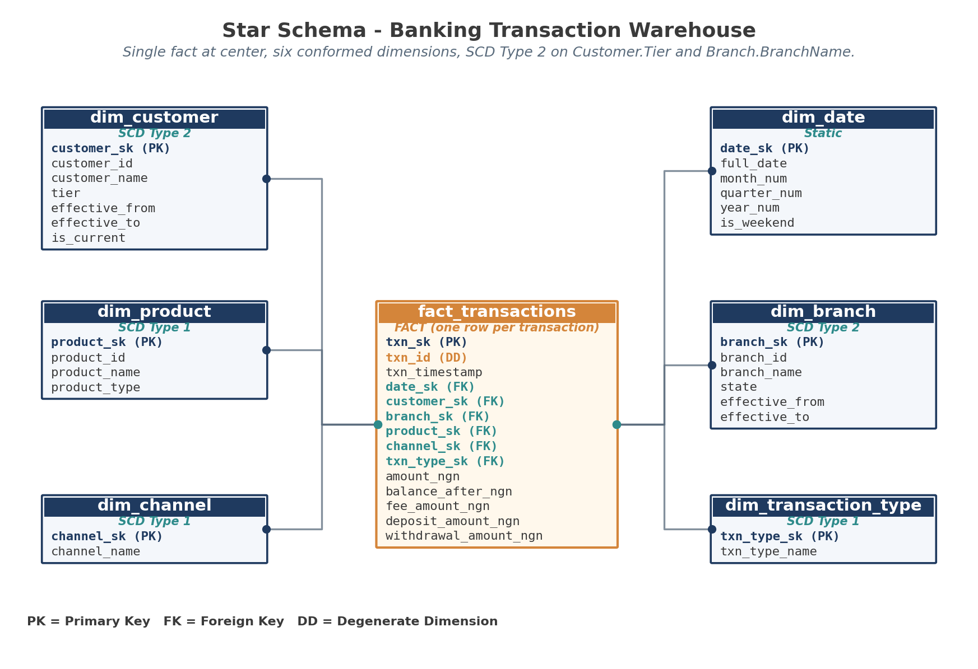
Figure 1. The star schema. One fact at center, six dimensions, surrogate-key foreign relationships.
Why a star, not a snowflake
A snowflake schema would normalize the dimensions further (for example, splitting dim_product into product, category, and subcategory tables). The star design keeps each dimension flat: dim_product contains product_id, product_name, and product_type in one row.
Star (chosen) | Snowflake (rejected)
Fewer joins required for queries. | More joins required; every query touches more tables.
Faster on typical analytical workloads. | Slightly less storage but rarely matters at this scale.
Easier for analysts to understand and write SQL against. | Stricter normalization but harder to use.
Industry standard for OLAP workloads. | Used in special cases where storage is critical or hierarchies are deeply variable.
Table 4. Star versus snowflake trade-off.

5. Surrogate Keys
Every dimension uses a surrogate key as its primary key. The natural key from the source remains as an attribute.
Dimension | Surrogate key | Natural key (kept as attribute)
dim_customer | customer_sk | customer_id
dim_branch | branch_sk | branch_id
dim_product | product_sk | product_id
dim_channel | channel_sk | (none - channel_name is the natural identifier)
dim_transaction_type | txn_type_sk | (none)
dim_date | date_sk | (date_sk is YYYYMMDD - acts as both)
Table 5. Surrogate key naming across all dimensions.

Why surrogate keys
- Source keys can be reused (rare but real). A reused customer ID would create ambiguity in joins; the surrogate key isolates the warehouse from this.
- Source keys can change format (the bank may migrate from 8-character to 12-character IDs). The surrogate key is stable across such changes.
- Source keys can have gaps. Surrogate keys are dense and sequential.
- Surrogate keys enable SCD Type 2. The same customer_id can appear in multiple rows (one per version) but each must have a unique primary key. The surrogate key fills that role.
- Joins on smaller integer keys are faster than joins on varchar natural keys.

6. Slowly Changing Dimensions
Three of the six dimensions need SCD logic[object Object]. The choice of SCD type per attribute reflects the business question the model must answer.
6.1 dim_customer - SCD Type 2 on Tier
Customer tier (Silver, Gold, Platinum) changes over time. One of the five business questions is are high-value customers reducing activity. To answer that correctly, every transaction must report the tier the customer had at transaction time, not their current tier.
If only the current tier is stored, a customer who was Silver in 2023 and is now Gold would have all their 2023 transactions report as Gold. The historical churn analysis would be wrong.
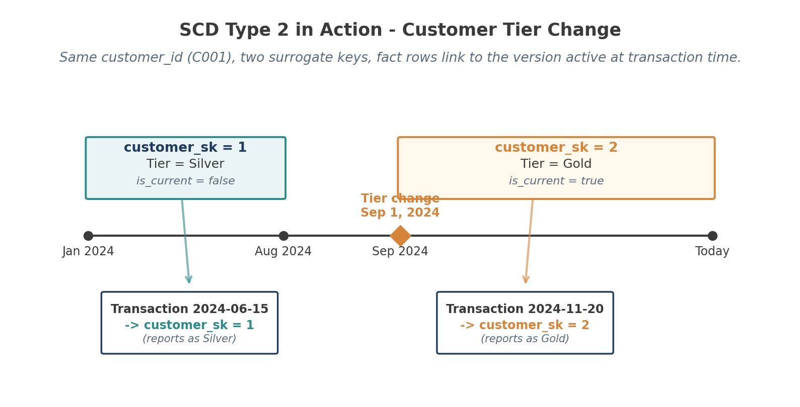
Figure 2. SCD Type 2 example. A customer changes from Silver to Gold; the warehouse keeps both versions; each transaction links to the version active when it occurred.
6.2 dim_customer - SCD Type 1 on Customer_Name
Customer name changes are usually corrections (a typo, a married name, a legal name change). The business doesn't need to see the old spelling on old transactions. Type 1 overwrites the previous value; the row_hash is recalculated.
6.3 dim_branch - SCD Type 2 on Branch_Name
Branches occasionally get renamed (rebrand, merger, address change). Old reports should still show the name the branch had at the time of the transaction. Type 2 preserves this.
6.4 dim_branch - SCD Type 1 on State
Branch state changes are extremely rare. When they do occur, they are usually corrections. Type 1 unless the business specifically requires historical state tracking (in which case promote to Type 2).
6.5 Other dimensions - SCD Type 1
Dimension | SCD treatment and rationale
dim_product | Type 1 across all attributes. Product changes are usually corrections; if a product is genuinely new, it gets a new product_id.
dim_channel | Type 1. Channel names rarely change; when they do, it's a rename of an existing channel and old data should reflect the new name.
dim_transaction_type | Type 1. Transaction type names are stable taxonomy.
dim_date | No SCD. Dates do not change.
Table 6. SCD treatment for the remaining four dimensions.

7. Table Definitions
7.1 Staging - stg_transactions
The staging table receives raw data from the source. It is rebuilt on every load. No constraints (apart from a default timestamp); the goal is to land the data before any validation.
CREATE TABLE stg_transactions (
txn_id VARCHAR(30),
txn_datetime TIMESTAMP,
customer_id VARCHAR(30),
customer_name VARCHAR(150),
tier VARCHAR(30),
branch_id VARCHAR(30),
branch_name VARCHAR(150),
state VARCHAR(80),
product_id VARCHAR(30),
product_name VARCHAR(150),
product_type VARCHAR(80),
txn_type VARCHAR(50),
channel VARCHAR(50),
amount_ngn NUMERIC(18,2),
balance_after_ngn NUMERIC(18,2),
load_batch_id VARCHAR(50),
loaded_at TIMESTAMP NOT NULL DEFAULT CURRENT_TIMESTAMP
);
Listing 1. Staging table definition.

7.2 dim_customer (representative dimension with SCD Type 2)
CREATE TABLE dim_customer (
customer_sk BIGINT GENERATED ALWAYS AS IDENTITY PRIMARY KEY,
customer_id VARCHAR(30) NOT NULL, -- natural key from source
customer_name VARCHAR(150) NOT NULL, -- Type 1: overwrite on change
tier VARCHAR(30) NOT NULL, -- Type 2: track history
effective_from DATE NOT NULL,
effective_to DATE NOT NULL DEFAULT DATE '9999-12-31',
is_current BOOLEAN NOT NULL DEFAULT TRUE,
row_hash TEXT, -- for change detection
CONSTRAINT uq_customer_version UNIQUE (customer_id, effective_from)
);

CREATE INDEX idx_dim_customer_lookup
ON dim_customer (customer_id, effective_from, effective_to);

CREATE INDEX idx_dim_customer_current
ON dim_customer (customer_id, is_current);
Listing 2. Customer dimension with SCD Type 2 columns and indexes.

Key features of this definition:
- customer_sk uses GENERATED ALWAYS AS IDENTITY - PostgreSQL's preferred replacement for SERIAL.
- effective_to defaults to '9999-12-31' for current rows. This sentinel value avoids NULL handling in queries that compare against transaction dates.
- is_current is a denormalized boolean derived from effective_to. It exists for query speed: filtering on a boolean is faster than comparing dates.
- The unique constraint on (customer_id, effective_from) prevents duplicate version inserts during ETL errors.
- row_hash is used during incremental loads to detect changes without comparing column-by-column.
7.3 fact_transactions
CREATE TABLE fact_transactions (
txn_sk BIGINT GENERATED ALWAYS AS IDENTITY PRIMARY KEY,
txn_id VARCHAR(30) NOT NULL,
txn_timestamp TIMESTAMP NOT NULL,

-- Foreign keys to dimensions
date_sk INT NOT NULL,
customer_sk BIGINT NOT NULL,
branch_sk BIGINT NOT NULL,
product_sk BIGINT NOT NULL,
channel_sk BIGINT NOT NULL,
txn_type_sk BIGINT NOT NULL,

-- Measures
amount_ngn NUMERIC(18,2) NOT NULL,
balance_after_ngn NUMERIC(18,2),
fee_amount_ngn NUMERIC(18,2),
deposit_amount_ngn NUMERIC(18,2) NOT NULL DEFAULT 0,
withdrawal_amount_ngn NUMERIC(18,2) NOT NULL DEFAULT 0,
transaction_count INT NOT NULL DEFAULT 1,

CONSTRAINT uq_fact_txn_id UNIQUE (txn_id),
CONSTRAINT fk_fact_date FOREIGN KEY (date_sk)
REFERENCES dim_date(date_sk),
CONSTRAINT fk_fact_customer FOREIGN KEY (customer_sk)
REFERENCES dim_customer(customer_sk),
CONSTRAINT fk_fact_branch FOREIGN KEY (branch_sk)
REFERENCES dim_branch(branch_sk),
CONSTRAINT fk_fact_product FOREIGN KEY (product_sk)
REFERENCES dim_product(product_sk),
CONSTRAINT fk_fact_channel FOREIGN KEY (channel_sk)
REFERENCES dim_channel(channel_sk),
CONSTRAINT fk_fact_txn_type FOREIGN KEY (txn_type_sk)
REFERENCES dim_transaction_type(txn_type_sk),
CONSTRAINT chk_transaction_count CHECK (transaction_count = 1)
);
Listing 3. Fact table definition with all foreign keys and constraints.

Key features of the fact table definition:
- txn_id is preserved as a degenerate dimension - directly on the fact row, with a unique constraint to prevent duplicate transaction insertion.
- Six surrogate-key foreign keys: one per dimension.
- Pre-calculated deposit_amount_ngn and withdrawal_amount_ngn are stored alongside amount_ngn. This is denormalization for query speed; it avoids CASE WHEN repeated in every reporting query.
- transaction_count = 1 is a constant on every row; the CHECK constraint enforces the grain (one row per transaction). Reports SUM this column to get transaction count without needing COUNT(*).
- fee_amount_ngn is nullable - reserved for future fee data.

8. Hierarchies
The model supports four navigation hierarchies. Each hierarchy enables drill-down from summary to detail.
Hierarchy | Levels
Date | Year → Quarter → Month → Day. Implemented in dim_date.
Geography | State → Branch. Implemented in dim_branch.
Product | Product Type → Product. Implemented in dim_product.
Customer | Tier → Customer. Implemented in dim_customer (via SCD Type 2 history).
Table 7. Drill-down hierarchies supported by the model.

Example query path: an executive starts with yearly transaction value (year_num), drills into Q3 (quarter_num), then into September (month_num), then to a specific day (full_date). Each drill operates on dim_date and joins back to fact_transactions through date_sk.
9. Performance Strategy
Three performance techniques are built into the model.
9.1 Partitioning
fact_transactions is partitioned by month on txn_timestamp. Most banking reports are time-scoped (this quarter, last 30 days, year-to-date), and monthly partitions let PostgreSQL skip irrelevant data.
Query type | Partition pruning benefit
Last 30 days | Reads 1 partition. ~1/24 of total data scanned.
Current quarter | Reads 3 partitions. ~1/8 of total data scanned.
Year-over-year same month | Reads 2 partitions across years.
Full history (audit) | Reads all partitions; no pruning benefit but partitioning doesn't slow it down.
Table 8. Partitioning benefits by query type.

9.2 Indexes
Foreign key columns on fact_transactions are individually indexed:
- date_sk - used in every time-bounded query.
- customer_sk - used in customer behavior queries.
- branch_sk - used in branch performance queries.
- product_sk - used in product performance queries.
- channel_sk and txn_type_sk - used in channel and transaction-type breakdowns.
- txn_timestamp - used for fine-grained time-range scans inside a partition.

dim_customer has two indexes beyond the primary key: (customer_id, effective_from, effective_to) for SCD lookups during fact loading, and (customer_id, is_current) for queries against the current version.
9.3 Aggregate table
agg_monthly_branch_activity pre-calculates monthly performance at branch and product type grain. It supports the most common recurring reports (monthly branch dashboards) and reduces repeated full-table scans of fact_transactions.
Stored measure | Calculation
total_transaction_value | SUM(amount_ngn)
deposit_value_ngn | SUM(deposit_amount_ngn)
withdrawal_value_ngn | SUM(withdrawal_amount_ngn)
fee_income_ngn | SUM(fee_amount_ngn) - nullable until fee rules supplied
transaction_count | COUNT(*)
active_customer_count | COUNT(DISTINCT customer_sk)
Table 9. Pre-aggregated measures.

10. Sample Query
To illustrate how the model answers a business question, here is the SQL for: which customer tier drives the most transaction volume in Q3 2024.
-- Q: Which customer tier drives the most transaction volume in Q3 2024?
SELECT
c.tier,
COUNT(*) AS txn_count,
SUM(f.amount_ngn) AS total_value,
SUM(f.deposit_amount_ngn) AS deposit_value,
SUM(f.withdrawal_amount_ngn) AS withdrawal_value
FROM fact_transactions f
JOIN dim_customer c ON f.customer_sk = c.customer_sk
JOIN dim_date d ON f.date_sk = d.date_sk
WHERE d.year_num = 2024
AND d.quarter_num = 3
GROUP BY c.tier
ORDER BY total_value DESC;

-- Note: uses customer_sk, not customer_id.
-- This means the tier reported is the tier at the time of the transaction,
-- not the customer's current tier. That distinction is the entire point of SCD Type 2.
Listing 4. Sample query using surrogate-key joins. Note how SCD Type 2 affects the result.

WHY THE SURROGATE-KEY JOIN MATTERS HERE
The query joins on customer_sk, not customer_id. This means a customer who upgraded from Silver to Gold mid-quarter would have their pre-upgrade transactions counted in Silver and post-upgrade transactions counted in Gold. That's the correct historical reading. A join on customer_id would either count everything as the current tier (wrong) or require additional date-range logic to find the right version (slower).

11. SCD Type 2 Update Logic
When a customer's tier changes, the ETL must close the old row and insert a new one in a single transaction:
-- SCD Type 2 update on dim_customer when tier changes
BEGIN;

-- Step 1: Close out the old row
UPDATE dim_customer
SET effective_to = CURRENT_DATE - INTERVAL '1 day',
is_current = FALSE
WHERE customer_id = 'C001'
AND is_current = TRUE;

-- Step 2: Insert the new current row
INSERT INTO dim_customer (
customer_id, customer_name, tier,
effective_from, effective_to, is_current, row_hash
) VALUES (
'C001', 'Sample Customer', 'Gold',
CURRENT_DATE, DATE '9999-12-31', TRUE,
MD5('Sample Customer|Gold')
);

COMMIT;
Listing 5. SCD Type 2 update logic for a tier change.

Three things to note:
- The BEGIN/COMMIT wrap ensures atomicity. A failure between the UPDATE and INSERT would otherwise leave the customer with no current row.
- effective_to on the old row is set to yesterday (CURRENT_DATE - INTERVAL '1 day'). The new row's effective_from is today. There is no gap.
- row_hash is recalculated on the new row. The next change-detection pass uses this hash to determine whether the customer needs another SCD update.
12. Fee Income Limitation
OPEN ISSUE - DOCUMENTED HONESTLY
The source transaction file does not include a fee column. The business question 'which customer segments generate the most fee income' cannot be answered with current data. The model includes fee_amount_ngn as a nullable column so the question becomes answerable as soon as fee data or fee rules are supplied. Fee income is not fabricated.

If the Bank later supplies a fee rules table (for example: percentage on withdrawal, flat fee on transfer, tier-based fee waiver), the ETL can compute fee_amount_ngn during fact loading and the existing aggregate table will start including fee income automatically. No schema changes required.
Document Control
Version | Date | Change Summary | Author
0.1 | 2026-02-08 | Initial schema draft - grain and classification | Data Engineering
0.5 | 2026-02-22 | SCD logic, surrogate keys, performance section | Data Engineering
0.9 | 2026-03-05 | Sample queries and SCD update logic added | Data Engineering
1.0 | 2026-03-15 | Approved as reference design | Data Engineering
Table 10. Revision history.

