**Setting up Matlab to record cameras and send triggers to NIRS**

**Recording cameras**

1. Download scripts: /Volumes/EMBERSON/Current_Members/Ola/Exploration/scripts
2. Download Image Acquisition toolbox
   1. Matlab -> Add-ons Explorer -> Image Acquisition Toolbox
   2. Sign in to Matlab account (one associated with UBC)
   3. Install Image Acquisition Toolbox
3. F

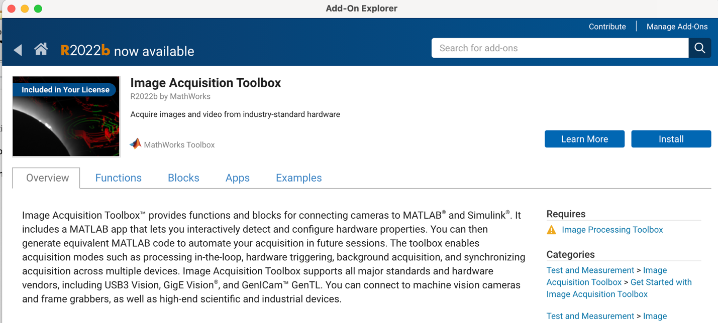

**Sending triggers to NIRS**

Find serial port that is connected to LUMO computer

Use **Serial Explorer** to identify available USB ports

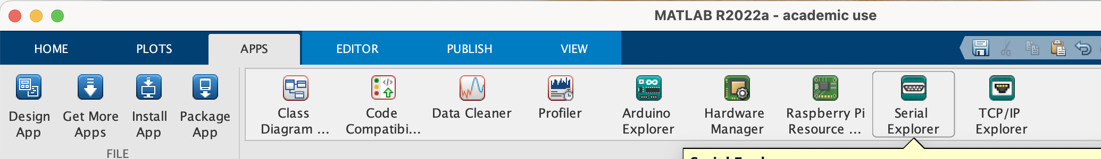

serialportObj = serialport("/dev/cu.usbserial-FTC1JK9U",9600);

serialportObj = serialport("/dev/tty.usbserial-FTC1JK9U",9600);

“For everything that's not a modem or that's not intended to be shared between call-out/call-in processes, you should use the /**dev/cu**.* as this gives you exclusive access to the device.”

Connect to the serial port

% Create a serialport object called serialportObj that connects to the port

% "/dev/cu.usbserial-FTC1JK9U" with a default baud rate of 9600.

device = serialport("/dev/cu.usbserial-FTC1JK9U",9600);

% Write the data "a" as uint8 using the serialport object serialportObj.

write(device,"a","uint8");

This sends the trigger “a”, triggers have to be letters to display propely in lumox

Cameras and NIRS trigger USB cannot be connected to the same USB-c port!