Blue Node Premium is our startup program designed to help you build and grow your business. With free tools, resources and expert support, it enables you to quickly get started on Blue Node, go to market faster, and lower costs. Whether you're beginning your journey or scaling your startup, Blue Node Premium helps you go further.

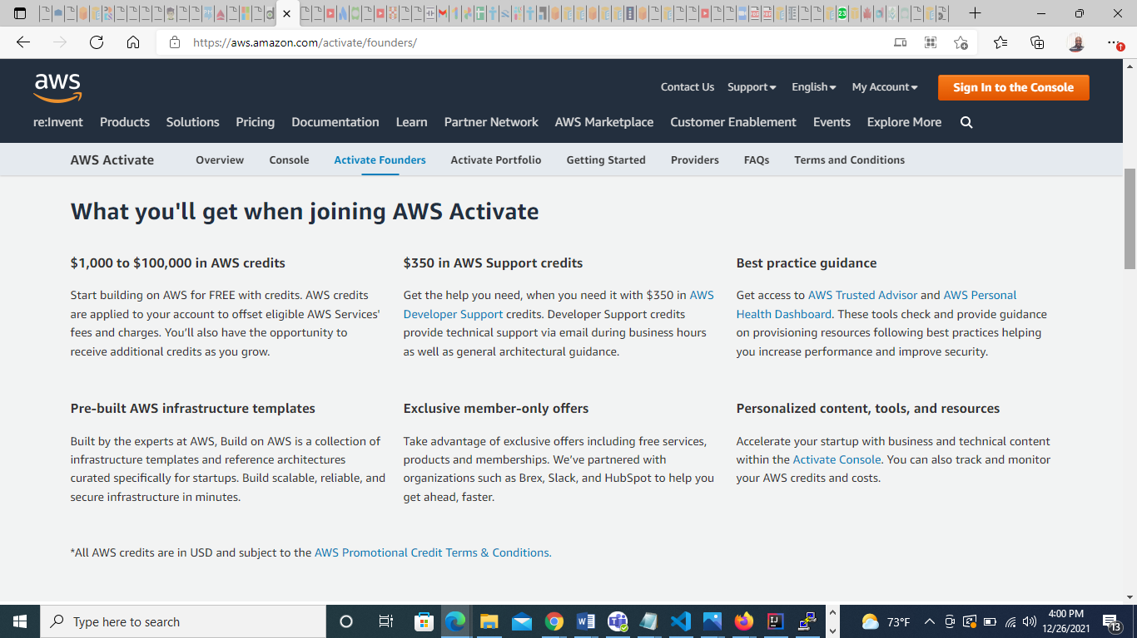

**What you’ll get when signing up for Blue Node Premium**

$1,000 to $100,000 credits

Start building on Blue Node for FREE with credits. Blue Node credits are applied to your account to offset eligible Blue Node Services' fees and charges. You’ll also have the opportunity to receive additional credits as you grow.

$350 in Blue Node Support credits

Get the help you need, when you need it with $350 in Blue Node Developer Support credits. Developer Support credits provide technical support via email during business hours as well as general architectural guidance.

**Sign up for Blue Node Premium**

Step 1 Register (Create Email field) Replaces verify account

Step 2 Complete startup profile

Step 3 Complete team profile

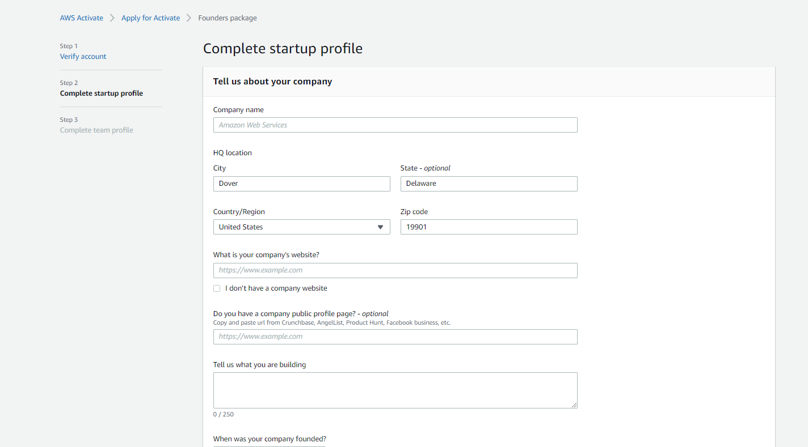

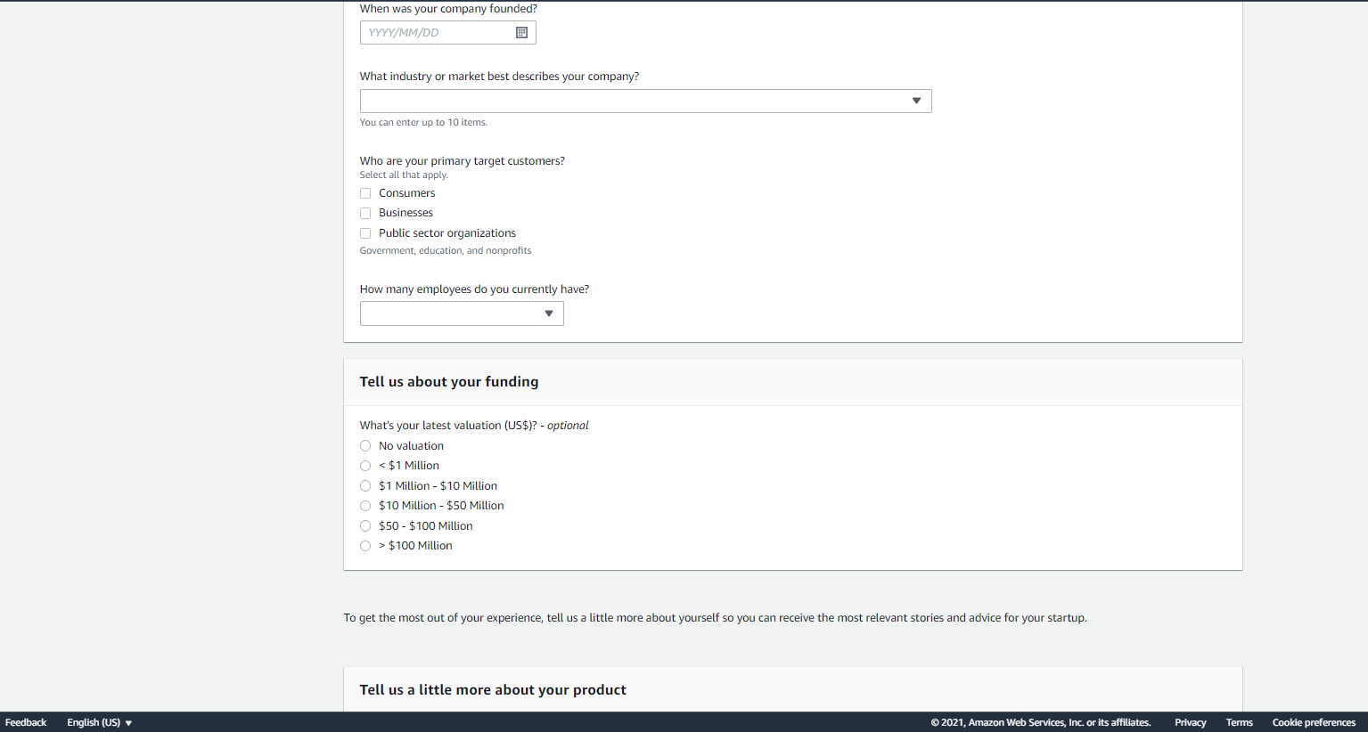

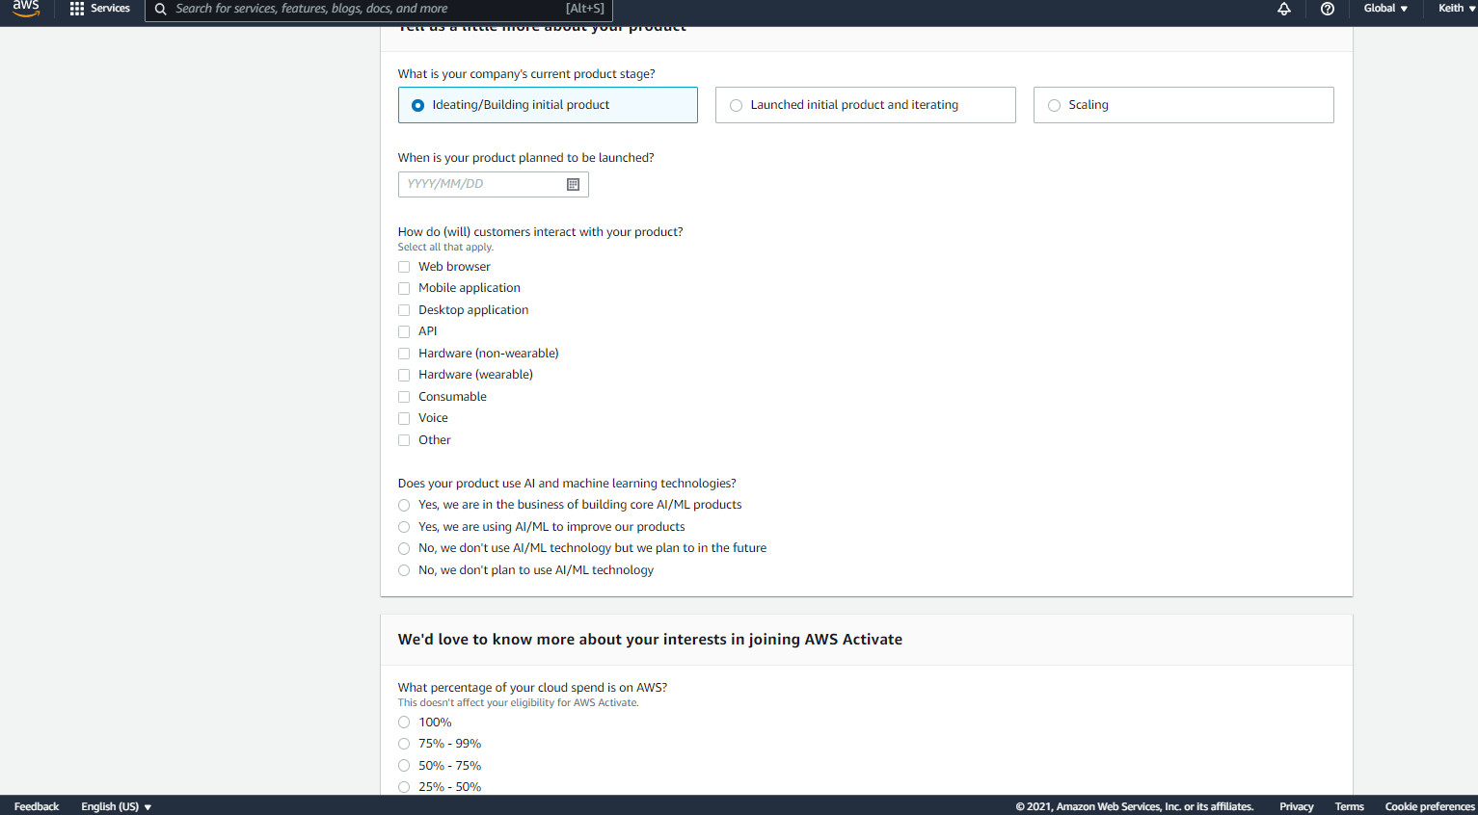

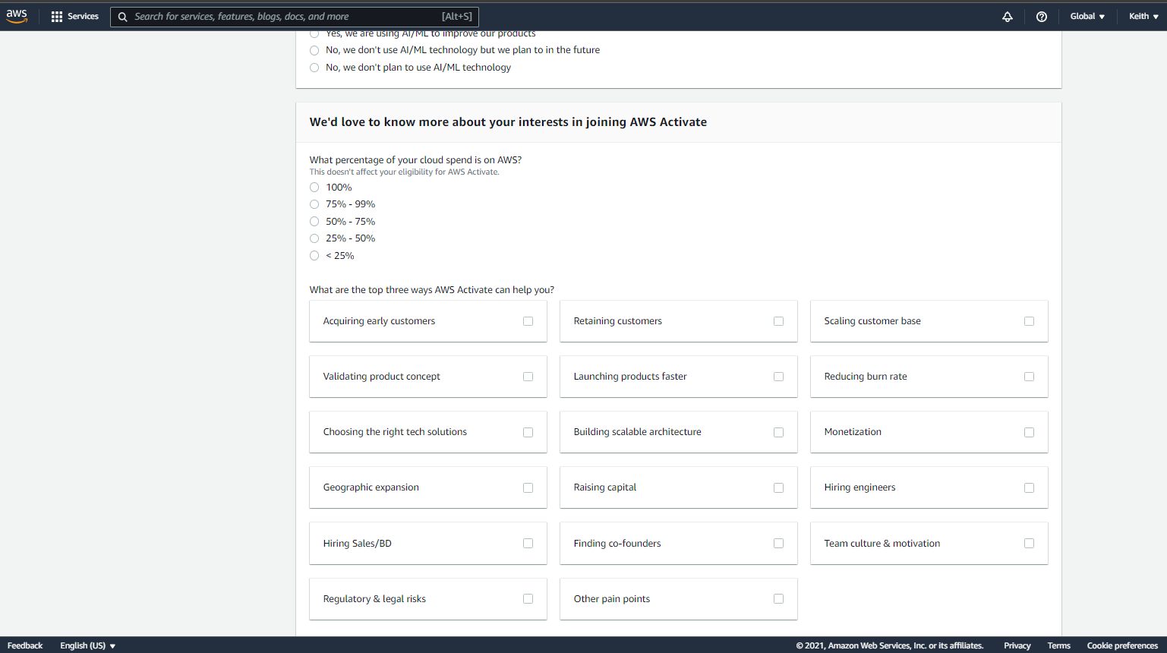

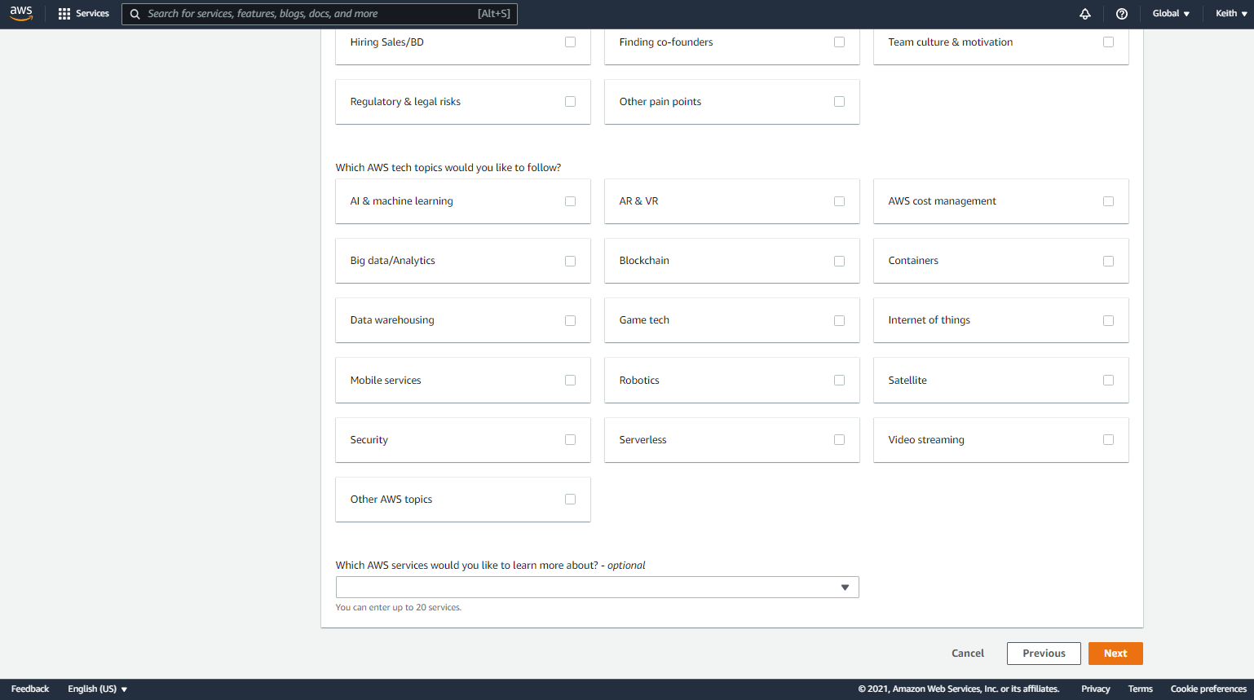

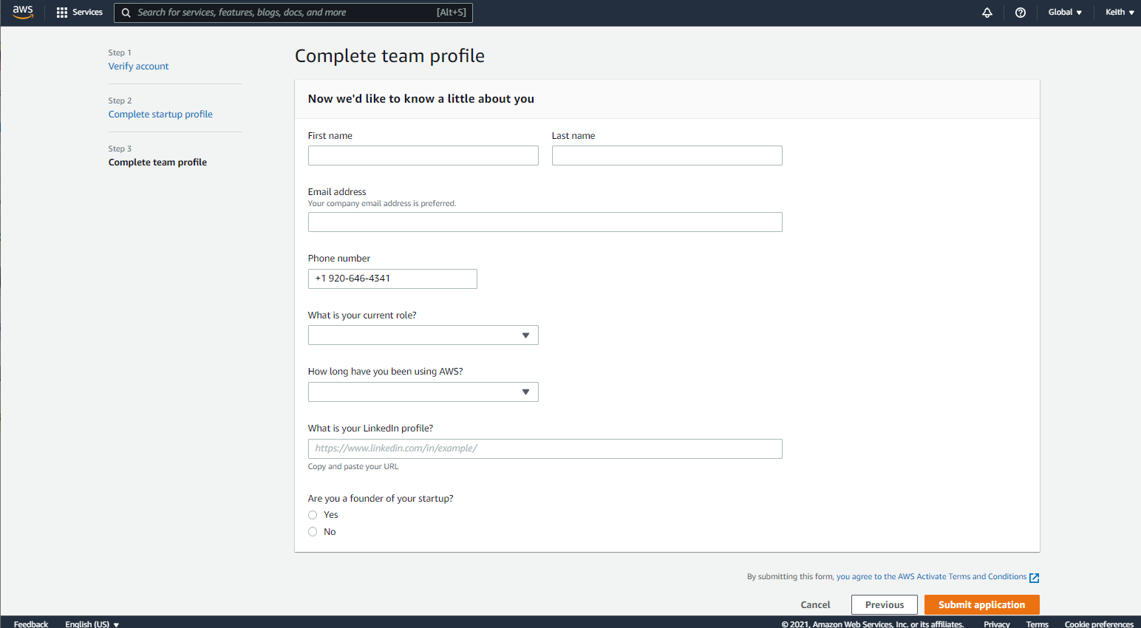

**NOTE: Please replace the word “AWS” with “Blue Node”**

**Thank you so much!!!!!**