README for Windows

How to build the Oak Manual on Windows

The Oak Manual relies on the free documentation software DocBook and Unix-tools for the build process. While most Linux distros (and other Unix-like systems) bring them from home, on Windows they have to be installed separately. Fortunately there is a an easy way to do so – it's called Cygwin.

1 Installing Cygwin

Cygwin can be obtained from the Cygwin homepage which is reachable below www.cygwin.com. You have only to download one file called setup.exe. This program will guide you through the install process and download all required data from the internet.

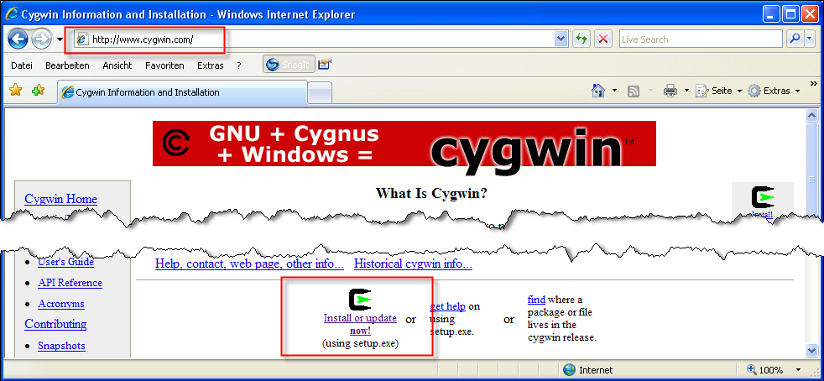
Download the file to your Desktop or some other common place. Double-click on the file setup.exe. The set up procedure will be launched. Click on the button Next.

Please note: Some buttons in the screen shots are in German, even if Cygwin itself is in English. Weiter means Next, Zurück means Back and Abbrechen means Cancel.

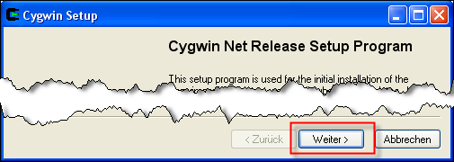

On the next screen shot you're being asked where you like to install the Cygwin software from. Check the radio button next to Install from Internet and click on Next.

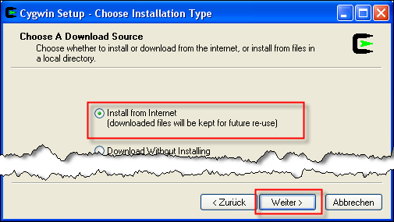
On the next step, you will be asked where the Cygwin root directory should be placed. The default value is C:\cygwin, but you can place it anywhere else where it fits your needs. We recommend some place that is easy reachable because you have to work with some directories below the root directory using the Windows Explorer.

Now you have to make sure that you check the radio button next to All Users below Install For and next to Unix/binary below Default Text File Type.

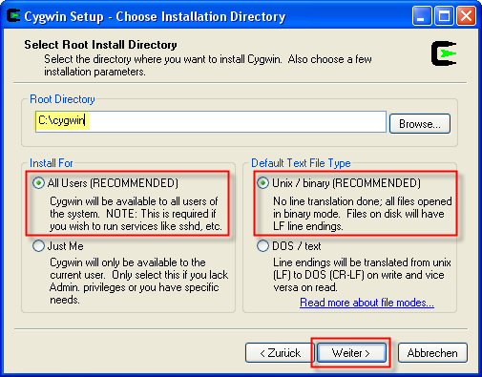
After you have clicked on Next, you'll be asked where to place the local package directory. In the local package directory all the installation files will be saved. We recommend to choose some place next to your Cygwin root directory. We've chosen C:\cygwin-package because our Cygwin root directory is C:\cygwin. But you can place it anywhere else.
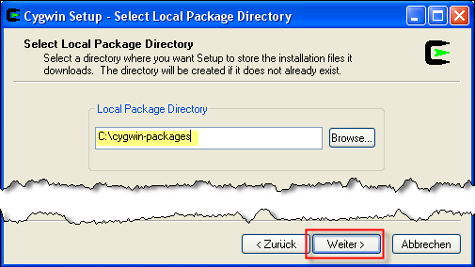
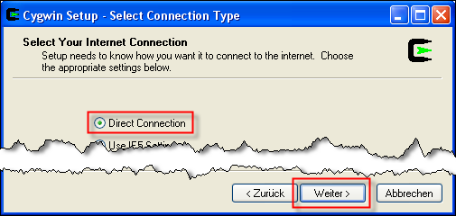
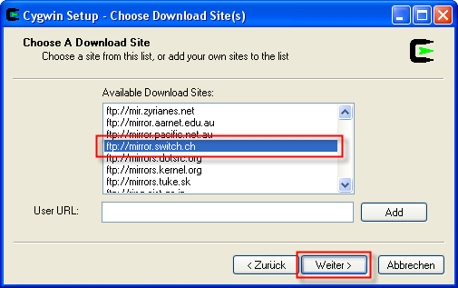
Now it's time to select a Download mirror. We recommend to pick the mirror next to you. As we're in Switzerland, we're going to use the mirror of the Swiss Education and Research Network SWITCH.

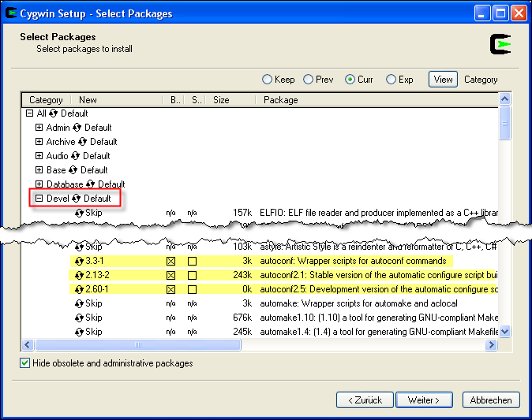
Now we've come to the package selection. Apart from the packages that will be shipped by default you have to install some additional packages. First, go to the section Devel and look for the package autoconf: Wrapper scripts for autoconf commands. Click on the icon next to Skip to select it for installation. After you did that, autoconf2.1 and autoconf2.5 will automatically be selected too. Now, scroll down and look for the three packages libxml2: XML C parser and tool kit (runtime and applications), libxml2-devel: XML C parser and tool kit (development) and make: The GNU version of the 'make' utility. Select it for installation.

Now, go to the section Libs and select the two packages libxslt: The GNOME XSLT C library (runtime) and libxslt-devel: The GNOME XSLT C library (development) for installation. Then, click to Next.
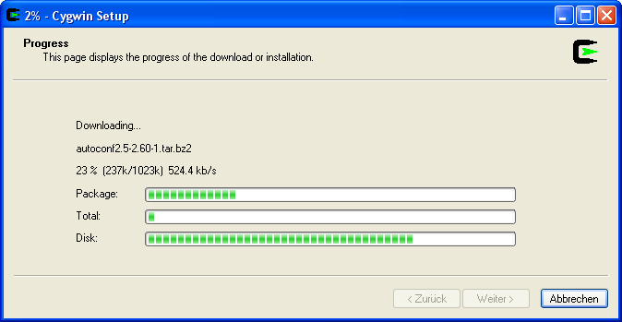
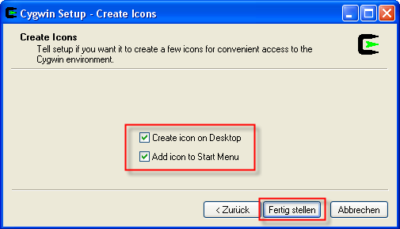
Let the set up create an icon on the desktop and one in the start menu. Then you can click on Finish and start using Cygwin.

2 Building the manual

To build the manual, double click on the Cygwin icon on your desktop. A windows command prompt will opened. Then you have to go to your home directory within the Cygwin environment.

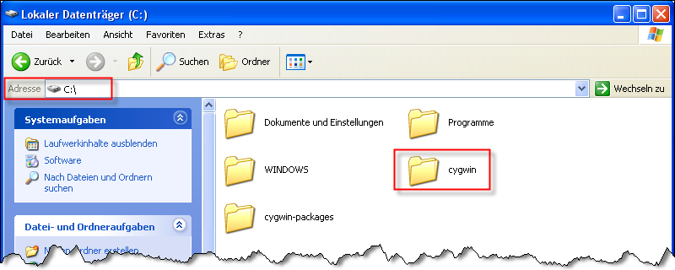
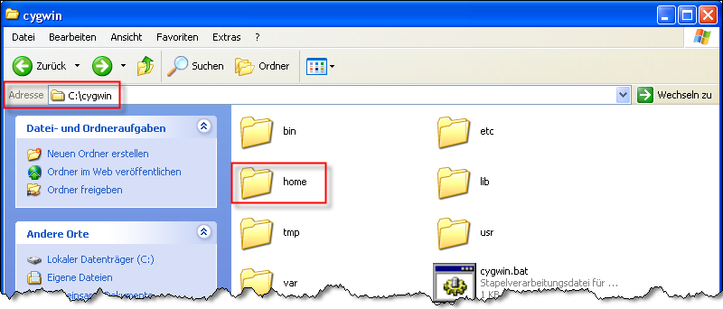
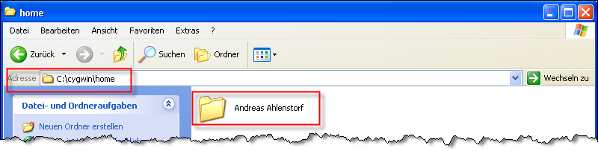
As you might remember, we've installed Cygwin to C:\cygwin. So go there and double click on home. There are all the home directories listed of the users on your computer. Click on the folder that's named after your user name. In this case it's Andreas Ahlenstorf, so the full path to the home directory is C:\cygwin\home\Andreas Ahlenstorf.

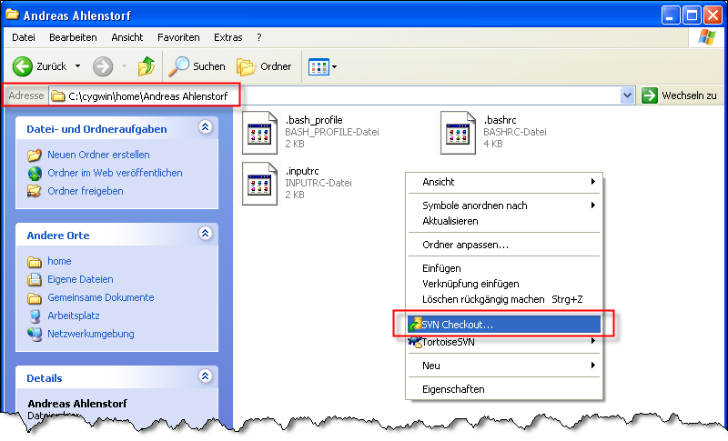
When you're there, create a checkout of the manual sources using Tortoise SVN (or a similar Subversion client). If you don't have it installed, go to http://tortoisesvn.tigris.org/ and grab your copy.

Enter https://www.dotthink.net/svn/Oak/trunk/documentation/manual as repository URL and C:\cygwin\home\<your user name>\manual as checkout directory.

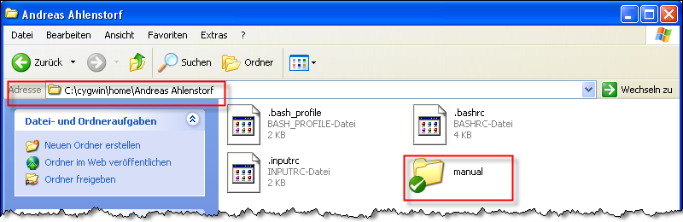

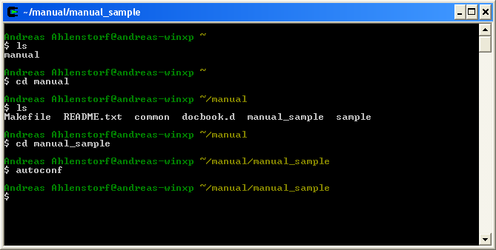
Now, go back to the windows command prompt. To build the Sample Manual, go to the directory manual_sample by typing:

$ cd manual/manual_sample

To start the build process, type:

$ autoconf
$ ./configure
$ make html-chunk

That will execute autoconf, which will prepare the configure script, that will be used to make sure that all the required programs are available and to generate the makefile. The makefile, which will be executed using the command make, controls the build process. The build process is separated in various tasks. To execute a specific task, type make taskname whereas you replace taskname with the name of the specific task. In the example above the task html-chunk will be executed. It creates a HTML manual that consists of multiple files, one for each chapter. To create a PDF, type make pdf. If you like to remove previously generated files, you don't have to remove them manually. You can simply run make clean.

