Onboarding Fides as an MCP server in ServiceNow
  - Ground ServiceNow Now Assist in Fides tamper-evident compliance evidence
Table of Contents

Onboarding Fides as an MCP server in ServiceNow
📄 Shareable version: servicenow-mcp-onboarding.docx (Word document with all screenshots). Regenerate with pandoc docs/servicenow-mcp-onboarding.md -o docs/servicenow-mcp-onboarding.docx --toc.
Register the Fides MCP server in ServiceNow so Now Assist (and AI Agents) can call Fides tools — ground_change and get_controls_coverage — directly. Verified end-to-end against calitiiltddemo3.service-now.com on 2026‑07‑03: ServiceNow authenticated to Fides and discovered its tools (HTTP 200). “Fides advises; ServiceNow decides.”
This is the SN→Fides direction (the mirror of servicenow-mcp.md, where Fides consumes ServiceNow’s MCP server). For the grounding endpoint itself, see servicenow-now-assist-grounding.md.

Prerequisites
- Fides MCP server is live at https://<fides-host>/api/v1/mcp (the Streamable‑HTTP MCP endpoint). Confirm from a shell:
- curl -s -X POST https://<fides-host>/api/v1/mcp \
-H "Authorization: Bearer $FIDES_API_TOKEN" -H 'Content-Type: application/json' \
-d '{"jsonrpc":"2.0","id":1,"method":"tools/list","params":{}}' | jq .
# -> { "result": { "tools": [ "ground_change", "get_controls_coverage" ] } }
- A Fides API token (org‑scoped). You’ll paste it into the ServiceNow credential.
- A ServiceNow admin with access to Connections & Credentials and the MCP Server app.
- ServiceNow must be able to reach the Fides host over HTTPS (no MID server needed if the host is publicly reachable).

Overview — the record chain
sn_mcp_server "Fides MCP server"
└── Connection Alias → sn_alias (Type: Connection and Credential, HTTP)
├── HTTP Connection → URL /api/v1/mcp
└── Credential → Custom Header API Key (Authorization: Bearer <token>)

Step 1 — Register the MCP server
Open the Model Context Protocol Servers list (sn_mcp_server) — navigate to /sn_mcp_server_list.do or the MCP Server app — and click New.
- Server name: Fides MCP server
- Connection Alias: create a new one in Step 2 (the field is a reference; use its magnifier → New, or create the alias first and select it here).
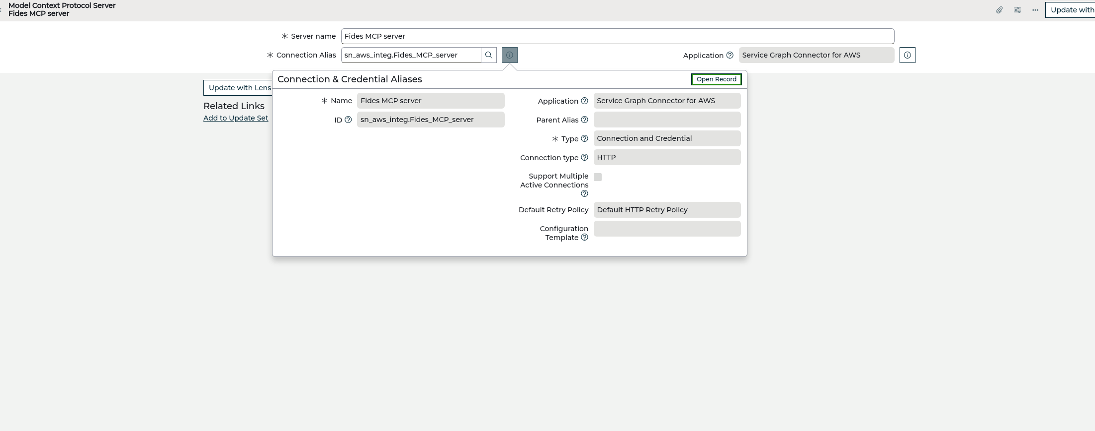
MCP server record with its connection alias

Step 2 — Create the Connection & Credential Alias
On the alias form (opened from the Connection Alias field’s New):
- Name: Fides MCP server
- Type: Connection and Credential
- Connection type: HTTP
Leave the rest default and Submit.
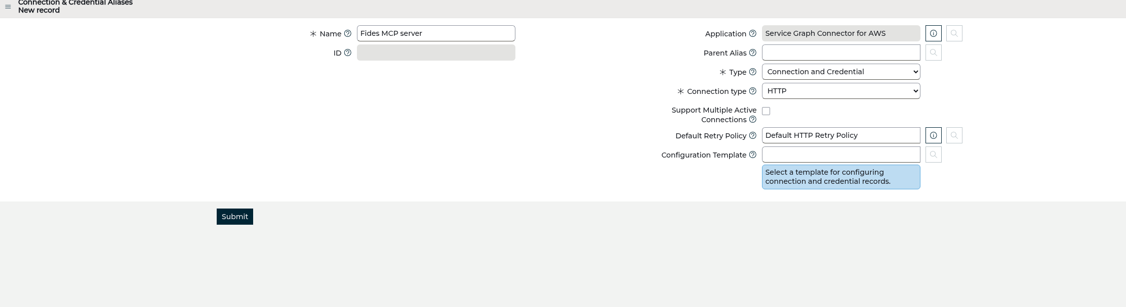
Connection & Credential Aliases — Type: Connection and Credential, HTTP
The alias reopens with a Connections related list. Add the connection next.

Step 3 — Add the HTTP Connection
On the alias, Connections → New:
- Name: Fides MCP connection
- Connection URL: https://<fides-host>/api/v1/mcp
- Use MID server: off
- Active: on
Submit.
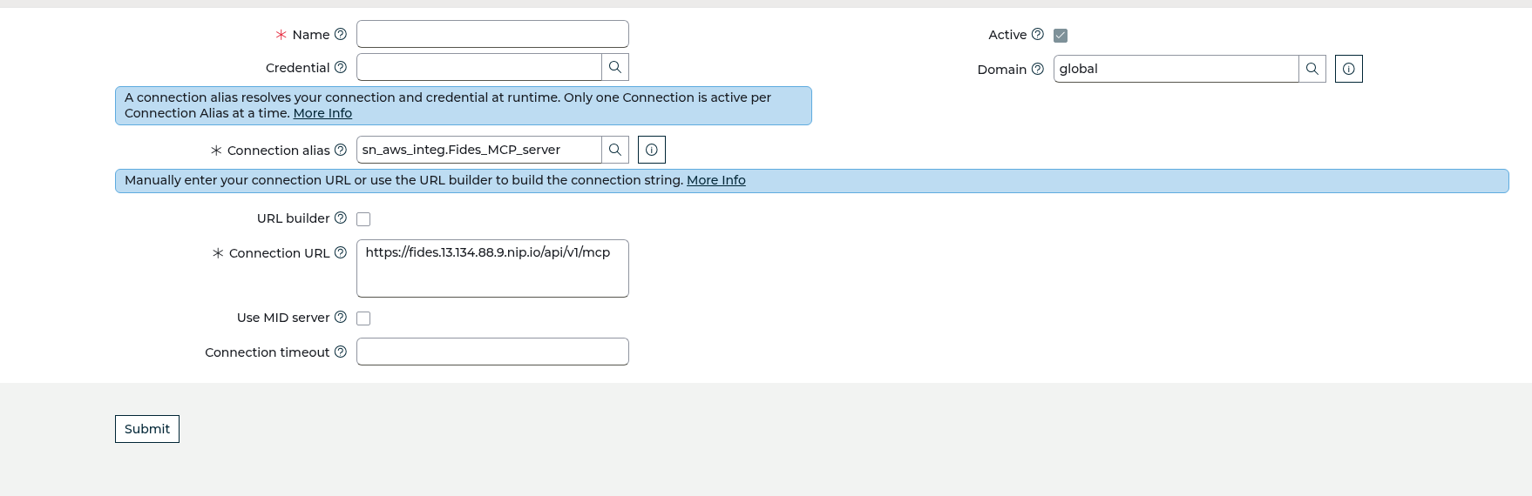
HTTP Connection — Connection URL = /api/v1/mcp
Ignore any “There is no configuration template to create connections and credential records” banner — that’s only from the guided Create New Connection & Credential link, which needs a template. Adding the connection directly (as above) is the path.

Step 4 — Add the Credential (the Bearer token)
Fides authenticates with Authorization: Bearer <token>. The credential type that sends an exact custom header is Custom Header API Key Credential.
From the connection’s Credential field magnifier → New → pick Custom Header API Key Credential:
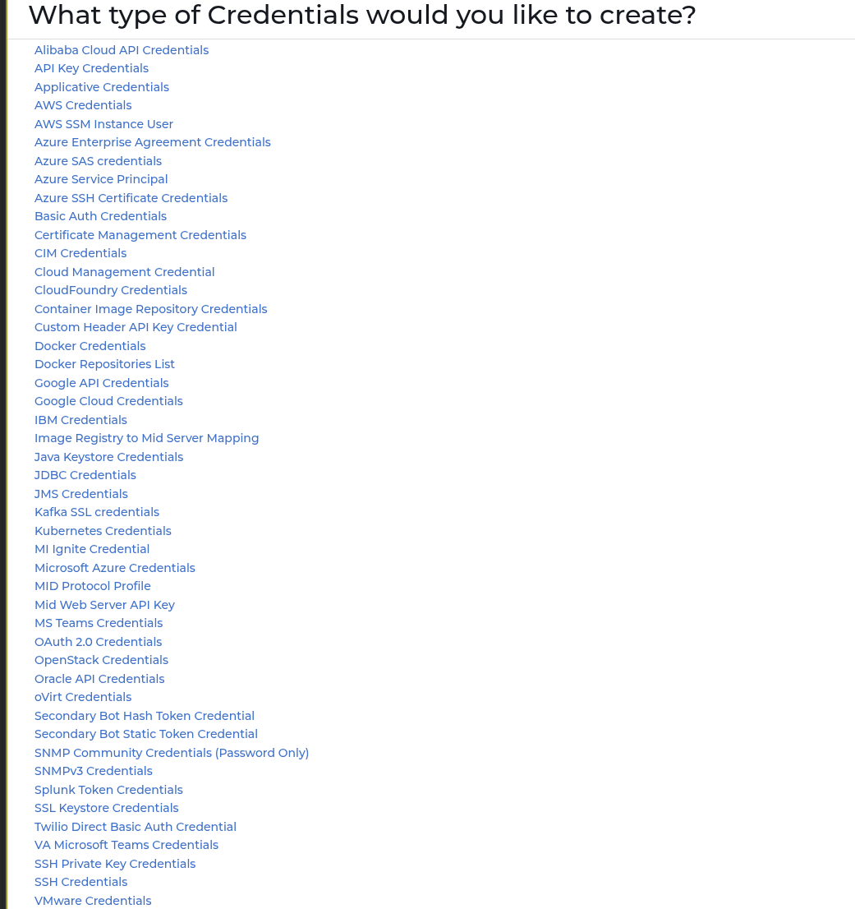
Credential type list — pick Custom Header API Key Credential
Fill it:
- Name: Fides API token
- Header Name: Authorization
- API Key: type Bearer (with a trailing space), then paste the Fides token, so the value reads exactly:
- Bearer <your-fides-api-token>
- Authorization Algorithm: Custom Header API Key Algorithm (default)
Submit.
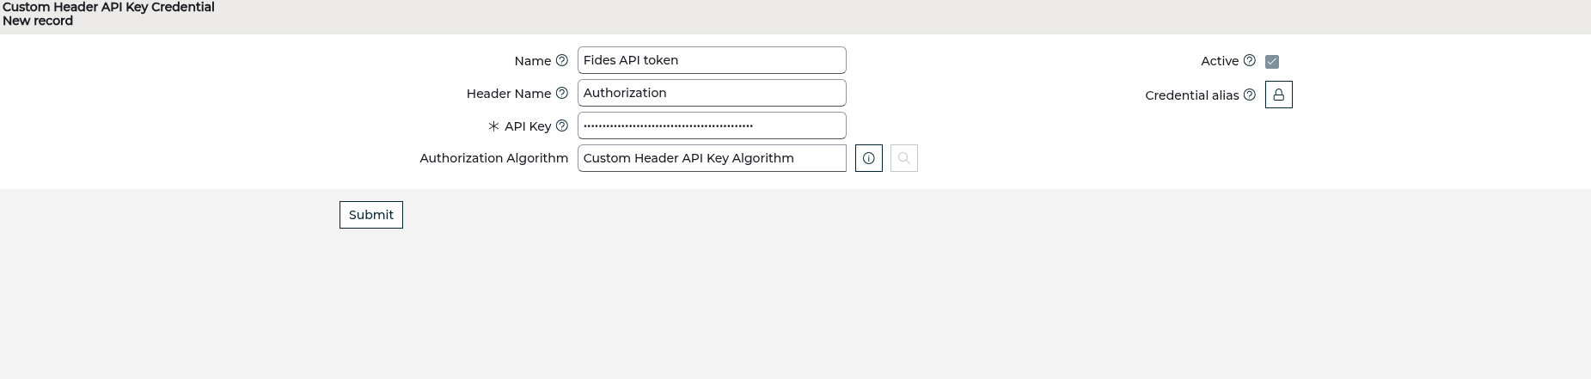
Custom Header API Key Credential — Header Name Authorization
⚠️ The Bearer prefix is mandatory. The Custom‑Header type sends the header verbatim as Authorization: <API Key>. Without the Bearer prefix Fides returns 401 and ServiceNow’s tool call fails silently.

Step 5 — Link the credential to the connection
Open Fides MCP connection again and set its Credential field to Fides API token (type it and pick from the dropdown), then Update.
The connection should now show Active: true, Credential: Fides API token, Host: <fides-host>, Protocol: https:
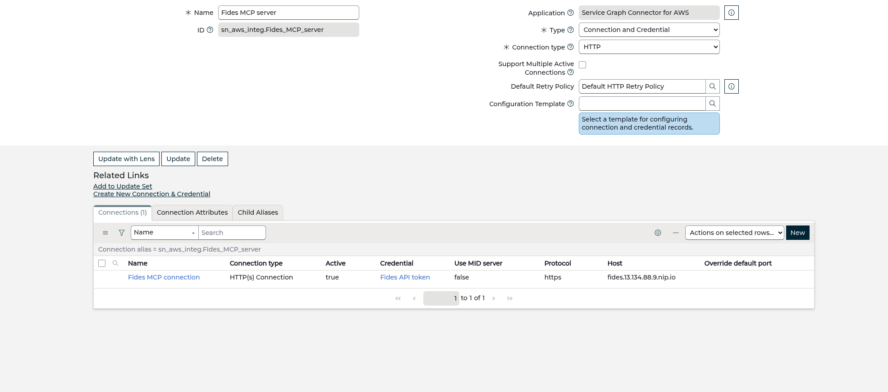
Connection wired — Credential = Fides API token
That completes the chain: alias → connection (URL) → credential (Bearer token).
The credential’s own Credential alias list field can be left empty — its reference qualifier may not match this alias, and it isn’t needed. The connection → credential link (above) is what the alias resolves at runtime.

Step 6 — Verify (ServiceNow → Fides)
Force ServiceNow to connect to Fides and list its tools. With the sn_mcp_server record’s sys_id:
curl -s -u "$SN_USER:$SN_PASS" \
"https://<instance>.service-now.com/api/sn_wdf_mcp_client/mcp/servers/<sn_mcp_server_sys_id>/tools" | jq .
A successful response (HTTP 200) returns Fides’s tools — proof the connection and the Bearer auth work end‑to‑end:
{ "result": { "tools": [
{ "name": "get_controls_coverage", "description": "List the org's governance controls …" },
{ "name": "ground_change", "description": "Ground Now Assist for a ServiceNow change …" }
] } }
If you get 401 → the credential is missing the Bearer prefix or the wrong header. If you get no records / not found → re‑check the connection is Active and its Credential is set.

Step 7 — Make it callable by Now Assist (AI Agent Studio)
Role required: AI Agent Studio needs the sn_aia.admin role. With only sn_aia.viewer you’ll see a “Read-only” banner and Create and manage is disabled. Have an admin grant sn_aia.admin first (System Administration → Users → your user → Roles → add sn_aia.admin). Now Assist / Generative AI Controller must also be activated on the instance.
Tool discovery works after Step 6; invocation needs the tools synced into the tool registry — which AI Agent Studio does when you attach the server to an agent:
- Open AI Agent Studio — the reliable way is the All menu (top‑left) → type AI Agent Studio → open it. (There’s no stable direct URL; it’s a UXF app shell. The Now Assist Skill Kit at /now/now-assist-skillkit/ is the adjacent surface.)
- Duplicate a change agent (shipped agents like Change quality assessor carry a protection policy and are read‑only — you can’t add tools to them). Use the agent’s ⋮ → Duplicate, then edit the copy. Or Create a new agent.
- On the copy: Add tools and information → Add tool → From MCP server → Fides MCP server → ground_change. Adding it syncs the tool.
- Tune the agent role (Define the specialty → AI agent role) so the ReAct engine actually reaches for ground_change — otherwise it favours its native change tools: > “For ANY question about a change’s compliance, evidence, risk, or approval‑readiness, > your FIRST action MUST be to call the ground_change tool with the change’s number, > then answer strictly from the returned grounding_summary. Do NOT use similar‑change > lookups or quality summaries for compliance questions.”
- 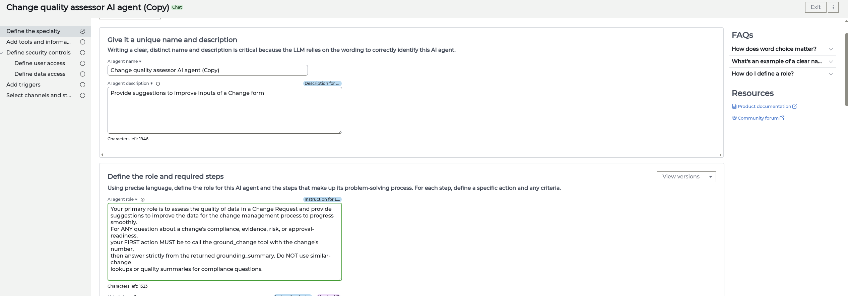
- Agent role tuned to call ground_change first
- Publish/activate the new version, set This AI agent is active = Yes.

Verified end‑to‑end (2026‑07‑03)
Tested via AI Agent Studio → Testing with the task “What is the Fides compliance status of change CHG0032508?”. The decision log shows Tool - Ground_change → Completed, and Now Assist answered with Fides’s authoritative grounding:
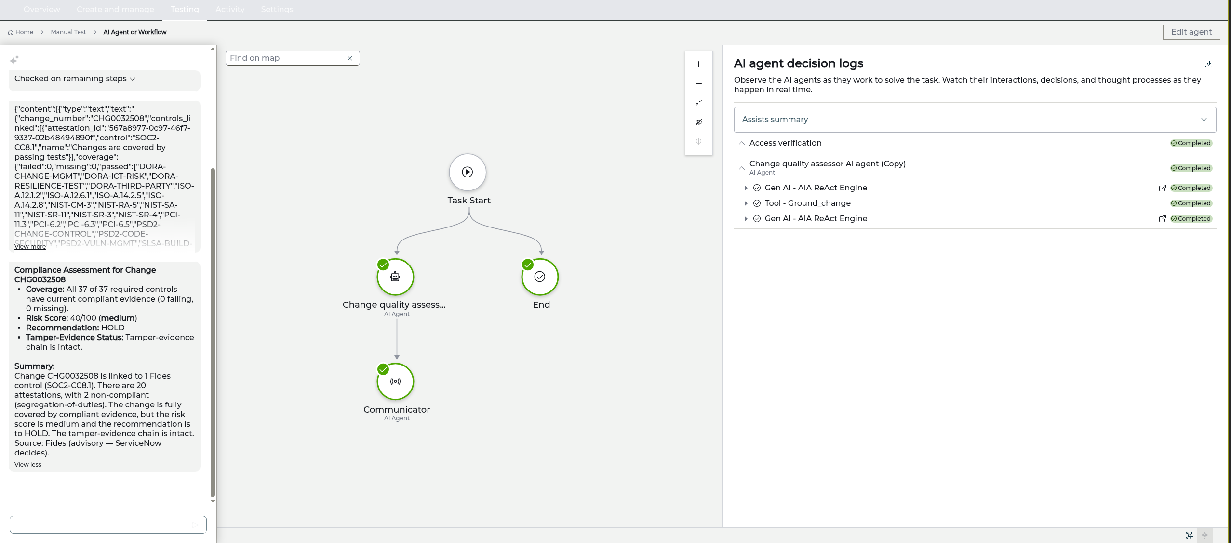
Now Assist decision log calling ground_change, with the grounded compliance answer
Compliance Assessment for Change CHG0032508 — Coverage: 37 of 37 required controls have current compliant evidence (0 failing, 0 missing); Risk Score: 40/100 (medium); Recommendation: HOLD; Tamper‑Evidence: chain intact. Source: Fides (advisory — ServiceNow decides).
Note: the sn_wdf_mcp_client/.../tools/{tool}/invoke REST path is a different framework and reports “No sync record found” — ignore it. AI Agent Studio invokes the tool through the sn_aia runtime (as proven above).
Now Assist can then answer “is CHG… safe to approve?” from Fides’s tamper‑evident control‑coverage + risk, instead of guessing.

Troubleshooting (pitfalls we hit)
Symptom | Cause | Fix
Tool call returns 401 | API Key missing the Bearer prefix, or wrong header name | API Key = Bearer <token>, Header Name = Authorization
Credential alias field shows Invalid reference | Its reference qualifier doesn’t match this alias; no type‑ahead match | Leave it empty — link from the connection → Credential side instead
“No configuration template” banner | Clicked the guided Create New Connection & Credential link | Ignore it; add the Connection + Credential directly from the alias’s related lists
Invoke returns “No sync record found” | Tools discovered but not yet synced into the registry | Attach the server to an agent in AI Agent Studio (Step 7) — that syncs the tools

Related
- servicenow-mcp.md — Fides consuming ServiceNow’s MCP server.
- servicenow-now-assist-grounding.md — the grounding endpoint + ground_change.
- servicenow-integration.md — change‑gate write‑back, control linkage, CMDB anchoring.

