Project description

1. Specification: 0 – 14 points, including:

- defining a short description of the project and the problem to be
solved by the designed application:
0 – 2 points,

Our project will be a simple multiplayer Ticktacktoe game. The problem at hand is that the multiplayer is cross client as opposed to local multiplayer. This problem will be solved with sessions and database polling.

- indication of at least four arguments why the web application
technology was selected as part of the project to solve the assumed
problem or indication, with at least four arguments, why the web
application technology will not work for a given problem:
0 – 4 points, where single argument = 1 point,

Works for:

- No need to install the game locally, can be played online.
- Can be played on any device (phone, tablet, computer, laptop)
- Updates can be published very fast

Doesn’t work for:

- High security applications
- Must have internet access
- High performance applications (video games / CAD)
- System hardware accessing applications (temp monitoring)

- determination of at least four functional requirements:
0 – 2 points, where single requirement = 0.5 point,

- Login
- Create User
- Game logic
- Multiplayer

- determination of at least two non-functional requirements:
0 – 2 points, where single requirement = 1 point,

- Design (CSS) and images
- Game History
- Profile view
- indication of at least two potential recipients of the system:
0 – 2 points, where 1 recipient = 1 point,

- Classmates
- Random (online) users

- indication of at least two potential goals for creating a system:
0 – 2 point, where 1 goal = 1 point.

- Working Tic-Tac-Toe game
- Invite code for friends to join

2. Technical documentation: 0 – 6 points, including:
- determination of the technological stack consisting of at least
three elements: 0 – 3 points, where 1 element = 1 point,

PHP,JavaScript,CSS

- database documentation or diagram (overall or for a selected part
of the application): 0 – 3 points, where 1 table + marking in it
primary and foreign keys and indexes (if any) = 1 point

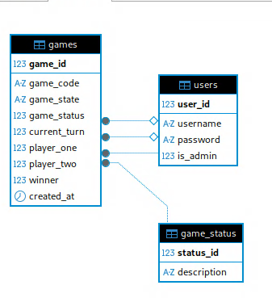
3. Functional layer: 0 – 20 points, including:
- compliance of the implementation with the functional requirements:
0 – 10 points (1 requirement / 2.5 points),

- compliance of the implemented architecture with the standards of
the selected framework or design pattern, with particular emphasis
on the separation of application layers: 0 – 10 points.

4. Use of the database (relational or non-relational): 0 – 20 points,
including:
- (relational database) normalized structure of the database (at
least the second normal form): 0 – 5 points
or
(non-relational database) criteria for 5 points in this respect
depend on the choice of non-relational database technology – please
contact me if you choose this option
- compliance of the database structure and implementation in the
application with the specification: 0 – 5 points,

- the use of at least three of the four core CRUD operations: 0 – 10
points, where 1 type of operation = 3.5 points.

5. View layer: 0 – 20 points, including:
- compliance of the view layer with selected parts of the
specification: 0 – 5 points,
- guaranteeing correct display regardless of the device size for at
least one screen: 0 – 15 points, where correctness on 1 screen for
three different, standard sizes = max 10 points (1 size / 5
points).

6. Using naming conventions in programming and formatting the code
typical for the selected technology: 0 – 10 points.

7. Demonstration of the specification and the source code of the project
along with an indication of the above-mentioned elements: 0 – 10
points; alternatively, the demonstration can be replaced with
multimedia material or extended documentation, showing the compliance
of the implemented project with the points indicated above.

