Code Review
Group27’s review of Group29’s code
Olafur Palsson o.fl.
General

What I really really liked

The variable naming. They say what they do and the code is readable. The code has an overall well defined structure and it is relatively easy to figure out what things are supposed to do even though it doesn’t have comments. In my opninion that’s the best.

Technology choices (the other thing I really liked)

“Avoiding complexity reduces bugs.” -- Linus Torvalds

This should be called technology usage. I like that the program has few dependencies on other libraries which – to completely rip off Linus Torvalds – reduces complexity. Also, React is a great choice for any web-applications even though the learning curve is pretty steep at first.

For every situation an appropriate tool is chosen for the job and every one of those tools are up to date with the latest technology.

One suggestion in the end though: Use a linter, they are in my opinion undervalued.

Foreword

Sorry, this is going to be opinionated, so take everything with a grain of salt. What i propose is a way of doing it but by no means the only way of doing it.

Back-end

Unnecessary code

By having the controllers return null (e.g. findOne with bad id) then the following can be trimmed away:
UnauthorizedException,
NotFoundException,
BadRequestException,
All try-catch’s on controllers,

Example 1:

Before
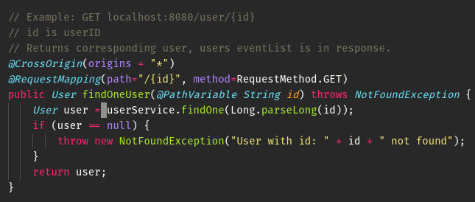
After
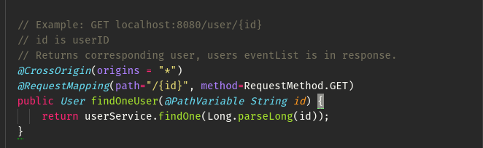

Example 2:

Before
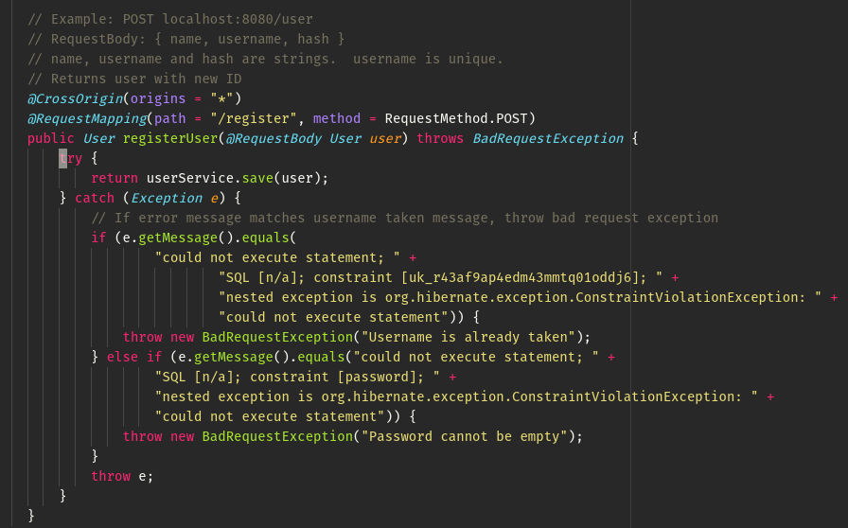
After
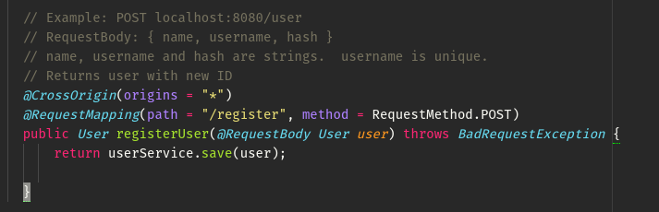

Hard to read

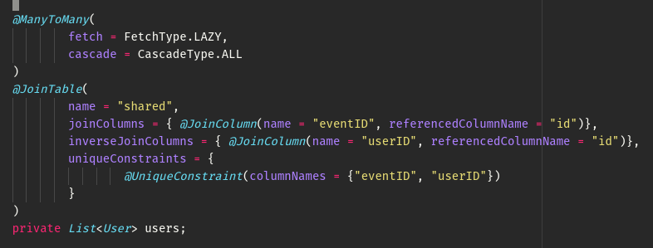
This annotation is very hard to read. Another option would be to manually add the user to the event when the event is added to the user and vice versa. The amount of lines will be roughly the same or fewer but it will be far more legible.

Linting

The coding style is not consistent.

Example in the same class

When seeing this
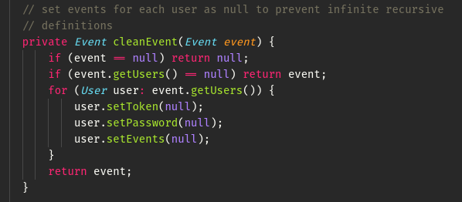

We expect this

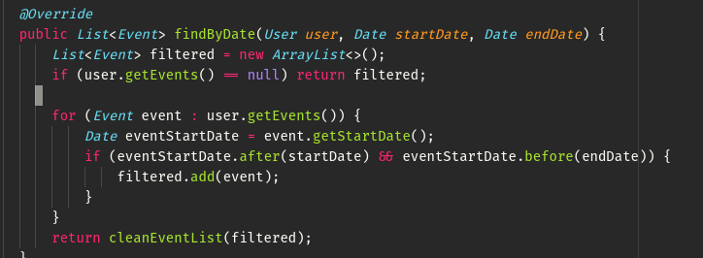
Not this

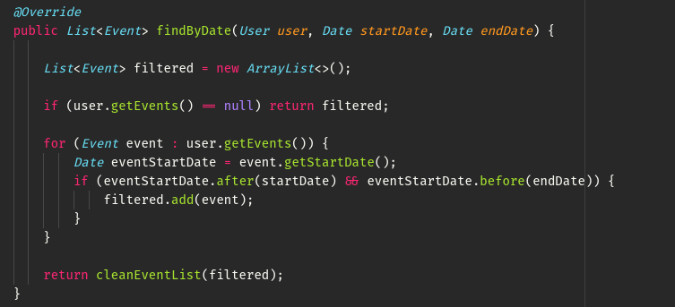
Unhadled exceptions

Should be one of the following:
‘throws’ keyword in declaration.
or
caught in method and handled if it actually causes an issue.

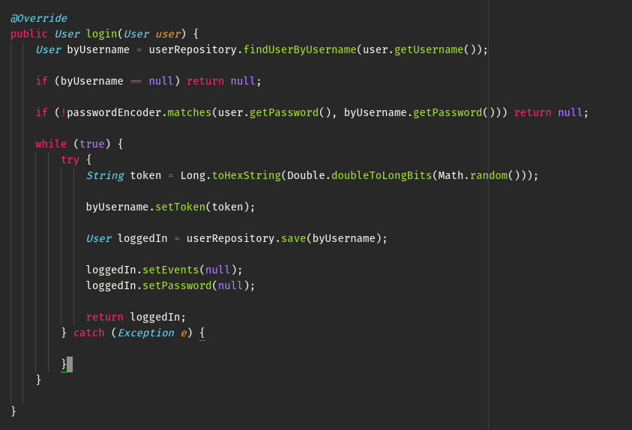
One personal point

I know the teacher provided a code like this, but we are not programming in C/C++, which allows us to safely be able to have declarations and implementations on the same place.

A great exception to this rule is when using ‘abstract’ classes since they may need methods that are dependent on how – or rather what – the extending class is.

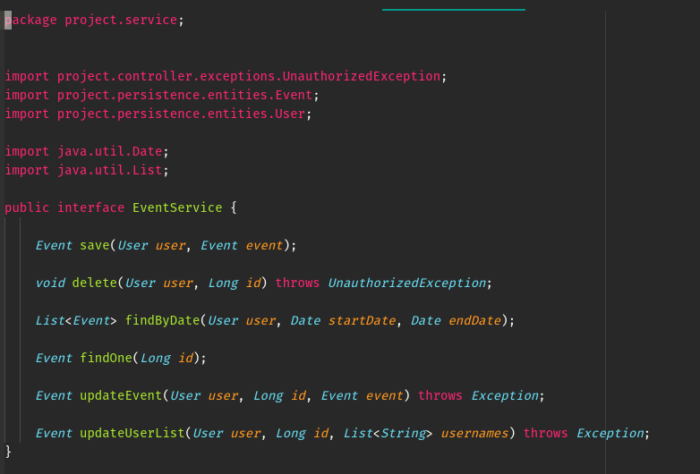

Front-end

I like react, so I’m going to write it with big letters for kicks.

React

Components that increase complexity rather than abstract away from it

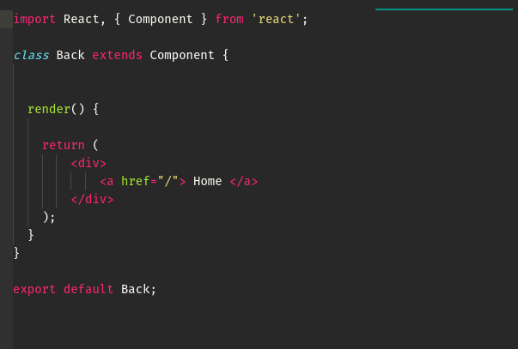

This component is literally “<div><a href=”/”> Home </a></div>”. By manually typing this I can add class and link to any instead of only the front page. This component makes the code more restricting to use instead of the default option.


It also has an accompanying empty file.

A couple of unnecessary lines here and there :)

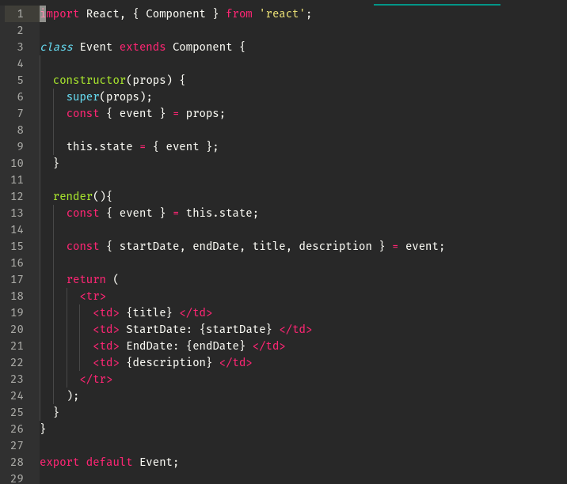

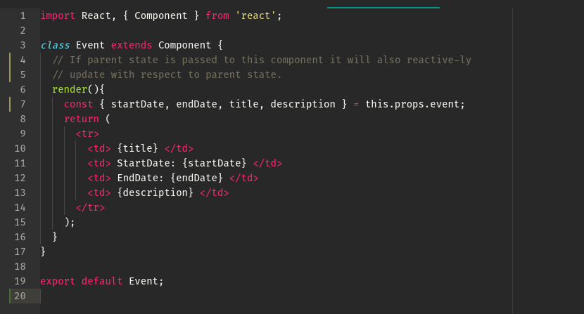
Repetitive Code

Example

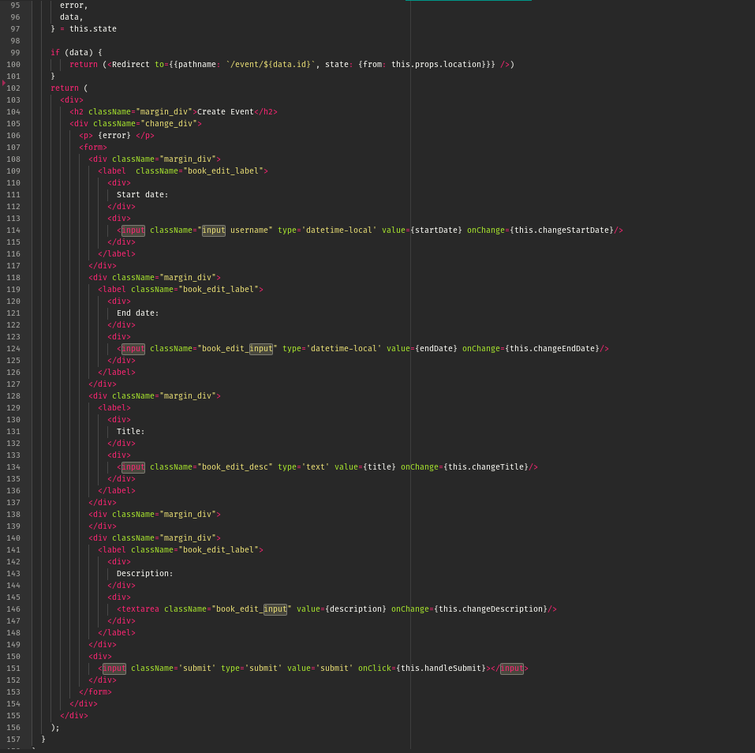

Should be abstracted into a function, e.g.

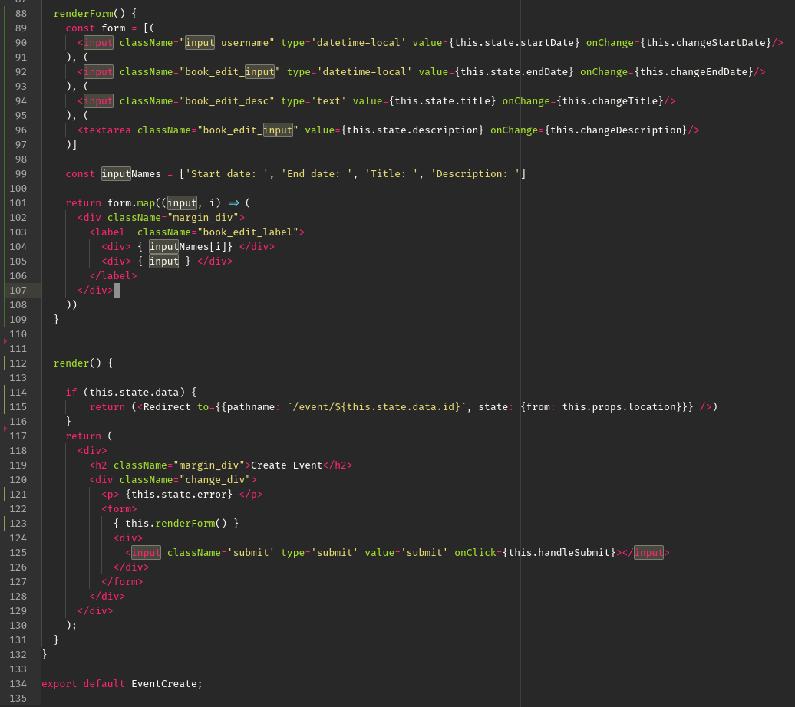
or event better: as a component.
Folder structure

These ones have been prematurely put into folders.

They each have exactly these files:
Name.css <-- is empty
Name.js
index.js <-- has no functionality
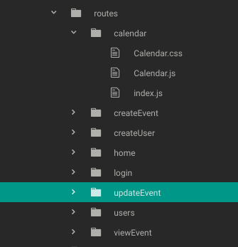

To take out these index.js files you change this:

To this:

Or with ‘babel-plugin-root-import’ to this (most comfortable):

here ‘@’ means the src folder in any component (also in subfolders).

Relation to planning docs.

-- Where the planning docs are sequence diagram, uml diagram and vision scope document.

It relates perfectly with the diagrams. I want to make this longer to make it clearer how good this part is but I can’t, it’s that good. 10/10 would read again.

Own Code

Design and technology issues with own system

History*.java are all useless since Routine can have a timestamp field that does the same job when combined with one ArrayList<Routine> on UserEntity.

User can’t see an exercise that he has already trained (yet).

The routing is unnecessarily complicated.

It sends many requests in a situation when it would take shorter time to send fewer.

A couple of bugs that I noticed (mostly unimplemented features)

Bug with login not working when the the user has never signed in.

User can’t change individual sets of his exercise.

In NewRoutine_addExercise when the page is reloaded has no routine to add the exercise to. Should rather go back.

No calendar.

Some things are ugly.

I’m not going to put effort into this

Coding style issues

TrainingView.vue:
This is very ugly. It should be refactored.
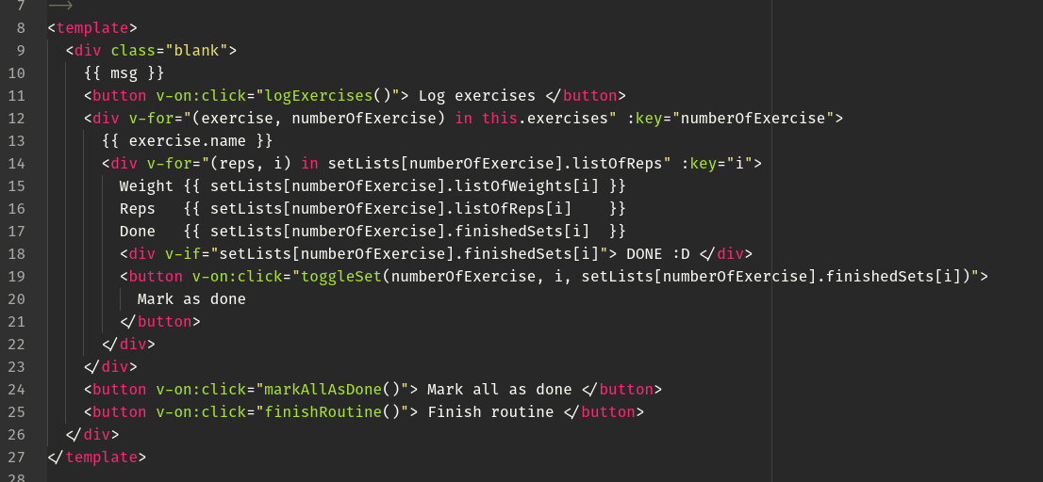
SelectReview.vue:
A parent variable is set directly instead of using a setter. Alse there are parent methods being referenced without mercy when they should obviously be bound to the component instead. (I still haven’t figured out this one).
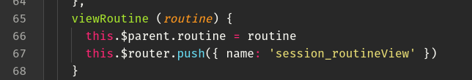

Home.vue
Checkmark is always displayed.

Database.js
Some methods are not straightforward like this one, it’s semi-legible at best (I’m still a big fan though, I use it 13 times in the file).
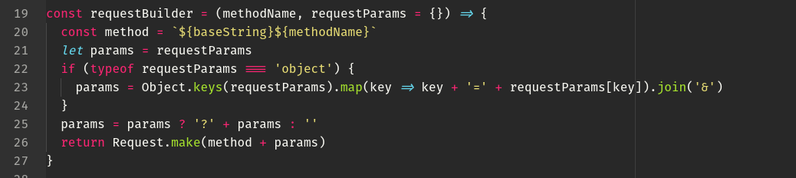

Some lines need comments
“// Cutting off the first ‘&’ sign” should be inserted in line 111 for example.
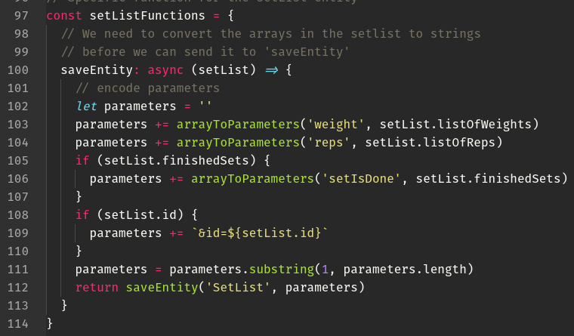

Cookiehandler.js
Not very legible, I only wrote 30% of it and I still don’t know why it works better than the one I wrote myself in the beginning.
