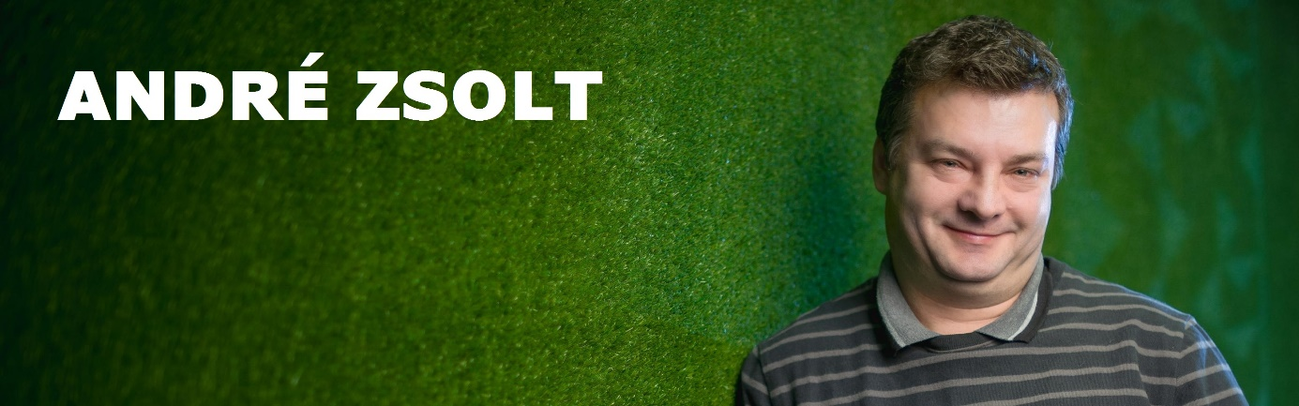

Summaryy

I’m an experienced senior electrical engineer and an ambitious junior software developer hunger for conquering a new area of technical sciences. I collected more than 23 years of working experience in the mobile telecommunication sector.
I think my most important skills and experiences are:
- analitical problem-solving skills (relevant experience in aftersales, sales, customer care, CRM)
- outstanding people management skills (huge experience in leading teams)
- ability and will to learn new technolgies (work experience in wired communication)
- good communication skills (working knowledge of English language)
- numerate, reliable, result-focused
I’m looking for an ambitious company which will challange my problem solving skills, and allow me to develop my knowledge through collecting ecperiences.
Skills

Languages: JavaScript, Python, HTML, CSS, Sass, Java
Technologies: Node.js, Angular JS
Tools: Tape, Jasmine, Supertest, AVA, Express, Gulp, Karma, Browserify, ESLint, JSHint, JSCS SourceControl: GIT
Methodology: Agile development – Scrum, Kanban, TDD
Databases: SQL, Postgres, ClearDB, MongoDB
OS: Windows, Linux
IDE: Brackets, Atom, Netbeans, Eclipse
Application servers: HEROKU, GlassFish

Work experince

2006-2015: | Magyar Telekom
 | Office Manager, Assistant Office Manager, Team Leader (After Sales ),
 | After Sales Engineer
1997-2006: | T-Mobile / Westel 900
 | Assistant Office Manager, Team Leader (After Sales ), After Sales Engineer
1992-1997: | Westel Mobile Telecommunication
 | Team Leader, Radio Engineer
Education

2015-2016: | Greenfox Academy – Budapest
 | Software Developer
2015-2015: | Ruander Oktatóközpont – Budapest
 | JAVA Programmer (JSE, JEE, Android)
1994-1996: | College Szolnok – Szolnok
 | Economist - Foreign Trade
 | Second Degree
1989-1992: | University Óbuda - Budapest
 | Electrical Engineer - Telecommunication
 | BSc
1985-1989: | Pálffy János Specialized Secondary School -Szolnok
 | Computer technician
 | Graduation

