MIM V3 — test case TC-04: investigate INC2667546 on Automated Claim Transaction PROD
Date | 23 Oct 2026
Dashboard | MIM V3, Kibana 9.5.3
Objective | Show that an application-service CI (not itself a server) is still fully investigable: section 2's CMDB links work, and Application Health resolves for the CI even before any server or service is picked — then confirm that picking one of its related servers and its APM service fills the rest of section 3.
Why this incident | Round 15's pick for TC-04 (queries_ro_run.md). Automated Claim Transaction PROD is a Mapped Application Service, still active since 21 Oct with 14 open incidents on it.
Result | Pass. Section 2 fully populated from the CMDB; Application Health resolved the CI on its own via its registered APM number; picking the related server vslrau1p276 and service clmact filled every remaining section 3 panel.

How this differs from TC-01 and TC-02
TC-01 used a CI that is itself a server with APM on it. TC-02 (scaffolded, pending) uses a server with no APM. This test uses a CI that is an application service — not a server at all — which is the most common shape for an incident in this estate (most active P1–P3 incidents sit on Mapped/Calculated/Tag-based application services, per Round 13-15).
The walkthrough was captured in two phases: first with nothing picked in the Server, Service or Application controls (to see what resolves on its own), then with a server and service picked from the CMDB relationships found in section 2.

Test flow
The path this test actually followed, reconstructed from the screenshots. Green boxes are what was observed; amber diamonds are the decision points this test exercises.
- Green: the step and its observed result.
- Amber: a decision point.
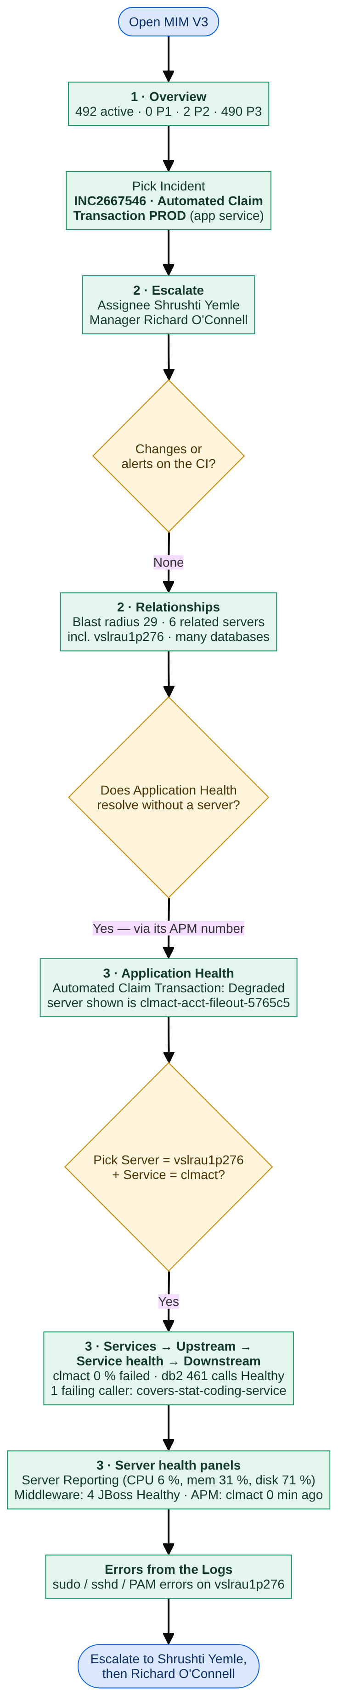
Test flow for INC2667546

Inputs
Control | Value | Why
Incident | INC2667546 · Automated Claim Transaction PROD | The incident under test; its affected CI is an application service, not a server
CI | (no CI selected) | Not needed: the incident's CI always wins
Server — phase 1 | (no server selected) | To see what resolves without picking one
Server — phase 2 | vslrau1p276 | One of the CMDB-linked servers found in Server View (also runs the CI's own APM service)
Health window | 24 hours | Default
Service — phase 1 | (services on this CI) | Default — finds nothing, since the CI itself has no host.name match
Service — phase 2 | clmact | The APM service registered against this CI's own APM number
Application | (all applications) | Not needed: Application Health resolves the CI directly

Step 1 — Major Incident Overview
What to show: the estate-wide picture, unrelated to this CI.
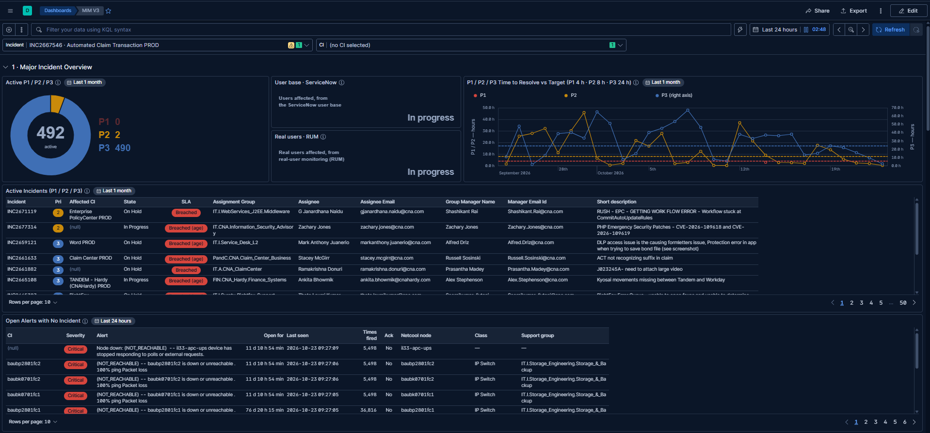
Section 1: controls, donut, time to resolve, active incidents, open alerts
Check | Result
Controls hold the inputs above | Pass
Active P1 / P2 / P3: 492 active (P1 0, P2 2, P3 490) | Pass
User base · ServiceNow / Real users · RUM: both "In progress" | Pass
Active Incidents: INC2667546 appears | Pass
Open Alerts with No Incident: several IP Switch / UPS alerts with no ticket | Pass

- Open Alerts with No Incident shows several infrastructure alerts (switches, UPS) with no incident raised — a reminder to glance at this table even when focused on one CI.

Step 2 — Escalate, Changes and Alerts
What to show: who owns this CI, and whether anything changed or alerted recently.
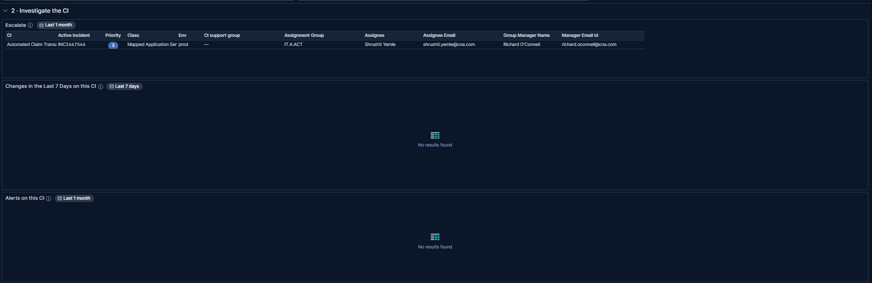
Escalate, Changes in the Last 7 Days, Alerts on this CI
Check | Result
Escalate: Automated Claim Transaction PROD · INC2667546 · P3 · Mapped Application Service · prod | Pass
Assignment Group IT.A.ACT, Assignee Shrushti Yemle, Manager Richard O’Connell | Pass
CI support group: blank (—) | Pass (gap, not a bug)
Changes in the Last 7 Days: empty | Pass — none on this CI
Alerts on this CI: empty | Pass — none on this CI

- Escalate found the assignee and manager from ServiceNow without needing a server or application to be picked.
- CI support group is blank for this CI — a data-quality gap in ServiceNow, not a dashboard defect.

Step 3 — The CI’s relationships
What to show: the CMDB links around this application service: what it depends on and what runs it.
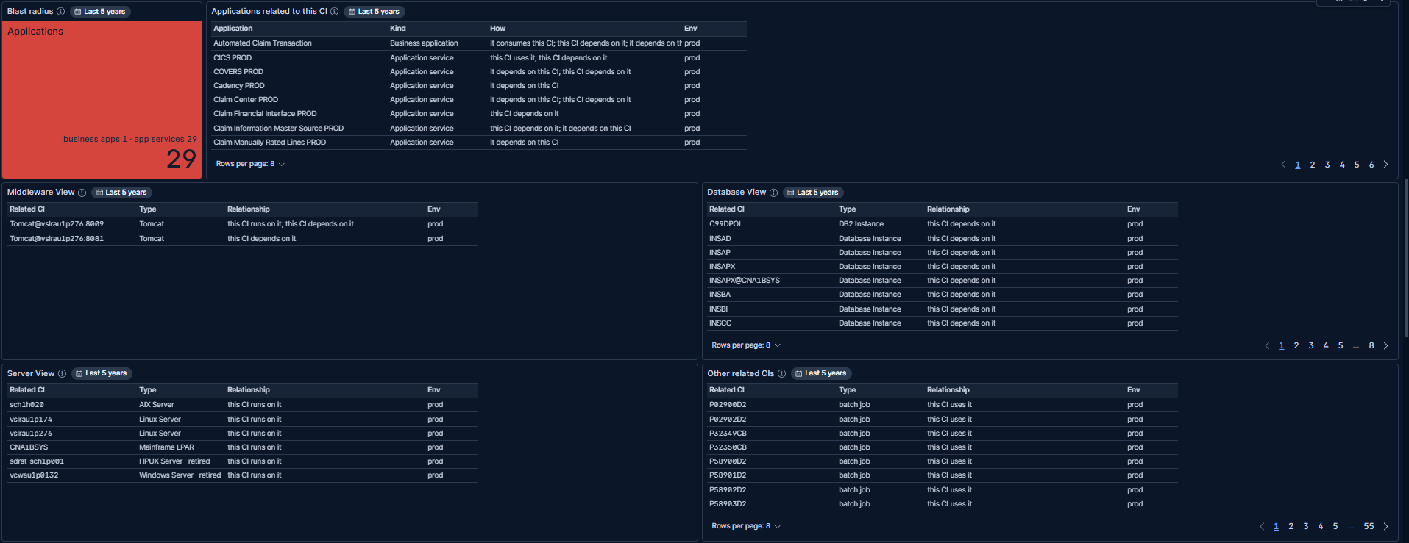
Blast radius, Applications related to this CI, Middleware View, Database View, Server View, Other related CIs
Check | Result
Blast radius: 29 (1 business application, 29 of 29 app services counted) | Pass
Applications related to this CI: Automated Claim Transaction (business app), CICS PROD, COVERS PROD, Cadency PROD, Claim Center PROD … | Pass
Middleware View: 2 Tomcat instances on vslrau1p276 | Pass
Database View: many Database Instances (DB2, Oracle) it depends on | Pass
Server View: 6 related servers — sch1h020 (AIX), vslrau1p174 / vslrau1p276 (Linux), CNA1BSYS (Mainframe LPAR), 2 retired | Pass
Other related CIs: 55 pages of batch jobs it uses | Pass

- This is the step that supplies the server picked in phase 2: Server View lists vslrau1p276 as one of the servers this application service runs on.
- Server View also shows two retired CIs (an HP-UX server and a Windows server), marked as such — old infrastructure the CI once ran on.

Step 4 — Application health, before picking a server
What to show: whether section 3 can say anything about this CI before any server or service is chosen.
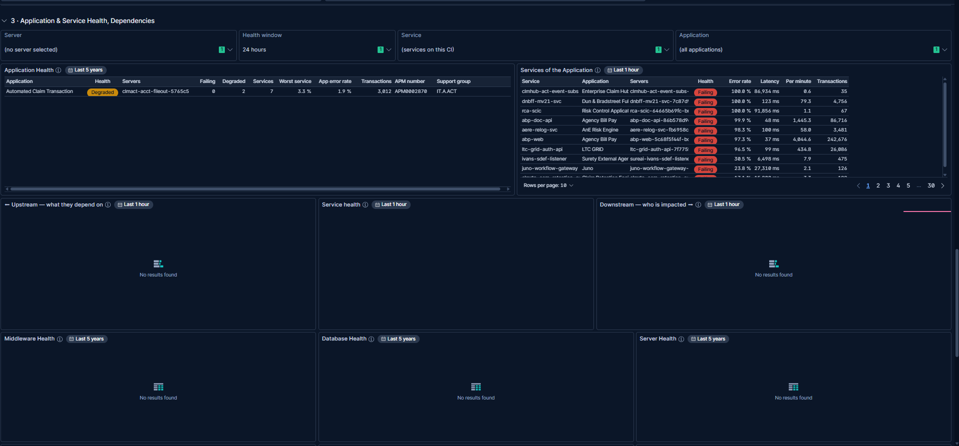
Section 3, phase 1: controls (nothing picked), Application Health, and everything else
Check | Result
Application Health: Automated Claim Transaction, Degraded, 7 services (0 failing, 2 degraded), 3.3 % worst service, 1.9 % app error rate | Pass
Servers column shows clmact-acct-fileout-5765c5 | Pass (see note)
Services of the Application: the estate-wide worst-first list (Service control still on default) | Pass — expected
Upstream, Service health, Downstream: empty | Pass — expected (no Service picked)
Middleware / Database / Server Health: empty | Pass — expected (no Server picked)

- This is the key finding of this test case: Application Health resolved the CI on its own, with nothing picked in the Server, Service or Application controls, because the CI is linked to a business application and that application carries an APM number.
- The value in the Servers column (clmact-acct-fileout-5765c5) is a Kubernetes-style pod name, not a traditional hostname — the same pattern seen in TC-06. It will not appear in the Server control’s list.

Step 5 — Picking the server and service
What to show: whether section 3 fills in once a related server and its APM service are picked.
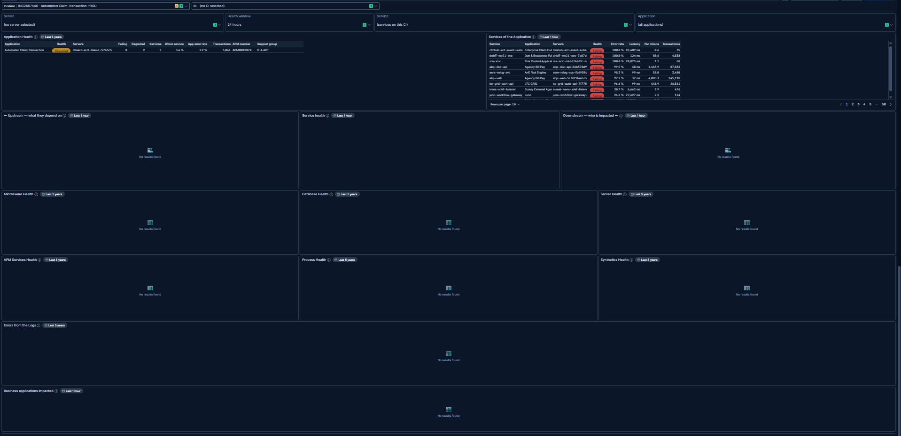
Section 3, phase 2: Server = vslrau1p276, Service = clmact
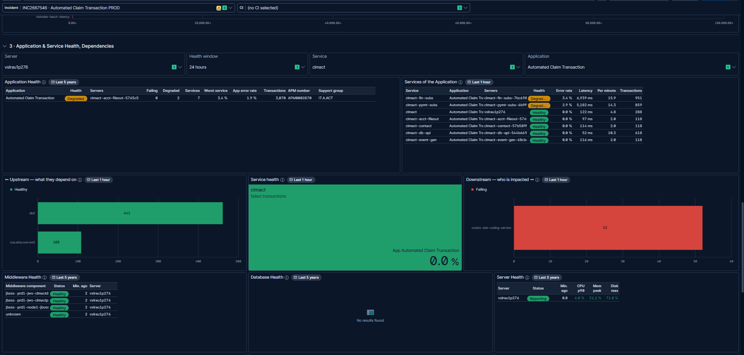
Application Health, Services of the Application, Upstream, Service health, Downstream, with the server picked
Check | Result
Services of the Application: narrows to clmact’s own 7 services (clmact-fin-subs, clmact-pymt-subs, clmact, clmact-acct-fileout, clmact-contact, clmact-db-api, clmact-event-gen) | Pass
Upstream — what they depend on: db2 (461 calls, Healthy), cna.okta.com:443 (108 calls, Healthy) | Pass
Service health: clmact, 0.0 % failed transactions | Pass
Downstream — who is impacted: 1 failing caller, covers-stat-coding-service (52 calls) | Pass — a real finding
Middleware Health: 4 JBoss instances on vslrau1p276, all Healthy | Pass
Server Health: vslrau1p276, Reporting, CPU 6.0 %, memory 31.2 %, disk 71.0 % | Pass
Database Health: empty | Pass — no database on this server

- Picking Server = vslrau1p276 and Service = clmact (the application’s own APM service name) filled every panel that was empty in Step 4.
- Downstream found one real failing caller: covers-stat-coding-service. This is the signal worth chasing during an actual incident.

Step 6 — The server’s remaining health panels and logs
What to show: APM, process and log-level detail for vslrau1p276.
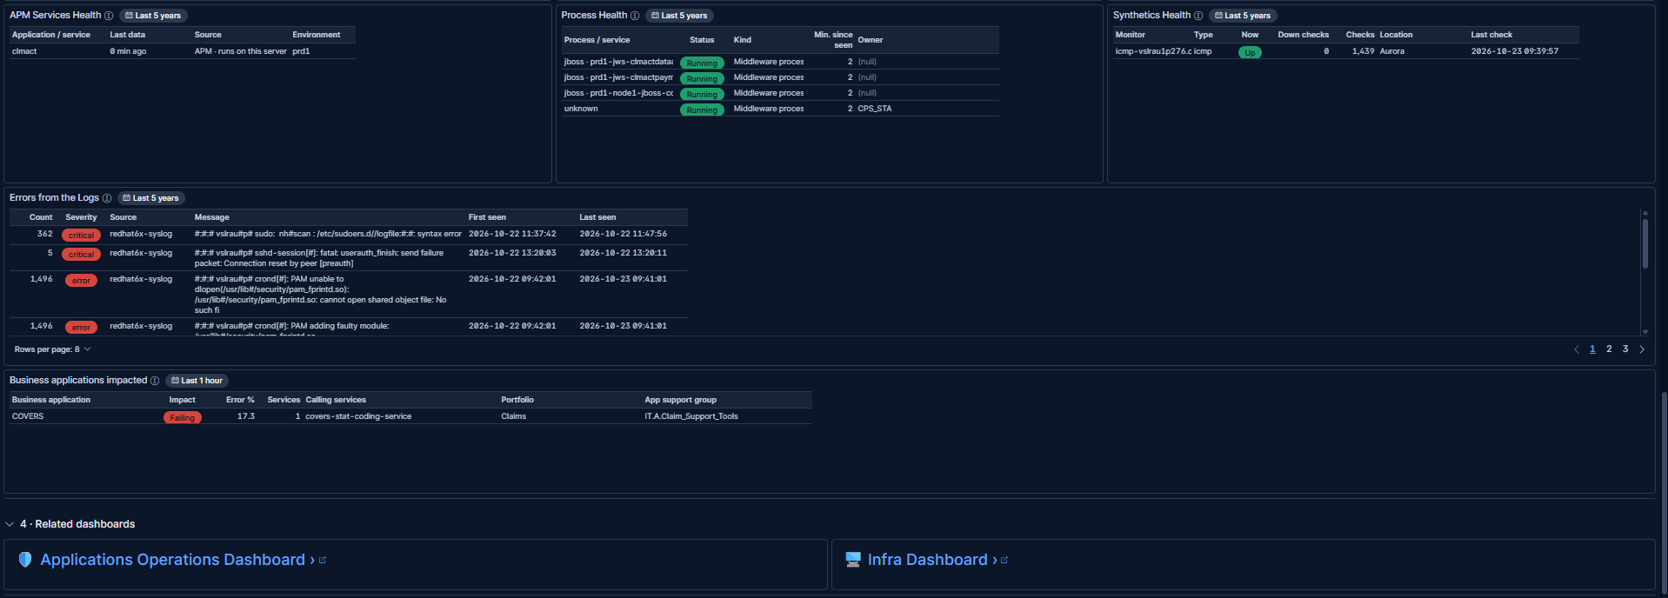
APM Services Health, Process Health, Synthetics Health, Errors from the Logs, Business applications impacted, Related dashboards
Check | Result
APM Services Health: clmact, data 0 min ago, APM · runs on this server, prd1 | Pass
Process Health: 4 JBoss / middleware processes, all Running | Pass
Synthetics Health: 1 ping monitor, Up, 1,439 checks, 0 down | Pass
Errors from the Logs: critical sudo / sshd errors and recurring PAM errors on vslrau1p276 | Pass
Business applications impacted: COVERS, Failing, 17.3 % error, 1 service, caller covers-stat-coding-service | Pass (see observation below)

- Errors from the Logs and Business applications impacted both point at the same thing from different angles: covers-stat-coding-service is failing when it calls this CI, and COVERS (its business application) is the one to tell.

Outcome
- The CI resolves to a Healthy/Degraded reading and a named owner with nothing picked, because Application Health finds it through its CMDB business-application link and its own APM number — an application-service incident does not need a server pick to start the investigation.
- Picking the related server (vslrau1p276, found in Server View) and the CI's own APM service (clmact) fills in the server, middleware, process and dependency panels, confirming the TC-05 precedence path from the test-case catalog.
- Real finding: covers-stat-coding-service is failing when it calls this CI’s clmact service, and that traces back to the COVERS business application — the concrete next step for an on-call engineer.
- Escalate to Shrushti Yemle, then Richard O’Connell.

Observations to follow up
- The cluster that produced these screenshots is running an older copy of the dashboard: SLO Error Burn Rate and Business applications impacted both still appear, although both were removed from MIM V3.ndjson on 20 Oct (round 20q). Re-import the latest MIM V3.ndjson with overwrite and use More → Reset changes to pick up that change — after that, Business applications impacted will no longer be a panel to check in future walkthroughs (Downstream already names the same caller).
- The Application Health “Servers” column can show a Kubernetes pod name instead of a hostname. That value is never going to appear in the Server control’s list — the CMDB-linked server (vslrau1p276, found via Server View) is the one to actually pick.
- Escalate’s CI support group was blank for this CI — a ServiceNow data-quality gap, not a dashboard defect, but worth flagging to the team that owns CMDB data quality.

