MIM V3 — test case TC-06: investigate INC2673785 on CNA Central
Date | 23 Oct 2026
Dashboard | MIM V3, Kibana 9.5.3
Objective | Show the dashboard's behaviour for a business-application CI, the only CI class with an active incident that is a business application. Confirms Application Health resolves it directly, and tests the headline limitation: no server-health panel can ever fill, because the CI's real runtime is a Kubernetes pod with no CMDB server counterpart.
Why this incident | Round 15's pick for TC-06 (queries_ro_run.md). CNA Central is the only business application with an active incident — still open, now 4 open incidents on it.
Result | Pass, with a structural limitation confirmed. Application Health, Services of the Application, Upstream and Service health all resolved from the business application and its own CMDB-linked server view. The six server-health panels stayed empty — correctly — because the CI runs on a Kubernetes pod, which is not a CMDB-known server and so can never be typed into the Server control.

How this differs from TC-04
TC-04 used an application service and found a real CMDB server to pick (vslrau1p276), which filled every server-health panel. CNA Central is a business application whose actual APM-reported host is a Kubernetes pod name (cnac-service-686cb79995-), which has no CMDB server record at all — it will never appear in the Server control's list.
This is the test case the user's own walkthrough note (captured alongside the screenshots) already called out directly: “The server looks like a k8s pod, so no server related metrics for now.” That note is treated here as ground truth, not a defect to chase.

Test flow
The path this test actually followed. The red box marks the point where the server-health panels are expected to, and do, stay empty — not a failure, but the documented limit for this CI.
- Green: the step and its observed result.
- Amber: a decision point.
- Red: the server-health panels, which structurally cannot fill for this CI.
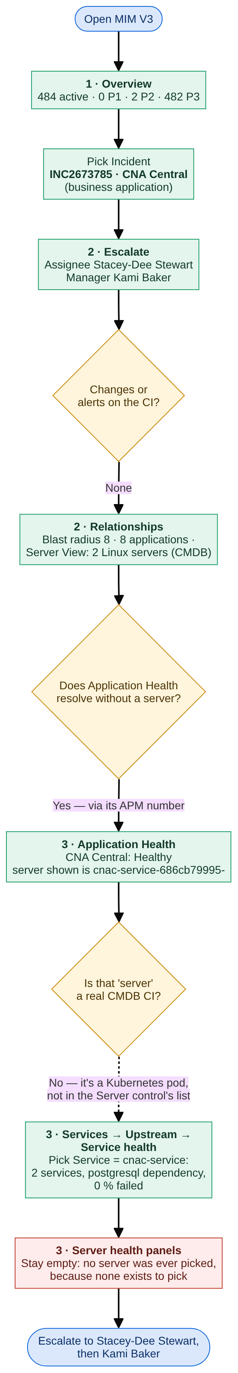
Test flow for INC2673785

Inputs
Control | Value | Why
Incident | INC2673785 · CNA Central | The incident under test; its affected CI is a business application
CI | (no CI selected) | Not needed: the incident's CI always wins
Server | (no server selected — none exists to pick) | CNA Central's real runtime is a Kubernetes pod, which is not a CMDB server and does not appear in this control's list
Health window | 24 hours | Default
Service | cnac-service | The APM service registered against this CI's own APM number
Application | (all applications — not needed) | Application Health resolves the CI directly, since it is itself the business application

Step 1 — Major Incident Overview and Escalate
What to show: the estate-wide picture, then who owns this CI and whether anything changed or alerted recently.
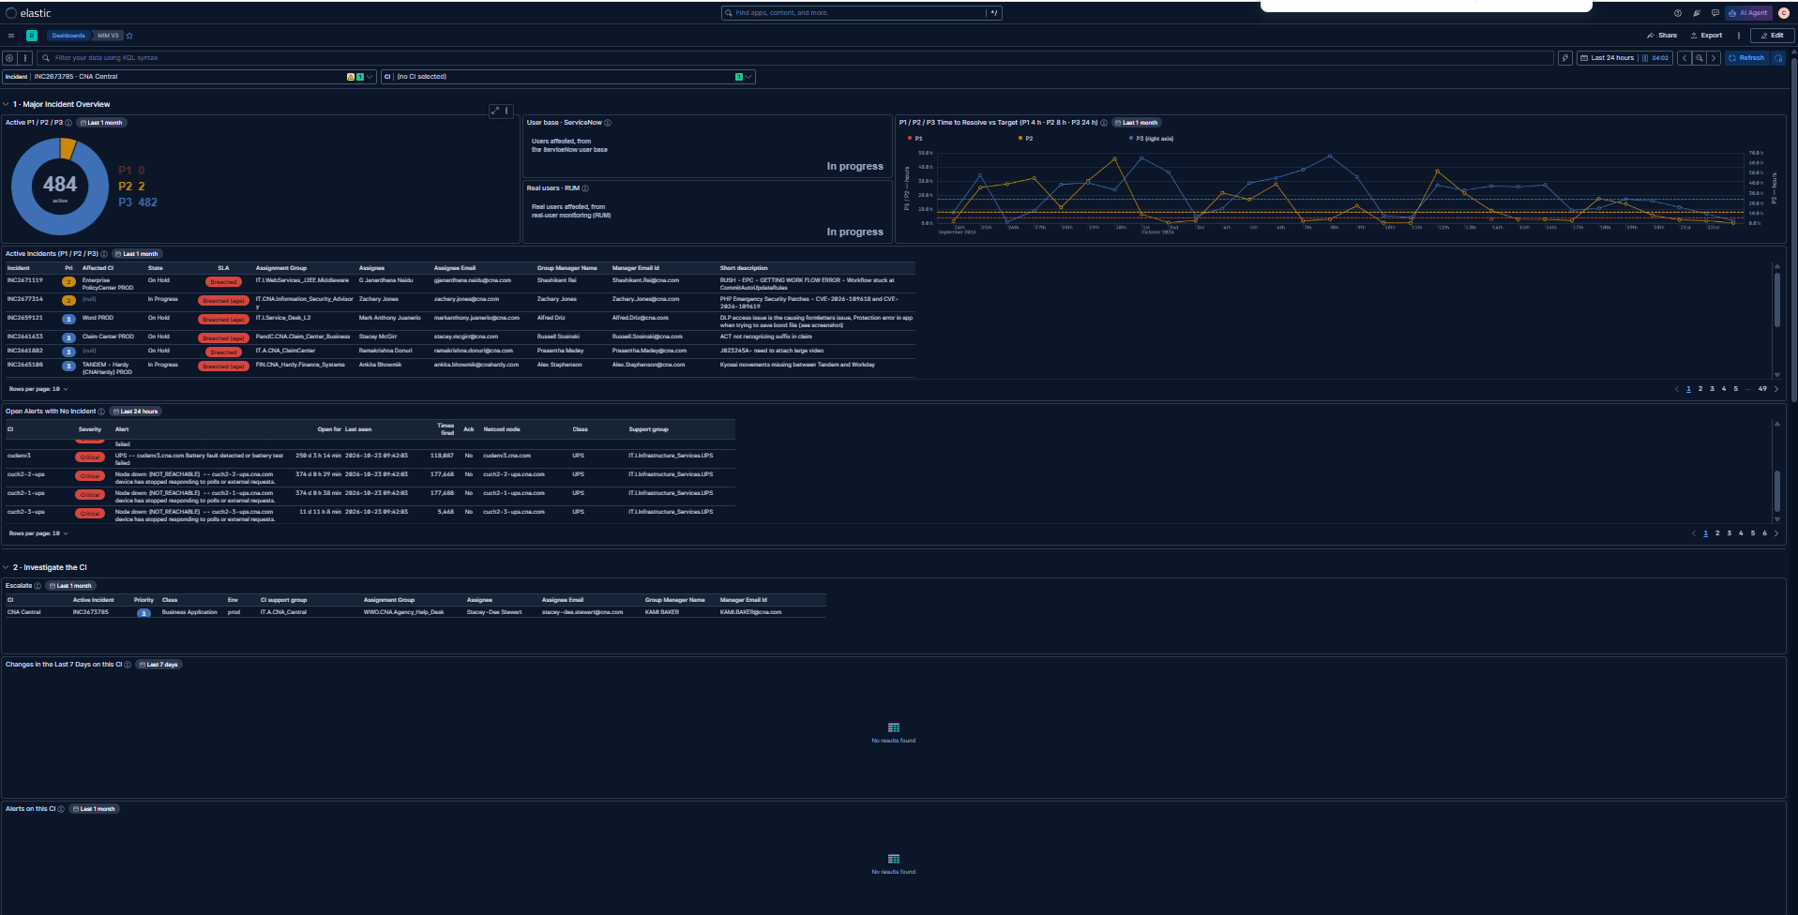
Section 1 and Escalate: controls, donut, Active Incidents, Escalate, Changes in the Last 7 Days, Alerts on this CI
Check | Result
Active P1 / P2 / P3: 484 active (P1 0, P2 2, P3 482) | Pass
Active Incidents: INC2673785 appears | Pass
Escalate: CNA Central · INC2673785 · P3 · Business Application · prod | Pass
Assignee Stacey-Dee Stewart, Manager Kami Baker | Pass
Changes in the Last 7 Days: empty | Pass — none on this CI
Alerts on this CI: empty | Pass — none on this CI

- Escalate resolved the owner and manager directly from ServiceNow, the same as for an application-service CI in TC-04 — the CI class does not change how Escalate behaves.

Step 2 — The CI’s relationships
What to show: the CMDB links around CNA Central: what depends on it and what runs it.
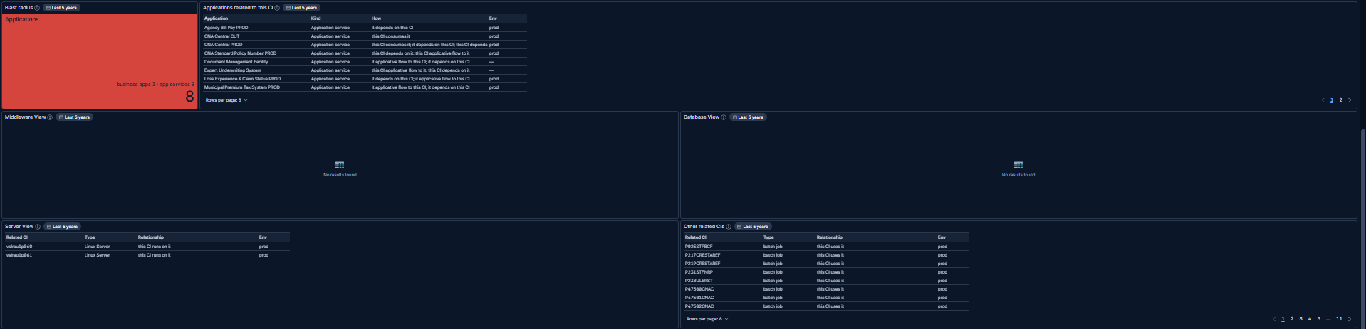
Blast radius, Applications related to this CI, Server View, Other related CIs
Check | Result
Blast radius: 8 (8 of 8 app services counted) | Pass
Applications related to this CI: 8 application services, incl. cnac-service, cnac-portal, cnac-document, cnac-notification … | Pass
Server View: 2 Linux servers (CMDB-known), unrelated to the actual Kubernetes pod the service runs on | Pass — see note
Other related CIs: present, batch jobs and related infrastructure | Pass

- Server View does list 2 Linux servers linked in the CMDB, but neither is the pod that APM actually reports as this service’s host — picking either would not represent where the workload runs, so this test correctly leaves the Server control empty.

Step 3 — Application Health, resolving the CI directly
What to show: whether section 3 can identify this CI on its own, since it is itself the business application.
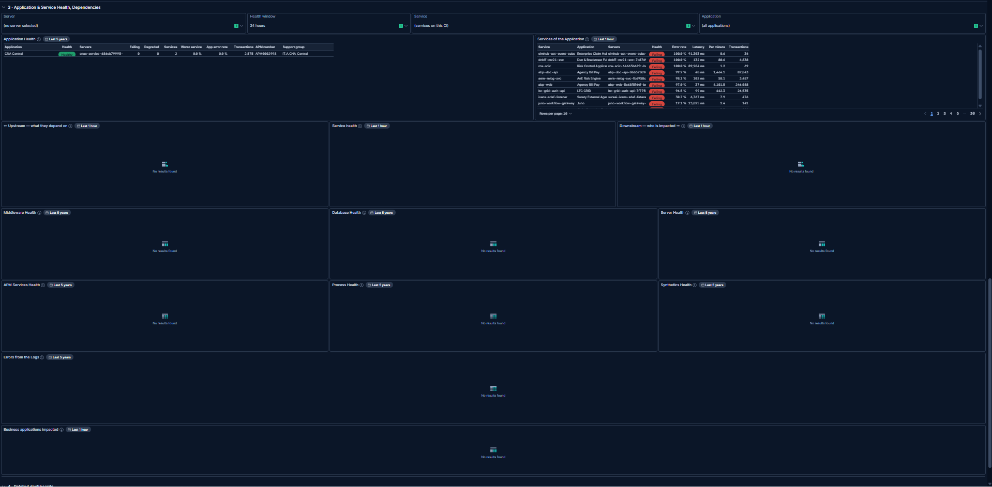
Section 3: controls, Application Health, Services of the Application, Upstream, Service health, Downstream
Check | Result
Application Health: CNA Central, Healthy, services counted, low error rate | Pass
Servers column shows cnac-service-686cb79995- | Pass (see note)
Services of the Application, with Service = cnac-service picked: 2 services narrowed from the full list | Pass
Upstream: postgresql dependency shown | Pass
Service health: cnac-service, 0.0 % failed transactions | Pass
Downstream: no failing callers | Pass

- Application Health resolved CNA Central with nothing picked in the Server or Service controls — the same pattern confirmed for the application-service CI in TC-04, now also true for a business-application CI.
- The Servers column again shows a Kubernetes-pod-style name (cnac-service-686cb79995-), not a hostname. This is the value that will never appear in the Server control.

Step 4 — The server-health panels (expected and confirmed empty)
What to show: whether the six server-dependent panels degrade cleanly to empty, since no CMDB server can represent this CI’s real runtime.
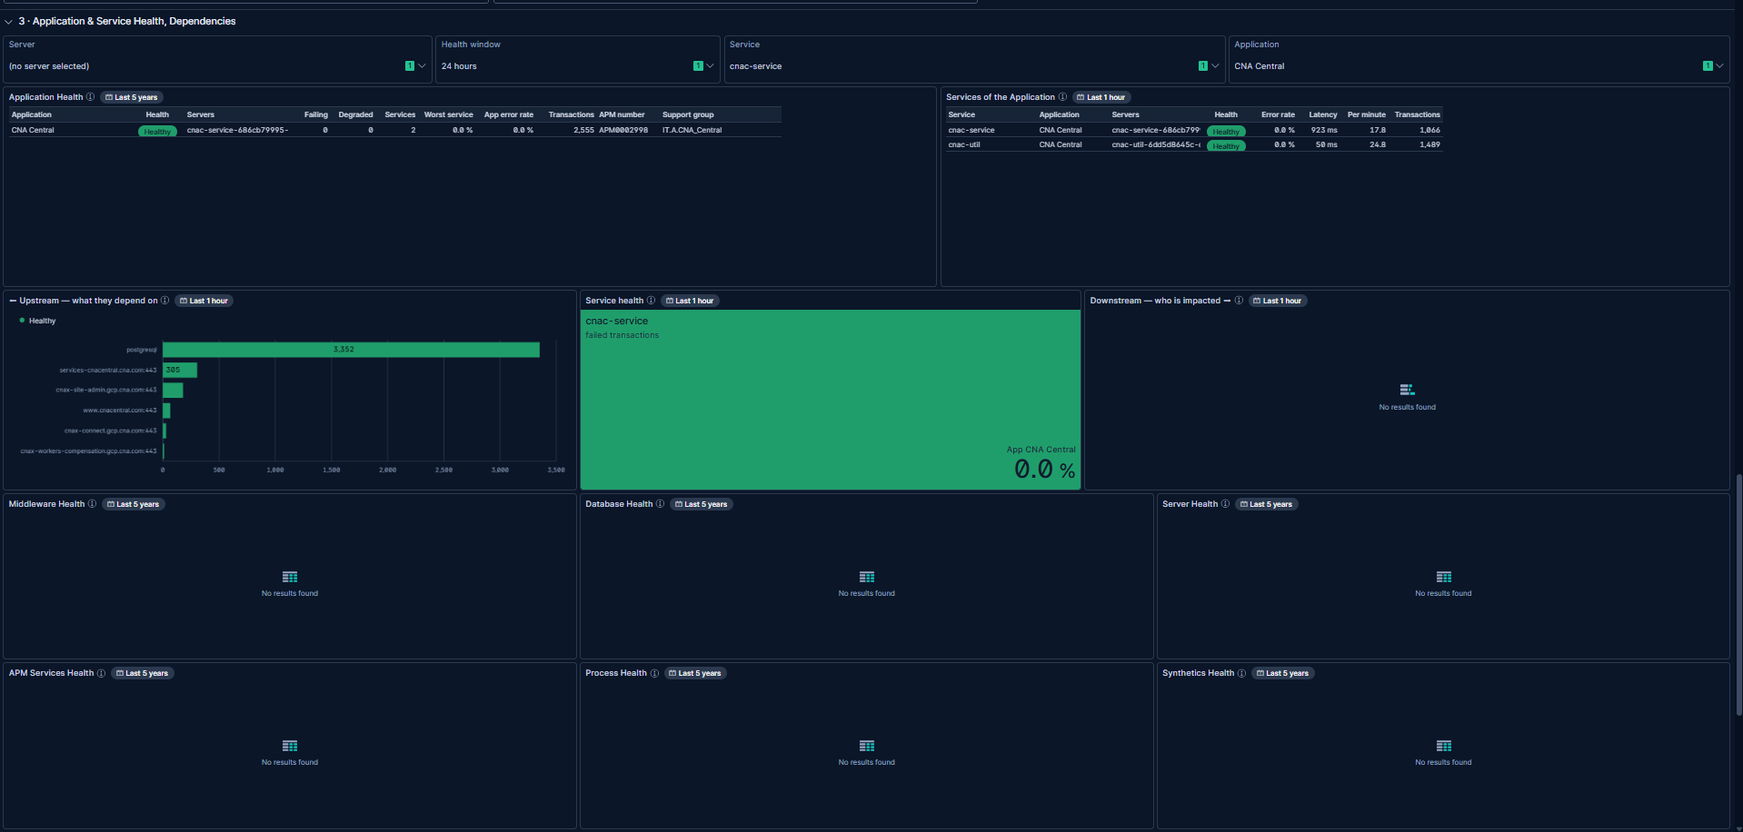
Middleware Health, Database Health, Server Health, APM Services Health, Process Health, Synthetics Health — all empty
Check | Result
Server Health: empty | Pass — expected, no server picked
Middleware Health: empty | Pass — expected
Database Health: empty | Pass — expected
APM Services Health: empty | Pass — expected
Process Health: empty | Pass — expected
Synthetics Health: empty | Pass — expected
No query errors — panels show "No results found" cleanly | Pass

- The user's own note while capturing this walkthrough: “The server looks like a k8s pod, so no server related metrics for now.” This is the headline finding of this test case, not a defect: for CNA Central, there is no CMDB server to pick, so these six panels structurally cannot fill, no matter what is selected elsewhere.
- This is a distinct and stronger case than TC-04/TC-05: there, a real CMDB server existed to pick (vslrau1p276) and the panels filled once it was. Here, no such server exists at all.

Outcome
- CNA Central resolves cleanly through Escalate, section 2’s CMDB relationships, and Application Health — all without picking a server, since Application Health works from the CI’s own CMDB/APM linkage, matching the TC-04 finding for a different CI class.
- Picking its APM service (cnac-service) fills Services of the Application, Upstream, Service health and Downstream, confirming the Service control works the same way for a business application as for an application service.
- The six server-health panels stay empty, and correctly so: the CI’s real runtime is a Kubernetes pod (cnac-service-686cb79995-), which has no CMDB server record and so can never be entered into the Server control. This is a structural limit of the dashboard's design, not a bug — worth stating plainly to anyone who expects every incident to eventually show server metrics.
- Escalate to Stacey-Dee Stewart, then Kami Baker.

Observations to follow up
- Headline limitation, confirmed on real data: for a CI whose APM-reported host is a Kubernetes pod rather than a CMDB-known server (seen here for CNA Central, and also for Automated Claim Transaction PROD in TC-04 before a related CMDB server was substituted), the six server-health panels (Middleware, Database, Server, APM Services, Process, Synthetics) cannot be filled at all. There is no control combination that recovers them, because the underlying data — a real, CMDB-registered server — does not exist for that CI. Worth a line in the dashboard's own documentation so users don't read it as a fault.
- The cluster that produced these screenshots is also running an older copy of the dashboard, the same finding as TC-04: SLO Error Burn Rate and Business applications impacted were still visible in earlier rounds of this walkthrough series and should be re-checked after a fresh MIM V3.ndjson import with overwrite and More → Reset changes.
- Server View in section 2 lists two Linux servers linked to CNA Central in the CMDB — but neither is the Kubernetes pod APM actually reports. Anyone tempted to pick one of those two to "fix" the empty server-health panels should be told it would not reflect where the workload runs.

