# CSWD Lab: HTML and CSS Revision Exercises

# Exercise 2

Unzip ex2Start.zip

1. Open Clients.html, examine the html, and add the appropriate CSS to layout the page like the following screenshot.
2. Styles should be added to the external CSS file – Style.css
   1. Use CSS to set an appropriate maximum height and/ or width for the client images
   2. Display the clients horizontally, three per row
   3. Apply appropriate borders, padding, and margins to the clients
   4. Format and align text.
   5. Format the client hyperlinks to match the screenshot:

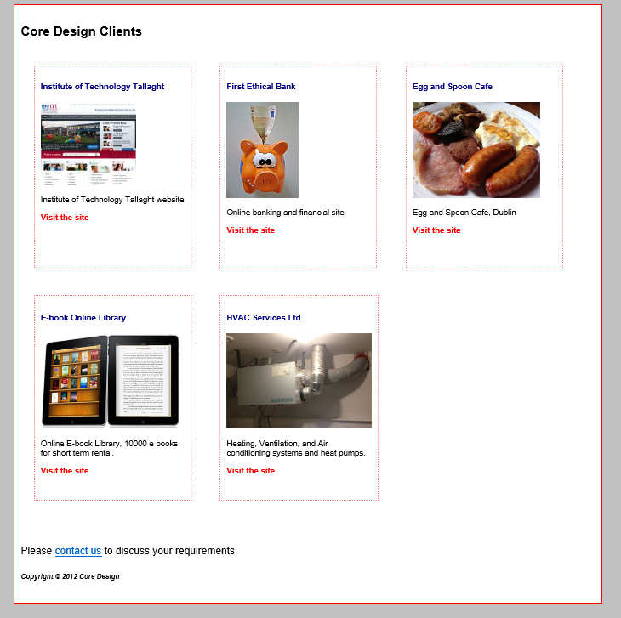

## Exercise 3

Unzip ex3Start.zip

Modify index.html (and style.css) so that it appears like the following screenshot in a web browser:

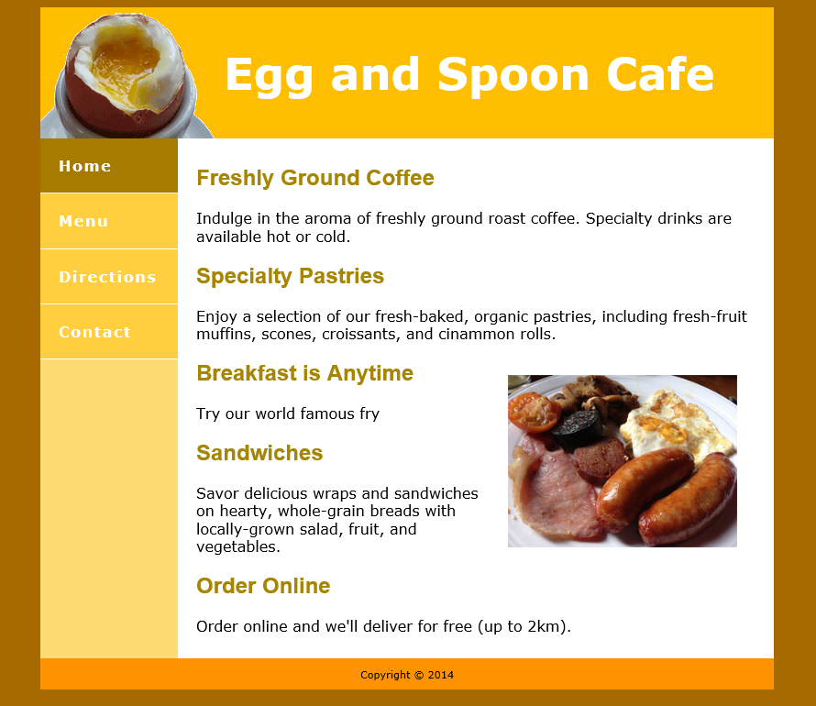

1. Styles should be added to the external CSS file – Style.css
   1. Position each page section (see div elements) correctly. Container should be centred in the browser window.
   2. Use CSS to format and display the navigation list as above (The Home link shows a:hover state)
   3. Format and position the header text.
   4. Format, position, and align content text as above.
   5. Use inline css to position the breakfast image.