**Transition Metal Chalcogenide: A Promising Material For The Photocatalytic Evolution Of Hydrogen**

In recent years, environmental sustainability and clean energy have become two of the most related issues that have garnered attention[1,2]. This is so because energy drives the social development and economy of every developed society, which in turn causes an increasing demand in the consumption of fossil fuels, since most of the currently used energy sources are reliant on them [2–4]. As of 2016, about 79.5% energy economy was thought to be reliant on conventional fossil energy sources like natural gases, coal, and petroleum which are non-renewable and environmentally benign, while 20.5% of global energy consumption is from renewable energy sources[5]. The energy demand has not reduced. Instead, it has been projected to increase from 16 Terawatt (TW) reported in 2010 to about 30 TW in 2050[6]. This implies that if sustainable energy sources are not developed, more fossil fuels will be used up, despite the rapid depletion of these resources and the accompanying generation of environmentally harmful greenhouse gasses like carbon dioxide, which cause global warming and many other environmental hazards[3,7]. There is thus a dire need to develop clean and renewable alternative energy that can be sustainable for a long time and resolve associated problems. Nature already offers many renewable energy sources such as solar, tidal, wind, and biomass [8]. Their intermittent availability, however, limits the ability to harness these energy sources when needed due to factors related to location and seasonal changes[8]. Hence, there is a need for efficient storage and conversion of generated energy that can efficiently generate and utilize these renewable energy sources on a larger scale. This need has birthed many innovative energy conversion and storage systems in recent years, such as hydrogen production from water splitting through electrolysis, fuel cells that use hydrogen to generate electricity, and metal-air batteries[9]. Due to the expensive nature and the need for a large facility area, the battery-based energy storage system has been found to be challenging to store excess electricity for large-scale production. Thus, there is a need for an alternative storage system, especially for energy sources that produce an excess amount of electricity like wind and large-scale solar.

Energy generated from the sun has been identified as the most abundant energy resource[8]. Converting this renewable energy has proven to be a promising strategy that can enable the sustainable use of its energy[8]. A notable example is the solar cell, which are limited by their inability to store excess electricity on a larger scale[8,10–12]. Thus, storing excess electrical energy in the form of chemical bonds such as hydrogen via, for instance, water splitting, has emerged as a promising strategy that can adequately cater to the problem of excess energy storage. This is so because hydrogen, due to its high energy density of about 143 kJ g−1, can store greater energy per unit weight or volume and, in turn, provide uninterrupted energy storage[8,13]. When in need, this stored electrical energy can be regenerated by fuel cells with a low level of pollution[8,13].

Hydrogen has been reported to be the cleanest energy carrier generated from renewable sources[14]. Its usage has been explored in fuel-cell electric vehicles and combustion engines[15]. The demand for hydrogen is expected to rise significantly in the short and long term [16]. Although hydrogen is the most common atom on earth, its gaseous form is not naturally occurring in our environment and thus must be produced. It is expected that its production will cost more in the near future than pumping up oil or other forms of fossil fuels[16]. Many methods are currently being explored for hydrogen evolution, including biofuels, fossil fuels, and water splitting. Currently, most of the hydrogen produced on a larger scale is mainly made from fossil fuels which involve pyrolysis of natural gases, reformation of methane, vaporization of coal, and oxidation of heavy oils[13]. The large consumption of these fossil fuels, in turn, results in a large generation of carbon dioxide gas, which is the primary cause of increased global temperature and adverse environmental problems worldwide [7]. On the other hand, hydrogen generation from biological sources via processes such as pyrolysis of biomass, photosynthetic bacteria breakage of organic matter, and fermentation of organic matter has proven to be a viable alternative with little harmful environmental consequences. Nevertheless, its large-scale usage is costly [17,18].

Water splitting has thus emerged as an eco-friendly approach that uses water as the source to produce hydrogen and oxygen. Depending upon the resource used, hydrogen and oxygen from split water can be produced via thermochemical, electrochemical, and photochemical processes [19]. Both thermochemical and electrochemical have several significant advantages[20–22]. However, these processes require other energy sources, which makes them not entirely eco-friendly [20–22]. It has been reported that for a thermochemical process, a large production scale is more suited to minimize energy losses brought about by high temperatures or multiple chemical reactions and auxiliary processes [21]. Water splitting through solar-generated electricity has been reported to be a more efficient technology; however, the conversion of solar to electricity efficiency is the major limitation[21]. Likewise, the efficiency of the solar-to-hydrogen has been reported to be significantly limited by the wavelength range of the photocatalysts and photoelectrodes in the photochemical and photoelectrochemical processes. Thus, photon-absorbing materials like photocatalysts play a significant role in determining hydrogen production efficiency. Studies showed that the band gap of such materials must exceed the bottom theoretical limit of 1.23 eV to split water molecules[21,22]. This review thus focuses solely on the photochemical process that does not involve using any electrodes.

The desire to produce hydrogen from water through green energy sources like solar light has increased interest in using photocatalytic water splitting[22]. However, the solar energy source is characterized by low density[22]. Hence a large surface area is needed to harvest this energy reasonably[21]. The evolution of hydrogen from water-splitting since using TiO2 single crystal electrodes in a photoelectrochemistry process has become a hot topic in research since the first report in 1972 [23]. The photoelectrocatalytic method is frequently used for its efficiency. Nevertheless, it requires an additional bias voltage to suppress the recombination of the photogenerated carriers [13]. In this review, the need for an additional energy source is beyond the scope of this report. As already established in literature, if an electrode is not needed in a photochemical process, the word “photocatalytic” indicates a setup that proceeds by a reaction mechanism that does not need electric potential to break the bond between oxygen and hydrogen[21]. The photocatalytic hydrogen evolution route has been identified as the most straightforward route for water splitting, which can produce a large scale of hydrogen at a very low cost[13].

The photocatalysis route uses energy from solar to split water into hydrogen via a two-electron or four-electron process. This process is eco-friendly and does not require extra energy. Many research findings have used noble metal or non-noble metal-based materials as photocatalysts. Noble metal-based photocatalysts have been extensively used due to their effectiveness as redox co-catalyst and because they generally possess excellent physicochemical properties, high catalytic activities, and electrical properties. In recent years, attention is now being shifted to the non-noble metal catalyst due to the low abundance and expensive nature of noble metals, limiting their application in water splitting reactions[24,25]. Moreover, the non-noble metal photocatalysts have also been reported to possess good efficiency because they are cheap, exhibit good stability, and do not become deactivated under certain conditions, unlike noble metal catalysts like platinum-based photocatalyst, which becomes deactivated in halide solutions[13]. With the above merit in mind, this review focuses mainly on photocatalytic hydrogen evolution via water splitting using Transition metal chalcogenide as a non-noble metal photocatalyst.

Numerous semiconductor materials are currently being explored as potential photocatalysts for water splitting and they have been categorized based on their composition as metal chalcogenides, metal oxide, and metal-free photocatalysts[26]. Since the emergence of TiO2 as an electrode for the solar-driven process of water splitting by Fujishima and Honda, due to the large yield of hydrogen gas produced, a wide array such as CuS, CdS, ZnO, C3N4, MoS2, and BiVO4, have been used in solar-driven photocatalytic splitting of water[27–34]. Even though significant progress has been made to date, these materials are still faced with some challenges such as, (i) many semiconductors photocatalyst like metal oxides have been found to only absorb ultraviolet light because of their wide band gap; (ii) due to improper band positions, some semiconductors materials are not suitable for overall water splitting because they only favor either oxidation or reduction activity (undergo a rapid co-existence of the electron-hole pair which brings about inefficiency in the charge separation); (iii) charge recombination occurs easily in their bulk and on the surface of the photocatalyst during the migration of photogenerated charge carries to the reactive sites on the surface which thus make them unsuitable for the photocatalytic process [27,34,35].

Therefore, new photoctalytic materials are needed to efficiently carry out the desired activity without the listed deficiencies to circumvent these concerns. The desire for novel materials has thus brought about much research into developing photoactive materials such as two-dimensional (2D) materials. The 2D materials represent an emerging class of thin materials with a sheet-like structure, whose thickness is typically less than 5 nm[36]. The first discovered material in this regime was graphene, which was found in 2004. It possesses a single layer of carbon material with excellent thermal, mechanical, and electrical properties[36]. Many other notable graphene-like 2D materials have been reported as photocatalysts since this discovery, with outstanding chemical and physical properties different from their bulk counterpart[34]. Transition metal chalcogenide belongs to this class of 2D materials that have shown great potential as a photocatalyst in various research areas due to their very useful intrinsic properties [26]. In conjunction with other semiconductor catalysts, they facilitate the charge transfer of the photogenerated electrons and holes[26]. Furthermore, they possess varying compositions with different lattice structures with unique electronic structures, which makes them a promising agent in energy applications [37,38], such as photocatalysis, electrochemical catalysis, metal-air batteries, and other energy conversion reactions. Due to their many defects sites[37,38], morphologies, and tunable electronic structures, transition metal chalcogenides have been found to increase the efficiency of the water splitting process[39]. However, they are not without disadvantages such as, low activity, poor conductivity and stability, which has limited their application in water splitting for large-scale industrial applications[39]. In this review, attention is given to photocatalytic water splitting processes based on transition metal chalcogenide photocatalysts. The numerous methods available for the synthesis of these materials will be explored, followed by the efficiency displayed in water spliting proceses. Attempt will also be made to identify the limitations of these materials and the proces being explored in circumventing them. we thus seek to explore in concise form some notable methods used in preparing these materials and the usefulness and limitation associated with their application as a promising photocatalytic agent in hydrogen gas evolution.

**2. Fundamentals of Hydrogen evolution from water splitting by photocatalysis**

The consideration of hydrogen as an ideal future energy carrier birthed the need for its production from water. However, its production from water requires a very high Gibbs free energy, as shown in equation 1, which is thermodynamically challenging to achieve [40].

 (1)

Although other methods have been used to produce hydrogen, these methods are associated with several unwanted environmental concerns. The photocatalysis route has thus emerged as an alternative platform for hydrogen evolution from water splitting because the raw material is cheap and abundant, and the process is also facile and environmentally benigh. . The combustion of hydrogen in air also produces H2O, thus makingthe whole process non-polluting and cyclical. The photocatalytic process proceeds in the presence of light, as seen in equation 2:

 (2)

The use of photocatalysts emerged due to the report by Honda and Fujishima[insert reference]. They showed the possibility of water splitting using a photoelectrochemical, which consists of a Pt cathode under ultraviolet (UV) light, an anode made from a single-crystalline TiO2 (rutile), and an external bias[41]. Their findings aroused the interest in using photoelectrochemical cells for water splitting. Nevertheless, the lack of appropriate photo-electrode materials with suitable band gaps and stability made the process complicated and difficult to use for maximum efficiency [42–44]. The continued interest during these early times birthed the use of particulate photocatalysts in a reaction pathway similar to photosynthesis [45–47]. The use of particulate photocatalysts has now been found more suited for large-scale productions than the more complex multilayer or tandem structure devices[47]. However, the simultaneous separation and collection of H2 and O2 are still being developed.

**2.1 Fundamental principles of Photocatalytic Water Splitting**

The fundamental principles behind the overall process of using a semiconductor material as a photocatalyst in water splitting are illustrated in Figure 1. Electrons from the valence band (VB) of the photocatalyst are excited by light radiation into the conduction band (CB), which in turn leaves holes in the VB. These excited electrons in the CB and the holes in the VB possess the capacity to reduce H+ to H2 and oxidize H2O to O2, respectively. However, to realize these, the negativity of the reduction potential of H+/H2 must be lesser than the bottom of the conduction band of the photocatalyst (0 V vs normal hydrogen electrode at pH = 0)[34]. In comparison, the positivity of the top of the phootocatalyst’s valence bands must be higher than the oxidation potential of H2O to O2 (1.23 V vs normal hydrogen electrode)[40]. Thus, for water to be split by a photocatalyst, the band gap energy of the semiconductor material must exceed the free energy (1.23 eV) of water splitting[34], and overpotentials from resistance and the slow reaction within the system can, however, increase the band gap[26]. The equation summarizing the reaction process is presented in Equation 3, which shows that the holes react with water molecules to give hydrogen ions, which react with the electrons to produce hydrogen. This reaction progresses in a 2:1 stoichiometry ratio[48].

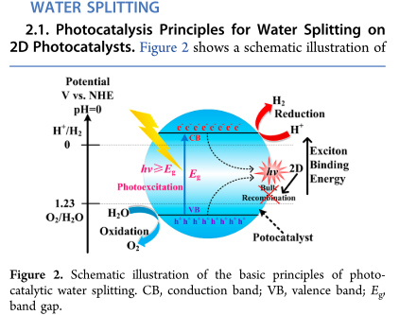

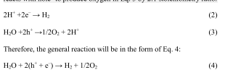

Overall, the hydrogen evolution through water splitting reaction on a semiconductor photocatalyst proceeds with the following steps summarized in figure 2[40].

* Photon energy from a light source greater than the band gap energy of the semiconductor is absorbed which in turn generates electron-hole pairs
* The electron-hole pairs generated by excitation process separate with minimum recombination and then migrate to the surface of the catalyst
* On the various reaction sites, the adsorbed water molecules are oxidized and reduced by the migrated holes and electrons to give O2 and H2, respectively.

Thus, the structural, morphological, and electronical properties of the photocatalyst play a key part in the proper functioning of the first and second phases. Furthermore, the stability of the photocatalyst is essential in other to prevent the backward recombination reaction of O2 and H2; Other fundamental conditions guiding the principles of the photocatalytic splitting of water includes increased surface area which in turn increases the absorption of water on the surface of the catalyst leading to enhanced reaction of photo excited electron-holes with the substrates. However, increased surface area often leads to the emergence of defects on the surface of the catalyst and these defects have been reported to be the site for electron-hole recombination. Consequently, this thus implies that as the surface area increases, the reaction gets faster and the lesser the possibility for recombination[40]. Therefore, to achieve a optimum performance from a photocatalyst, optimum crystallinity and surface area are required.

Despite the year of research and the continued interest in the design of photocatalysts, there remains a significant gap in developing a material that will be very efficient and robust enough for practical solar fuel production[49]. This is so because most of the available photocatalysts to date only function in the ultraviolet (UV) or near UV regime, which limits their application because of some related factors such as the mismatch between the band gap of the semiconductor and the solar spectrum, instability brought about by degradation of the semiconductor materials and inefficient charge separation and transportation[49]. Furthermore, the inadequate charge separation often leads to recombination of the generated electron-hole pair on their way to the surface of the catalyst, which in turn lower efficiency[34]. Thus, there is a need to shorten the distance of the charge transfer and increase the portion of the exposed surface to separate the electron−hole pairs effectively. This phenomenon has been adequately addressed in 2D materials like transition metal chalcogenides due to their ultra-thin nature[34].

**3. Two-Dimensional (2D) Materials**

Generally, the change from three-dimensional (3D) to two-dimensional (2D) materials has been found to bring about an increase in the band gap due to the effect of quantum confinement, which causes a blue shift in the optical absorption of 2D photocatalysts[50]. These materials represent an emerging class of materials with a sheet-like structure whose thickness is comparable to a single or few atoms[36]. These two-dimensional materials exhibit different chemical and physical properties than their bulk counterparts. Two-dimensional materials are characterized by a weak Van der Waal force, and strong plane bonds with highly specific surface area and exotic electronic properties have been produced by layered materials[51]. Thus, these materials possess unique chemical, physical and structural properties which have aroused many interests in using them as promising photocatalysts. The advantages of using 2D materials include the possibility of band gap and light absorption adjustments through tuning the number of layers [52,53]; the reduction of the recombination of holes and electron because of the ultra-thin nature [54,55]; and the improvement of the specific surface area of semiconductors by exposing most of the active sites on the surface of the catalyst to the photocatalytic process[56].

Many two-dimensional materials with a few layers or single-layer structures have been applied as a photocatalyst in recent years. These include graphene-based materials, 2D chalcogenides, 2D graphitic carbon nitride (g-C3N4), 2D oxides, and other 2D semiconductors. The bandgaps alongside the thickness of some of the 2D photocatalysts material in this class have been summarized in Figure 4.

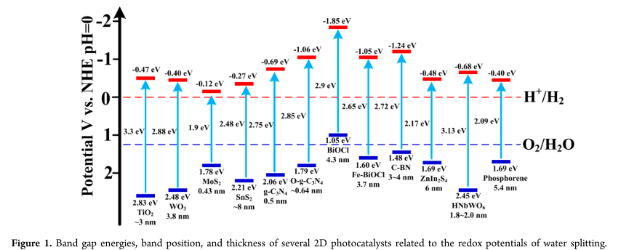

Among the class of two-dimensional materials that possess photo-responsive properties, two-dimensional (2D) chalcogenide materials have emerged as one of the most useful in recent times[57–62]. This class of materials represents a promising class of material with a layered structure similar to clay structure.

**3.1 Metal Chalcogenide**

The properties and the cost of materials play a crucial role in determining their choice of application. Many organic and inorganic materials have been extensively investigated for their application in renewable energy[63]. A prominent member of this class of semiconducting materials is the metal chalcogenides (sulfide, selenide, and telluride), which have recently received increased attention due to their fascinating optical, thermal, chemical, electrical, and mechanical properties. In addition, they possess low band gaps, diverse crystal structures, can be easily deposited in an ambient condition, possess the possibilities for band gap engineering, and possess an optimal combination of decent conversion efficiency [64]. These materials comprise of at least one more electro-positive element and at least one chalcogen anion. Although the word chalcogenide includes all elements in group 16, its usage in material science is more synonymous with sulfides, selenides, and tellurides, except oxides[65]. Notable metal chalcogenides semiconductors that have been extensively studied are shown in table 1.[63]

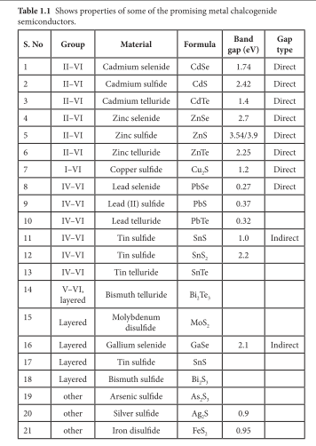

Some metal chalcogenides belonging to the class of the two-dimensional material shown in Table 1 have been reported to adequately possess properties that innately circumvent the gapless feature of graphene while facilitating the absorption of light, which favors their application in photodetection[66]. Thus according to the involved elements, they are categorized as main group metal chalcogenides (MMCs) and transition metal chalcogenides (TMCs)[66].

**3.2 Transition metal chalcogenides**

Transition metal chalcogenides have recently garnered much attention due to their availability and earth abundance. In this class of materials, zinc sulfide (ZnS) and cadmium sulfide (CdS) has been of interest in many research applications, with band gaps of 3.6 and 2.4 eV, respectively [67–70]. The band gap of CdS makes a choice of light-harvesting material amongst its counterpart. In contrast, ZnS possess a poorly visible light absorbability, even though it is inert in a corrosive environment and possesses an optimum band structure [71]. Cadmium sulfide is thermodynamically suitable for most photocatalytic processes due to its CB and VB positions. However, the separation and transfer of photogenerated electron-hole pairs in the material make it inefficiently susceptible to photocorrosion [71]. Many photocatalytic materials of transition metal chalcogenides origin have been studied and these include the binary and ternary forms and their nitride, carbides, and phosphides composites. In this review, however, the focus is mainly on the transition metal monochalcogenides. Other reports on the groups mentioned above have been extensively studied and reviewed in the literature[26,36,48,72–76].

Transition metal chalcogenide with planar structures has been studied widely for photocatalytic application due to their 2-dimensional planar nanostructures and larger surface area, making their active sites readily available for catalytic redox reactions on the surface with the absorbed species [77–79]. Compared to their bulk, at the surface of their two-dimensional nanostructures, they possess different atomic arrangements, which may be due to their structural disordering and surface atomic elongation that is perhaps responsible for the charge transfer processes at the interface of their defect density[80,81]. Furthermore, they have improved photocatalytic reaction kinetics due to the promotion of charge migration which leads to a reduced interfacial charge transfer resistance[82]. Another significant advantage is that one particular facet with distinct atomic arrangement is dominantly exposed in the 2D planar configuration, favoring the separation of the photogenerated charged pair and the subsequent utilization of the photon[71]. Several studies have reported the influence of thickness and lateral dimensions on the band position and energies of some 2D TMCs[83–87]. In most cases, there is either a shift in the CB edge towards the H2 reduction potential or the VB edge towards the O2 oxidation potential or both happening simultaneously[85]. In addition, the distinctive 2D layered structure of the TMCs has been identified to possess the potential to induce some optical characteristics, such as the plasmonic effect, which can likely increase their absorption range in the solar spectrum[88,89].

A notable subset has received much attention as a two-dimensional material due to its structure-dependent bandgap and the indirect to direct bandgap transition on thinning to their monolayer and a band gap of 1.0 to 2.1 eV is the transition metal dichalcogenides (TMDs) [77]. This is a class of metal chalcogenides with the formula MX2 (where X represents chalcogens = S, Se, Te and M represent transition metals = Mo, W, Ti, Zr, Hf, Nb, etc.). Besides the TMDs, other notable transition metal chalcogenides have found applications as promising optoelectronic candidates. These include those with the formula MX, MX2, and M2X3 (where M = Ga, In, Ge, Sn; X=S, Se, Te). However, this current review is limited to the application of transition metal dichalcogenides (TMDs) as a photocatalyst for hydrogen evolution in water splitting [63].

**3.3 Transition Metal Dichalcogenides**

Transition metal dichalcogenides belong to the class of two-dimensional chalcogenides that possess a layered structure, as illustrated in figure 2, which depending on the thickness of the material, may have one or more atoms[62,90–92]. The side view of the monolayer presented in figure 2a shows a three-atom stick monolayer. The aerial view in Figure 2b shows the sheet-like morphology of the monolayer while The lateral view shows a few stack monolayers in figure 2c [26].

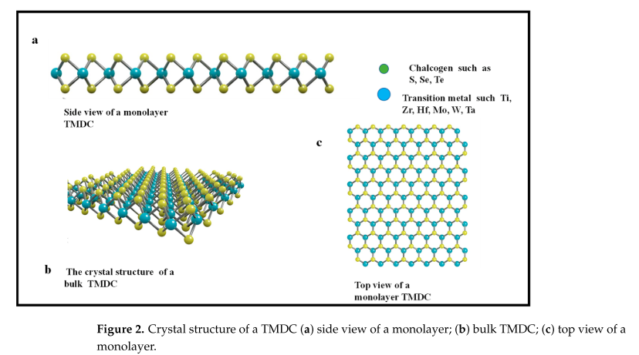

The interest in this material emerged due to the exfoliation of a single-layered carbon material of graphene. The many valuable properties of graphene, including thermal, mechanical, and electrical, gave rise to interest in other monolayered materials like TMDs. However, unlike graphene, which is made up of only one atom, TMDs are made up of layers of transition metal atom, which includes elements such as Mo, Hf, Ta, Zr, Ti embedded between two atoms of chalcogens in a three-atom thick system [62,92]. Weak Van Der Waals forces and covalent bonds have been identified as the existing forces between the layers. This material possesses an excellent electronic property with large specific surface areas [90,92]. Their monolayer or few layered forms exhibit some excellent characteristics, making them a choice material of interest in many research applications such as catalysis. Transition metal dichalcogenides have several notable advantages as excellent catalysts in hydrogen evolution due to their high photosensitivity and appropriate bandgap within the needed range for water splitting. In addition, their photogenerated carriers recombine slowly compared to other common photocatalysts, and their large surface area provides room for many active sites during photocatalysis[34,93,94]. Although this class of material is very useful with many advantages, they are limited in their application due to high exciton energy, which lowers the efficiency of the photocatalytic process. Also, the propensity for oxidation in aqueous solutions and ambient conditions usually results in photo corrosion or flocculation. Although recombination is not severe compared to their bulk, it is an accompanied occurrence in their usage as photocatalyst process. They also do not have enough reduction and oxidation potential to complete the water splitting process [58,60,91].

These drawbacks have, in turn, birthed the use of different synthetic methods and approach to circumvent the respective limitations. These methods/approaches include metal doping, non-metal doping, defect inducement, and semiconductor or metal junction formation [27,34,95,96]. The approach of heterojunction fabrication have been found to be exceptionally promising because of the simplicity of the facile process which do not require the use of toxic oxidizing or reducing agents, or even strong acids which are commonly used in modifying semiconductor catalyst with graphene or metals[97]. The proper fabrication of a two-dimensional transition metal dichalcogenides thus entails appropriate alignment of the catalyst and the promoters (TMDs), which is referred to as energy band engineering [26]. This avenue favourably provides a platform for the simple design and upgrade of both the optoelectronics and electronic features.

Surface properties of bulk TMCs have been effectively modified by elemental doping for efficient light harvesting and to enhance redox activities[98]. These dopants may be metal or non-metal elements [98]. When dopping is carried out using non-metal elements, the band gap of the material is generally narrowed because of the orbital overlap between the dopant element and chalcogenide atoms[99]. Some studies have also suggested that the narrowing of the band gap may have resulted from the contribution of the formation of localized states within the bandgap by the dopant [100]. Meaning that the electron generated by photon energy can be excited from the dopant gap state to the CB of the material instead of the VB edge of the semiconducting material as seen in Figure 6.

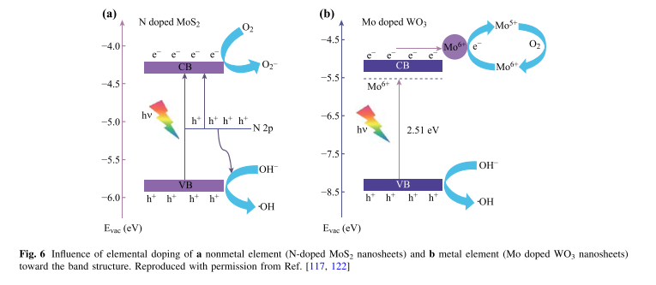[71]

On the other hand, some properties such as the valence state and ionic radius of the host metal cation, play a major role in determining the occupied sites and electronic characteristics of the dopant in metal doping [71]. These dopants may influence the position of the Fermi level, surface properties and also conductivity within the matrix[101]. Nevertheless, the dopant’s interaction with the host lattice often bring about the emergence of a new energy levels which may be beyond or within the bandgap of TMCs [101]. Hence, the photon absorption end can experience a red shift via the electronic transitions from the VB and/or to the CB as shown in Figure 6. In appropriate concentrations, both metal and non-metal dopant can facilitate charge separation by acting as a deep trap site for one type of charge carrier, and then allowing the other reach the desired redox reaction surface of the material[98].

Heterojunction formation using semiconductor/semiconductor material represents another significant architectural improvement for the photocatalytic performance of TMDs[49]. The fast recombination of photogenerated charge carriers in many individuals 2D TMDs have limited their light-harvesting potential. Hence, fabricating a 2D TMDs-based heterojunction with an appropriate semiconductor has been found to adequately address this drawback [71]. The use of a semiconductor with matching CB and VB energetic levels of the 2D TMDs can effectively mitigate recombination by producing a suitable pathway for the photogenerated charge carriers from one another[71]. The most prominent of the approaches used in heterojunction is the Type II band presented in Figure 4, which involves the transfer of photogenerated electrons from a more positive to the less positive CB edge one, while photogenerated holes move from the more negative edge to the less negative VB. This phenomenon leads the spatial charge carrier separation[102]. However, this process depends on factors like crystallinity and defect density, which can appreciably influence the coupling efficiency by altering the band structures of the materials [98]. In addition, the size and dimensionality of the coupled semiconductor materials may play a major role in the hetero-interfacial contacts [103]. Specifically, 2D-2D heterostructures have been found to possess better stability and coupling heterointerfaces because of the short exciton diffusion length and the large contact surface in the contact that makes the transfer and separation of photoexcited pairs easier compared to the 2D/low dimensional counterpart[103]. Nonetheless, not many studies have been done on the 2D-2D semiconducting heterojunctions with type II band alignment [71].

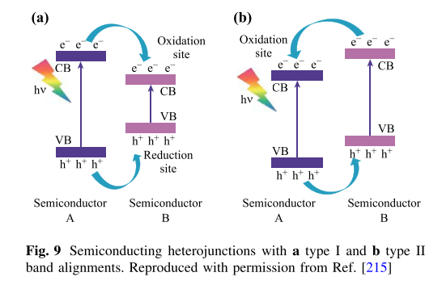

**3.4 Synthesis of Transition metal dichalcogenides (TMDs)**

Generally, the transition metal dichalcogenides have been found to possess three layers: the middle layer of the transition metal atoms sandwiched between the top and bottom layers of chalcogenide atoms[104]. When thinned from their bulk to monolayer, these materials, such as MoS2, WS2, MoSe2, and WSe2, change their bandgap from indirect to direct bandgap[105–107]. They possess bandgap energy between 1 and 2 eV [108–110]. This material favors the type two heterojunction because of band alignment[108,110,111]. Their monolayer can absorb up to 10% of the incident light, similar to the strong light interaction materials[112]. The monolayer of the transition metal dichalcogenides possesses two equivalent valleys at the corner of a Brillouin zone due to inversion symmetry breaking [113]. The inequivalent valleys and the strong spin-orbit both lead to valley-dependent optical selection rule and spin-valley locking [114]. These aforementioned properties have led to the extensive synthesis, studies, and applications of this material in optical devices, electronics, catalysis, energy harvesting, and sensor devices.

Currently, different methods have been used in the preparation of single or few layered two-dimensional transition metal dichalcogenides, such as mechanical exfoliation[104,115], chemical vapor deposition[116,117], solvothermal processes[9,118,119], and chemical [11,12,120,121]and liquid phase exfoliation[122–124]. This methods have been categorized into top down and the bottom up approaches. In the top-down approach, the layered nanomaterials is obtained from the bulk crystals through different exfoliation ways, while in the bottom up, individual atoms and molecules are, under certain conditions, are built up into the layered nanomaterials [125].

**3.4.1 Mechanical Cleavage**

This method of monolayer preparation involves using adhesive tape to separate a single from the few-layer structure of the bulk material. It is the most used top-down approach in synthesizing many ultrathin two-dimensional TMDs [126–128]. Monolayer TMDs produce via this methods have been found to have several advantages, such as very useful intrinsic physicochemical properties and highly crystalline nanosheets with large size and few defects, which makes them useful in the design of electronic devices. Nevertheless, they are also plagued by disadvantages, such as a lack of control in size and thickness and a low production rate. Furthermore, a substrate is needed to support the nanosheet. In a very high demanding application, this method of preparation is not sufficient to meet the need [129]. Examples of the monolayer TMDs materials isolated using this technique include MoS2 and NbSe2[130]. TMDs of Group IVB nanomaterial that easily decomposes in air and becomes oxidized have been prepared using the mechanical exfoliation methods carried out in a glove box and a vacuum chamber for immediate passivation with protective encapsulation layers[131–133]. Few layers of HfS2 have been fabricated by Chae et al. using a SiO2/Si as a substrate in a vacuum cluster system to avoid oxidation [131]. Similarly, a few layers of HfS2 have been prepared from its bulk crystals using scotch tape and SiO2/Si/Al2O3 as a substrate. The small piece collected on the tap was then cleaved several times to give a thin film of average size of thickness[134].

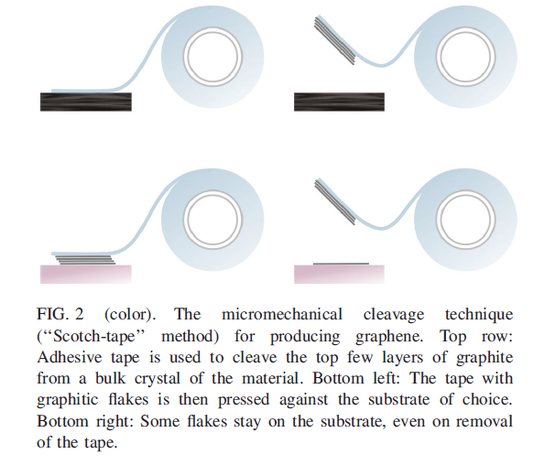[135]

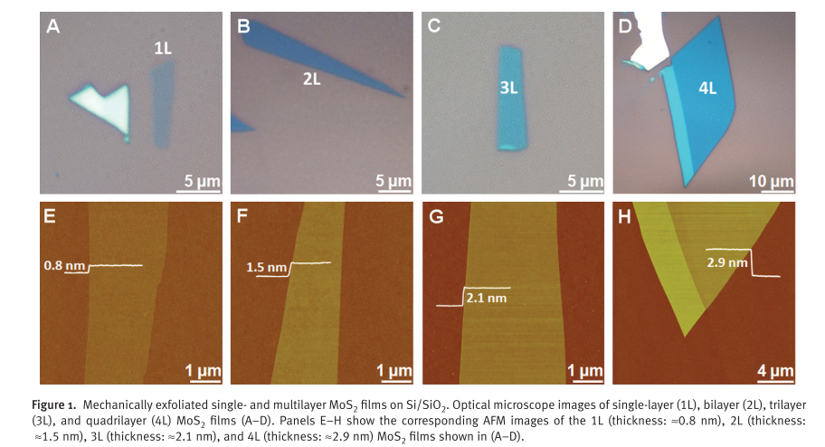[136]

**3.4.2 Liquid Exfoliation**

This is another top-down approach that involves exfoliation of the bulk via ultrasonication in certain solvents [137–139]. This sonication breaks the weak Van der Waal forces between the atoms. However, the intercalation is not strong enough to break the covalent bonds in-plane. Hence, for successful exfoliation, ultrasonic intensity and time are essential. The solvent in this system helps stabilize and prevent the reassemblage of the exfoliated nanosheets [124]. Through the van der Waals interaction, the molecules of the solvent carrying the appropriate energy bind to the surface of the sheets, which in turn helps the exfoliation efficiency because of their matching surface free energy. The currently used solvent includes N-methyl-pyrrolidone (NMP) and dimethylformamide (DMF) which are mainly organic solvents [140]. Their intrinsic properties are crucial for breaking the cohesive forces exiting between the layered material [26]. Experimental conditions such as sonication time, the mass of the starting bulk, the nature of the solvent, and the sonication conditions play a role in the thickness, size, and laterality of the produced monolayer, as observed by Coleman et al. [122]. In this report involving the preparation of MoS2 monolayer, an increase in the sonication time led to the production of a material with a small lateral size and broad size distribution [122]. The method of exfoliation makes up for some deficiencies in the mechanical exfoliation approach in terms of the large-scale preparation of ultrathin two-dimensional transition metal dichalcogenides with good photo-electrical properties. The disadvantage here is that most of the used solvents are highly undesirable, and very difficult to produce a single-layered material using this method. This, in turn, has led to using volatile and aqueous solvents. However, it has been found that all suitable solvents for liquid exfoliation of MoS2 must be about 40 mJm−2 [122]. When water was used as a dispersing solvent, the nanomaterial became oxidized [122] beacsue traces of water was left on the materials. This has been reported to oxidize group IVB TMDs materials via hydrolysis, resulting to production of metal oxides (MOx) [131,141–144]. Several ultrathin two-dimensional TMDs material have be prepared using the liquid exfoliation approach such as NbSe2, TaSe2, and NiTe2[122], WS2 [123], and MoS2 [138].

Another notable form of liquid exfoliation in the use of ion intercalation such as those used in lithium intercalation process or ultrasound-promoted hydration, which allows for the exfoliation of layers in a liquid [145]. This approach inlvoves the submergence of a bulk material powder into solution that contains lithium like n-butyllithium ifr several days so as to allow the intercallation of lithium ion into the bulk layers. This material is then exposed to water which then produces hydrogen gas on reaction with the embeded lithium ions within the layer and in turn causes exfoliation of the layers [121,137]. This approach has been reported to submicrometre-sized monolayers at an appraciable amount [146]. However, the physicochemical properties such as structure and electrica properties differs significantly from the bulk. Specifically, in the case of MoS2 the semiconducting properties changes to a metallic properties while the Mo coordination changes to octahedral (1T-MoS2) from prismatic (2H-MoS2). Nevertheless, on annealing at 300 oC the semiconduction properties and the MoS2 phase can be reverted their initial state. Lithium-based exfoliation have been employed for several TMDs such as SnS2, WS2, MoS2 and MoSe2 [147,148].

Other lithiation methods have been developed but anotbale one that makes use of an electrochemical cell using lithium foil anode and TMDC-containing cathode have been reported as an alternative approach as shown in figure 7 [120,149]. In this approach, as the intercallation progresses, the galvanic discharge also occurs simiultaneously in the electrochemical cell which thus help the monitoring and in turn controls of the degree of lithiation. After this , the Li-intercalted material is put in water then ultrasonicated to give nanosheets of TMD monolayers. This approach has been used to prepare several TMDs such as graphene, ZrS2, TaS2, MoS2, TiS2, and WS2 [120]. They have also been used for other materials such as Bi2Te3, Sb2Se3, BN, NbSe2, and WSe2[149]. The edge this method has over the ordinrary lithium-compound based exfoliation is that it only reuires few hours compared to the several day requirement of the former.

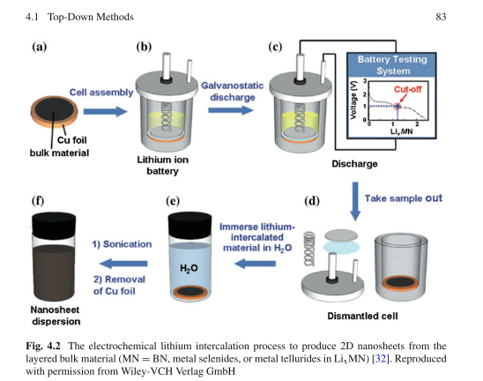[145]

**3.4.3 Chemical Vapor Deposition**

This is a well known bottom-top approach in which the reacting precursor compounds is exposed to the substrate in a very high tepertaure and pressure. In the method, the fuction of the precursors compound is to supply the chalcogenide and the transition metal atoms respectively, The reaction of these precursor compounds then results in the production of the ultrathin two-dimsensional TMDs as seen in figure 8[124]. This product of these reaction is then deposited on a substrate to give 2D TMDs [116,150–152]. Most ultrathin TMds produced through this method have been found to have high crystallinity and an excellent electronic property. However, this approach requires high temperature and a vaccum for the synthetic process to proceed. The Chemical vapour deposition (CVD) involve the thermal decomposition of the precursors. Although most of the mthods uses a subsrtae but the product can also be formed without having a substrate [26]. In this synthetic technique, inert gases like argon are usually introdiced into the system alongside hyderogen gas which helps to prevent the oxidation of the material and reduce impurities in the system as illusated in Figure 8 [30,60,153–156].

A prominent technique that has garnered attention is the chemical vapour transport (CVT). They have been studied for the synthesis of group IVB TMDCs than the chemcial deposition methods (CVD)[157–159]. This approach is mostly used for the bulk single crystal, and it involes the use of iodine as the transport gas. This process takes days to achieve aftewehich the monolayers or few layer of the 2D materials are exfoliated [160] The preparation of the ZrS2 nanoflakes have been achieved via this method. At first, ZrS3 was formed through the reaction of ZrCl4 and elemental sulphur. This reaction was carried out at different temperature and for 1h respectively. On heating the resulting ZrS3, it decomposes at a temperature of 800 ◦C with no traces of impurities to give ZrS2[160] [71]. In other report by Fu et al., with lillte adjustment, similar approach was used to synthesize HfS2 by using HfCl4 powder and elemental sulfur powder[30]. This two precursor materials were put at one end of the quartz tubing and then heated to a temperature which is below 200 oC, while placing the subsatrte at the hot zone at about 930 ◦C. heating of the system was simulatneously carried out some minutes and then stopped. With the aid of a mangnet, the unreacted precursors were removed after which the system was cooled down as shown in figure 9.

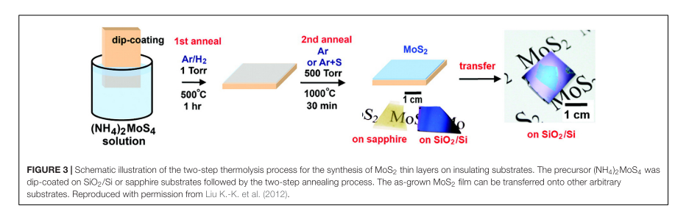

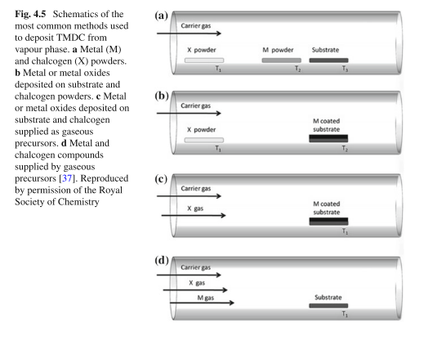[145]

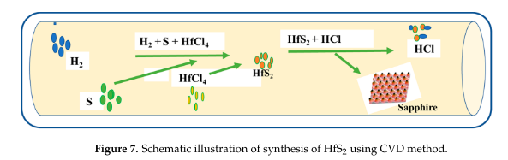

Solvo-Thermal Synthesis

Solvo-thermal synthesis is another bottom-up method. By solvo- thermal method, ultrathin 2D TMDCs could be obtained from precursors under the condition of specific solvent and specific reaction time (Peng et al., 2001a,b; Cao et al., 2014). The results show that after the reaction ofmolybdic acid or tungstic acid with thiourea at 773K for 3 h, the ultrathin MoS2 or WS2 nanosheets can be prepared. The strength of this method is that it could realize the high-yield preparation of ultrathin 2D TMDCs at a lower cost. Hence this method will be promising for industrial application of 2D TMDCs. The shortage of solvo-thermal synthesis is that single-layer nanosheet is difficult to be obtained.

Hydrothermal or solvothermal synthesis Hydrothermal or solvothermal method is a versatile and effective synthetic route to produce the nanomaterials with different array of morphologies. Hydrothermal synthesis is one of the most important methods for producing fine powders of metal oxides. The process entails the reactants being dissolved in a solvent, which is then introduced into an autoclave. If the solvent for the reaction is non-aqueous, it is referred as solvothermal; whereas, if the solvent for the reaction media is water, it is termed hydrothermal [101]. Teflon-lined autoclaves are used in this process; they are preferred over glass and quartz autoclaves, since they can tolerate high temperatures and pressures. Furthermore, they support alkaline solutions as well as are resistant to hydrofluoric acid. The flexibility of the method makes it easier to manipulate reaction parameters to produce nanomaterials with desired properties and quality. This method is very appropriate for production of products with different array of shapes in contrast with other methods. It has been extensively used for preparing metal oxide nanoparticles, chalcogenide and phosphide nanomaterials [102–104]. Chen and Fan [102] synthesized NiSe2, NiS2, CoS2, FeS2, MoSe2 and MoS2 using hydrothermal synthesis at a low temperature while varying the synthesis parameters. They found that adjusting the reaction variables could extend the method of synthesis to other products. The method is commonly used for the synthesis of group VIB TMDCs and their nano composites [34,105–109]. Huang et al. [105] synthesized MoS2 nanosheets with a net-like morphology of well linked nanoflakes, the nanoflower material had thickness of a few nanometres for use as capacitor electrode materials using hydrothermal process. The[26]

**References**

[1] S. Wang, A. Lu, C.J. Zhong, Hydrogen production from water electrolysis: role of catalysts, Nano Converg. 8 (2021). https://doi.org/10.1186/s40580-021-00254-x.

[2] S. Singh, S. Jain, V. Ps, A.K. Tiwari, M.R. Nouni, J.K. Pandey, S. Goel, Hydrogen: A sustainable fuel for future of the transport sector, Renew. Sustain. Energy Rev. 51 (2015) 623–633. https://doi.org/10.1016/j.rser.2015.06.040.

[3] M.A. Khan, H. Zhao, W. Zou, Z. Chen, W. Cao, J. Fang, J. Xu, L. Zhang, J. Zhang, Recent Progresses in Electrocatalysts for Water Electrolysis, Springer Singapore, 2018. https://doi.org/10.1007/s41918-018-0014-z.

[4] K. HASSMANN, H. KUHNE, Primary energy sources for hydrogen production, Int. J. Hydrogen Energy. 18 (1993) 635–640. https://doi.org/10.1016/0360-3199(93)90115-Q.

[5] J. Zhu, L. Hu, P. Zhao, L.Y.S. Lee, K.Y. Wong, Recent Advances in Electrocatalytic Hydrogen Evolution Using Nanoparticles, Chem. Rev. 120 (2020) 851–918. https://doi.org/10.1021/acs.chemrev.9b00248.

[6] N.S. Lewis, D.G. Nocera, Powering the planet: Chemical challenges in solar energy utilization, Proc. Natl. Acad. Sci. U. S. A. 103 (2006) 15729–15735. https://doi.org/10.1073/pnas.0603395103.

[7] K.C. Majhi, M. Yadav, Transition metal chalcogenides based nanocomposites as efficient electrocatalyst for hydrogen evolution reaction over the entire pH range, Int. J. Hydrogen Energy. 45 (2020) 24219–24231. https://doi.org/10.1016/j.ijhydene.2020.06.230.

[8] J. Song, C. Wei, Z.F. Huang, C. Liu, L. Zeng, X. Wang, Z.J. Xu, A review on fundamentals for designing oxygen evolution electrocatalysts, Chem. Soc. Rev. 49 (2020) 2196–2214. https://doi.org/10.1039/c9cs00607a.

[9] N.T. Suen, S.F. Hung, Q. Quan, N. Zhang, Y.J. Xu, H.M. Chen, Electrocatalysis for the oxygen evolution reaction: Recent development and future perspectives, Chem. Soc. Rev. 46 (2017) 337–365. https://doi.org/10.1039/c6cs00328a.

[10] T.J. Meyer, The art of splitting water, Nature. 451 (2008) 778–779. https://doi.org/10.1038/451778a.

[11] A. Shatskiy, M.D. Kärkäs, B. Åkermark, The Art of Splitting Water: Storing Energy in a Readily Available and Convenient Form, Eur. J. Inorg. Chem. 2019 (2019) 2020–2024. https://doi.org/10.1002/ejic.201801548.

[12] S. Chu, A. Majumdar, Opportunities and challenges for a sustainable energy future, Nature. 488 (2012) 294–303. https://doi.org/10.1038/nature11475.

[13] W. Zhao, Z. Chen, X. Yang, X. Qian, C. Liu, D. Zhou, T. Sun, M. Zhang, G. Wei, P.D. Dissanayake, Y.S. Ok, Recent advances in photocatalytic hydrogen evolution with high-performance catalysts without precious metals, Renew. Sustain. Energy Rev. 132 (2020) 110040. https://doi.org/10.1016/j.rser.2020.110040.

[14] M. Balat, Possible methods for hydrogen production, Energy Sources, Part A Recover. Util. Environ. Eff. 31 (2009) 39–50. https://doi.org/10.1080/15567030701468068.

[15] M.F. Demirbas, Hydrogen from various biomass species via pyrolysis and steam gasification processes, Energy Sources, Part A Recover. Util. Environ. Eff. 28 (2006) 245–252. https://doi.org/10.1080/009083190890003.

[16] M. Saxe, P. Alvfors, Advantages of integration with industry for electrolytic hydrogen production, Energy. 32 (2007) 42–50. https://doi.org/10.1016/j.energy.2006.01.021.

[17] N. Ren, G. Cao, A. Wang, D.J. Lee, W. Guo, Y. Zhu, Dark fermentation of xylose and glucose mix using isolated Thermoanaerobacterium ihermosaccharolyticum W16, Int. J. Hydrogen Energy. 33 (2008) 6124–6132. https://doi.org/10.1016/j.ijhydene.2008.07.107.

[18] W. Khetkorn, R.P. Rastogi, A. Incharoensakdi, P. Lindblad, D. Madamwar, A. Pandey, C. Larroche, Microalgal hydrogen production – A review, Bioresour. Technol. 243 (2017) 1194–1206. https://doi.org/10.1016/j.biortech.2017.07.085.

[19] C. Acar, I. Dincer, G.F. Naterer, Review of photocatalytic water-splitting methods for sustainable hydrogen production, Int. J. Energy Res. 40 (2016) 1449–1473. https://doi.org/10.1002/er.3549.

[20] K. Mistry, Jalja, R. Lakhani, B. Tripathi, S. Shinde, P. Chandra, Recent trends in MXene/Metal chalcogenides for electro-/photocatalytic hydrogen evolution reactions, Int. J. Hydrogen Energy. (2022). https://doi.org/10.1016/j.ijhydene.2022.02.049.

[21] Z. Wang, R.R. Roberts, G.F. Naterer, K.S. Gabriel, Comparison of thermochemical, electrolytic, photoelectrolytic and photochemical solar-to-hydrogen production technologies, Int. J. Hydrogen Energy. 37 (2012) 16287–16301. https://doi.org/10.1016/j.ijhydene.2012.03.057.

[22] A. Kudo, Photocatalysis and solar hydrogen production, Pure Appl. Chem. 79 (2007) 1917–1927. https://doi.org/10.1351/pac200779111917.

[23] A. FUJISHIMA, K. HONDA, Electrochemical Photolysis of Water at a Semiconductor Electrode, Nature. 238 (1972) 37–38. https://doi.org/10.1038/238037a0.

[24] S. Kahng, H. Yoo, J.H. Kim, Recent advances in earth-abundant photocatalyst materials for solar H2 production, Adv. Powder Technol. 31 (2020) 11–28. https://doi.org/10.1016/j.apt.2019.08.035.

[25] V. Pareek, A. Bhargava, R. Gupta, N. Jain, J. Panwar, Synthesis and Applications of Noble Metal Nanoparticles: A Review, Adv. Sci. Eng. Med. 9 (2017) 527–544. https://doi.org/10.1166/asem.2017.2027.

[26] P.O. Fadojutimi, S.S. Gqoba, Z.N. Tetana, J. Moma, Transition Metal Dichalcogenides [MX2] in Photocatalytic Water Splitting, Catalysts. 12 (2022). https://doi.org/10.3390/catal12050468.

[27] W. Peng, Y. Li, F. Zhang, G. Zhang, X. Fan, Roles of Two-Dimensional Transition Metal Dichalcogenides as Cocatalysts in Photocatalytic Hydrogen Evolution and Environmental Remediation, Ind. Eng. Chem. Res. 56 (2017) 4611–4626. https://doi.org/10.1021/acs.iecr.7b00371.

[28] N. Zhang, Y. Zhang, X. Pan, M.Q. Yang, Y.J. Xu, Constructing ternary CdS-graphene-TiO 2 hybrids on the flatland of graphene oxide with enhanced visible-light photoactivity for selective transformation, J. Phys. Chem. C. 116 (2012) 18023–18031. https://doi.org/10.1021/jp303503c.

[29] J. Du, M. Yang, F. Zhang, X. Cheng, H. Wu, H. Qin, Q. Jian, X. Lin, K. Li, D.J. Kang, Enhanced charge separation of CuS and CdS quantum-dot-cosensitized porous TiO2-based photoanodes for photoelectrochemical water splitting, Ceram. Int. 44 (2018) 3099–3106. https://doi.org/https://doi.org/10.1016/j.ceramint.2017.11.075.

[30] L. Fu, F. Wang, B. Wu, N. Wu, W. Huang, H. Wang, C. Jin, L. Zhuang, J. He, L. Fu, Y. Liu, Van der Waals Epitaxial Growth of Atomic Layered HfS2 Crystals for Ultrasensitive Near-Infrared Phototransistors, Adv. Mater. 29 (2017) 1700439. https://doi.org/https://doi.org/10.1002/adma.201700439.

[31] Y. Pihosh, I. Turkevych, K. Mawatari, J. Uemura, Y. Kazoe, S. Kosar, K. Makita, T. Sugaya, T. Matsui, D. Fujita, M. Tosa, M. Kondo, T. Kitamori, Photocatalytic generation of hydrogen by core-shell WO3/BiVO4 nanorods with ultimate water splitting efficiency, Sci. Rep. 5 (2015) 1–2. https://doi.org/10.1038/srep11141.

[32] S. Shanmugaratnam, S. Rasalingam, Transition Metal Chalcogenide (TMC) Nanocomposites for Environmental Remediation Application over Extended Solar Irradiation, Nanocatalysts. (2019) 1–22. https://doi.org/10.5772/intechopen.83628.

[33] D. Chaudhary, S. Singh, V.D. Vankar, N. Khare, ZnO nanoparticles decorated multi-walled carbon nanotubes for enhanced photocatalytic and photoelectrochemical water splitting, J. Photochem. Photobiol. A Chem. 351 (2018) 154–161. https://doi.org/10.1016/j.jphotochem.2017.10.018.

[34] T. Su, Q. Shao, Z. Qin, Z. Guo, Z. Wu, Role of Interfaces in Two-Dimensional Photocatalyst for Water Splitting, ACS Catal. 8 (2018) 2253–2276. https://doi.org/10.1021/acscatal.7b03437.

[35] J. Moma, J. Baloyi, Modified Titanium Dioxide for Photocatalytic Applications, in: Photocatal. - Appl. Attrib., IntechOpen, 2019: p. 13. https://doi.org/10.5772/intechopen.79374.

[36] C. Tan, X. Cao, X.J. Wu, Q. He, J. Yang, X. Zhang, J. Chen, W. Zhao, S. Han, G.H. Nam, M. Sindoro, H. Zhang, Recent Advances in Ultrathin Two-Dimensional Nanomaterials, Chem. Rev. 117 (2017) 6225–6331. https://doi.org/10.1021/acs.chemrev.6b00558.

[37] S. Chandrasekaran, L. Yao, L. Deng, C. Bowen, Y. Zhang, S. Chen, Z. Lin, F. Peng, P. Zhang, Recent advances in metal sulfides: from controlled fabrication to electrocatalytic, photocatalytic and photoelectrochemical water splitting and beyond, Chem. Soc. Rev. 48 (2019) 4178–4280. https://doi.org/10.1039/C8CS00664D.

[38] S. Anantharaj, S.R. Ede, K. Sakthikumar, K. Karthick, S. Mishra, S. Kundu, Recent Trends and Perspectives in Electrochemical Water Splitting with an Emphasis on Sulfide, Selenide, and Phosphide Catalysts of Fe, Co, and Ni: A Review, ACS Catal. 6 (2016) 8069–8097. https://doi.org/10.1021/acscatal.6b02479.

[39] J. Yin, J. Jin, H. Lin, Z. Yin, J. Li, M. Lu, L. Guo, P. Xi, Y. Tang, C.H. Yan, Optimized Metal Chalcogenides for Boosting Water Splitting, Adv. Sci. 7 (2020). https://doi.org/10.1002/advs.201903070.

[40] M.R. Pai, A.M. Banerjee, A.K. Tripathi, S.R. Bharadwaj, Fundamentals and Applications of the Photocatalytic Water Splitting Reaction, in: Funct. Mater., Elsevier, 2012: pp. 579–606. https://doi.org/10.1016/B978-0-12-385142-0.00014-3.

[41] A. Fujishima, K. Honda, Electrochemical photolysis of water at a semiconductor electrode, Nature. 238 (1972) 37–38.

[42] Y. Sakai, S. Sugahara, M. Matsumura, Y. Nakato, H. Tsubomura, Photoelectrochemical water splitting by tandem type and heterojunction amorphous silicon electrodes, Can. J. Chem. 66 (1988) 1853–1856. https://doi.org/10.1139/v88-299.

[43] O. Khaselev, J.A. Turner, A monolithic photovoltaic-photoelectrochemical device for hydrogen production via water splitting, Science (80-. ). 280 (1998) 425–427.

[44] S. Licht, B. Wang, S. Mukerji, T. Soga, M. Umeno, H. Tributsch, Efficient Solar Water Splitting, Exemplified by RuO 2 -Catalyzed AlGaAs/Si Photoelectrolysis, J. Phys. Chem. B. 104 (2000) 8920–8924. https://doi.org/10.1021/jp002083b.

[45] K. Domen, S. Naito, M. Soma, T. Onishi, K. Tamaru, Photocatalytic decomposition of water vapour on an NiO–SrTiO 3 catalyst, J. Chem. Soc. Chem. Commun. (1980) 543–544.

[46] S. Sato, J.M. White, Photodecomposition of Water over Pt/TiO2 Catalysts., TEXAS UNIV AT AUSTIN DEPT OF CHEMISTRY, 1980.

[47] A.J. Bard, M.A. Fox, Artificial Photosynthesis: Solar Splitting of Water to Hydrogen and Oxygen, Acc. Chem. Res. 28 (1995) 141–145. https://doi.org/10.1021/ar00051a007.

[48] A. Akhoondi, A. Sharma, D. Pathak, M. Yusuf, T.B. Demissie, R. Guo, A. Ali, Hydrogen evolution via noble metals based photocatalysts: A review, Synth. Sinter. 1 (2021) 223–241. https://doi.org/10.53063/synsint.2021.1468.

[49] Y. Qu, X. Duan, Progress, challenge and perspective of heterogeneous photocatalysts, Chem. Soc. Rev. 42 (2013) 2568–2580. https://doi.org/10.1039/c2cs35355e.

[50] J. Hu, Z. Guo, P.E. McWilliams, J.E. Darges, D.L. Druffel, A.M. Moran, S.C. Warren, Band Gap Engineering in a 2D Material for Solar-to-Chemical Energy Conversion, Nano Lett. 16 (2016) 74–79. https://doi.org/10.1021/acs.nanolett.5b02895.

[51] J. Low, S. Cao, J. Yu, S. Wageh, Two-dimensional layered composite photocatalysts, Chem. Commun. 50 (2014) 10768. https://doi.org/10.1039/C4CC02553A.

[52] S. Kouser, A. Thannikoth, U. Gupta, U. V Waghmare, C.N.R. Rao, 2D-GaS as a Photocatalyst for Water Splitting to Produce H2, Small. 11 (2015) 4723–4730. https://doi.org/https://doi.org/10.1002/smll.201501077.

[53] Q. Fan, J. Liu, Y. Yu, S. Zuo, B. Li, A simple fabrication for sulfur doped graphitic carbon nitride porous rods with excellent photocatalytic activity degrading RhB dye, Appl. Surf. Sci. 391 (2017) 360–368. https://doi.org/10.1016/j.apsusc.2016.04.055.

[54] P. Niu, L. Zhang, G. Liu, H.-M. Cheng, Graphene-Like Carbon Nitride Nanosheets for Improved Photocatalytic Activities, Adv. Funct. Mater. 22 (2012) 4763–4770. https://doi.org/https://doi.org/10.1002/adfm.201200922.

[55] X. She, L. Liu, H. Ji, Z. Mo, Y. Li, L. Huang, D. Du, H. Xu, H. Li, Template-free synthesis of 2D porous ultrathin nonmetal-doped g-C3N4 nanosheets with highly efficient photocatalytic H2 evolution from water under visible light, Appl. Catal. B Environ. 187 (2016) 144–153. https://doi.org/10.1016/j.apcatb.2015.12.046.

[56] Y. Sun, S. Gao, F. Lei, Y. Xie, Atomically-thin two-dimensional sheets for understanding active sites in catalysis, Chem. Soc. Rev. 44 (2015) 623–636. https://doi.org/10.1039/C4CS00236A.

[57] A.K. Samantara, S. Ratha, Metal oxides/chalcogenides and composites : emerging materials for electrochemical water splitting, 2019.

[58] A.A. Tedstone, D.J. Lewis, P. O’Brien, Synthesis, Properties, and Applications of Transition Metal-Doped Layered Transition Metal Dichalcogenides, Chem. Mater. 28 (2016) 1965–1974. https://doi.org/10.1021/acs.chemmater.6b00430.

[59] C.D. Layered, Well-De fi ned Colloidal 2 ‑ D Layered Transition-Metal Chalcogenide Nanocrystals via Generalized Synthetic Protocols, (2012) 1–4.

[60] C. Yan, L. Gan, X. Zhou, J. Guo, W. Huang, J. Huang, B. Jin, J. Xiong, T. Zhai, Y. Li, Space-Confined Chemical Vapor Deposition Synthesis of Ultrathin HfS2 Flakes for Optoelectronic Application, Adv. Funct. Mater. 27 (2017) 1702918. https://doi.org/https://doi.org/10.1002/adfm.201702918.

[61] Y. Shi, L.-J. Li, Synthesis of Transition Metal Dichalcogenides, in: 2D Mater., Cambridge University Press, 2017: pp. 344–358. https://doi.org/10.1017/9781316681619.020.

[62] C. Yan, C. Gong, P. Wangyang, J. Chu, K. Hu, C. Li, X. Wang, X. Du, T. Zhai, Y. Li, J. Xiong, 2D Group IVB Transition Metal Dichalcogenides, Adv. Funct. Mater. 28 (2018) 1803305. https://doi.org/https://doi.org/10.1002/adfm.201803305.

[63] M.N. Tahir, J.K. Sahoo, F. Hoshyargar, W. Tremel, Metal Chalcogenide Nanostructures for Renewable Energy Applications, John Wiley & Sons, Inc., Hoboken, NJ, USA, 2014. https://doi.org/10.1002/9781119008934.

[64] R.M. Harrison, S.J. De Mora, Chemistry of the elements, in: Introd. Chem. Environ. Sci., Cambridge University Press, 1996: pp. 148–209. https://doi.org/10.1017/CBO9780511809224.005.

[65] E. Roduner, Size matters: Why nanomaterials are different, Chem. Soc. Rev. 35 (2006) 583–592. https://doi.org/10.1039/b502142c.

[66] Z. Xiong, J. Tang, Two-dimensional materials and hybrid systems for photodetection, in: Synth. Model. Charact. 2D Mater. Their Heterostruct., Elsevier, 2020: pp. 325–349. https://doi.org/10.1016/B978-0-12-818475-2.00015-5.

[67] J.F. Reber, K. Meier, Photochemical production of hydrogen with zinc sulfide suspensions, J. Phys. Chem. 88 (1984) 5903–5913. https://doi.org/10.1021/j150668a032.

[68] M. Kanemoto, T. Shiragami, C. Pac, S. Yanagida, Semiconductor photocatalysis. 13. Effective photoreduction of carbon dioxide catalyzed by zinc sulfide quantum crystallites with low density of surface defects, J. Phys. Chem. 96 (1992) 3521–3526. https://doi.org/10.1021/j100187a062.

[69] H. Yin, Y. Wada, T. Kitamura, S. Yanagida, Photoreductive Dehalogenation of Halogenated Benzene Derivatives Using ZnS or CdS Nanocrystallites as Photocatalysts, Environ. Sci. Technol. 35 (2001) 227–231. https://doi.org/10.1021/es001114d.

[70] M. Sathish, B. Viswanathan, R.P. Viswanath, Alternate synthetic strategy for the preparation of CdS nanoparticles and its exploitation for water splitting, Int. J. Hydrogen Energy. 31 (2006) 891–898. https://doi.org/10.1016/j.ijhydene.2005.08.002.

[71] F. Haque, T. Daeneke, K. Kalantar-zadeh, J.Z. Ou, Two-Dimensional Transition Metal Oxide and Chalcogenide-Based Photocatalysts, Nano-Micro Lett. 10 (2018) 1–27. https://doi.org/10.1007/s40820-017-0176-y.

[72] Z. Hu, Z. Wu, C. Han, J. He, Z. Ni, W. Chen, Two-dimensional transition metal dichalcogenides: Interface and defect engineering, Chem. Soc. Rev. 47 (2018) 3100–3128. https://doi.org/10.1039/c8cs00024g.

[73] Y. Zhao, S. Wei, K. Pan, Z. Dong, B. Zhang, H.H. Wu, Q. Zhang, J. Lin, H. Pang, Self-supporting transition metal chalcogenides on metal substrates for catalytic water splitting, Chem. Eng. J. 421 (2021) 129645. https://doi.org/10.1016/j.cej.2021.129645.

[74] J.F. Callejas, J.M. McEnaney, C.G. Read, J.C. Crompton, A.J. Biacchi, E.J. Popczun, T.R. Gordon, N.S. Lewis, R.E. Schaak, Electrocatalytic and photocatalytic hydrogen production from acidic and neutral-pH aqueous solutions using iron phosphide nanoparticles, ACS Nano. 8 (2014) 11101–11107. https://doi.org/10.1021/nn5048553.

[75] Y.K. Kim, H. Park, Light-harvesting multi-walled carbon nanotubes and CdS hybrids: Application to photocatalytic hydrogen production from water, Energy Environ. Sci. 4 (2011) 685–694. https://doi.org/10.1039/c0ee00330a.

[76] J.S. Jang, D.J. Ham, N. Lakshminarasimhan, W. yong Choi, J.S. Lee, Role of platinum-like tungsten carbide as cocatalyst of CdS photocatalyst for hydrogen production under visible light irradiation, Appl. Catal. A Gen. 346 (2008) 149–154. https://doi.org/10.1016/j.apcata.2008.05.020.

[77] Q.H. Wang, K. Kalantar-Zadeh, A. Kis, J.N. Coleman, M.S. Strano, Electronics and optoelectronics of two-dimensional transition metal dichalcogenides, Nat. Nanotechnol. 7 (2012) 699–712. https://doi.org/10.1038/nnano.2012.193.

[78] K. Kalantar-zadeh, J.Z. Ou, T. Daeneke, M.S. Strano, M. Pumera, S.L. Gras, Two-Dimensional Transition Metal Dichalcogenides in Biosystems, Adv. Funct. Mater. 25 (2015) 5086–5099. https://doi.org/https://doi.org/10.1002/adfm.201500891.

[79] K. Kalantar-zadeh, J.Z. Ou, T. Daeneke, A. Mitchell, T. Sasaki, M.S. Fuhrer, Two dimensional and layered transition metal oxides, Appl. Mater. Today. 5 (2016) 73–89. https://doi.org/10.1016/j.apmt.2016.09.012.

[80] M. Nasilowski, B. Mahler, E. Lhuillier, S. Ithurria, B. Dubertret, Two-Dimensional Colloidal Nanocrystals, Chem. Rev. 116 (2016) 10934–10982. https://doi.org/10.1021/acs.chemrev.6b00164.

[81] Y. Sun, Z. Sun, S. Gao, H. Cheng, Q. Liu, F. Lei, S. Wei, Y. Xie, All-Surface-Atomic-Metal Chalcogenide Sheets for High-Efficiency Visible-Light Photoelectrochemical Water Splitting, Adv. Energy Mater. 4 (2014) 1300611. https://doi.org/https://doi.org/10.1002/aenm.201300611.

[82] B. Luo, G. Liu, L. Wang, Recent advances in 2D materials for photocatalysis, Nanoscale. 8 (2016) 6904–6920. https://doi.org/10.1039/c6nr00546b.

[83] A. Splendiani, L. Sun, Y. Zhang, T. Li, J. Kim, C.Y. Chim, G. Galli, F. Wang, Emerging photoluminescence in monolayer MoS2, Nano Lett. 10 (2010) 1271–1275. https://doi.org/10.1021/nl903868w.

[84] H.R. Gutiérrez, N. Perea-López, A.L. Elías, A. Berkdemir, B. Wang, R. Lv, F. López-Urías, V.H. Crespi, H. Terrones, M. Terrones, Extraordinary room-temperature photoluminescence in triangular WS 2 monolayers, Nano Lett. 13 (2013) 3447–3454. https://doi.org/10.1021/nl3026357.

[85] X. Chen, Y. Zhou, Q. Liu, Z. Li, J. Liu, Z. Zou, Ultrathin, Single-Crystal WO3 Nanosheets by Two-Dimensional Oriented Attachment toward Enhanced Photocatalystic Reduction of CO2 into Hydrocarbon Fuels under Visible Light, ACS Appl. Mater. Interfaces. 4 (2012) 3372–3377. https://doi.org/10.1021/am300661s.

[86] Y. Peng, L. Shang, T. Bian, Y. Zhao, C. Zhou, H. Yu, L.-Z. Wu, C.-H. Tung, T. Zhang, Flower-like CdSe ultrathin nanosheet assemblies for enhanced visible-light-driven photocatalytic H2 production, Chem. Commun. 51 (2015) 4677–4680. https://doi.org/10.1039/C5CC00136F.

[87] Y. Wang, J.Z. Ou, S. Balendhran, A.F. Chrimes, M. Mortazavi, D.D. Yao, M.R. Field, K. Latham, V. Bansal, J.R. Friend, S. Zhuiykov, N. V Medhekar, M.S. Strano, K. Kalantar-zadeh, Electrochemical Control of Photoluminescence in Two-Dimensional MoS2 Nanoflakes, ACS Nano. 7 (2013) 10083–10093. https://doi.org/10.1021/nn4041987.

[88] I. Robel, M. Kuno, P. V. Kamat, Size-dependent electron injection from excited CdSe quantum dots into TiO2 nanoparticles, J. Am. Chem. Soc. 129 (2007) 4136–4137. https://doi.org/10.1021/ja070099a.

[89] J.A. Scher, J.M. Elward, A. Chakraborty, Shape Matters: Effect of 1D, 2D, and 3D Isovolumetric Quantum Confinement in Semiconductor Nanoparticles, J. Phys. Chem. C. 120 (2016) 24999–25009. https://doi.org/10.1021/acs.jpcc.6b06728.

[90] S. Jeong, D. Yoo, J. Jang, M. Kim, J. Cheon, Well-Defined Colloidal 2-D Layered Transition-Metal Chalcogenide Nanocrystals via Generalized Synthetic Protocols, J. Am. Chem. Soc. 134 (2012) 18233–18236. https://doi.org/10.1021/ja3089845.

[91] W. Choi, N. Choudhary, G.H. Han, J. Park, D. Akinwande, Y.H. Lee, Recent development of two-dimensional transition metal dichalcogenides and their applications, Mater. Today. 20 (2017) 116–130. https://doi.org/10.1016/j.mattod.2016.10.002.

[92] A.K. Singh, P. Kumar, D.J. Late, A. Kumar, S. Patel, J. Singh, 2D layered transition metal dichalcogenides (MoS2): Synthesis, applications and theoretical aspects, Appl. Mater. Today. 13 (2018) 242–270. https://doi.org/10.1016/j.apmt.2018.09.003.

[93] J. Ran, J. Zhang, J. Yu, M. Jaroniec, S.Z. Qiao, Earth-abundant cocatalysts for semiconductor-based photocatalytic water splitting, Chem. Soc. Rev. 43 (2014) 7787–7812. https://doi.org/10.1039/c3cs60425j.

[94] V. Kumaravel, M.D. Imam, A. Badreldin, R.K. Chava, J.Y. Do, M. Kang, A. Abdel-Wahab, Photocatalytic hydrogen production: Role of sacrificial reagents on the activity of oxide, carbon, and sulfide catalysts, Catalysts. 9 (2019). https://doi.org/10.3390/catal9030276.

[95] A. Kagkoura, T. Skaltsas, N. Tagmatarchis, Transition-Metal Chalcogenide/Graphene Ensembles for Light-Induced Energy Applications, Chem. – A Eur. J. 23 (2017) 12967–12979. https://doi.org/https://doi.org/10.1002/chem.201700242.

[96] E. Rahmanian, R. Malekfar, M. Pumera, Nanohybrids of Two-Dimensional Transition-Metal Dichalcogenides and Titanium Dioxide for Photocatalytic Applications, Chem. – A Eur. J. 24 (2018) 18–31. https://doi.org/https://doi.org/10.1002/chem.201703434.

[97] X. Gan, D. Lei, R. Ye, H. Zhao, K.Y. Wong, Transition metal dichalcogenide-based mixed-dimensional heterostructures for visible-light-driven photocatalysis: Dimensionality and interface engineering, Nano Res. 14 (2021) 2003–2022. https://doi.org/10.1007/s12274-020-2955-x.

[98] H. Zhang, G. Chen, D.W. Bahnemann, Photoelectrocatalytic materials for environmental applications, J. Mater. Chem. 19 (2009) 5089. https://doi.org/10.1039/b821991e.

[99] R. Asahi, T. Morikawa, T. Ohwaki, K. Aoki, Y. Taga, Visible-Light Photocatalysis in Nitrogen-Doped Titanium Oxides, Science (80-. ). 293 (2001) 269–271. https://doi.org/10.1126/science.1061051.

[100] S.A. Bilmes, P. Mandelbaum, F. Alvarez, N.M. Victoria, Surface and Electronic Structure of Titanium Dioxide Photocatalysts, J. Phys. Chem. B. 104 (2000) 9851–9858. https://doi.org/10.1021/jp0010132.

[101] N. Serpone, D. Lawless, J. Disdier, J.-M. Herrmann, Spectroscopic, Photoconductivity, and Photocatalytic Studies of TiO2 Colloids: Naked and with the Lattice Doped with Cr3+, Fe3+, and V5+ Cations, Langmuir. 10 (1994) 643–652. https://doi.org/10.1021/la00015a010.

[102] T. Jafari, E. Moharreri, A.S. Amin, R. Miao, W. Song, S.L. Suib, Photocatalytic water splitting - The untamed dream: A review of recent advances, Molecules. 21 (2016). https://doi.org/10.3390/molecules21070900.

[103] M. Zhou, X.W. Lou, Y. Xie, Two-dimensional nanosheets for photoelectrochemical water splitting: Possibilities and opportunities, Nano Today. 8 (2013) 598–618. https://doi.org/10.1016/j.nantod.2013.12.002.

[104] E.-H. Yang, D. Datta, J. Ding, G. Hader, Synthesis, Modeling, and Characterization of 2D Materials, and Their Heterostructures, Elsevier, 2020. https://doi.org/10.1016/C2018-0-02288-4.

[105] I.G. Lezama, A. Arora, A. Ubaldini, C. Barreteau, E. Giannini, M. Potemski, A.F. Morpurgo, Indirect-to-Direct Band Gap Crossover in Few-Layer MoTe 2, Nano Lett. 15 (2015) 2336–2342. https://doi.org/10.1021/nl5045007.

[106] K.F. Mak, C. Lee, J. Hone, J. Shan, T.F. Heinz, Atomically Thin MoS₂: A New Direct-Gap Semiconductor, Phys. Rev. Lett. 105 (2010) 136805. https://doi.org/10.1103/PhysRevLett.105.136805.

[107] Y. Zhang, T.-R. Chang, B. Zhou, Y.-T. Cui, H. Yan, Z. Liu, F. Schmitt, J. Lee, R. Moore, Y. Chen, H. Lin, H.-T. Jeng, S.-K. Mo, Z. Hussain, A. Bansil, Z.-X. Shen, Direct observation of the transition from indirect to direct bandgap in atomically thin epitaxial MoSe2, Nat. Nanotechnol. 9 (2014) 111–115. https://doi.org/10.1038/nnano.2013.277.

[108] J. Kang, S. Tongay, J. Zhou, J. Li, J. Wu, Band offsets and heterostructures of two-dimensional semiconductors, Appl. Phys. Lett. 102 (2013) 012111. https://doi.org/10.1063/1.4774090.

[109] A. Arora, M. Koperski, K. Nogajewski, J. Marcus, C. Faugeras, M. Potemski, Excitonic resonances in thin films of WSe2: From monolayer to bulk material, Nanoscale. 7 (2015) 10421–10429. https://doi.org/10.1039/c5nr01536g.

[110] V.O. Öz\ifmmode \mbox\cc\else ç\fielik, J.G. Azadani, C. Yang, S.J. Koester, T. Low, Band alignment of two-dimensional semiconductors for designing heterostructures with momentum space matching, Phys. Rev. B. 94 (2016) 35125. https://doi.org/10.1103/PhysRevB.94.035125.

[111] C.-H. Lee, G.-H. Lee, A.M. van der Zande, W. Chen, Y. Li, M. Han, X. Cui, G. Arefe, C. Nuckolls, T.F. Heinz, J. Guo, J. Hone, P. Kim, Atomically thin p–n junctions with van der Waals heterointerfaces, Nat. Nanotechnol. 9 (2014) 676–681. https://doi.org/10.1038/nnano.2014.150.

[112] X. Li, H. Zhu, Two-dimensional MoS2: Properties, preparation, and applications, J. Mater. 1 (2015) 33–44. https://doi.org/10.1016/j.jmat.2015.03.003.

[113] H. Zeng, J. Dai, W. Yao, D. Xiao, X. Cui, Valley polarization in MoS2 monolayers by optical pumping, Nat. Nanotechnol. 7 (2012) 490–493. https://doi.org/10.1038/nnano.2012.95.

[114] D. Xiao, G.-B. Liu, W. Feng, X. Xu, W. Yao, Coupled Spin and Valley Physics in Monolayers of MoS2 and Other Group-VI Dichalcogenides, Phys. Rev. Lett. 108 (2012) 196802. https://doi.org/10.1103/PhysRevLett.108.196802.

[115] H. Li, G. Lu, Y. Wang, Z. Yin, C. Cong, Q. He, L. Wang, F. Ding, T. Yu, H. Zhang, Mechanical Exfoliation and Characterization of Single- and Few-Layer Nanosheets of WSe 2 , TaS 2 , and TaSe 2, Small. 9 (2013) 1974–1981. https://doi.org/10.1002/smll.201202919.

[116] K.-K. Liu, W. Zhang, Y.-H. Lee, Y.-C. Lin, M.-T. Chang, C.-Y. Su, C.-S. Chang, H. Li, Y. Shi, H. Zhang, C.-S. Lai, L.-J. Li, Growth of Large-Area and Highly Crystalline MoS2 Thin Layers on Insulating Substrates, Nano Lett. 12 (2012) 1538–1544. https://doi.org/10.1021/nl2043612.

[117] K.K. Kim, A. Hsu, X. Jia, S.M. Kim, Y. Shi, M. Hofmann, D. Nezich, J.F. Rodriguez-Nieva, M. Dresselhaus, T. Palacios, J. Kong, Synthesis of Monolayer Hexagonal Boron Nitride on Cu Foil Using Chemical Vapor Deposition, Nano Lett. 12 (2012) 161–166. https://doi.org/10.1021/nl203249a.

[118] H.S.S. Ramakrishna Matte, A. Gomathi, A.K. Manna, D.J. Late, R. Datta, S.K. Pati, C.N.R. Rao, MoS2 and WS2 Analogues of Graphene, Angew. Chemie Int. Ed. 49 (2010) 4059–4062. https://doi.org/https://doi.org/10.1002/anie.201000009.

[119] Y. Peng, Z. Meng, C. Zhong, J. Lu, W. Yu, Z. Yang, Y. Qian, Hydrothermal Synthesis of MoS2 and Its Pressure-Related Crystallization, J. Solid State Chem. 159 (2001) 170–173. https://doi.org/https://doi.org/10.1006/jssc.2001.9146.

[120] Z. Zeng, Z. Yin, X. Huang, H. Li, Q. He, G. Lu, F. Boey, H. Zhang, Single-Layer Semiconducting Nanosheets: High-Yield Preparation and Device Fabrication, Angew. Chemie Int. Ed. 50 (2011) 11093–11097. https://doi.org/10.1002/anie.201106004.

[121] G. Eda, H. Yamaguchi, D. Voiry, T. Fujita, M. Chen, M. Chhowalla, Photoluminescence from Chemically Exfoliated MoS2, Nano Lett. 11 (2011) 5111–5116. https://doi.org/10.1021/nl201874w.

[122] J.N. Coleman, M. Lotya, A. O’Neill, S.D. Bergin, P.J. King, U. Khan, K. Young, A. Gaucher, S. De, R.J. Smith, I. V. Shvets, S.K. Arora, G. Stanton, H.-Y. Kim, K. Lee, G.T. Kim, G.S. Duesberg, T. Hallam, J.J. Boland, J.J. Wang, J.F. Donegan, J.C. Grunlan, G. Moriarty, A. Shmeliov, R.J. Nicholls, J.M. Perkins, E.M. Grieveson, K. Theuwissen, D.W. McComb, P.D. Nellist, V. Nicolosi, Two-Dimensional Nanosheets Produced by Liquid Exfoliation of Layered Materials, Science (80-. ). 331 (2011) 568–571. https://doi.org/10.1126/science.1194975.

[123] V. Vega-Mayoral, C. Backes, D. Hanlon, U. Khan, Z. Gholamvand, M. O’Brien, G.S. Duesberg, C. Gadermaier, J.N. Coleman, Photoluminescence from Liquid-Exfoliated WS 2 Monomers in Poly(Vinyl Alcohol) Polymer Composites, Adv. Funct. Mater. 26 (2016) 1028–1039. https://doi.org/10.1002/adfm.201503863.

[124] X. Zhou, H. Sun, X. Bai, Two-Dimensional Transition Metal Dichalcogenides: Synthesis, Biomedical Applications and Biosafety Evaluation, Front. Bioeng. Biotechnol. 8 (2020) 1–13. https://doi.org/10.3389/fbioe.2020.00236.

[125] G. Fiori, F. Bonaccorso, G. Iannaccone, T. Palacios, D. Neumaier, A. Seabaugh, S.K. Banerjee, L. Colombo, Electronics based on two-dimensional materials, Nat. Nanotechnol. 9 (2014) 768–779. https://doi.org/10.1038/nnano.2014.207.

[126] K.S. Novoselov, Electric Field Effect in Atomically Thin Carbon Films, Science (80-. ). 306 (2004) 666–669. https://doi.org/10.1126/science.1102896.

[127] A. Splendiani, L. Sun, Y. Zhang, T. Li, J. Kim, C.-Y. Chim, G. Galli, F. Wang, Emerging Photoluminescence in Monolayer MoS2, Nano Lett. 10 (2010) 1271–1275. https://doi.org/10.1021/nl903868w.

[128] B. Radisavljevic, A. Radenovic, J. Brivio, V. Giacometti, A. Kis, Single-layer MoS2 transistors, Nat. Nanotechnol. 6 (2011) 147–150. https://doi.org/10.1038/nnano.2010.279.

[129] Y. Chen, C. Tan, H. Zhang, L. Wang, Two-dimensional graphene analogues for biomedical applications, Chem. Soc. Rev. 44 (2015) 2681–2701. https://doi.org/10.1039/C4CS00300D.

[130] K.S. Novoselov, D. Jiang, F. Schedin, T.J. Booth, V. V. Khotkevich, S. V. Morozov, A.K. Geim, Two-dimensional atomic crystals, Proc. Natl. Acad. Sci. U. S. A. 102 (2005) 10451–10453. https://doi.org/10.1073/pnas.0502848102.

[131] S.H. Chae, Y. Jin, T.S. Kim, D.S. Chung, H. Na, H. Nam, H. Kim, D.J. Perello, H.Y. Jeong, T.H. Ly, Y.H. Lee, Oxidation Effect in Octahedral Hafnium Disulfide Thin Film, ACS Nano. 10 (2016) 1309–1316. https://doi.org/10.1021/acsnano.5b06680.

[132] M.J. Mleczko, C. Zhang, H.R. Lee, H.H. Kuo, B. Magyari-Köpe, R.G. Moore, Z.X. Shen, I.R. Fisher, Y. Nishi, E. Pop, HfSe2 and ZrSe2: Two-dimensional semiconductors with native high-κ oxides, Sci. Adv. 3 (2017). https://doi.org/10.1126/sciadv.1700481.

[133] S. Mañas-Valero, V. García-López, A. Cantarero, M. Galbiati, Raman spectra of ZrS2 and ZrSe2 from bulk to atomically thin layers, Appl. Sci. 6 (2016). https://doi.org/10.3390/app6090264.

[134] T. Kanazawa, T. Amemiya, A. Ishikawa, V. Upadhyaya, K. Tsuruta, T. Tanaka, Y. Miyamoto, Few-layer HfS2 transistors, Sci. Rep. 6 (2016) 1–9. https://doi.org/10.1038/srep22277.

[135] K.S. Novoselov, Nobel Lecture: Graphene: Materials in the Flatland, Rev. Mod. Phys. 83 (2011) 837–849. https://doi.org/10.1103/RevModPhys.83.837.

[136] H. Li, Z. Yin, Q. He, H. Li, X. Huang, G. Lu, D.W.H. Fam, A.I.Y. Tok, Q. Zhang, H. Zhang, Fabrication of Single- and Multilayer MoS2 Film-Based Field-Effect Transistors for Sensing NO at Room Temperature, Small. 8 (2012) 63–67. https://doi.org/10.1002/smll.201101016.

[137] P. Joensen, R.F. Frindt, S.R. Morrison, Single-layer MoS2, Mater. Res. Bull. 21 (1986) 457–461. https://doi.org/10.1016/0025-5408(86)90011-5.

[138] G.S. Bang, K.W. Nam, J.Y. Kim, J. Shin, J.W. Choi, S.-Y. Choi, Effective Liquid-Phase Exfoliation and Sodium Ion Battery Application of MoS2 Nanosheets, ACS Appl. Mater. Interfaces. 6 (2014) 7084–7089. https://doi.org/10.1021/am4060222.

[139] Y. Yong, L. Zhou, Z. Gu, L. Yan, G. Tian, X. Zheng, X. Liu, X. Zhang, J. Shi, W. Cong, W. Yin, Y. Zhao, WS2 nanosheet as a new photosensitizer carrier for combined photodynamic and photothermal therapy of cancer cells, Nanoscale. 6 (2014) 10394–10403. https://doi.org/10.1039/C4NR02453B.

[140] A. Jawaid, D. Nepal, K. Park, M. Jespersen, A. Qualley, P. Mirau, L.F. Drummy, R.A. Vaia, Mechanism for Liquid Phase Exfoliation of MoS2, Chem. Mater. 28 (2016) 337–348. https://doi.org/10.1021/acs.chemmater.5b04224.

[141] A. Cruz, Z. Mutlu, M. Ozkan, C.S. Ozkan, Raman investigation of the air stability of 2H polytype HfSe2 thin films, MRS Commun. 8 (2018) 1191–1196. https://doi.org/10.1557/mrc.2018.185.

[142] T. Kanazawa, T. Amemiya, V. Upadhyaya, A. Ishikawa, K. Tsuruta, T. Tanaka, Y. Miyamoto, Performance Improvement of HfS2 Transistors by Atomic Layer Deposition of HfO2, IEEE Trans. Nanotechnol. 16 (2017) 582–587. https://doi.org/10.1109/TNANO.2017.2661403.

[143] M. Mattinen, G. Popov, M. Vehkamäki, P.J. King, K. Mizohata, P. Jalkanen, J. Räisänen, M. Leskelä, M. Ritala, Atomic Layer Deposition of Emerging 2D Semiconductors, HfS2 and ZrS2, for Optoelectronics, Chem. Mater. 31 (2019) 5713–5724. https://doi.org/10.1021/acs.chemmater.9b01688.

[144] P.C. Sherrell, K. Sharda, C. Grotta, J. Ranalli, M.S. Sokolikova, F.M. Pesci, P. Palczynski, V.L. Bemmer, C. Mattevi, Thickness-Dependent Characterization of Chemically Exfoliated TiS2 Nanosheets, ACS Omega. 3 (2018) 8655–8662. https://doi.org/10.1021/acsomega.8b00766.

[145] L. Zhang, Y. Xia, X. Li, L. Li, X. Fu, J. Cheng, R. Pan, Janus two-dimensional transition metal dichalcogenides, 2022. https://doi.org/10.1063/5.0095203.

[146] H.-L. Tsai, J. Heising, J.L. Schindler, C.R. Kannewurf, M.G. Kanatzidis, Exfoliated−Restacked Phase of WS2, Chem. Mater. 9 (1997) 879–882. https://doi.org/10.1021/cm960579t.

[147] R.A. Gordon, D. Yang, E.D. Crozier, D.T. Jiang, R.F. Frindt, Structures of exfoliated single layers of WS 2, MoS 2, and MoSe 2 in aqueous suspension, Phys. Rev. B. 65 (2002) 125407.

[148] S. Kirmayer, E. Aharon, E. Dovgolevsky, M. Kalina, G.L. Frey, Self-assembled lamellar MoS2, SnS2 and SiO2 semiconducting polymer nanocomposites, Philos. Trans. R. Soc. A Math. Phys. Eng. Sci. 365 (2007) 1489–1508.

[149] Z. Zeng, T. Sun, J. Zhu, X. Huang, Z. Yin, G. Lu, Z. Fan, Q. Yan, H.H. Hng, H. Zhang, An Effective Method for the Fabrication of Few-Layer-Thick Inorganic Nanosheets, Angew. Chemie Int. Ed. 51 (2012) 9052–9056. https://doi.org/https://doi.org/10.1002/anie.201204208.

[150] Y.-H. Lee, X.-Q. Zhang, W. Zhang, M.-T. Chang, C.-T. Lin, K.-D. Chang, Y.-C. Yu, J.T.-W. Wang, C.-S. Chang, L.-J. Li, T.-W. Lin, Synthesis of Large-Area MoS2 Atomic Layers with Chemical Vapor Deposition, Adv. Mater. 24 (2012) 2320–2325. https://doi.org/https://doi.org/10.1002/adma.201104798.

[151] X. Ling, Y.-H. Lee, Y. Lin, W. Fang, L. Yu, M.S. Dresselhaus, J. Kong, Role of the Seeding Promoter in MoS2 Growth by Chemical Vapor Deposition, Nano Lett. 14 (2014) 464–472. https://doi.org/10.1021/nl4033704.

[152] X. Wang, H. Feng, Y. Wu, L. Jiao, Controlled Synthesis of Highly Crystalline MoS2 Flakes by Chemical Vapor Deposition, J. Am. Chem. Soc. 135 (2013) 5304–5307. https://doi.org/10.1021/ja4013485.

[153] D.J. Brooks, R.E. Douthwaite, R. Brydson, C. Calvert, M.G. Measures, A. Watson, Synthesis of inorganic fullerene (MS2, M ≤ Zr, Hf and W) phases using H2S and N2/H2 microwave-induced plasmas, Nanotechnology. 17 (2006) 1245–1250. https://doi.org/10.1088/0957-4484/17/5/014.

[154] M. Zhang, Y. Zhu, X. Wang, Q. Feng, S. Qiao, W. Wen, Y. Chen, M. Cui, J. Zhang, C. Cai, L. Xie, Controlled Synthesis of ZrS2 Monolayer and Few Layers on Hexagonal Boron Nitride, J. Am. Chem. Soc. 137 (2015) 7051–7054. https://doi.org/10.1021/jacs.5b03807.

[155] Y. Zhu, X. Wang, M. Zhang, C. Cai, L. Xie, Thickness and temperature dependent electrical properties of ZrS2 thin films directly grown on hexagonal boron nitride, Nano Res. 9 (2016) 2931–2937. https://doi.org/10.1007/s12274-016-1178-7.

[156] Y. Wen, Y. Zhu, S. Zhang, Low temperature synthesis of ZrS2 nanoflakes and their catalytic activity, RSC Adv. 5 (2015) 66082–66085. https://doi.org/10.1039/C5RA12412C.

[157] Y. Shimazu, Y. Fujisawa, K. Arai, T. Iwabuchi, K. Suzuki, Front Cover: Synthesis and Characterization of Zirconium Disulfide Single Crystals and Thin-Film Transistors Based on Multilayer Zirconium Disulfide Flakes (ChemNanoMat 10/2018), ChemNanoMat. 4 (2018) 1021. https://doi.org/https://doi.org/10.1002/cnma.201800426.

[158] Z. Muhammad, K. Mu, H. Lv, C. Wu, Z. ur Rehman, M. Habib, Z. Sun, X. Wu, L. Song, Electron doping induced semiconductor to metal transitions in ZrSe2 layers via copper atomic intercalation, Nano Res. 11 (2018) 4914–4922. https://doi.org/10.1007/s12274-018-2081-1.

[159] J. You, M.D. Hossain, Z. Luo, Synthesis of 2D transition metal dichalcogenides by chemical vapor deposition with controlled layer number and morphology, Nano Converg. 5 (2018). https://doi.org/10.1186/s40580-018-0158-x.

[160] R. Tenne, Advances in the Synthesis of Inorganic Nanotubes and Fullerene-Like Nanoparticles, Angew. Chemie Int. Ed. 42 (2003) 5124–5132. https://doi.org/https://doi.org/10.1002/anie.200301651.