**🔐 How I Simulated and Secured an Insecure AWS S3 Bucket as a Cloud Security Beginner**

**🧩 Introduction**

Getting into cloud security can feel overwhelming at first, but one of the best ways I’ve found to learn is through hands-on experience. Recently, I worked on a hands-on project using AWS that helped me understand how simple misconfigurations in S3 buckets and IAM policies can lead to serious security risks.  
 This is my beginner-friendly breakdown of what I built, what went wrong (on purpose), and how I fixed it using AWS security best practices.

**⚙️ Project Setup**

**Tools I used:**

* AWS Management Console
* S3 (Simple Storage Service)
* IAM (Identity and Access Management)
* AWS CLI (Command Line Interface)

**Objective:**  
 Create an insecure S3 bucket to simulate a common security mistake — then lock it down properly using the principle of least privilege.

**🔓 Step 1: Simulating an Insecure S3 Bucket**

I started by creating a bucket called olalesi-cloudsec-demo.  
 Then, I uploaded a simple file: sensitive.txt.

To simulate a common misconfiguration:

* I **disabled “Block Public Access”**
* Applied a **public-read policy** to the bucket
* Tested it — and yes, the file was **downloadable from the internet without any authentication**.

👉 This proves how risky it is to leave S3 buckets open to the public — even by mistake.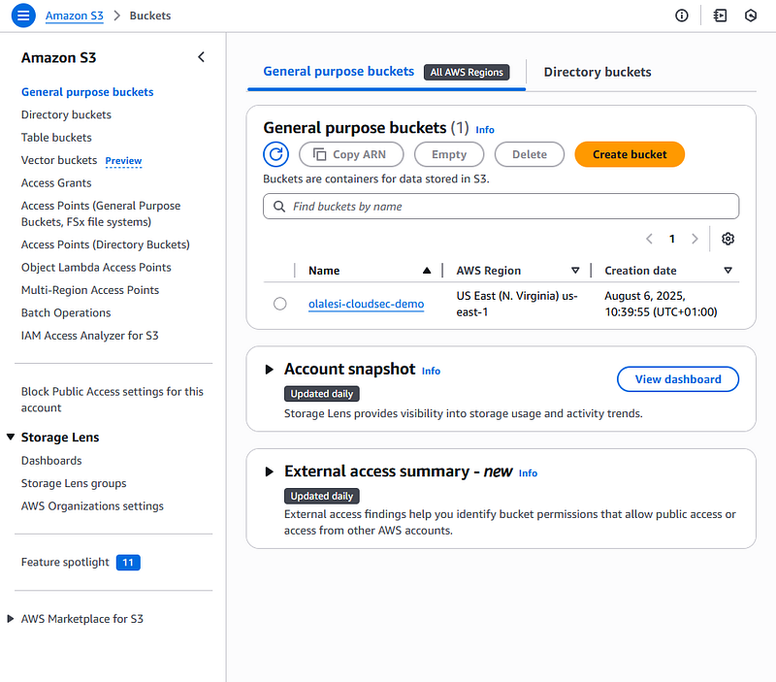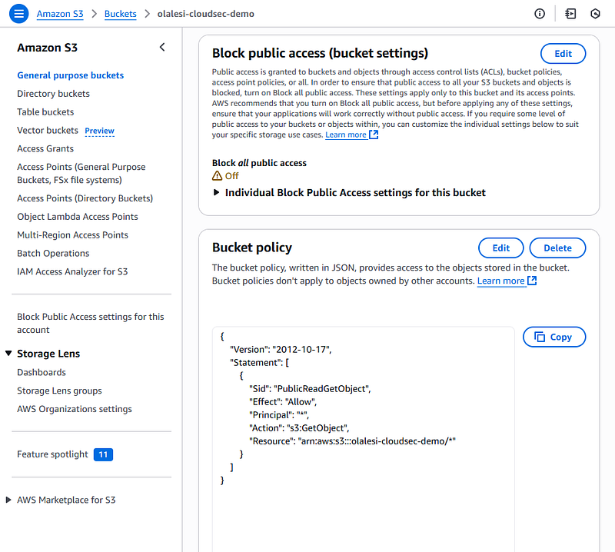

**👤 Step 2: Creating an IAM User with Excessive Permissions**

Next, I created a new IAM user called junior-analyst and gave it full access to all S3 buckets.  
 I connected to AWS using this user’s **Access Keys** via the CLI, and sure enough — the user had **way too much access**.

This was intentional, of course, but it highlighted how easy it is to **over-permission** users if you’re not careful.

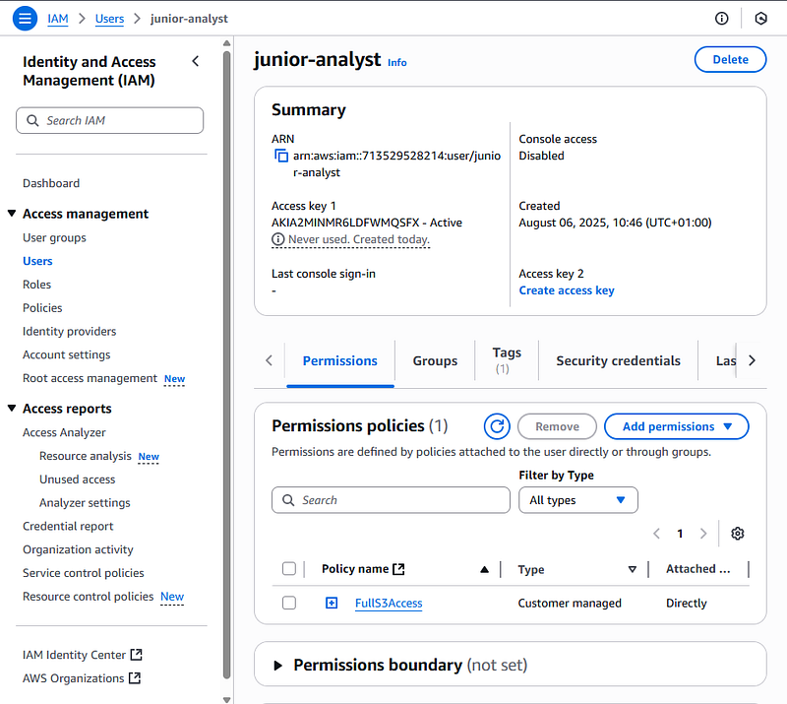

**🔐 Step 3: Securing the Bucket**

Now it was time to fix the issues:

✅ I **re-enabled “Block Public Access”** on the bucket  
 ✅ I **removed the public bucket policy**  
 ✅ Then, I applied a **strict IAM policy** — allowing only the junior-analyst user to access the bucket, and nothing more  
 ✅ I also enabled **S3 Server Access Logging** and directed the logs to a separate bucket called olalesi-logs

These changes significantly tightened security and followed the principle of **least privilege**.

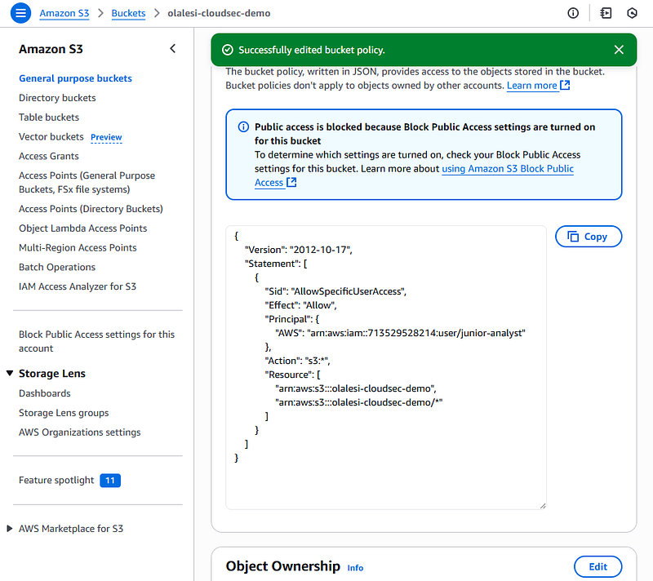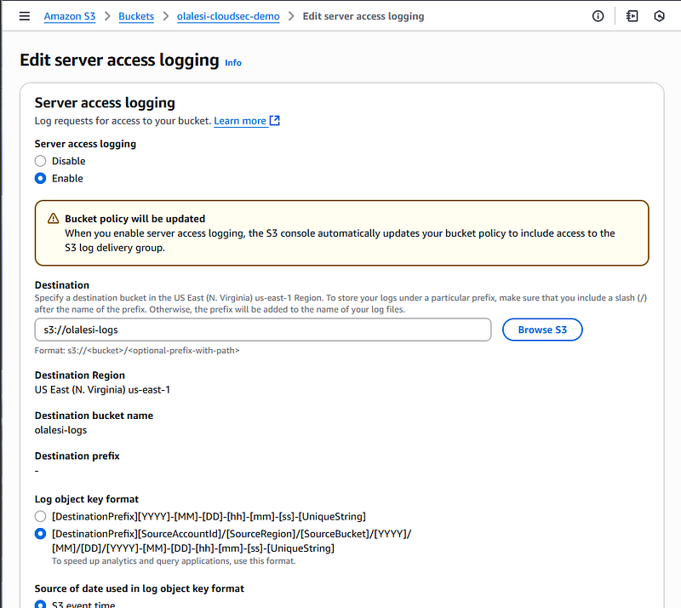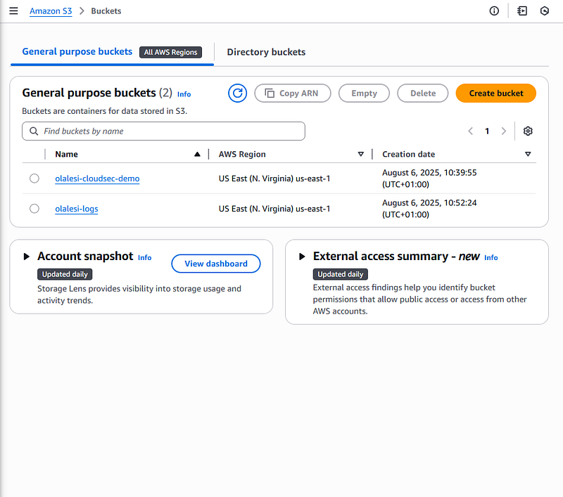

**📈 What I Learned**

🔸 **Misconfigurations are real threats** — Even small mistakes can expose sensitive data  
 🔸 **Least privilege is essential** — Only give access that’s absolutely necessary  
 🔸 **Logging matters** — Monitoring and traceability help you detect and investigate issues

**💡 Final Thoughts**

This small project was a big eye-opener. It helped me understand not just how to set up AWS services, but how to **secure them like a cloud professional**. Seeing firsthand how a misconfigured S3 bucket can leak data — and then remediating it — gave me real confidence in cloud security fundamentals.