BIT 4107 - MOBILE APPLICATION DEVELOPMENT
ENHANCED PROFESSIONAL STUDENT LOGBOOK

Student Name: OLAME BARHIBONERA EBEN-EZER
Admission Number: BIT/2023/66873
School/Faculty: School of Computing and Informatics
Programme: Bachelor of Information Technology (BIT)
Academic Year: 2025/2026
Semester: Eighth Semester
Lecturer: Nyoro Michael
Phone Number: 0110411706
Project: HostelHub - University Hostel Finder for Kenyan Students

Week 1: Introduction to Mobile Application Development (Installation)

Practical Activities Undertaken
- Installed Node.js and verified with node -v.
- Installed npm and verified with npm -v.
- Installed Git and verified with git --version.
- Installed Cursor (VS Code) as the development IDE.
- Installed Expo tools and verified with npx expo --version.
- Installed Expo Go on Android phone for device testing.
- Set up Android emulator for virtual device testing.
- Created HostelHub project and confirmed first successful app launch.

Screenshots
# | Label
1 | Development environment - Node.js, npm, Expo versions
2 | HostelHub splash screen running
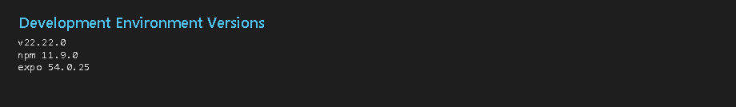
Figure 1.1 - Development environment

Figure 1.2 - HostelHub splash screen

Tools/Software Used
Cursor (VS Code), Node.js, npm, Git, Expo SDK 54, Expo Go, Android Emulator

Personal Reflection
Week 1 focused on installation and setup. After installing Node.js, npm, Git, and Expo tools, I successfully launched HostelHub in Expo Go. The development environment is ready for practical mobile development.

Week 2: Mobile Development Environment

Screenshots

# | Label
1 | Login screen
2 | Register screen
3 | Home dashboard after login
4 | Git commit history
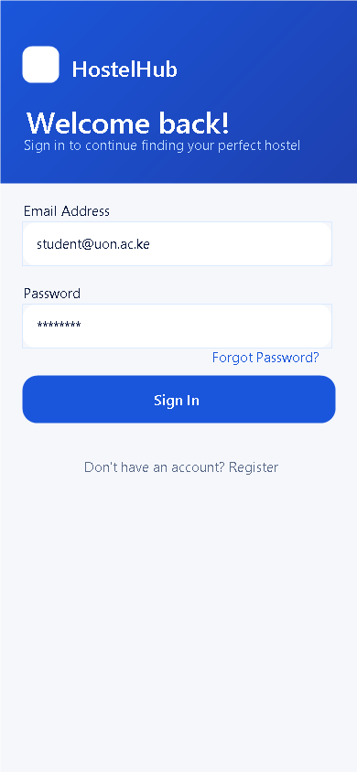Figure 2.2 - Register screen
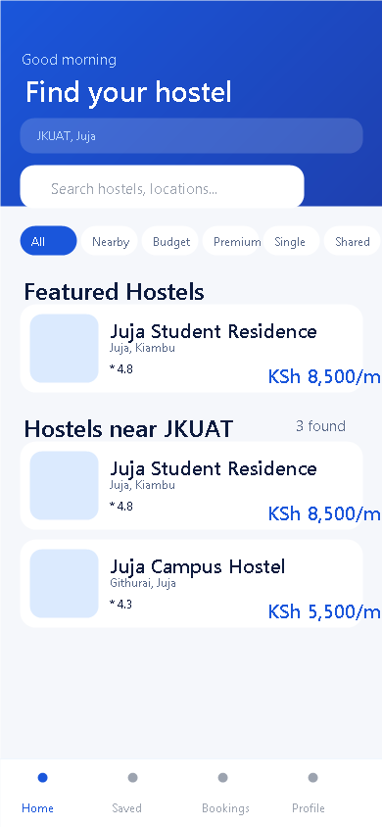
Figure 2.3 - Home dashboard
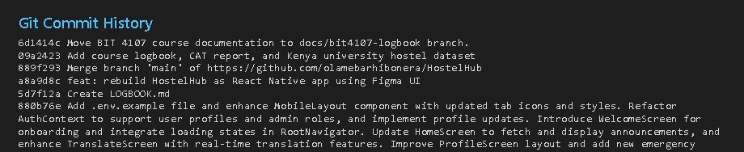
Figure 2.4 - Git commits

Tools/Software Used
React Native, Expo SDK 54, TypeScript, Expo Router, React Context API, Lucide React Native, npm, Git, GitHub, Vs Code

Personal Reflection
Week 2 moved from installation to development. I built core screens, configured routing, and solved package issues. I now understand how to set up a working mobile project environment.

Week 3: User Interface Design

Screenshots
# | Label
1 | Splash screen
2 | Login and Register screens
3 | Home screen with search and filters
4 | Location picker
5 | Hostel details and Booking screens
6 | Favourites, Bookings, Profile tabs

Figure 3.1 - Splash screen

Figure 3.2 - Login screen
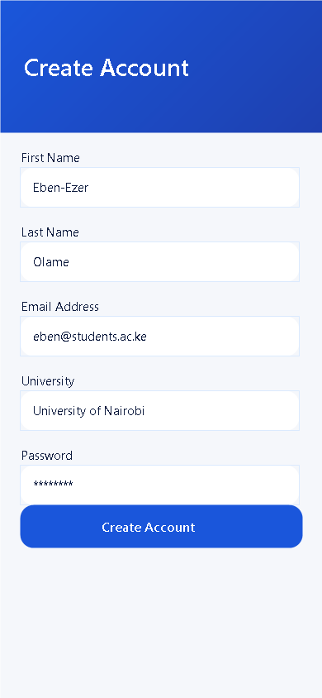
Figure 3.3 - Register screen

Figure 3.4 - Home screen
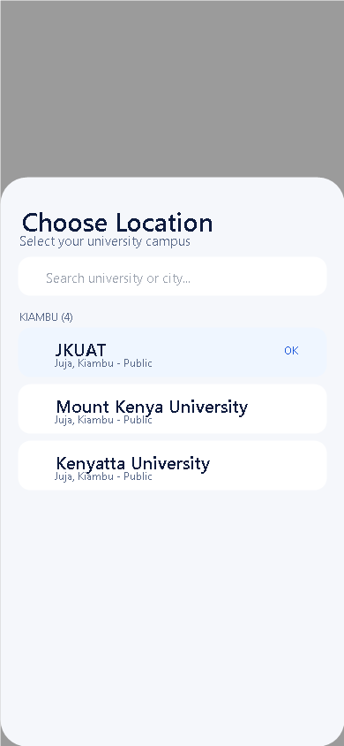
Figure 3.5 - Location picker
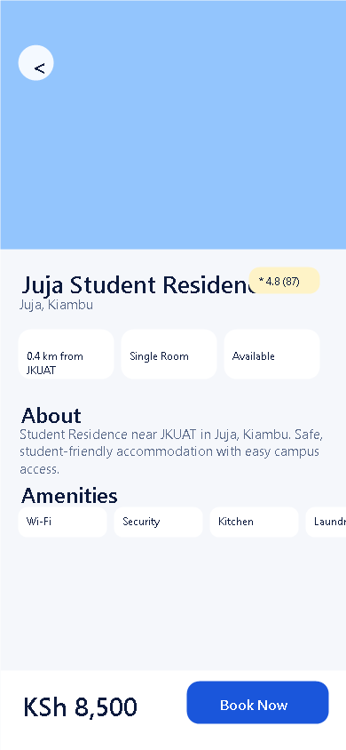
Figure 3.6 - Hostel details
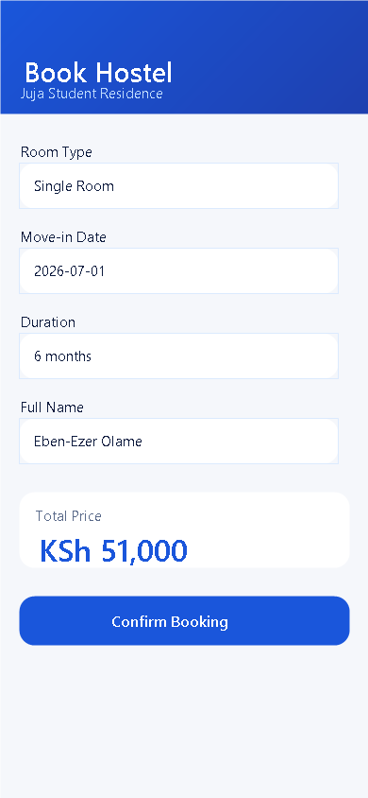
Figure 3.7 - Booking screen
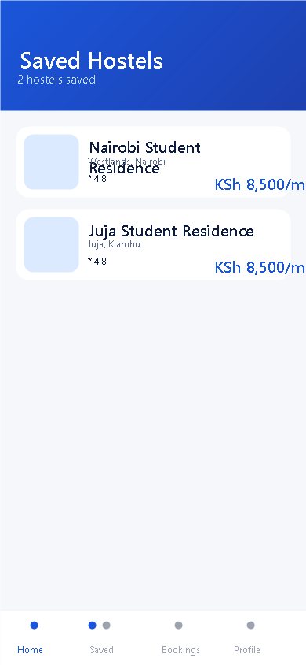
Figure 3.8 - Favourites tab
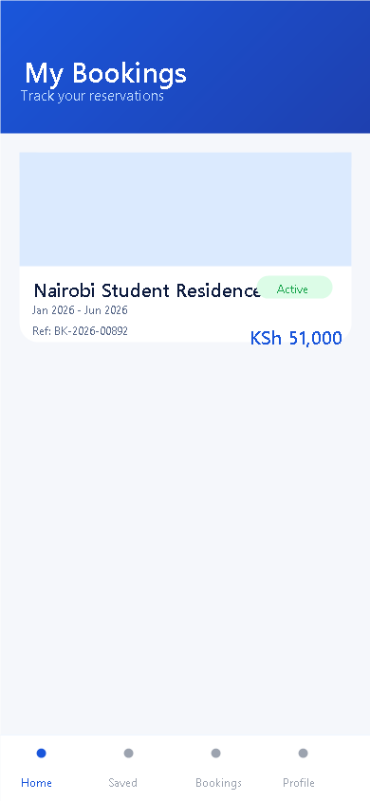
Figure 3.9 - Bookings tab
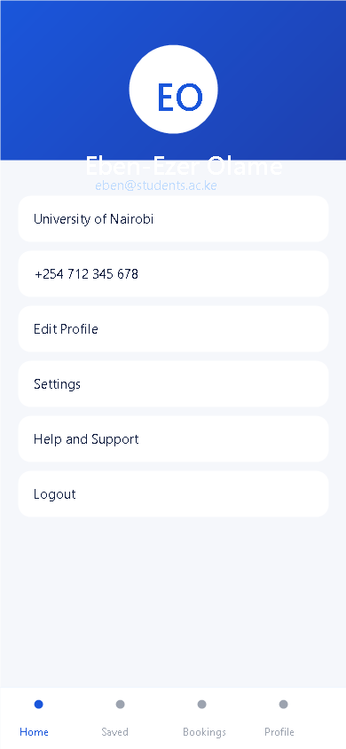
Figure 3.10 - Profile tab

Tools/Software Used
Figma, React Native, Expo SDK 54, NativeWind v4, Tailwind CSS, Expo Linear Gradient, Expo Font, Lucide React Native, Expo Go

Personal Reflection
Week 3 was creative. Converting Figma designs into thirteen HostelHub screens using NativeWind was rewarding. The app now looks modern and student-friendly.

Week 4: Event Handling and User Interaction

Screenshots
# | Label
1 | Budget category filter
2 | Location picker modal
3 | Login failed alert
4 | Favourites screen
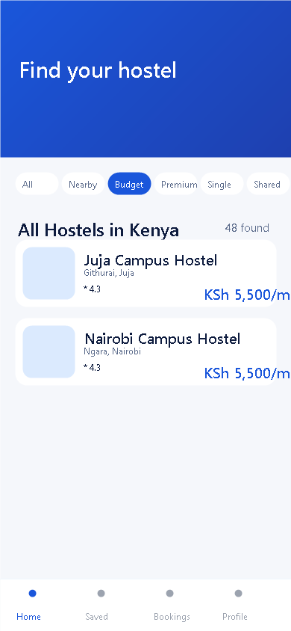
Figure 4.1 - Budget filter

Figure 4.2 - Location picker
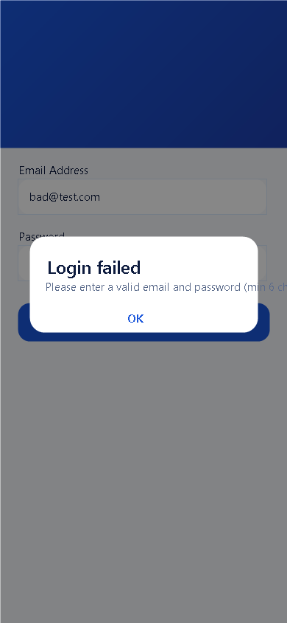
Figure 4.3 - Login error alert

Figure 4.4 - Favourites screen

Tools/Software Used
React Native (Pressable, TextInput, Alert, Modal), React (useState, useMemo), Expo Router, React Context API, Lucide React Native

Personal Reflection
Week 4 taught event-driven programming. Every tap, search, and filter required careful state management across multiple HostelHub screens.

Week 5: Data Management

Screenshots
# | Label
1 | Universities data (50 Kenyan universities)
2 | Booking service CRUD
3 | Home screen listings
4 | Favourites records
5 | Bookings records
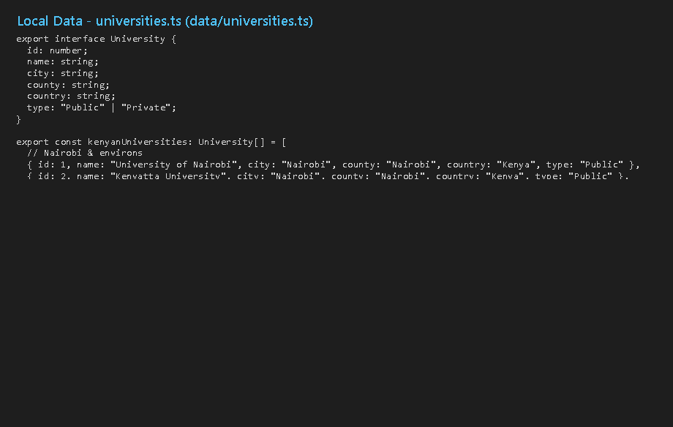
Figure 5.1 - Universities data
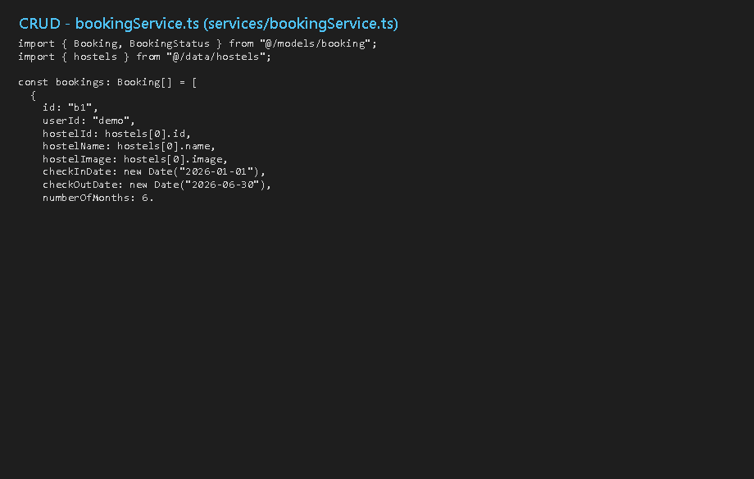
Figure 5.2 - Booking service CRUD

Figure 5.3 - Home listings

Figure 5.4 - Favourites records

Figure 5.5 - Bookings records

Tools/Software Used
TypeScript, React Context API, Expo Router, local TypeScript data files (data/, models/, services/)

Personal Reflection
Week 5 showed that good data structure drives every feature. Organising universities, hostels, and bookings into models and services made CRUD straightforward.

Week 6: Networking and APIs

Screenshots
# | Label
1 | Async hostel service code
2 | Login error handling
3 | Hostel details async load
4 | Booking async flow
5 | TypeScript compile check
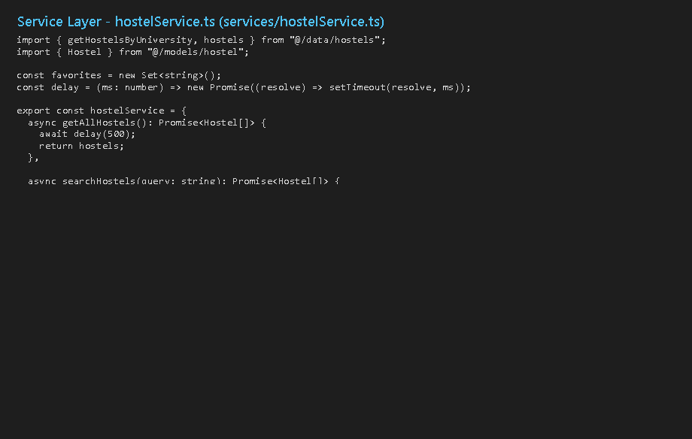
Figure 6.1 - Hostel service

Figure 6.2 - Login error

Figure 6.3 - Hostel details

Figure 6.4 - Booking screen
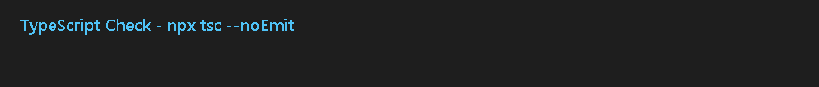
Figure 6.5 - TypeScript check

Tools/Software Used
TypeScript, JavaScript async/await, Expo SDK 54, React Native (Image, ActivityIndicator, Alert), HTTP/HTTPS, JSON

Personal Reflection
Week 6 connected HostelHub to networking concepts. Async services and loading indicators keep the UI responsive while data is processed.

Week 7: Application Architecture

Screenshots
# | Label
1 | Service layer - hostelService.ts
2 | Data layer - universities.ts
3 | Booking service - bookingService.ts
4 | Git version control history

Figure 7.1 - Service layer

Figure 7.2 - Data layer

Figure 7.3 - Booking service

Figure 7.4 - Git history

Tools/Software Used
Expo Router, React Context API, TypeScript, Git, GitHub, Cursor (VS Code)

Personal Reflection
Week 7 made HostelHub maintainable. Separating screens, services, models, and data helped me add fifty universities without breaking existing features.

Final Approval
Student Name: OLAME BARHIBONERA EBEN-EZER
Student Signature: _________________________
Date: _________________________

Lecturer Name: Nyoro Michael
Lecturer Remarks: _________________________
Date: _________________________

