MOBILE APPLICATION DEVELOPMENT

Student Name: OLAME BARHIBONERA EBEN-EZER
Registration Number: BIT/2023/66873
School: SCHOOL OF COMPUTING AND INFORMATICS
Year: FOURTH YEAR
Semester: EIGHTH SEMESTER
Supervisor: NYORO MICHAEL
Supervisor Contact: 0110411706

Project Name: HostelHub
Platform: React Native (Expo SDK 54)
Project Description: A mobile application that helps university students in Nairobi and East Africa discover, compare, and book campus hostels.

Week 1
Practical Activities Undertaken
Screenshot 1: Installing Node.js
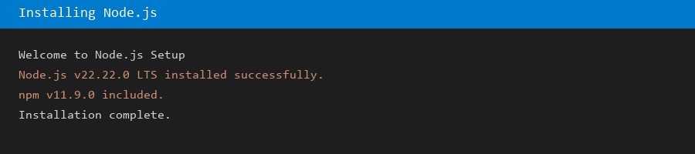
Screenshot 2: Verifying Node.js and npm in terminal
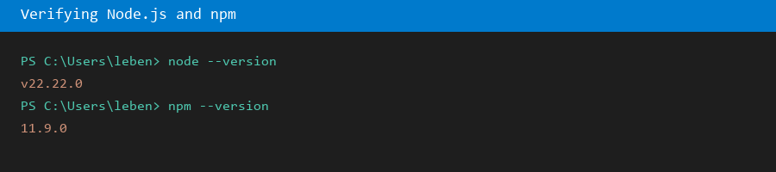
Screenshot 3: Installing Android Studio
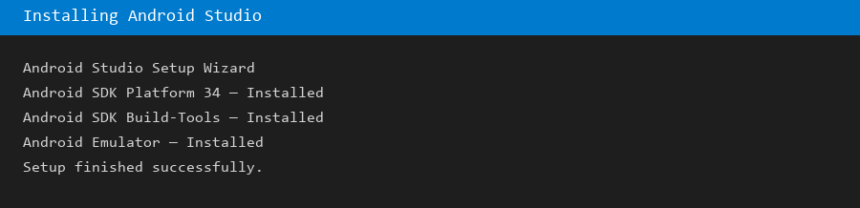
Screenshot 4: Creating HostelHub Expo project
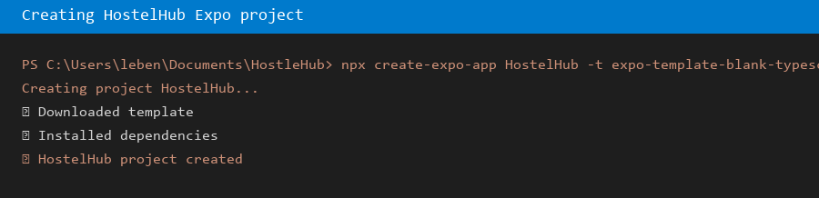
Screenshot 5: Running npx expo start for the first time
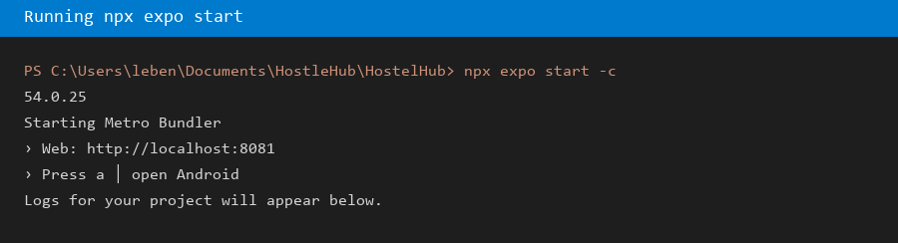
Screenshot 6: HostelHub splash screen on emulator

Screenshots/Evidence Attached (Yes/No)
Yes
Tools/Software Used
Node.js, npm, Expo, Android Studio, VS Code, Expo Go
Personal Reflection
Setting up Node.js and Expo felt overwhelming at first, but seeing the splash screen appear on the emulator made all the installation steps worthwhile.

Week 2
Practical Activities Undertaken
Screenshot 7: Configuring app.json (app name, splash, icons)
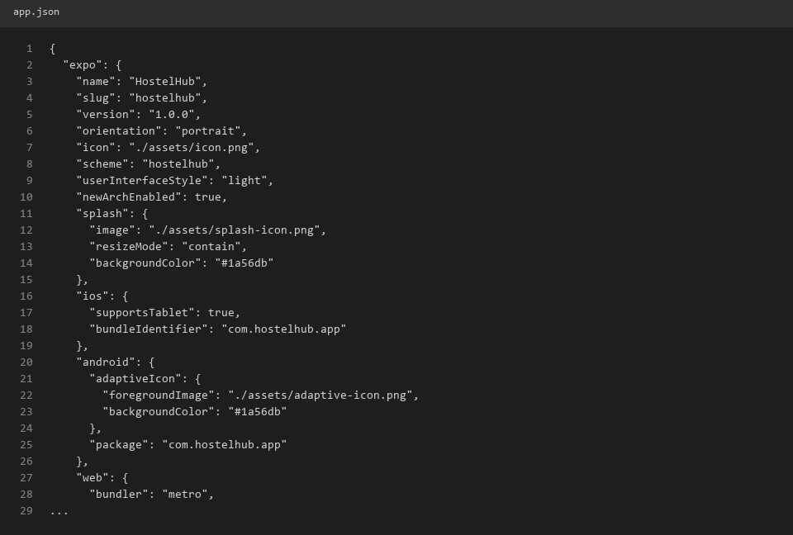
Screenshot 8: Setting up TypeScript (tsconfig.json)
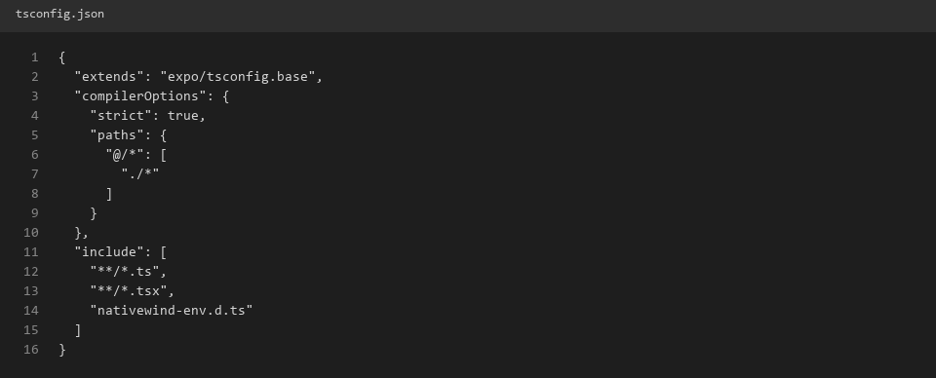
Screenshot 9: Installing and configuring NativeWind (tailwind.config.js, global.css)
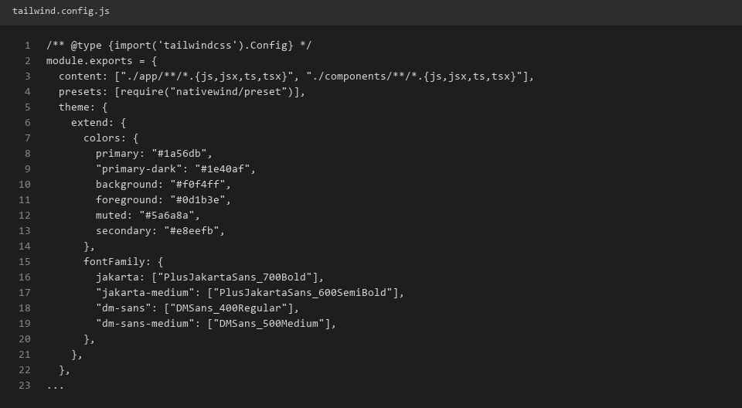
Screenshot 10: Configuring Expo Router folder structure (app/ directory)
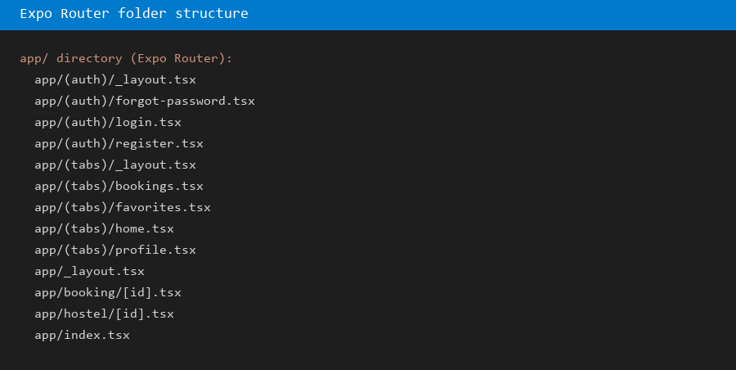
Screenshot 11: Loading custom fonts (Plus Jakarta Sans, DM Sans)
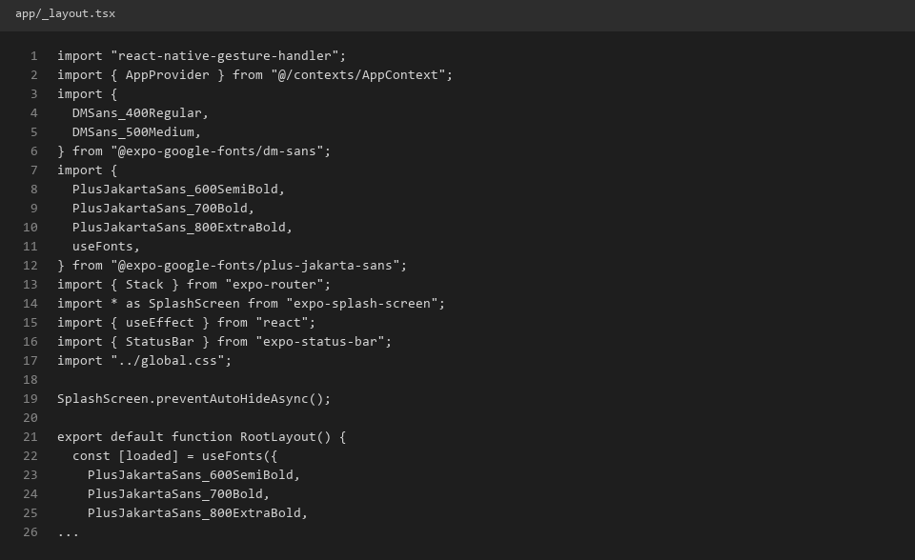
Screenshot 12: HostelHub app running with styled splash screen

Screenshots/Evidence Attached (Yes/No)
Yes
Tools/Software Used
TypeScript, NativeWind, Tailwind CSS, Expo Router, Expo Google Fonts
Personal Reflection
Configuring NativeWind with Expo Router took patience, especially aligning Tailwind classes with React Native. The custom fonts gave HostelHub a polished, professional look.

Week 3
Practical Activities Undertaken
Screenshot 13: Home screen header with greeting and location
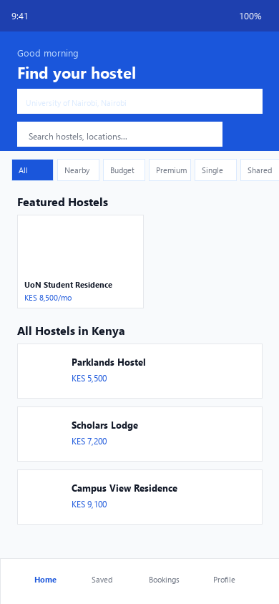
Screenshot 14: Hostel search bar and category filters

Screenshot 15: Featured hostels horizontal scroll (HostelCard component)

Screenshot 16: Location picker showing Nairobi universities
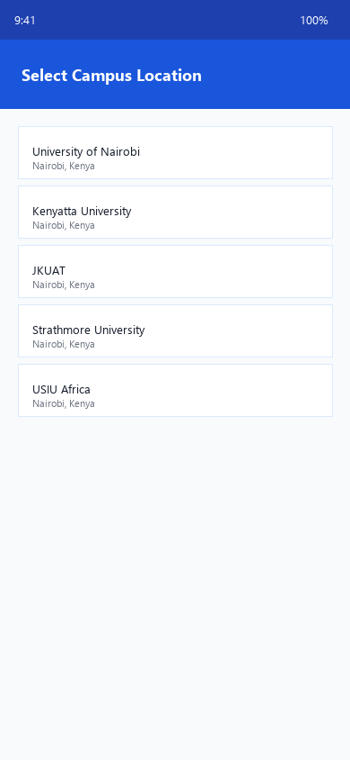
Screenshot 17: Hostel details screen with image and amenities
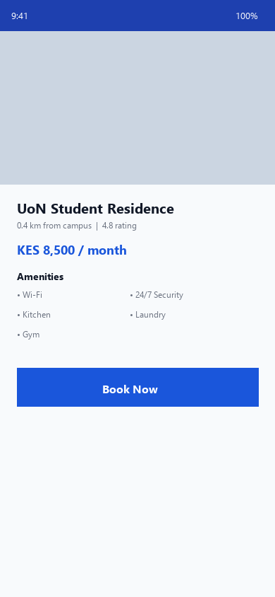
Screenshot 18: VS Code showing HostelCard.tsx and LocationPicker.tsx
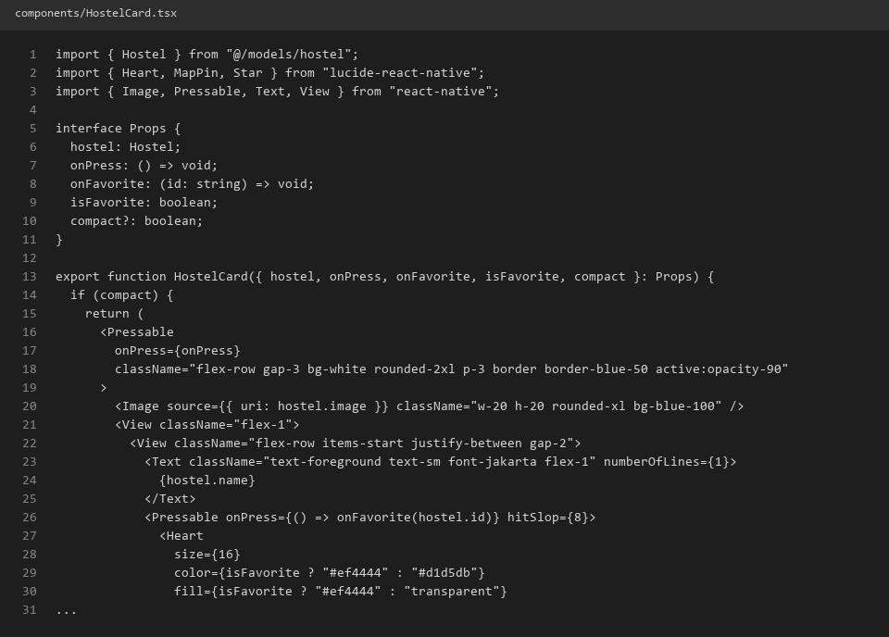
Screenshots/Evidence Attached (Yes/No)
Yes
Tools/Software Used
React Native, NativeWind, Lucide React Native, VS Code, Figma
Personal Reflection
Building the home screen taught me how reusable components save time. Matching the Figma design with NativeWind classes was challenging but satisfying when it came together.

Week 4
Practical Activities Undertaken
Screenshot 19: Login screen with email and password fields
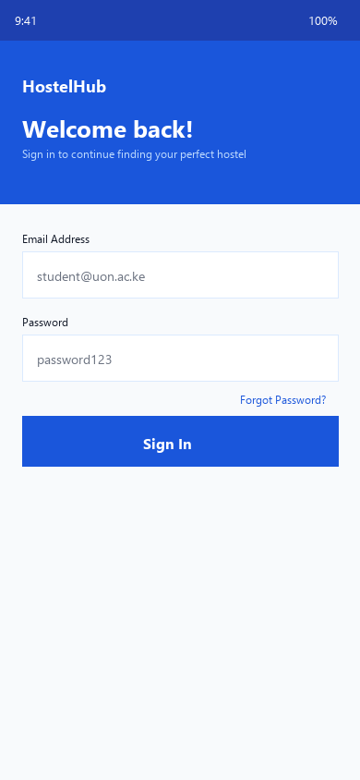
Screenshot 20: Register screen with validation fields
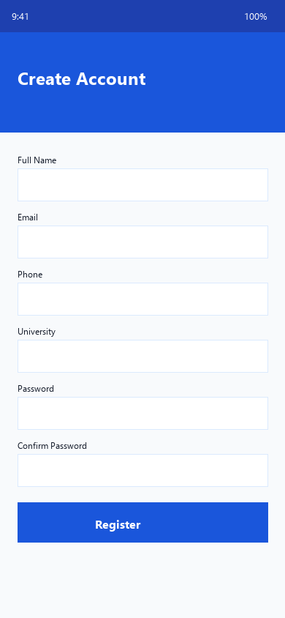
Screenshot 21: Forgot password screen
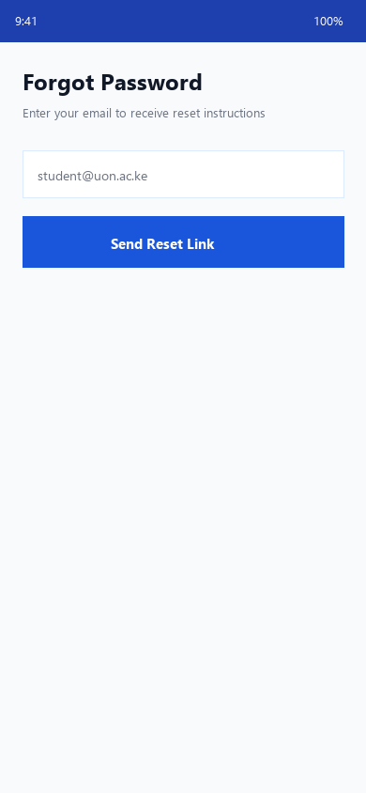
Screenshot 22: Successful login navigating to home

Screenshot 23: Bottom tab navigation (Home, Saved, Bookings, Profile)

Screenshot 24: Stack navigation to hostel details screen

Screenshots/Evidence Attached (Yes/No)
Yes
Tools/Software Used
Expo Router, React Native, TypeScript, VS Code
Personal Reflection
Expo Router made navigation clearer than I expected. Wiring up login forms with validation helped me understand how user input flows through React Native components.

Week 5
Practical Activities Undertaken
Screenshot 25: data/hostels.ts static hostel data in VS Code
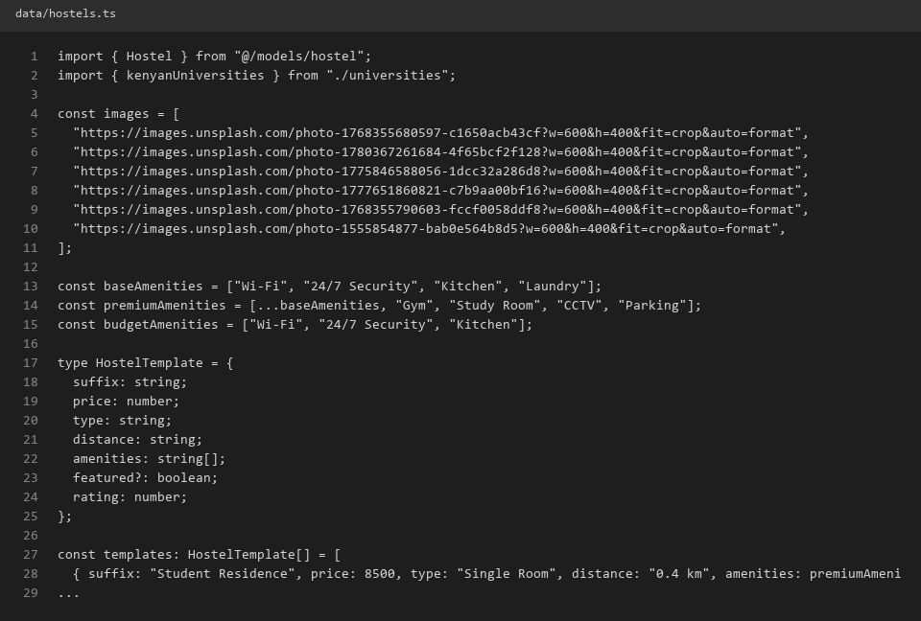
Screenshot 26: data/universities.ts and data/locations.ts
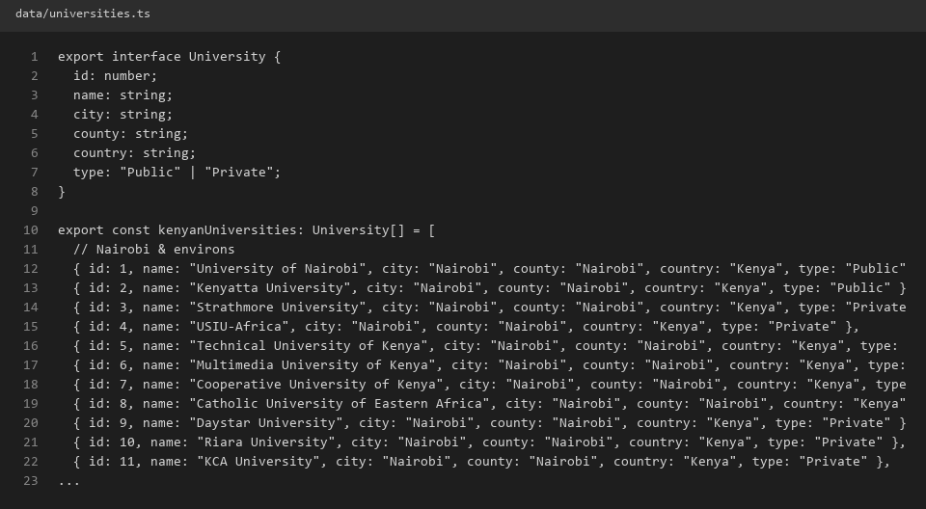
Screenshot 27: AppContext.tsx showing user, favorites, and location state
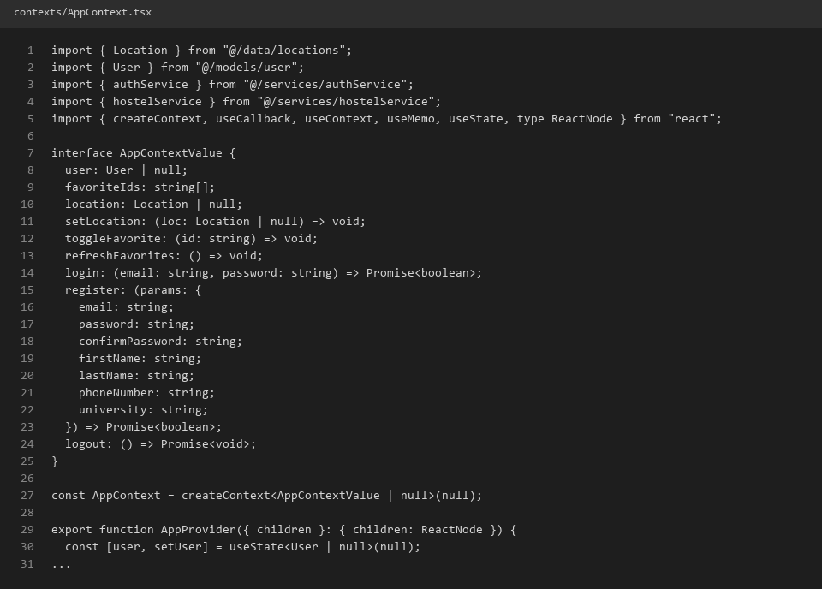
Screenshot 28: Toggling favorite heart icon on a hostel card

Screenshot 29: Saved tab showing favorited hostels
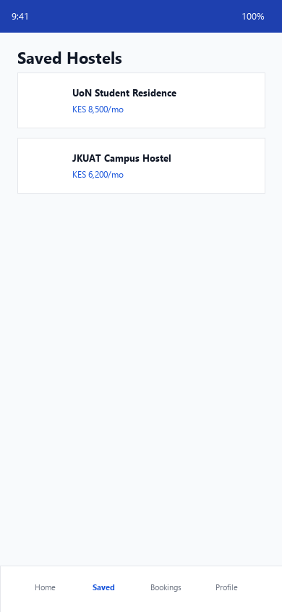
Screenshot 30: Filtering hostels by Budget category on home screen
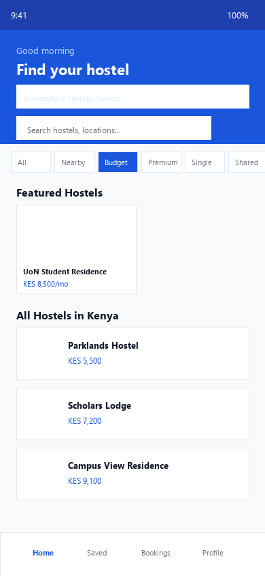
Screenshots/Evidence Attached (Yes/No)
Yes
Tools/Software Used
TypeScript, React Context, VS Code
Personal Reflection
Using React Context for favorites and location state simplified sharing data across screens. Filtering hostels by category showed me the power of local data combined with UI state.

Week 6
Practical Activities Undertaken
Screenshot 31: authService.ts login and register logic in VS Code
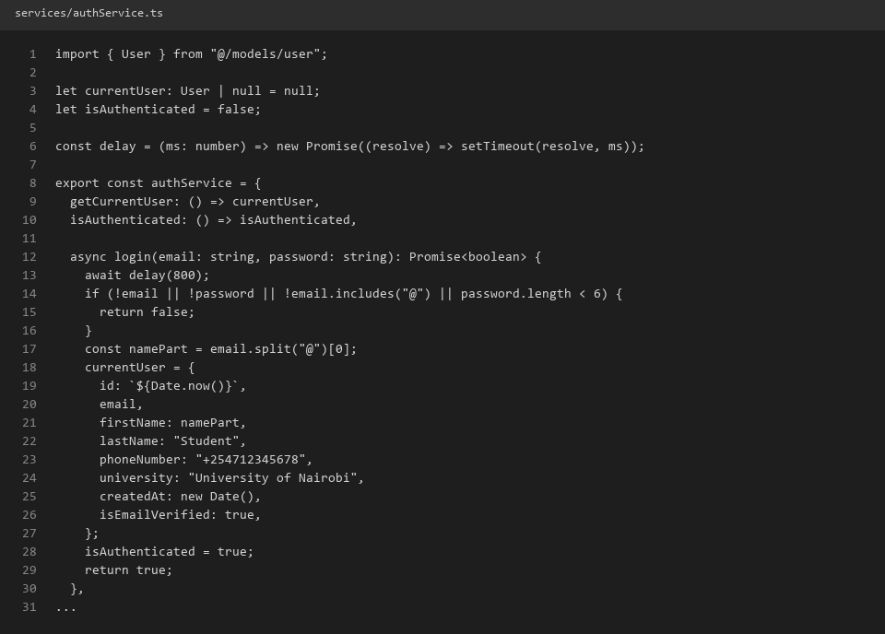
Screenshot 32: hostelService.ts search and favorites methods
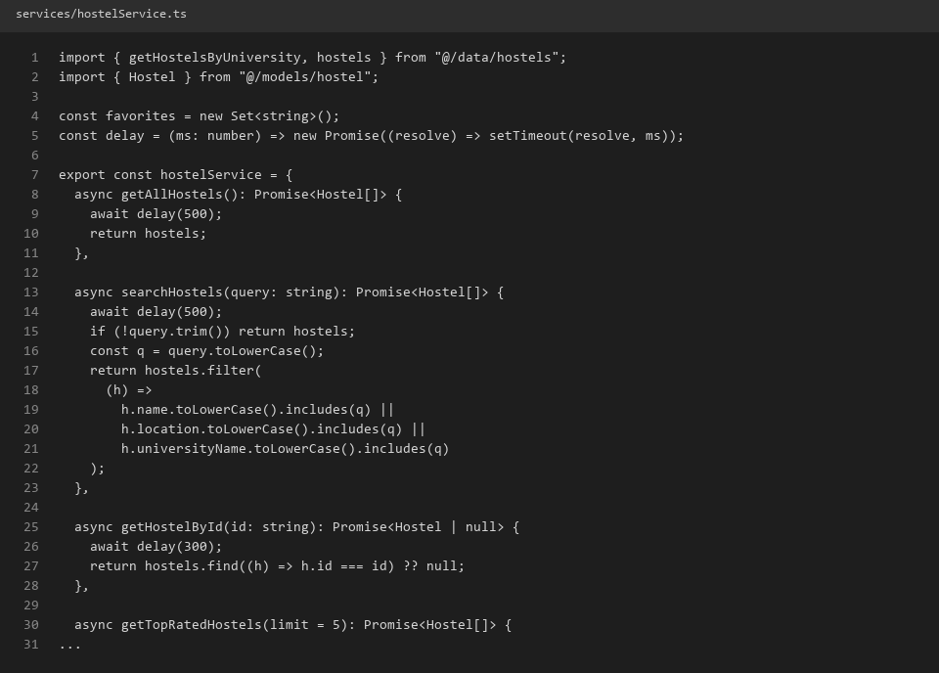
Screenshot 33: bookingService.ts create booking logic
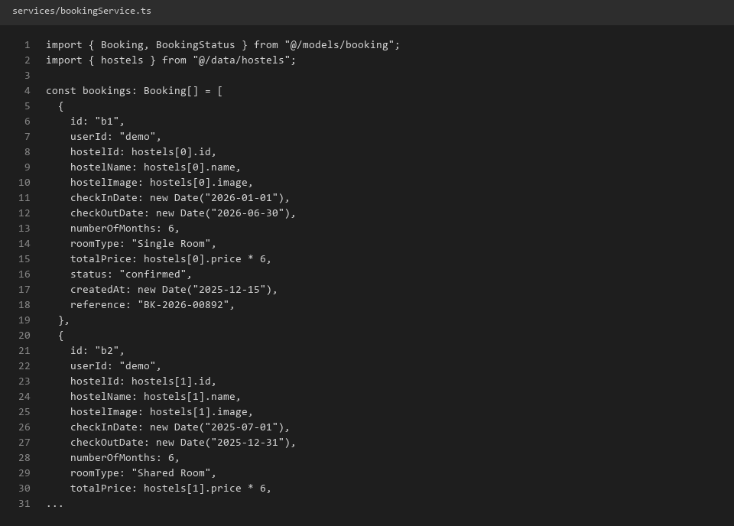
Screenshot 34: Login form with loading indicator during auth

Screenshot 35: Booking form with room type and duration selection
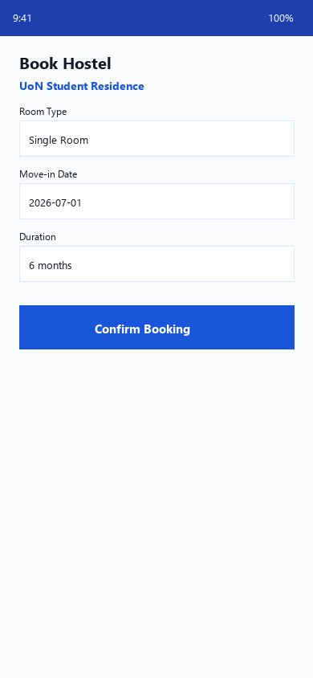
Screenshot 36: Booking confirmation screen with reference number
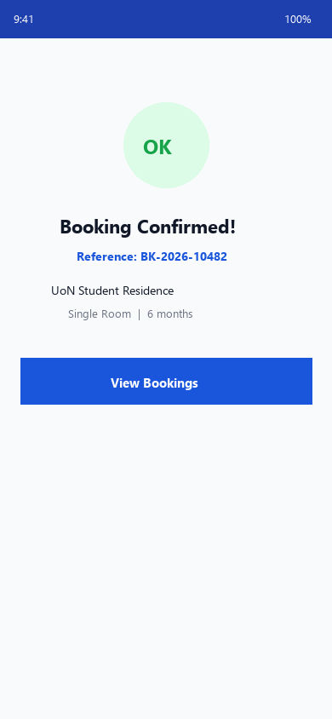
Screenshots/Evidence Attached (Yes/No)
Yes
Tools/Software Used
TypeScript, VS Code, React Native, Expo
Personal Reflection
Writing mock services with async delays simulated real API behaviour well. Seeing the booking confirmation with a reference number made the app feel genuinely functional.

Week 7
Practical Activities Undertaken
Screenshot 37: Project folder structure (app, components, contexts, data, models, services)
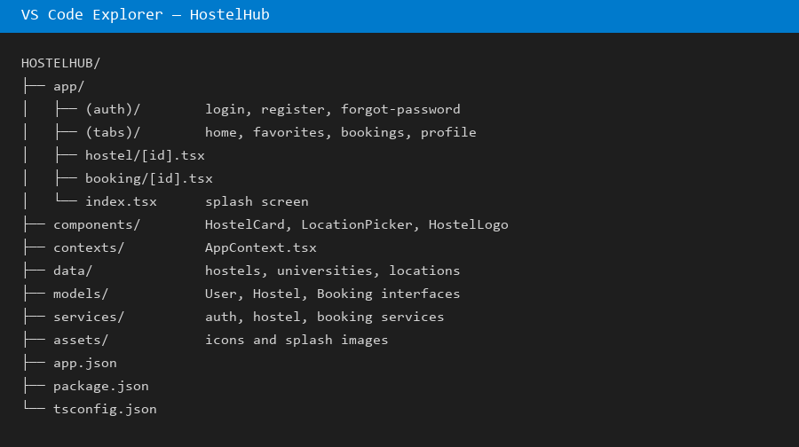
Screenshot 38: models/hostel.ts and models/booking.ts TypeScript interfaces
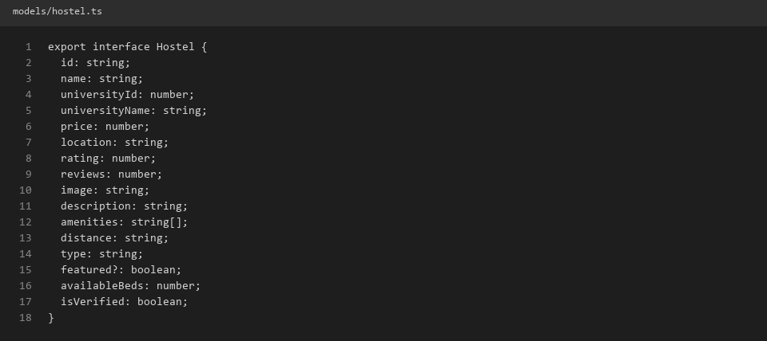
Screenshot 39: HostelLogo.tsx reusable component
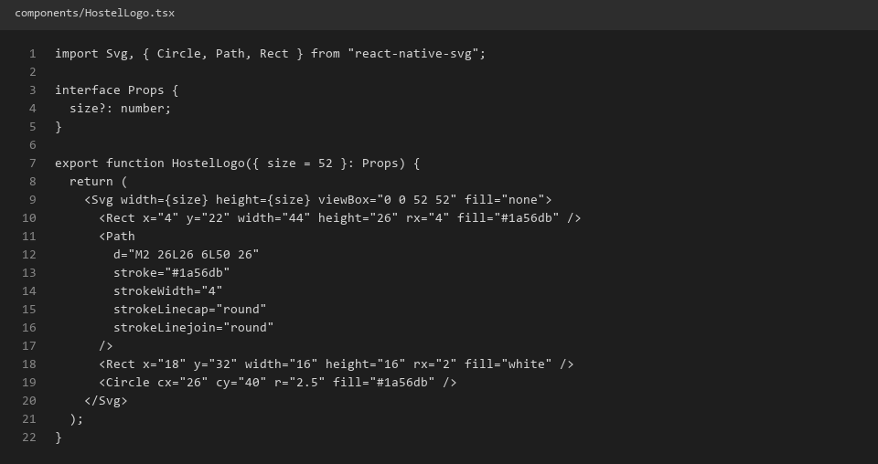
Screenshot 40: Bookings tab showing active and completed bookings
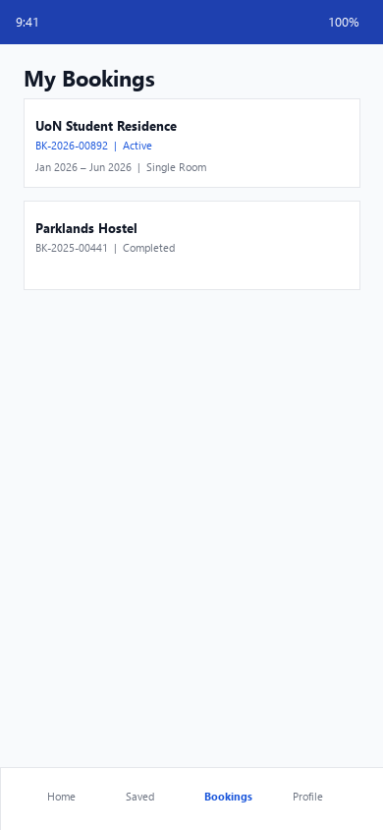
Screenshot 41: Profile screen with user details and logout
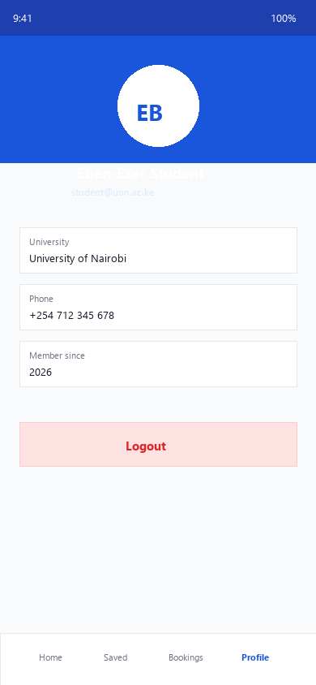
Screenshot 42: README.md project documentation in VS Code
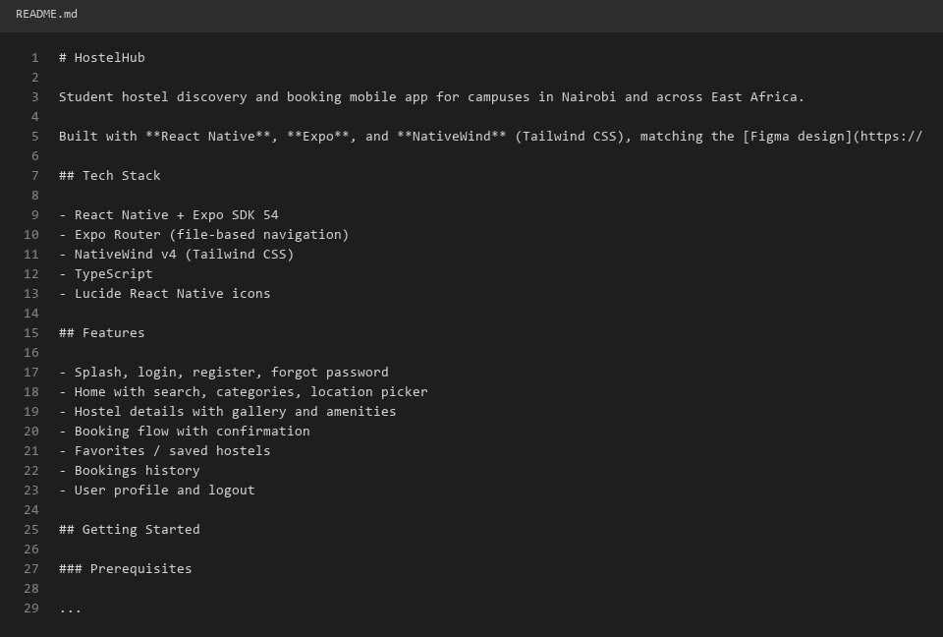
Screenshots/Evidence Attached (Yes/No)
Yes
Tools/Software Used
TypeScript, VS Code, Git, GitHub
Personal Reflection
Organising code into models, services, and components improved readability greatly. The bookings and profile screens brought together everything I had built over previous weeks.

Week 8
Practical Activities Undertaken
Screenshot 43: Git commit history for HostelHub on GitHub
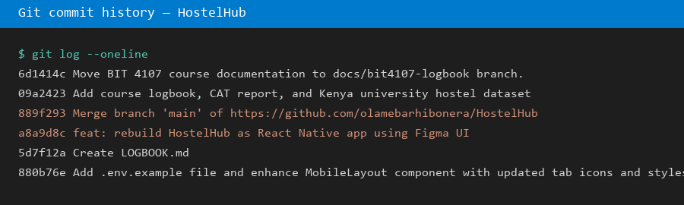
Screenshot 44: Full home screen final UI on emulator

Screenshot 45: Complete booking flow from hostel details to confirmation

Screenshot 46: All four tabs visible in final app

Screenshot 47: Terminal showing successful expo start with no errors
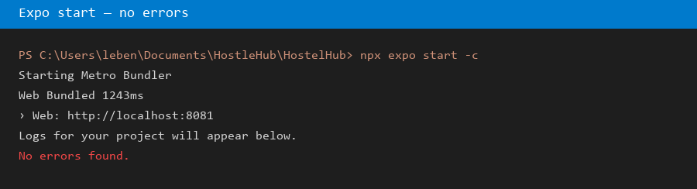
Screenshot 48: Final project overview in VS Code explorer

Screenshots/Evidence Attached (Yes/No)
Yes
Tools/Software Used
Git, GitHub, VS Code, Expo, Android Studio, Expo Go
Personal Reflection
Reviewing the finished HostelHub app, I am proud of the progress made this semester. The project taught me mobile development fundamentals I can apply to future applications.

