**QUESTION 1:**

Options 2 and 3 are correct

**QUESTION 2:**

SELECT g.yr, c.country FROM games g JOIN city c ON c.name = g.city;

**QUESTION 3:**

**Left Join:**

**Query =** [SELECT](http://localhost/phpmyadmin/url.php?url=https://dev.mysql.com/doc/refman/8.0/en/select.html" \t "http://localhost/phpmyadmin/index.php?route=/mysql_doc) * FROM games g [left](http://localhost/phpmyadmin/url.php?url=https://dev.mysql.com/doc/refman/8.0/en/string-functions.html%23function_left" \t "http://localhost/phpmyadmin/index.php?route=/mysql_doc) JOIN city c ON g.city = c.name;

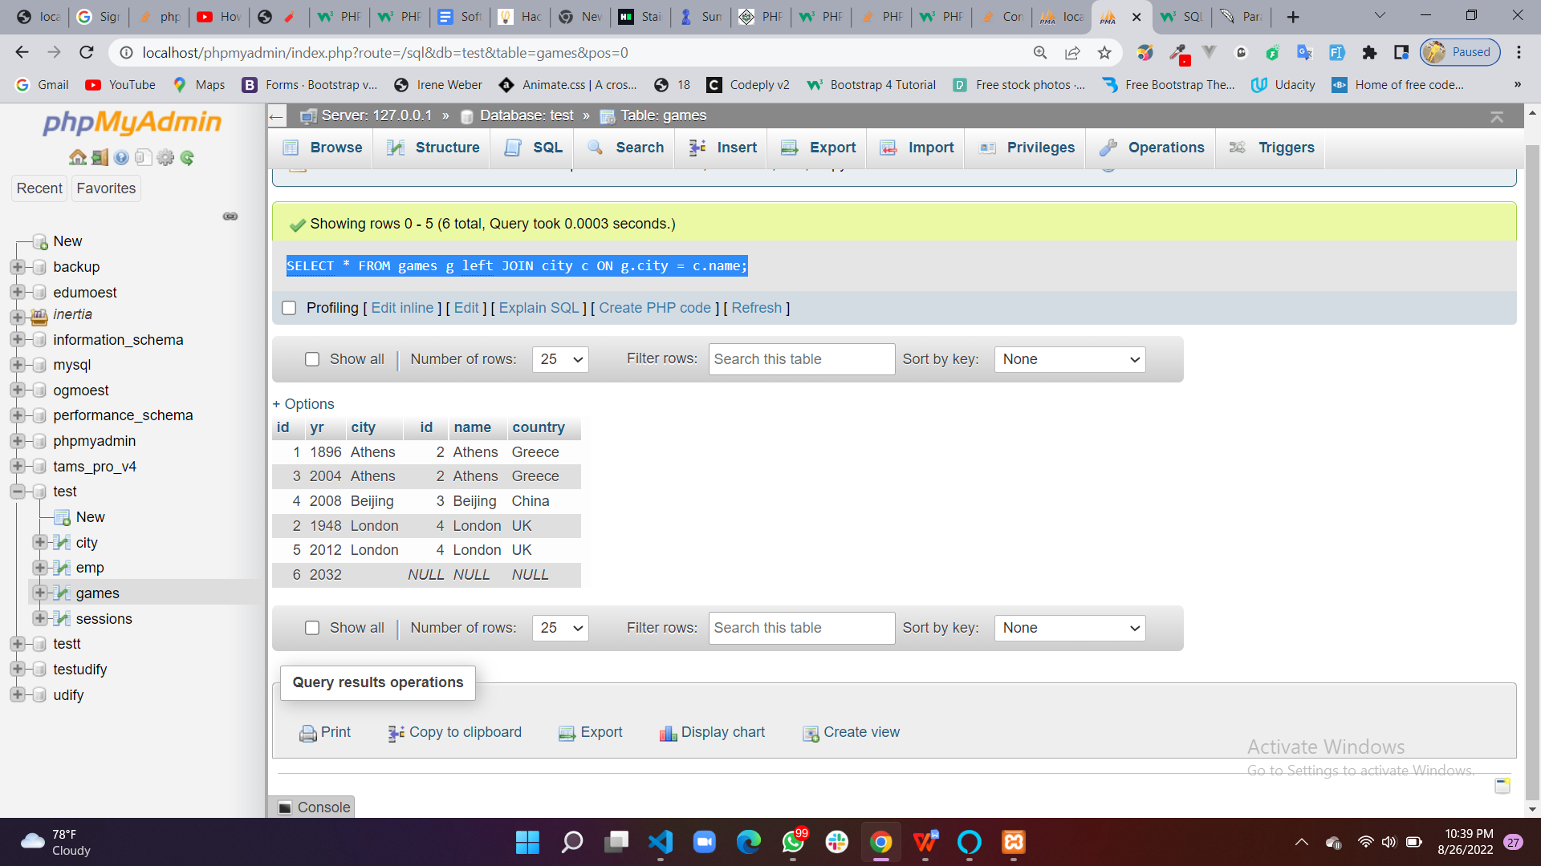

The LEFT JOIN keyword returns all records from the left table (games table), and the matching records from the right table (city table) leaving empty the cells that does not have full records on both tables.

**Right Join:**

**Query =** [SELECT](http://localhost/phpmyadmin/url.php?url=https://dev.mysql.com/doc/refman/8.0/en/select.html" \t "http://localhost/phpmyadmin/index.php?route=/mysql_doc) * FROM games g [Right](http://localhost/phpmyadmin/url.php?url=https://dev.mysql.com/doc/refman/8.0/en/string-functions.html%23function_right" \t "http://localhost/phpmyadmin/index.php?route=/mysql_doc) JOIN city c ON g.city = c.name ORDER BY c.id;

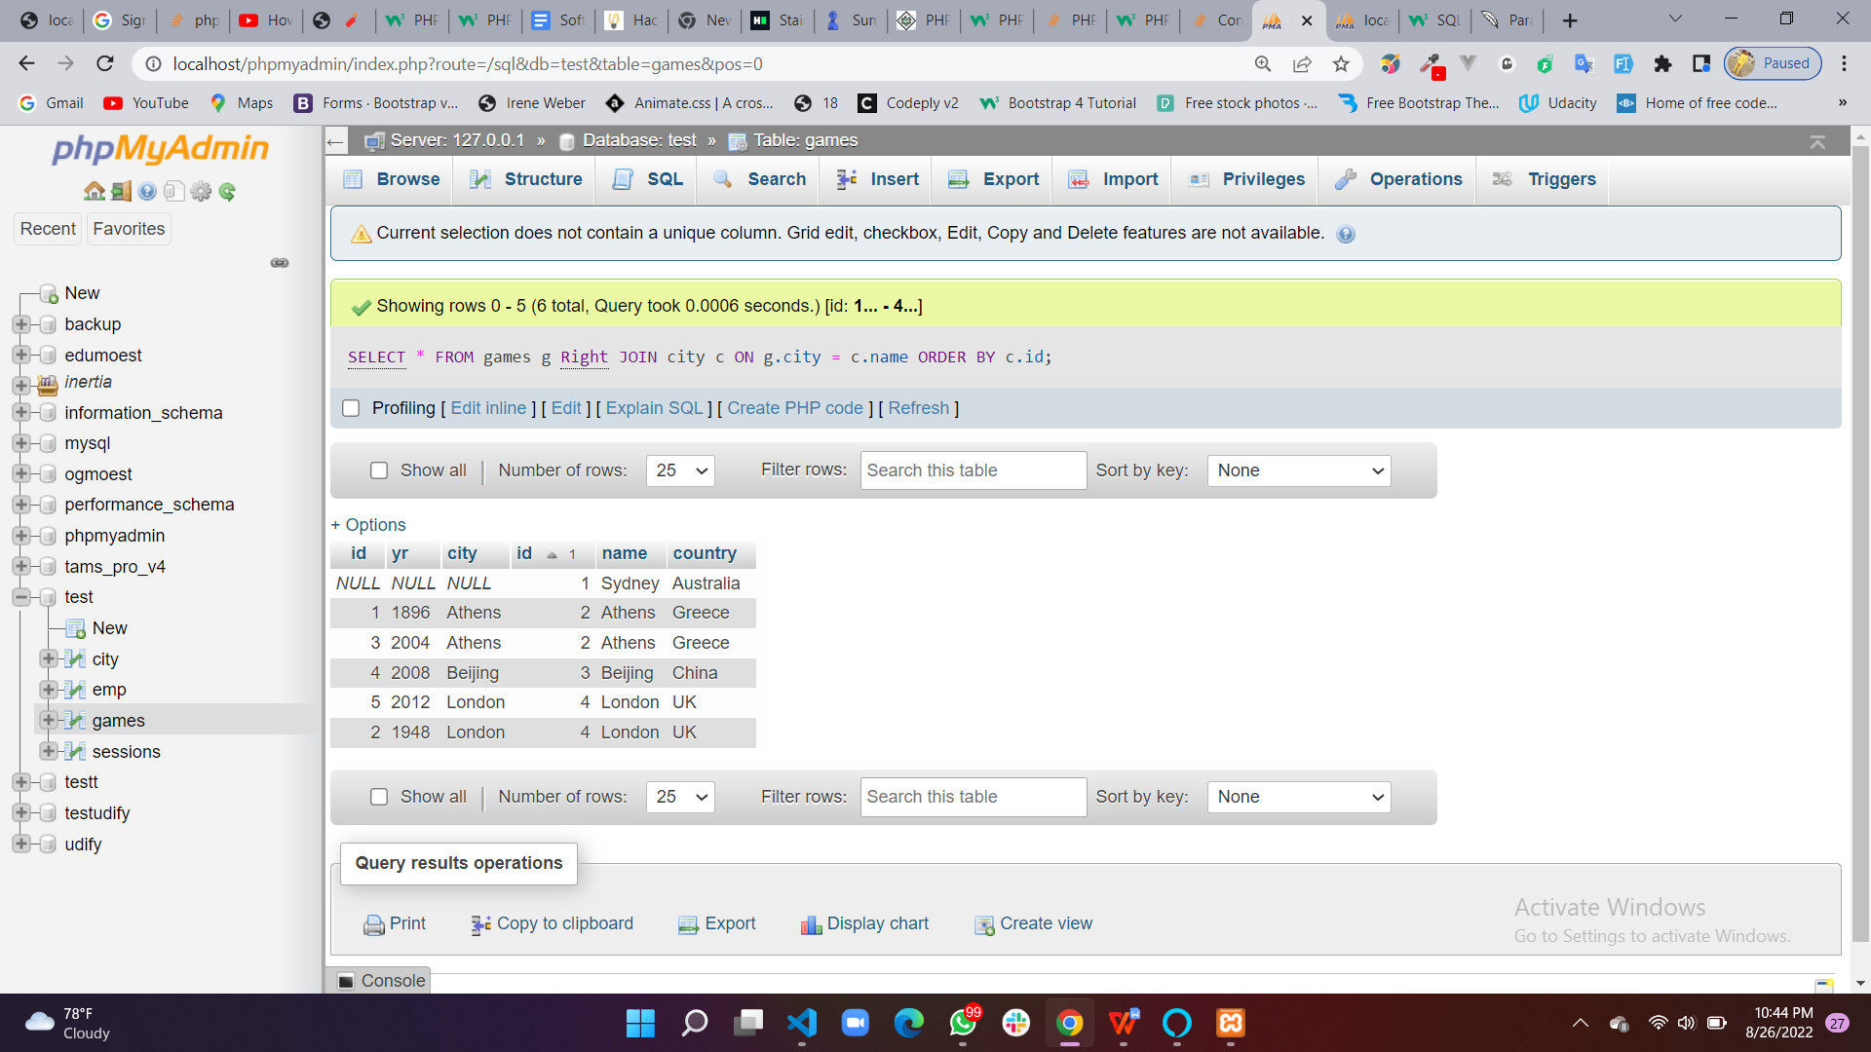

The RIGHT JOIN keyword returns all records from the right table (city table), and the matching records from the left table (games table)

**QUESTION 4:**

SELECT userid, avg(duration) as AverageDuration FROM sessions GROUP BY userid HAVING COUNT(userid) > 1;