SIDONPAY
Business Intelligence & Customer Segmentation Report
Week 4 — Team Beta
Prepared by: Ahmed Abdullahi Olamilekan | Submission: Monday, 27th September 2026

1. Introduction
This report accompanies the Week 4 Power BI Executive Dashboard, built across two pages: a Business Intelligence overview of transaction behavior, and a Customer Behaviour & Segmentation view. Both treat the PaySim dataset (6,362,620 transactions) as SIDONPAY's first month of live transaction history, translating raw transaction logs into insights for Executive, Product, Marketing, and Risk stakeholders ahead of launch.

2. Transaction Overview
Metric | Value
Total Transactions | 6,362,620
Total Transaction Value | ₦1.14 Trillion
Average Transaction Value | ₦179,860

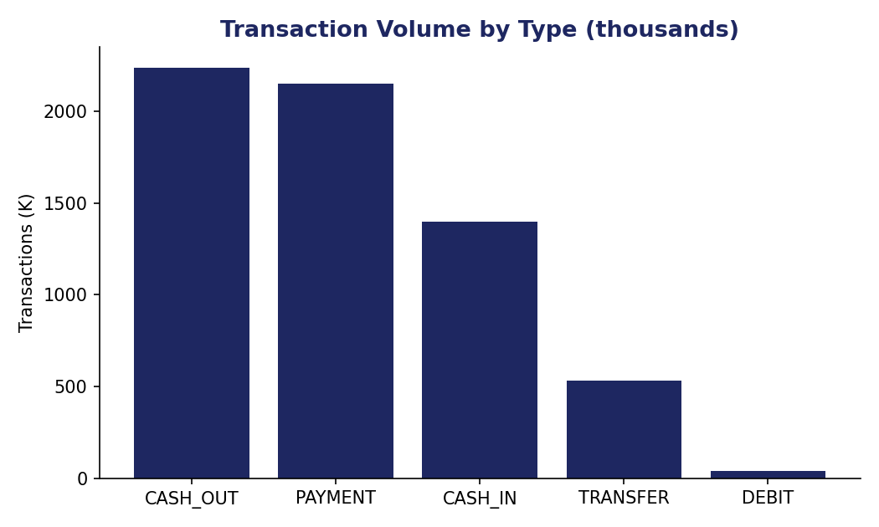
Figure 1 — Transaction volume by type.
CASH_OUT (2,238K) and PAYMENT (2,151K) dominate transaction volume, followed by CASH_IN (1,399K), TRANSFER (533K), and DEBIT (41K).
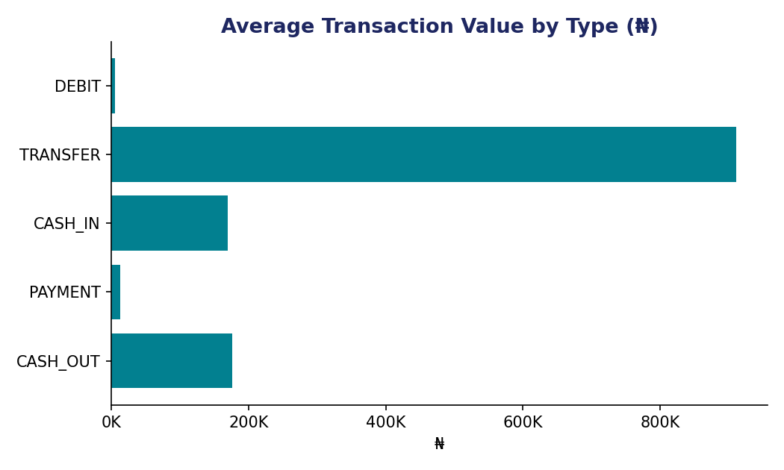
Figure 2 — Average transaction value by type.
TRANSFER carries by far the highest average value (₦910,647) despite low volume — consistent with its role moving larger sums between accounts rather than everyday spending. PAYMENT, the second most common transaction type, averages just ₦13,058, reflecting small day-to-day purchases.

3. Operational Performance
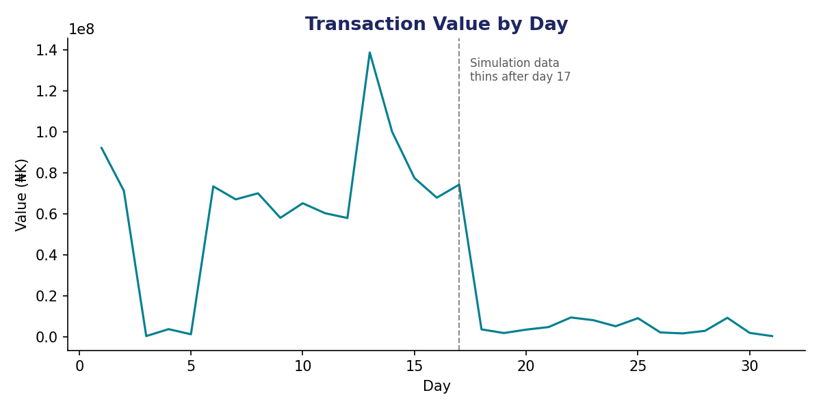
Figure 3 — Transaction value by day across the 31-day period.
Transaction value holds a steady rhythm through day 17 before dropping sharply for the remainder of the period. This reflects how the underlying PaySim simulation run was scaled down for public release, rather than a genuine business or seasonal pattern — day-over-day comparisons after day 17 should not be read as real trends.
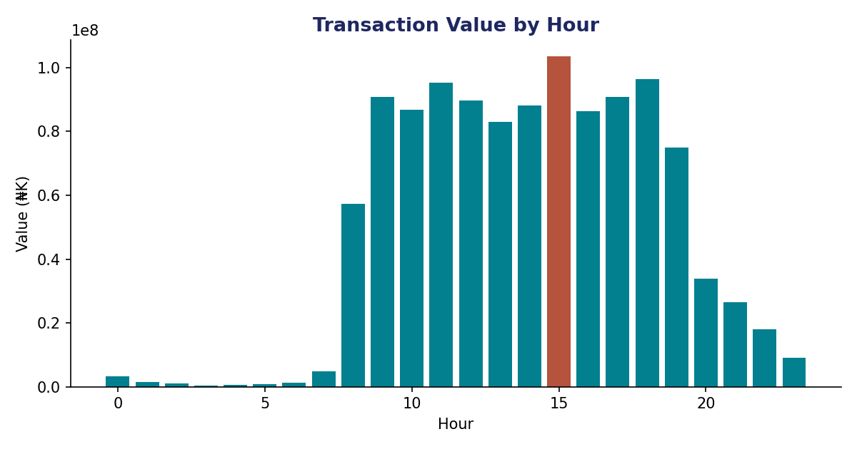
Figure 4 — Transaction value by hour of day; the peak hour (highlighted) is 15:00.
Transaction value is negligible overnight (hours 0–7) and rises sharply from 08:00 onward, holding a high, fairly flat plateau through the day. The single highest hour is 15:00 (₦103.5 billion in this sample), narrowly ahead of 18:00 and 11:00. Capacity planning should provision for this full daytime/early-evening window (08:00–19:00) rather than a single spike — the plateau, not just the peak hour, is what infrastructure needs to sustain.

4. Customer Segmentation

4.1 Note on Methodology
The segmentation dashboard shows 6,353,307 “customers” at an average of 1.00 transaction per customer. This confirms the segmentation is built on the originating account field (nameOrig) rather than a repeat-customer view: in this dataset, 99.85% of nameOrig IDs appear in only one transaction, so each “customer” here effectively represents a single transaction's profile rather than an account with an ongoing relationship to SIDONPAY.
This is a reasonable and usable segmentation — it groups transactions by size and type, which is still actionable for pricing and risk design — but it should be read as a transaction-profile segmentation rather than a customer-loyalty segmentation. A complementary view (segmenting the receiving account field, nameDest, where real repeat behavior exists across 571,961 accounts) would be needed to analyze retention or lifetime value. Both views are documented here for completeness; the dashboard itself reflects the nameOrig-based view.

4.2 Segment Overview
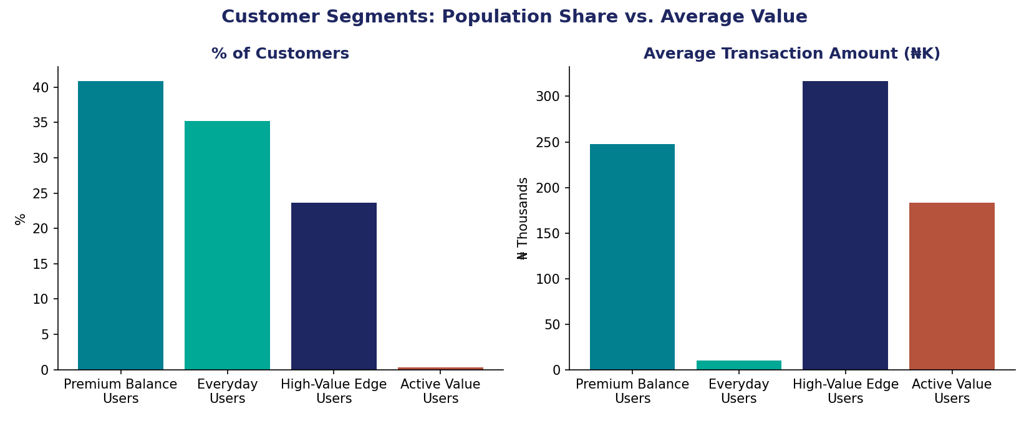
Figure 5 — Segment population share vs. average transaction value.
Segment | % of Customers | Avg. Amount | Transaction Volume
Premium Balance Users | 40.85% | ₦247,310 | 2,599K
Everyday Users | 35.24% | ₦9,940 | 2,242K
High-Value Edge Users | 23.62% | ₦316,680 | 1,503K
Active Value Users | 0.29% | ₦183,160 | 19K

4.3 Segment Profiles & Recommendations
Premium Balance Users (40.85% — the largest group) — a balanced mix of CASH_IN and CASH_OUT activity with a solid average value (₦247,310) and the platform's highest transaction volume. Recommendation: this is the core segment to design default product experience and retention efforts around, given its size and balanced engagement.
Everyday Users (35.24%) — dominated by PAYMENT transactions with by far the lowest average value (₦9,940), consistent with small day-to-day purchases. Recommendation: low-friction, low-fee experience matters most here — this segment is value-sensitive and high-volume, so small fee or UX improvements compound quickly.
High-Value Edge Users (23.62%) — the highest average transaction value (₦316,680), dominated by CASH_OUT activity. Recommendation: prioritize this segment for premium features, higher transaction limits, and dedicated support — large cash-outs are also the profile most associated with fraud risk per the Week 3 analysis, so this segment also warrants closer monitoring.
Active Value Users (0.29% — a very small, distinct group) — moderate average value (₦183,160) but by far the lowest transaction volume (19K) relative to its behavior profile, suggesting a small set of unusual or edge-case accounts. Recommendation: investigate this segment specifically before drawing product conclusions — its small size means it's easy to over-interpret, but worth a manual review given how distinct it is from the other three.

5. Recommendations by Stakeholder

5.1 Executive Management
- Total platform value (₦1.14T across 6.36M transactions) is heavily concentrated in TRANSFER and CASH_OUT activity despite their lower volume — track value health by transaction type mix, not just raw transaction counts.
- The Premium Balance and High-Value Edge segments together represent 64.5% of customers and carry the platform's highest-value activity — executive reporting should track these two cohorts specifically.

5.2 Product Team
- Design default onboarding and UX around Premium Balance Users (the largest, most balanced segment), while keeping the PAYMENT flow used heavily by Everyday Users as frictionless as possible given their fee sensitivity.
- Consider a dedicated high-limit or premium tier for High-Value Edge Users given their outsized average transaction value.

5.3 Marketing Team
- Everyday Users' high volume but low average value makes them a strong target for volume-based loyalty incentives (e.g. cashback after N transactions) rather than value-based offers.
- Daytime/evening activity concentration (Figure 4) is the right window for promotional pushes and in-app messaging.

5.4 Risk Team
- High-Value Edge Users' CASH_OUT-heavy, high-value profile overlaps with the fraud pattern identified in Week 3 (fraud concentrated in TRANSFER/CASH_OUT, correlated with transaction size) — this segment should receive proportionally more fraud monitoring attention.
- The small, distinct Active Value Users segment should be reviewed manually — unusual segments emerging from clustering are sometimes a sign of data anomalies or edge-case behavior worth investigating directly.

6. Tools & Methodology
Power BI was used to build the two-page Executive Dashboard (Business Intelligence Overview and Customer Behaviour & Segmentation), including all transaction-type, time-based, and segment visualizations referenced in this report. The underlying PaySim dataset and supporting Python analysis from Week 3 (data cleaning, fraud pattern investigation) remain the foundation for the fraud-related recommendations in Section 5.4.

7. Sources
- Lopez-Rojas, E. A., Elmir, A., and Axelsson, S. “PaySim: A financial mobile money simulator for fraud detection.” The 28th European Modeling and Simulation Symposium (EMSS), Larnaca, Cyprus, 2016.
- SIDONPAY Week 3 Fraud Detection & Transaction Analysis (internal, Team Beta) — fraud pattern findings referenced in Section 5.4.
- SIDONPAY Internship Program — Week 4 Task Brief (internal document, Team Beta).

