SIDONPAY
Funnel Analysis Framework
Simulated Customer Journey — Week 6, Team Beta
Prepared by: Ahmed | Submission Deadline: Monday, 5th October 2026

1. Introduction
SIDONPAY does not yet have real user data — the platform is still pre-launch. This week's task is to think the way a product analyst does before data exists: map the customer journey a new user is expected to take, define what “healthy” looks like at each step, build a plausible simulated dataset, and use it to practice spotting bottlenecks. The goal isn't to predict SIDONPAY's exact numbers — it's to build the analytical framework that will be ready to apply the moment real data starts flowing.
The journey modeled here has five stages, as specified in the task brief: Awareness, Sign-Up, Verification (KYC), First Transaction, and Repeat Usage. Where possible, the assumptions in this framework are grounded in patterns already surfaced in this internship's earlier work — particularly the KYC friction and extremely low repeat-usage rate found in the real PaySim transaction analysis (Weeks 3–4).

2. The Customer Journey: Stage-by-Stage Definitions

1. Awareness
Aspect | Detail
User Intention | A potential user becomes aware that SIDONPAY exists and could solve a real problem for them — juggling multiple apps for local transfers, a USD account, and gift cards.
Required Actions | See an ad, referral, or app-store listing; read enough to decide the app is worth trying; download or open the app.
Success / Failure Factors | Clear, specific messaging beats generic fintech marketing. Trust signals (reviews, app store rating, referral from someone they know) matter heavily at this stage, since the user has made zero commitment yet.
Key Metrics | Impressions, click-through rate, app installs, cost per install, install-to-open rate.

2. Sign-Up
Aspect | Detail
User Intention | The user wants to create an account quickly, with minimal typing, and without feeling like they've already committed more than they intended to.
Required Actions | Enter phone number/email, set a password or PIN, confirm via OTP, accept terms.
Success / Failure Factors | Every additional form field or screen costs conversions. OTP delivery reliability (network/SMS issues) is a common silent failure point. Users abandon fastest here if the value proposition isn't reinforced during the flow.
Key Metrics | Sign-up start rate, sign-up completion rate, average time to complete sign-up, OTP delivery/verification success rate.

3. Verification (KYC)
Aspect | Detail
User Intention | The user wants to unlock real functionality (holding balance, transacting) and expects this step to be the described “verify in minutes” experience.
Required Actions | Submit a government ID, take a selfie/liveness check, provide BVN/NIN or address proof depending on tier.
Success / Failure Factors | This is historically the most fragile step in fintech onboarding. Document quality issues, lighting for selfie checks, and manual review queues all introduce delay. Prior SIDONPAY research (Week 3) found real-world KYC delays of 24–48 hours at competitors — expectation-setting matters as much as actual speed.
Key Metrics | KYC start rate, KYC completion rate, time to KYC completion (median and 90th percentile), document rejection rate, resubmission rate.

4. First Transaction
Aspect | Detail
User Intention | Having verified their identity, the user wants to actually experience the product's value — send money, pay a bill, or fund their account for the first time.
Required Actions | Fund the wallet, select a transaction type, confirm and complete the first transaction.
Success / Failure Factors | A gap often opens here between 'verified' and 'activated' — a user can complete KYC and still not transact if they don't have an immediate use case in mind. Friction in funding the wallet (no easy first deposit method) is a common failure point.
Key Metrics | Verified-to-transacting rate, time to first transaction, first transaction type distribution, first transaction value distribution.

5. Repeat Usage
Aspect | Detail
User Intention | The user wants a reason to come back — a second transaction is the real signal that the product has become part of their routine rather than a one-off experiment.
Required Actions | Return to the app within a meaningful window (this framework uses 30 days), initiate a second transaction of any type.
Success / Failure Factors | This is the single largest risk area for SIDONPAY specifically. Real transaction-log analysis in Week 4 of this internship found that 99.85% of observed accounts had only one transaction in a month — repeat usage should not be assumed, it must be actively designed for (funding prompts, next-action nudges, habit-forming features).
Key Metrics | 30-day repeat transaction rate, time between first and second transaction, feature adoption breadth (how many product features a user tries), churn rate after first transaction.

3. Synthetic Funnel Data
Since no real user data exists yet, a simulated cohort of 100,000 “aware” users was modeled through the funnel using assumptions grounded in typical fintech onboarding benchmarks and this internship's own earlier findings (particularly around KYC friction and repeat-usage risk).
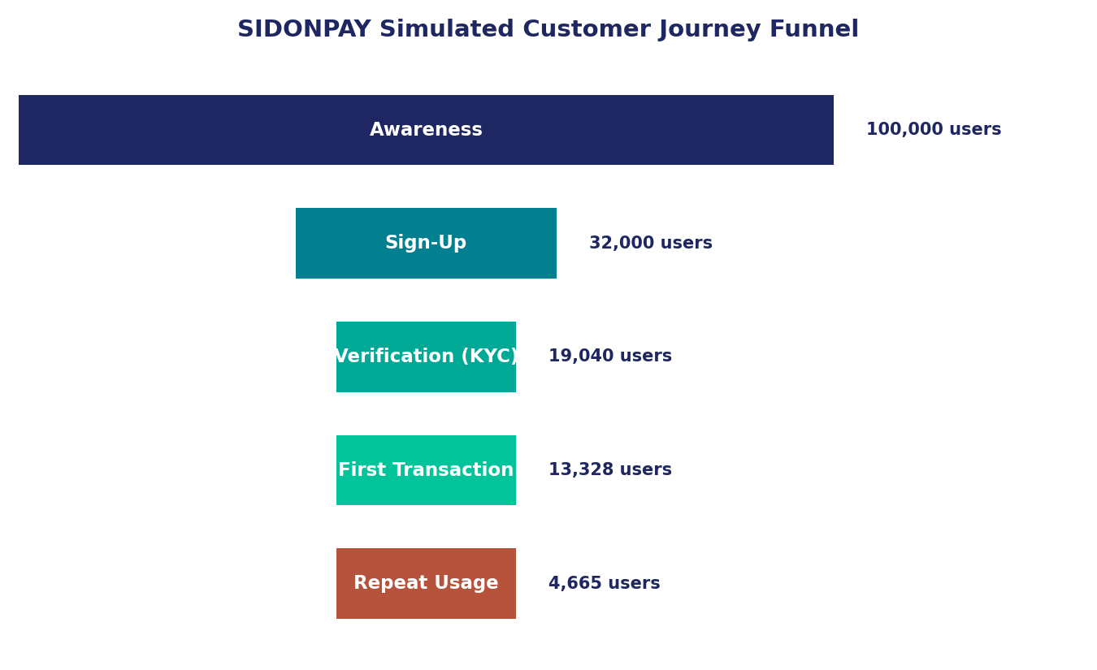
Figure 1 — Simulated customer journey funnel, 100,000 starting users.
Stage | Users Entering | Users Completing | Conversion % | Drop-off Count | Drop-off %
Awareness | — | 100,000 | — (entry point) | 0 | —
Sign-Up | 100,000 | 32,000 | 32.0% | 68,000 | 68.0%
Verification (KYC) | 32,000 | 19,040 | 59.5% | 12,960 | 40.5%
First Transaction | 19,040 | 13,328 | 70.0% | 5,712 | 30.0%
Repeat Usage | 13,328 | 4,665 | 35.0% | 8,663 | 65.0%

Overall Awareness-to-Repeat-Usage conversion: 4.67% (4,665 of 100,000). Simulated time-to-complete assumptions: median sign-up time ~3 minutes; median KYC completion ~45 minutes (bimodal — many complete instantly, a meaningful share wait 24–48 hours for manual review, consistent with the competitor KYC delays found in Week 3); median time to first transaction ~2 days after verification; median time to second transaction (among those who return) ~18 days.
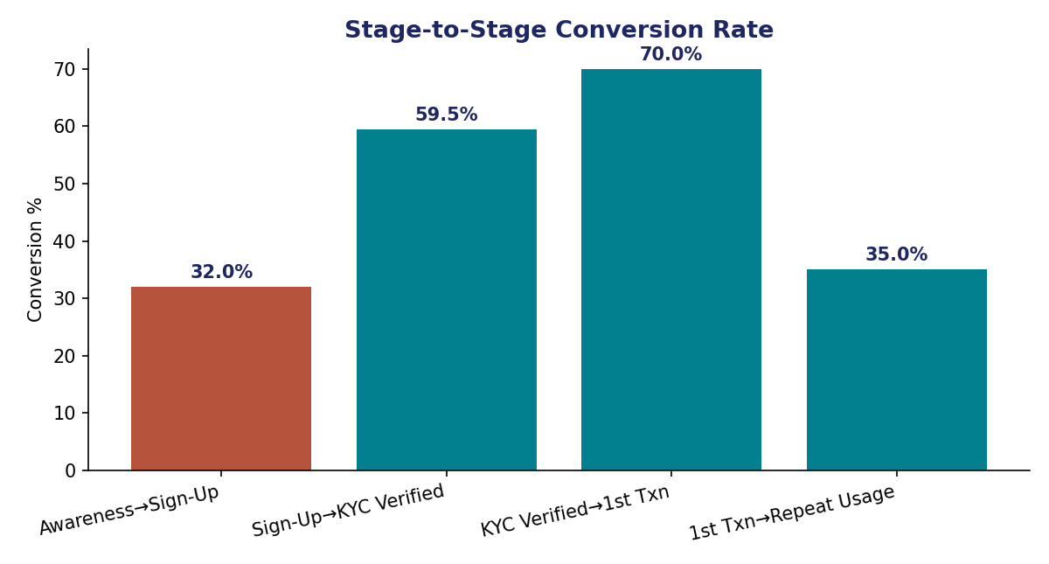
Figure 2 — Conversion rate between each consecutive stage.

4. Analysis: Patterns, Strengths & Bottlenecks

4.1 The Two Biggest Leaks
Two stages account for most of the lost users: Awareness→Sign-Up (68% drop-off) and First Transaction→Repeat Usage (65% drop-off). These are very different problems. The Awareness leak is a top-of-funnel marketing/UX question — most funnels lose the majority of users here, and 32% is within a plausible range for a new fintech app, though it leaves room for improvement through clearer value-proposition messaging before download.
The Repeat Usage leak is the more urgent one. A 35% repeat-usage rate in this simulation is already an optimistic assumption — the real transaction data analyzed in Week 4 of this internship showed only 0.15% of observed accounts had more than one transaction in a month. If SIDONPAY's actual repeat rate lands anywhere close to that historical pattern rather than this simulation's 35% target, retention becomes the platform's single largest risk, not fraud or onboarding friction.

4.2 KYC Is a Real Bottleneck, Not Just a Simulated One
The 59.5% Sign-Up→KYC-Verified conversion in this simulation is deliberately conservative, based on real friction points already documented elsewhere in this internship: Chipper Cash's 24–48 hour manual KYC review delay (Week 1 competitor research) and the operational reality that verification steps requiring a selfie or document upload consistently see the highest abandonment in fintech onboarding generally. SIDONPAY's “verify in minutes” promise is a genuine differentiator only if actual completion times beat this simulated baseline meaningfully.

4.3 What's Working
The Verification→First-Transaction (70%) and, implicitly, the KYC-completion-to-attempt steps show that once a user clears identity verification, most do follow through to an actual transaction. This suggests the core problem is not persuading verified users to transact — it's (a) getting more people through KYC in the first place, and (b) giving transacting users a reason to come back.

5. How Analytics Can Improve Onboarding, Activation & Engagement
Funnel Stage | Analytics-Driven Improvement
Awareness → Sign-Up | A/B test onboarding copy and the first screen users see; track install-to-open rate by acquisition channel to identify which channels bring users who actually engage, not just install.
Sign-Up → KYC | Instrument step-level drop-off within the KYC flow itself (document upload vs. selfie vs. review wait) so Design knows exactly which sub-step to fix first, rather than treating KYC as one opaque stage.
KYC → First Transaction | Track time-to-first-transaction as a core activation KPI, and trigger a targeted nudge (e.g. a funding prompt) for verified users who haven't transacted within 48 hours.
First Transaction → Repeat Usage | Treat 30-day repeat rate as the platform's north-star retention metric from day one. Segment first-time transaction types to learn which first actions (bill pay vs. transfer vs. gift card) correlate with higher repeat rates, then design onboarding to steer users toward those actions.

More broadly, this framework's value is that it defines what to instrument before the product launches. Once real usage data exists, SIDONPAY's Product and Marketing teams can replace every simulated number here with an actual one, and the stage definitions, metrics, and bottleneck hypotheses built this week become the lens for interpreting it.

6. Conclusion
This simulated funnel highlights two priorities for SIDONPAY ahead of launch: reducing friction in the Sign-Up and KYC stages, and treating repeat usage as a designed outcome rather than an assumption. The real transaction data already analyzed in this internship (Weeks 3–4) suggests the retention risk in particular is not hypothetical — it is the single most important pattern to watch once SIDONPAY has live users.

7. References
Required reading/viewing for this task, per the Week 6 brief:
- “What is a Funnel?” — introductory YouTube video, as assigned in the Week 6 task brief reading list.
- Google. [GA4] Funnel exploration — Google Analytics Help. Official Google resource on building and reading funnel reports from a marketing/analytics perspective.
- Mester, T. What is Funnel Analysis? — Data36.
- Daasity. What Is Your Conversion Funnel Analysis Telling You and What Should You Do About It?
- Collins, B. Funnel Charts in Google Sheets — benlcollins.com.
- Atlassian (formerly Chartio). A Complete Guide to Funnel Charts.
- SIDONPAY Internship Program — Week 6 Task Brief (internal document, Team Beta).
- SIDONPAY Week 3 & Week 4 internal analyses (Team Beta) — real transaction-level findings on KYC friction and repeat-usage rates, referenced throughout this framework as grounding for synthetic data assumptions.

