1/16/2026
THINKFORGE

GROUP 4
BIOMEDICAL ENGINEERING
MLS 413

LECTURER -IN-CHARGE
ENGR. DR. SULEIMAN ABIMBOLA YAHAYA

THINKFORGE
(GROUP 4)

BIOMEDICAL ENGINEERING
MLS 413
GROUP MEMBERS
Olafusi Marvelous Kehinde 21/47pw097
Ogungbade Olamilekan Matthew 22/47pw126
Adeyemi Fathia Wuraola 21/47pw037
Akinsola Mutmainah Opeyemi 22/47pw117
Adeeko Aishat Oluwatosin 21/47pw027
Yakubu Nezibetu Eleojo 21/47pw126
Azeez Aishat Temilade 21/47pw057
Adedimeta Hikmat Bisola 21/47pw026
Adewoyin Fatimoh Adeyemisi 21/47pw036
Oladejo Mubarakah Olanrewaju 21/47pw096
Salaudeen Rodiat Omowunmi 21/47pw116
Olowookere Juwon Taiwo 21/47pw106
Abidoye John Oluwatobi 21/47pw017
Abdulkareem Sodiq Olalekan 21/47pw006
Akinsade Emmanuel Oluwafemi 22/47pw116
Muhammed-Fatiu Adinoyi 21/47pw087
Ayodele Grace Motunrayo 21/47pw056
Abdullahi Aishat Abiodun 21/47pw007
Olatunde Samuel Elujoba 21/47pw067
Abdulwahab Shekinah Foluke 21/47pw016
Muhammed Halimah Ladidi 21/47pw086
Oladimeji Oluwasanmi Solomon 22/47pw127
Oludare Emmanuel Anuoluwapo 21/47pw107
Amodu Awal Adekola 21/47pw047
Abdus-Salam Radiya 21/48kc007
Salihu Faridah 21/47pw117

Table of Contents
INTRODUCTION 6
The Lab Coat That Crossed the Line 6
Problem Statement 7
Objectives 8
EXISTING LITERATURE REVIEW 9
Dipowin (2025) – LabGuard Lab Coat Detection Device 9
Grekkom PPE Monitor 10
PROPOSED SOLUTION: SMART ENTRY SENTRY 11
Justification and Significance 11
Methodology 12
Method and Fabrication Process 13
Results 16
Limitation 16
Recommendation 16
Conclusion 16

INTRODUCTION

The Lab Coat That Crossed the Line
In the quiet hum of a medical laboratory, every detail matters — every drop, every movement, every habit.
Zara, a young lab scientist, had finished analyzing some critical samples. Focused and fast, she left the lab still in her lab coat to grab something from the media prep room. She didn’t know it, but that single move carried more than just her presence — it carried microbial hitchhikers, silently threatening the sterility of the environment she stepped into. Contamination didn’t announce itself. But days later, when unexpected results and repeat tests began to pile up, someone traced the source… and it all led back to that coat.
That day sparked a change — the need for a system. A smart, quiet reminder that lab coats must stay where they belong.
That’s what we set out to build: A solution that protects spaces, specimens, and science — one coat at a time.
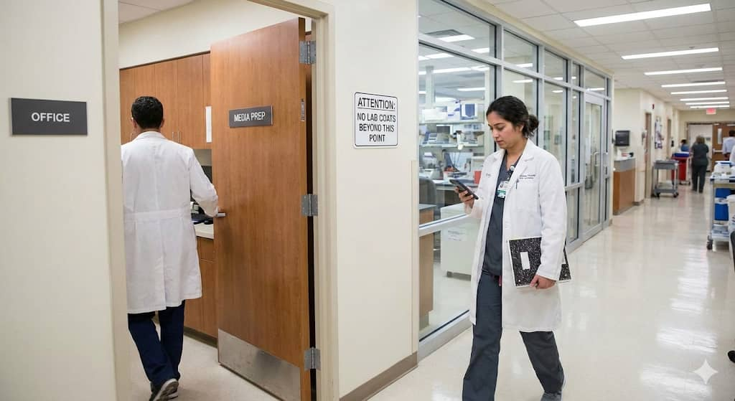

In healthcare system, the control of cross contamination is paramount, directly influencing the accuracy of diagnostic result and the safety of personnels, non-personnels and patients. There are fundamental protocols that guide the operations and activities in the laboratory, most important of which is stringent use of PPE (Personal Protective Equipment) such as lab coat, hand gloves among others.
Despite established guidelines, compliance with PPE protocols remains inconsistent, often due to human error or oversight. This poses a significant risk, especially in sterile zones where even minor breaches can lead to contamination, diagnostic errors, and potential outbreaks. To address this challenge, there is a growing need for an automated, real-time system that ensures only properly dressed individuals can access designated sterile environments.

Problem Statement
In Medical Laboratory settings, cross-contamination is a critical risk. Personal Protective Equipment (PPE) like lab coats, scrubs, nose masks and gloves, which are essential in the laboratory, act as fomites (carriers of contamination) when worn into sterile areas like culture media rooms, administrative offices, restrooms and public places.
Imagine a scenario where a laboratory scientist handles a hepatitis B–positive sample while wearing PPE. Instead of removing it before leaving the work area, he walks into the administrative office, restroom, and even shared public spaces with the same PPE on. Because hepatitis B can survive on surfaces for long periods, the contaminated PPE can transfer the virus to anything it touches. Anyone who later comes into contact with those surfaces risks exposure and possible infection.
Current enforcement is dependent on human memory and supervision, which are both prone to error. Laboratory staff or security officers cannot monitor every entrance at all times, and fatigue or distraction can easily lead to lapses.
Aim
To develop an automated system that detects lab coat use at key points (sterile areas and public places) to prevent cross-contamination between laboratory and sterile areas, ensuring biosafety through real-time monitoring.

Objectives
- To design and implement a vision-based system capable of recognizing lab coats in real time.
- To integrate the detection system with an alert system that notifies personnel when a lab coat is detected.
- To improve adherence to laboratory sterility protocols by providing a consistent, automated monitoring solution.
- To minimize contamination of sterile areas and prevent spread of contaminants.
- Evaluate facility-wide compliance trends through centralized data analytics to drive continuous safety improvements.

EXISTING LITERATURE REVIEW

Dipowin (2025) – LabGuard Lab Coat Detection Device
Dipowin (2025) developed LabGuard, an automated PPE-monitoring system designed to detect laboratory coats at controlled entry points. The system integrates a Huskylens AI camera with an ESP32 and Arduino microcontroller to identify whether personnel are wearing lab coats before entering restricted areas. When incorrect PPE usage is detected, the system triggers both an audible alarm and a cloud-based notification for supervisory monitoring. The project demonstrates that real-time PPE enforcement greatly reduces human-supervision dependency and improves compliance in laboratory environments.
Strengths:
- Provides automated monitoring at access points
- Cloud notifications allow remote tracking by supervisors
- Demonstrates practical proof-of-concept and real-time feedback
Limitations Identified:
Despite being simpler than high-end industrial AI systems, LabGuard still relies on specialised hardware, including a commercially manufactured AI camera module (Huskylens), which significantly increases system cost. The solution also depends on cloud connectivity—which introduces recurring data expenses, the need for internet access, and possible security or downtime concerns. Furthermore, the system monitors only one type of PPE (lab coats) and does not actively restrict where PPE is worn after leaving the lab, meaning cross-contamination risk in sterile or public areas still persists.
Gap Addressed by Our Project:
Unlike LabGuard, the focus of the current project is to control PPE movement between laboratory and non-laboratory zones, thereby preventing cross-contamination into sterile rooms and public spaces. The proposed system emphasizes offline, low-cost components that remove the need for expensive AI cameras, Wi-Fi modules, or cloud alert infrastructure. By relying on embedded sensors and localized alarms, our design ensures functionality even in low-resource settings, night shifts, or areas with unstable internet connectivity. This makes the system more accessible, scalable, and suitable for medical laboratories in environments with budget or infrastructure constraints.
https://www.hackster.io/dipowin/labguard-lab-coat-detection-device-for-laboratory-safety-08202f

Grekkom PPE Monitor
Grekkom PPE monitor is among the most advanced video analytic systems for real-time safety compliance. The system works with standard IP cameras, detects a wide range of PPE (helmets, safety vests, protective clothing including lab coats in principle), and provides real-time alerts, logging, and dashboard-based reporting.
However, the Grekkom PPE monitor, like most generic PPE systems ,is designed for broad industrial environments to ensure the safety of workers/personnels. It is not tailored to the healthcare settings and does not monitor the PPE being worn to sterile environments such as administrative offices, culture media room and areas outside the lab.
Because of these limitations, we propose to build a custom lab-coat detection and alert system device. By focusing solely on “lab-coat presence/absence + alert/light/buzzer” for our sterile room entry, we expect to achieve higher reliability, easier deployment and full integration with our lab’s workflow , advantages that generic PPE monitors like Grekkom cannot guarantee out-of-the-box.
https://grekkom.com/en/products/our-analytics/work-safety/ppe-monitor/

PROPOSED SOLUTION: SMART ENTRY SENTRY
We propose the development of the "Smart Entry Sentry," an automated safety device capable of recognizing Personal Protective Equipment (PPE). This system uses Computer Vision and is designed to be installed at the doorway of restricted "clean" areas (such as offices or media rooms).
The system functions through the following three steps:
Continuous Monitoring:
A camera module installed at the entrance maintains constant surveillance, capturing a live video feed of every individual approaching the doorway.
Real-Time Analysis:
The system processes the video feed instantly using an object-detection algorithm. It is programmed to specifically identify the visual characteristics (color and shape) of a medical lab coat on a person's body.
Automated Alert System:
If a lab coat is detected, the device immediately activates a dual-alarm mechanism to stop the breach:
- Visual Alarm: A red indicator light flashes to signal "Stop."
- Auditory Alarm: A buzzer sounds to provide an urgent warning to the user.

Justification and Significance
Maintaining sterility in laboratory environments is critical to ensuring accurate diagnostic results and safeguarding both patient and staff safety. Despite clear protocols, human error often leads to breaches in sterile zones, primarily due to improper use of lab coats outside designated areas. Lab coats, while essential within the lab, can inadvertently become carriers of microbes, introducing contaminants to sterile spaces and compromising experimental integrity.
The Smart Entry Sentry device addresses this gap by automatically detecting and restricting lab coat usage in non-laboratory sterile areas, such as media rooms or administrative zones. By doing so, it minimizes the risk of microbial transfer, reduces the incidence of contamination-related experimental failures, and lowers associated financial losses due to wasted materials.
The device’s non-invasive, camera-based detection system operates in real time, ensuring continuous compliance without disrupting workflow or requiring additional manpower. Ultimately, this innovation strengthens laboratory biosafety, optimizes operational efficiency, and supports the delivery of reliable healthcare outcomes.

Methodology
Components and Uses
Components required to build a lab coat detection device using the ESP32 micro-controller
COMPONENTS | USES
ESP32-Cam module | Main processing unit
LEDs | Captures and processes images
Resistors | Current limiting resistor for the LED and buzzer
Enclosure | Houses and protects all components
Flex wire | Provides flexible electrical connections between components
Active buzzer | Alarm notifications
Transformer | Adjusts voltage for the circuits
Printed circuit board (PCB) | Holds and connects electronic components
Rectifier | Coverts AC to DC voltage
Filtering side | Smooths voltage and reduces noise
Regulator | Maintains a stable voltage for the circuit
Batteries | Supply electrical power to the circuit
Diodes | Allows current to flow in one direction
Header pin | Connects wires or modules
Jumper wire | Connects circuit components
DC converter | Changes direct current voltage levels
Wire (AC cord) | Supplies alternate current power to the circuit
Vero board | For building and testing electronic circuit
PIR sensor | Detects motion by sensing changes in infrared radiation
Transistor
Terminal block 2pin | To connect external wires
Soldering lead | To join electronic components together

Method and Fabrication Process
Circuit Construction
The transformer, rectifier, capacitor, and regulator were mounted on a power board.
The printed circuit board (PCB) is the backbone of the electronic device. It is designed to connect the electronic components using conductive pathways printed onto it. The Printed circuit board (PCB) was designed attributing every components and then it was printed at a electronic laboratory and afterwards, every components were placed accordingly on their specific locations. Soldering iron with soldering lead was a major equipment used in fixing the components on the printed circuit board.
The system was programmed using the Arduino framework on the ESP32-CAM to implement an automated PPE detection mechanism. A Passive Infrared (PIR) sensor is first used to detect the presence of a person, which triggers the camera to capture an image. The captured image is processed in RGB565 format, and a region corresponding to the torso area is analyzed to compute the ratio of white pixels based on predefined threshold values. This white pixel ratio serves as a simple heuristic for detecting the presence of a laboratory coat. If the computed ratio exceeds the set limit, access is denied and a red LED with a buzzer is activated; otherwise, access is granted by illuminating a green LED. A cooldown mechanism is incorporated to prevent repeated detections within a short time frame, ensuring system stability and efficient operation.
Assembly and Preparation
ESP32-CAM is a microcontroller and acts as the brain of the project. It contains the microprocessor.
The code is on the ESP32-CAM and controls the camera. The microcontroller processes the signal from the PIR (passive infrared) sensor and determines whether the user meets PPE requirements. It is the first component to sense the person.
The PIR is connected to the ESP32-CAM and 5 V supplied from a battery (a direct current supply).The PIR sensor detects human presence by sensing body heat (infrared radiation). Once a person on labcoat walks into the sensor's field of view, it outputs a signal indicating motion and triggers the ESP32-CAM.
The device is powered from a 220 V AC current (alternating current) from the socket .The current needs to be stepped down because 220V is too high. The 220V is stepped down with a transformer to 12V.
The alternating Current (AC) is converted to Direct Current using a bridge diode / bridge rectifier. Two terminals (+12 V and –12 V) from the rectifier are connected to the battery. The battery is connected to a capacitor to remove remaining AC ripple and finally regulated to 5V DC using a voltage regulator to safely power the ESP32 and PIR.
The red, green lights and buzzer(via transistor) are connected to the battery and ESP32-CAM.The programmed ESP32-CAM is loaded with firmware that interprets PIR signals and triggers output devices.
All components are neatly installed in a compact casing (enclosure) to prevent electrical hazards and allow wall-mounting near the door.
Based on the programmed logic:
If the person is wearing a lab coat; the system activates the red LED and sounds the buzzer, indicating restricted entry.
If the person is not wearing a lab coat; the green LED lights up, and the buzzer remains silent.
The system resets automatically after each detection.
DIAGRAMS AND FLOW CHART
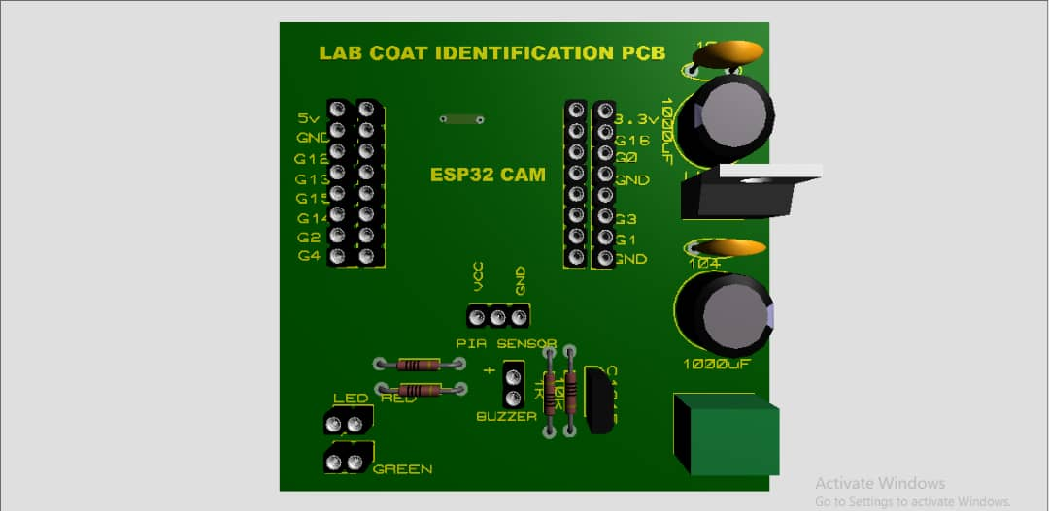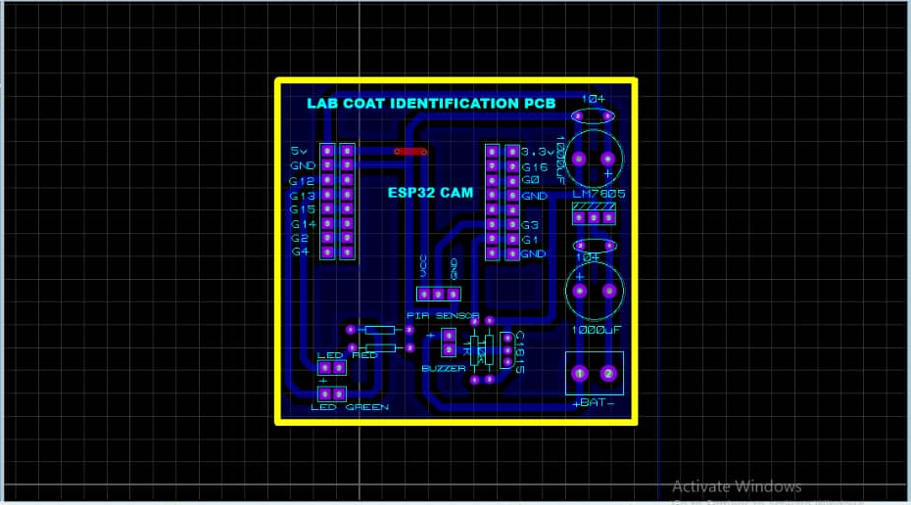
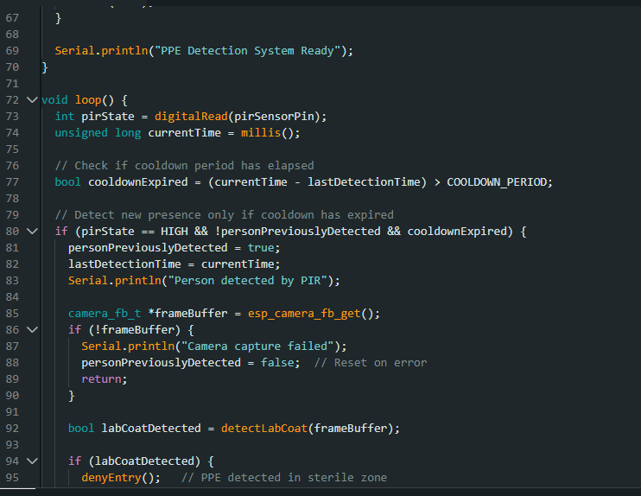
Snippet of the code logic

(DON’T FORGET TO UPLOAD THE CIRCUIT DIAGRAMS)
Implementation
After assembly, the system is mounted at the entrance of a designated lab area. Power is supplied through the regulated DC source. The device continuously monitors incoming personnel and enforces PPE compliance by triggering clear alert using Led (red light).

Results
The Smart Entry Sentry, an automated PPE monitoring system with a ESP32-CAM accurately identify users wearing lab coat with 85-95% detection accuracy. The system provide real time results (3 – 5 seconds) and trigger clear alert using Led (red light) to remind the personnel. This improve laboratory safety by ensuring PPE compliance and reduced contamination risks.
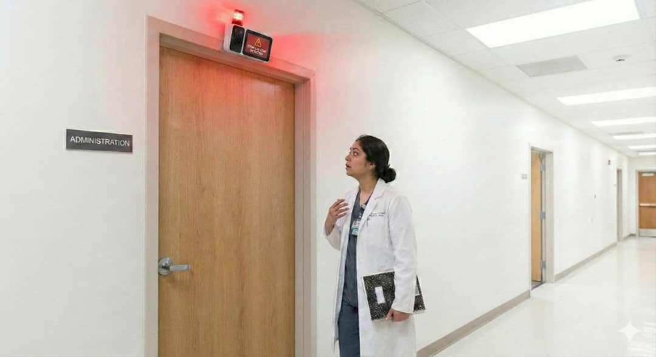

Limitation
Although Raspberry pi 4 would have been an highly effective component for the proposed project. Due to the high cost, it was therefore replaced with a more affordable component, ESP32-CAM Module.
The doorway environment must be properly illuminated to ensure a high quality image can be captured.

Recommendation
The system can be improved and scalable for future addition such as automated door control that denies the entry of personnel on lab coat into the sterile areas and public places.

Conclusion

