CS4116 Software Test Report.

Student Name: Olan Healy

Student ID number: 21318204

Student Group Number: 4

Group being tested: 5

Date of test: 10/04/24

1. **Was there an index.html file? Was it obvious what the website was from the first page?**

There is no index.html file but there is an index.php file. The index.php file acts as an entry to the website and redirects the user to a login page. So, with the url, I typed in “index.php” at the end and it brought me to the same page. This is exactly the same as what we have now, the index file redirects us to our login page.

I tired accessing the index.html but I got a 404 error which means not found. We currently have the same setup for our website, using an index.php as a redirect file. But it could be useful to include and index.html file as a static page to engage users before prompting them for login credentials. You could display basic information about the website etc. and then use buttons just to redirect to login / signup, something we plan on doing. Explaining how you can connect with other users is included in the project spec

Just from accessing the site itself based off the index, it is not obvious what it is. There is no logo, no title, nothing that is distinguishing that the site is a dating website. Even when you go to registration, it is not clear that it is a dating website

1. **What is the site for? Describe the sort of people that the site targets.**

It is not clear what sort of people the site targets. It is hard to see that it is a dating site, especially considering I can register for an account if I am under 18-year olds. A dating website should typically require you to be over the age of 18 as the purpose of such site is to pursue some sort of sexual relationship.

I would recommend when registering having an option for looking for or something along them lines. You could have it as an ENUM and then make it clear that you are looking for a serious relationship with a female. It directs be to a login page, which is the same as what we do at the moment.

I’m also not sure of how the suggestion works for displaying potential matches. When I login, I am greeted with this page:

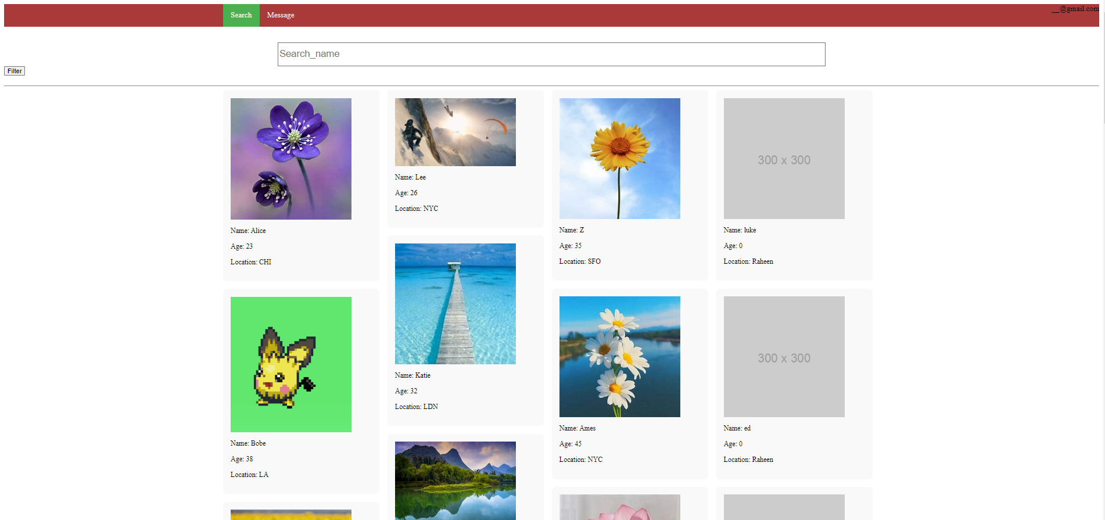

It looks good, but it is just displaying the users who are registered and not in any specific order. I would suggest having some sort of page that suggest users that are potential matches based off inputs you put in while registering. From this homepage, to me, this website just seems like a messaging platform. I can see other users, I can search other users and then I can message them. But then when I go to messages, it is then prompting me to join a chat room. It is very unclear on what the goal/objective of the site is.

1. **How well did the registration section work? What happened when you put in malformed input (for example, mismatched passwords, wrong types, etc.)?**

**Mobile Number Validation:**

* ***Problem:*** You can type a String in as a mobile number, so for example, I put my phone number in as “hello” and was able to register.
* ***Recommendation:*** You have a data type check of tel which is good, but I would definitely suggest to include some regex pattern to make sure the phone number is valid. The field should only accept numbers and possibly include a format validation to accommodate international formats if needed.

**Date of birth**

* ***Problem:*** Good job on constraining the date that you cannot select a date it the future but you Can be less than 1 year old signing up to the website. A dating website usually encourages some form of potential sexual relationship so I don’t think that’s appropriate (GDPR guidelines!)
* ***Recommendation:*** You have this in currently ``` <input type="date" name="dob" required="" max="2024-04-10"> ```

I suggest that you could change this by having the max sent to be an 18-year old’s date? And update this each time. I believe javascript is being used as it’s getting the current date or whatever is being used you could edit it to get the date for an minimum age of 18 year old based off current date and then go from there.

**Registration Date:**

* **Problem:** I believe a user would not need to see this information of their registration date.

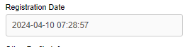

Technically I have not actually registered yet, I am registering, so the title itself is a bit misleading. This is probably being stored in the database (or not) but I don’t get the need for displaying this.

* ***Recommendation:*** I think you should only store this information in the backend and not to the user. As me being a user, I personally don’t need this as from my view I can see the date in many places, my desktop phone etc.

**Making an account with missing fields:**

* ***Problem:*** I Can make an account without having a description or other profile info or last name.
* ***Recommendation:*** I recommend changing these fields to be required when registering for an account. If they should not be required when registering, make it clear to the user as when I was using, I hadn’t a clue if I needed these or not.

***Any file can be put in for profile picture***

* ***Problem:*** I am able to put any file as a profile picture. I can put in a .mp3 file etc. and it will still be accepted and registered.
* ***Recommendation*** What we did with our website was make sure the file uploaded ended in “png” or “Jpeg”/”jpg” form. If it is we accept the file but if its not we then throw an error display message with invalid file type and that only the certain files are allowed.

***Password validation check***

* ***Problem:*** There is no checks done for inputting a password. For example, I can put 1 character in as my password “1”, “@”, it can be anything!
* ***Recommendation*** I would suggest adding in different checks such as password length and capital letter and special character (_, ?, %, etc.). This way users have a more unique password

***Password and confirm password don’t have to match***

* ***Problem:***  For password, I can type Hello and for confirm password I can type World. It will still register the account with the password being Hello
* ***Recommendation:*** Have some check to make sure the password and the confirm password match eachother before continuing onto the next site

***Crashing issue when registering an account (HTTP 500 error)***

* ***Problem:*** A major issue is not knowing if your account is created properly. Only by trying to login did I actually find out my account had been created. So when you actually register an account, you get a HTTP 500 Internal server error which could mean a multitude of different reasons. I believe it it’s because when you click register button and if the details are correct, it’s not redirecting the user anywhere. So what we do is once all registration checks are complete and validated, we start a session for this user id after its inserted to the database (it doesn’t look like this is using a MySQL database) and then we redirect a user to a page to edit certain details. I think you should have it so when someone registers, it logs them in too and then they can access your homepage button is never actually assigned to submit the data somewhere.
* ***Recommendation:*** To me it seems like there is no database to communicate with. The form is a POST which is good and it is using register_process.php on server side. However, it is getting a 500 HTTP Internal Server error which means something is going wrong in the script (image below). The database is not setup so it’s not actually posting the information anywhere. I would highly recommend to use a database and is one of the core features of the module.

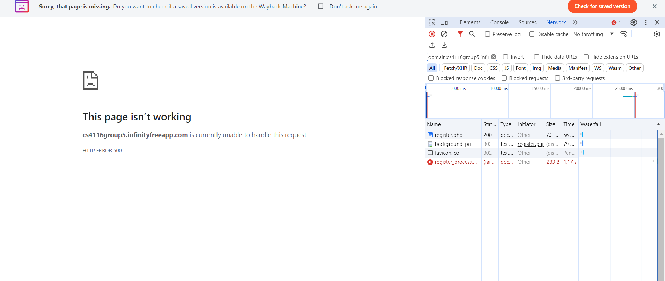

***If you get an error message, it doesn’t ever clear them message when you type in a new email and it makes a new account while giving you an error***

* ***Problem:*** If you try register with an email, that is already used, I get an error saying email is already used which is good. However, I should be able here to use a different email and continue the registration process. When I type in a new email and register, it still displays the error about email in use but If I try to sign in it actually makes the account
* ***Recommendation:*** The image below is me testing making an account with a new email after I first make one with email already used. It stays on the register page, displaying email already been used which is misleading. It seems that register.php is actually handling the registration posting this information t a String with relevant data. The register_process.php is coming up as 302 found here as it it still displaying the error from before where I try make an email which is already used. To me there are just more methods that need to be implemented to make sure fully functional.

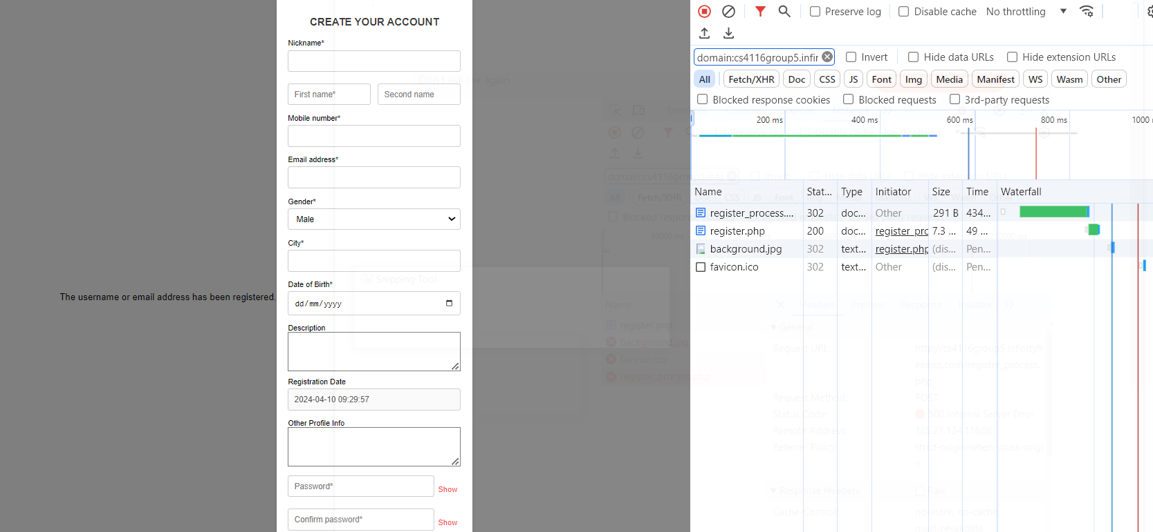

Overall, I would really recommend using a database to store users data. It is unsafe for users to have their information stored publicly on a live website. The spec also requires you to have a database.

1. **Did the search function work?**

The search function works (somewhat).

* The Age filter worked perfectly, great job. It displayed the users currently on registered who were under the age of whatever was selected. This worked as expected
* The search_name filter works, but it is a bit too strict. You have to type the exact “nickname” of the user you are searching for. This is fine if you were to know a user, but say hypothetically you met someone on a night out and only remembered their age and first name. You knew they were registered on this site and wanted to try find them the next day. It would be very difficult to actually find this person as you would need their full name (nickname).
* As I said I would highly recommend using a SQL database as not only is it in the script, it makes this much easier. You could use SQL `LIKE` query which will allow users to find other users by having part of their name right eg If you were searching for Olan Healy and had Olan, the user Olan Healy should show up.
* If you had it that you could search some of their name and you could have an autocomplete feature maybe using javascript that would suggest users based off what you are typing. This could help user experience as while users are searching for another user, they will be suggested the completion. It will also help misspellings
* You could improve the search_for query by also including an option for interests (other user info) based off you make this an ENUM. It will improve users experience as they can search for users with similar interest to them.
* You should also include a gender filter for searching as it is included in the project spec (e.g. list all women over 31 with a particular hobby)

1. **What was the “look and feel” of the site like? Was it pleasant to use or were there rendering problems and/or missing links?**

The website was not too pleasant to use. When I first typed in the url, I got directed to this

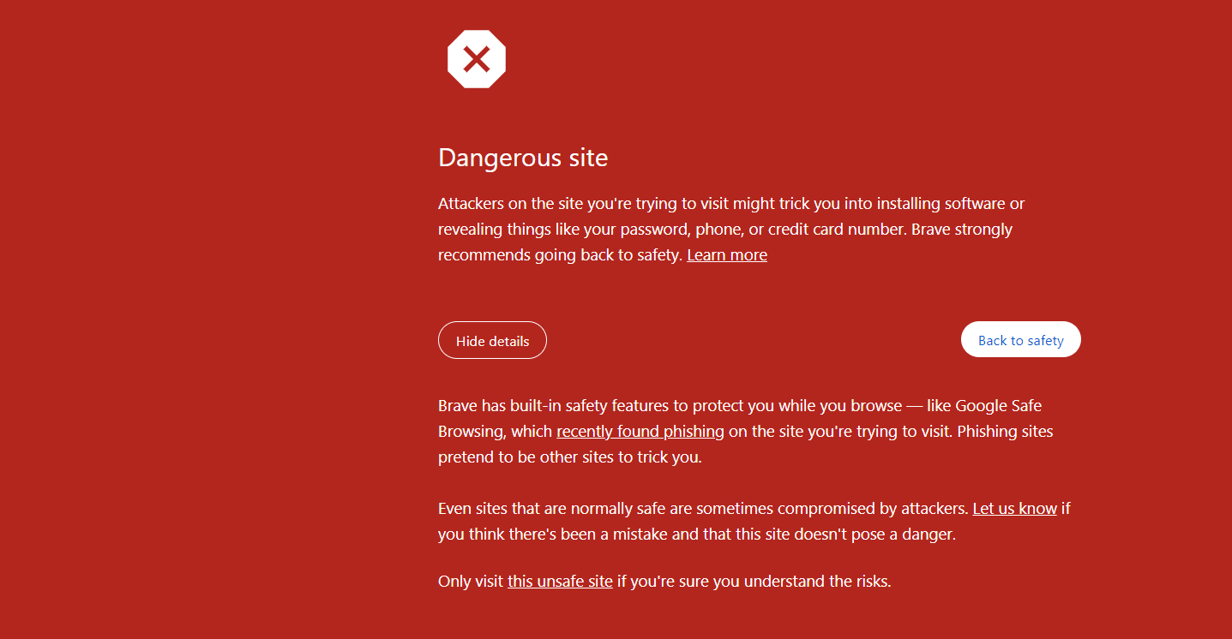

so I quickly went into private browsing. To be honest, I wouldn’t have continued going into the website only for that I knew it was made by people in our module. lt would significantly deter users from proceeding further due to concerns over their online safety. No one would want to give any sensitive information to this website after seeing this. I believe it is being displayed due to the aforementioned no database and sensitive information is being stored on the site itself.

The login page is good and it is easy to use. However when you get to registration, to even use it on desktop, you have to zoom out. It hides the entry “nickname” so you actually cannot register without zooming out. Also, on mobile, you cannot see the error you get say for example if you register with an email that already exists. The homepage is good and displayed at a proper view for mobile and desktop (mobile could be bit cleaner with the profile display!).

The message page is a bit confusing. When you get to it looks good but it is confusing on its actual purpose and how it works.

1. **Do you have any additional suggestions or advice for your classmates? If so, please make them here.**

* I would say you definitely need to include a SQL database. Not only for data privacy concerns but it is also included in the spec
* The messages page. I don’t understand the whole idea of it. When I am directed I can see in the url it is called login.html? You are given a form with username and room number. You can now type in any username you want and any room number (can be letter or anything but if it’s a number it’s a room with that number, if it’s a letter or anything else it’s the same room as any letter). The form action is of type GET but you are doing a POST of a new username (should get your old username) and then joining a random new room. Other users can chat in this room but at the moment all you can do is chat I don’t understand the idea of it. Maybe make it clearer what the idea of the messages page is and have a way of connecting with other users in this like what the spec says
* Definitely include a landing page and it has given me the idea to include a landing page for us. From a user’s side, it needs to be made clear what the websites intention is and it needs to captivate the users attention and encourage engagement
* I would suggest including sessions when you get a database working. When I logged in, I found out that your homepage was called MainPage.php. I then went onto a new browser and typed this URL in:

<http://cs4116group5.infinityfreeapp.com/MainPage.php>  
I was able to access the HomePage without logging in and when checking the Network option in developer tools, it was clear to me that no cookies were used.

* I would definitely suggest and has also giving me the idea to include an SSL cert for HTTPS encryption. This would ensure data transmitted between the user's browser and the website, ensuring that sensitive information like passwords, emails etc. are securely transmitted over the internet. The website would have ‘https://’ prefix with an ssl cert, and I believe it can be done easily on infinityfree which you are using.
* I would definitely suggest improving the layout of the registration page, making sure all the details fit on the screen and that the error messages display better for mobile and desktop.
* I would suggest checking your error logging messages. If I know a users email, I can type in that email and then any password and type login. I then get this message:

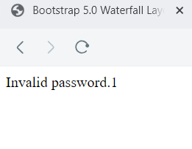

Not only should the error message popup on the screen, but that 1 is the actual password of the user I’m trying to login to.

* From looking at the sample users, I can see it is intended for a user registering to enter a bio in the tag **description** and hobbies in **other user 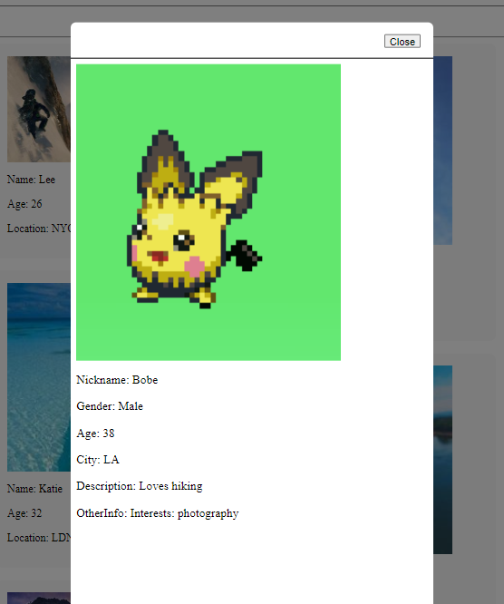info**

This is good and keeps to the spec, but maybe change the other user info to be interests and make the html show a list and they can tag certain interests based of this list? It would keep it easier to manage. Other info was not a clear field to me and if it was hobbies, it may be easier to identify that “oh okay, so the website wants me to enter hobbies”.