**HWK 1**

I **THOMAS, Olaoluwa O.**, pledge on my honor that I have not given or received unauthorized assistance on this assignment/examination. I further pledge that I have not copied any material from a book, article, the Internet or any other source except where I have expressly cited the source.

Signature: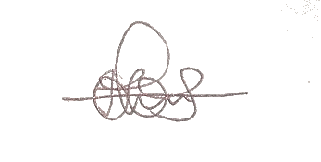 Date: October 1st, 2017

1. The number of lines in the file is 8993
2. The number of lines in the file after eliminating the lines with NA values is 6876
3. The most common education level is 1 to 3 years of college (level 4)
4. The most common income level where the respondent has had some grad school is level 9; $75,000 or more.