**LAB 1**

I **THOMAS, Olaoluwa O.**, pledge on my honor that I have not given or received unauthorized assistance on this assignment/examination. I further pledge that I have not copied any material from a book, article, the Internet or any other source except where I have expressly cited the source.

Signature: Date: October 1st, 2017

1. Only two columns have null values, MonthlyIncome & NumberofDependents

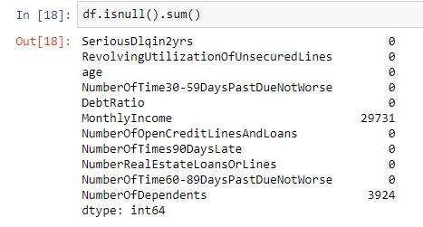

1. The column names would have to be re-written as they cannot be adequately snakified as they are.

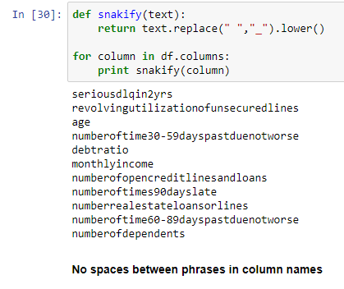

1. There are 76,151 cases of people above 34 who have been delinquent in the last two years and have less than 10 lines of credit and loans.
2. There are 539 cases of people who have been delinquent in the last two years and are in the top 90% of highest earners.