**LAB 2**

I **THOMAS, Olaoluwa O.**, pledge on my honor that I have not given or received unauthorized assistance on this assignment/examination. I further pledge that I have not copied any material from a book, article, the Internet or any other source except where I have expressly cited the source.

Signature: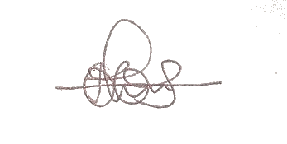 Date: October 7th, 2017

Data Exploration:

Dataframe of 13 predictor variables and one target; price.

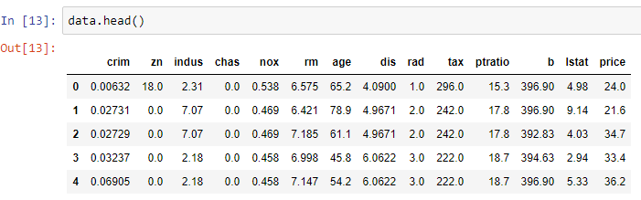

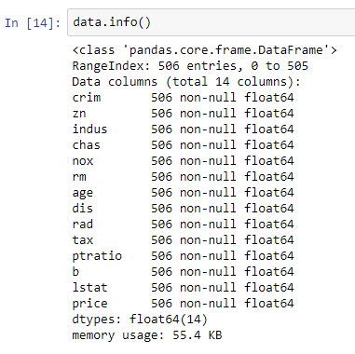

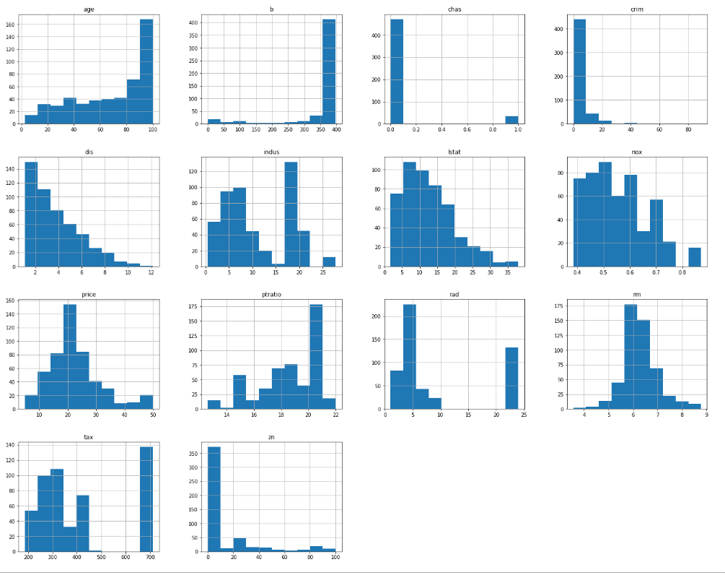

I split the data into train and test with an 80-20 split:

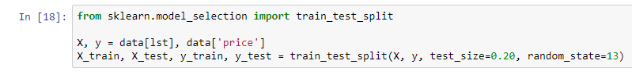

I fit the model and feed the test data in to get predicted price and compute prediction error using Root Mean Square Error. On average, predictions are off by 6.156 units of price.

