CASE STUDY: ONLINE PHARMACY MANAGEMENT SYSTEM
Business Description: Customers can use an online platform to browse, order, and buy prescription and over the counter medication from an online pharmacy. Pharmacists receive orders, approve prescriptions, and maintain inventory. For the patients, doctors input prescriptions straight into the system. Customer profiles, orders, medication inventories, and deliveries are all managed through the platform.

Conceptual Model
- Customer: CustomerId, CustomerName, Email, Phone, City, State, DocId
- Doctor: DocId, DocName
- Prescription: PrescriptionId, DocId, PrescriptionFile, Status
- Product: ProductId, ProductName, ProductCategory, QuantityInStock, BuyPrice
- Order: OrderId, OrderDate, Status, CustomerId
- Invoice: InvoiceId, CustomerId, PaymentMethod, Amount

Entity Relationship Diagram
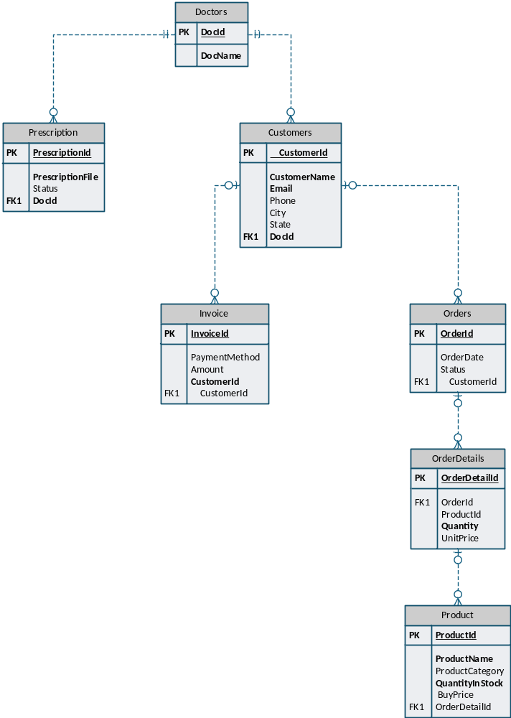
Logical Model
- Customer (
CustomerId Primary Key,
CustomerName,
Email,
Phone,
City,
State,
DocId Foreign Key
)
- Doctor (
DocId Primary Key,
DocName
)
- Prescription (
PrescriptionId Primary Key,
DocId Foreign Key,
PrescriptionFile,
Status
)
- Product (
ProductId Primary Key,
ProductName,
ProductCategory,
QuantityInStock,
BuyPrice
)
- Order (
OrderId Primary Key,
OrderDate,
Status,
CustomerId Foreign Key
)

- OrderDetails (
OrderDetailsId Primary Key,
OrderId,
ProductId,
Quantity,
UnitPrice
)
- Invoice (
InvoiceId Primary Key,
CustomerId Foreign Key,
PaymentMethod,
Amount
)

Physical Model
CREATE DATABASE ONLINE_PHARMACY;
USE ONLINE_PHARMACY;

Customer table
CREATE TABLE Customers (
CustomerId INT PRIMARY KEY,
CustomerName VARCHAR(100) NOT NULL,
Email VARCHAR(50) UNIQUE NOT NULL,
Phone VARCHAR(11),
City VARCHAR(50),
State VARCHAR(50),
DocId INT,
CONSTRAINT FK_CUSTOMERS_DOCTORS FOREIGN KEY (DocId) REFERENCES DOCTORS(DocId)
);

Doctor table
CREATE TABLE Doctors (
DocId INT,
DocName VARCHAR(100) NOT NULL,
CONSTRAINT PK_DOCTOR PRIMARY KEY (DocId)
);

Prescription table
CREATE TABLE Prescription (
PrescriptionId INT PRIMARY KEY,
PrescriptionFile VARCHAR(50) NOT NULL,
Status VARCHAR(50),
Doctors INT,
CONSTRAINT FK_DOCTORS FOREIGN KEY (Doctors) REFERENCES DOCTORS(DocId)
);

Product table
CREATE TABLE Product (
ProductId INT PRIMARY KEY,
ProductName VARCHAR(50) NOT NULL,
ProductCategory VARCHAR(50) NOT NULL,
QuantityInStock INT NOT NULL DEFAULT 0,
BuyPrice DECIMAL(10,2)
);

Orders table
CREATE TABLE Orders (
OrderId INT PRIMARY KEY,
OrderDate DATE,
Status VARCHAR (50),
CustomerId INT,
CONSTRAINT FK_CUSTOMERS FOREIGN KEY (CustomerId) REFERENCES CUSTOMERS(CustomerId)
);

OrderDetails table
CREATE TABLE OrderDetails (
OrderDetailId INT PRIMARY KEY AUTO_INCREMENT,
OrderId INT,
ProductId INT,
Quantity INT NOT NULL,
UnitPrice DECIMAL(10,2),
CONSTRAINT FK_ORDERDETAILS_ORDERS FOREIGN KEY (OrderId) REFERENCES Orders(OrderId),
CONSTRAINT FK_ORDERDETAILS_PRODUCT FOREIGN KEY (ProductId) REFERENCES Product(ProductId)
);

Invoice table
CREATE TABLE Invoice (
InvoiceId INT PRIMARY KEY,
PaymentMethod VARCHAR(20),
Amount DECIMAL(10,2),
CustomerId INT,
CONSTRAINT FK_INVOICE_CUSTOMERS FOREIGN KEY (CustomerId) REFERENCES CUSTOMERS (CustomerId)
);

DML
INSERT INTO Doctors (DocId, DocName) VALUES
(1, 'Dr. Arogundade Ayomide'),
(2, 'Dr. Oluwaseun Lawal'),
(3, 'Dr. Temilade Ogunsanwo'),
(4, 'Dr. Damilola Omoniyi'),
(5, 'Dr. Bolaji Olatunde');

INSERT INTO Customers (CustomerId, CustomerName, Email, Phone, City, State, DocId) VALUES
(1, 'Olaoluwa Oyebola', 'olaoye@gmail.com', '1234567890', 'Yaba', 'LG', 3),
(2, 'Favour Oluwadare', 'favdare@gmail.com', '0987654321', 'Akute', 'OG', 2),
(3, 'Folusho Fatoye', 'folutoye@gmail.com', '1122334455', 'Ilesa', 'OS', 4),
(4, 'Joseph Obika', 'josbika@gmail.com', '6677889900', 'Awka', 'AN', 5),
(5, 'Solomon Ede', 'chukssoles@gamil.com', '5566778899', 'Asaba', 'DT', 1);

INSERT INTO Prescription (PrescriptionId, PrescriptionFile, Status, Doctors) VALUES
(1, 'pt001.pdf', 'Pending', 5),
(2, 'pt002.pdf', 'Approved', 4),
(3, 'pt003.pdf', 'Dispensed', 3),
(4, 'pt004.pdf', 'Pending', 2),
(5, 'pt005.pdf', 'Approved', 1);
INSERT INTO Product (ProductId, ProductName, ProductCategory, QuantityInStock, BuyPrice) VALUES
(1, 'Aspirin', 'Pain Relief', 100, 5.99),
(2, 'Cough Syrup', 'Cold & Flu', 50, 7.49),
(3, 'Vitamin C', 'Supplements', 200, 8.99),
(4, 'Antibiotic Cream', 'Topical', 75, 6.25),
(5, 'Allergy Pills', 'Allergy', 150, 9.50);

INSERT INTO Orders (OrderId, OrderDate, Status, CustomerId) VALUES
(1, '2024-04-01', 'Processing', 1),
(2, '2024-04-02', 'Shipped', 2),
(3, '2024-04-03', 'Delivered', 3),
(4, '2024-04-04', 'Cancelled', 4),
(5, '2024-04-05', 'Shipped', 5);

INSERT INTO OrderDetails (OrderId, ProductId, Quantity, UnitPrice) VALUES
(1, 1, 2, 5.99),
(1, 3, 1, 8.99),
(2, 2, 3, 7.49),
(3, 5, 2, 9.50),
(4, 4, 1, 6.25);

INSERT INTO Invoice (InvoiceId, PaymentMethod, Amount, CustomerId) VALUES
(1, 'Credit Card', 19.99, 1),
(2, 'Cash', 29.99, 2),
(3, 'Debit Card', 39.49, 3),
(4, 'Online Transfer', 49.00, 4),
(5, 'Credit Card', 59.75, 5);
QUERIES
- # all customers with their assigned doctors
SELECT C.CustomerName as Patient, D.DocName as Assigned_Doctor
FROM customers c
JOIN doctors d ON c.DocId = d.DocId;
Patient | Assigned_Doctor
Solomon Ede | Dr. Arogundade Ayomide
Olaoluwa Oyebola | Dr. Temilade Ogunsanwo
Joseph Obika | Dr. Bolaji Olatunde
Folusho Fatoye | Dr. Damilola Omoniyi
Favour Oluwadare | Dr. Oluwaseun Lawal

- # all prescriptions with doctor names
SELECT P.PrescriptionId, P.PrescriptionFile, P.Status, D.DocName
FROM prescription P
JOIN doctors D ON P.Doctors = D.DocId;
PrescriptionId | PrescriptionFile | Status | DocName
1 | pt001.pdf | Pending | Dr. Bolaji Olatunde
2 | pt002.pdf | Approved | Dr. Damilola Omoniyi
3 | pt003.pdf | Dispensed | Dr. Temilade Ogunsanwo
4 | pt004.pdf | Pending | Dr. Oluwaseun Lawal
5 | pt005.pdf | Approved | Dr. Arogundade Ayomide

- # all products with low stock (less than 100)
SELECT ProductId, ProductName, ProductCategory, QuantityInStock
FROM Product
WHERE QuantityInStock < 100;
ProductId | ProductName | ProductCategory | QuantityInStock
2 | Cough Syrup | Cold & Flu | 50
4 | Antibiotic Cream | Topical | 75

- # show all orders along with the customer and order status
SELECT O.OrderId, O.OrderDate, O.Status, C.CustomerName
FROM Orders O
JOIN Customers C ON O.CustomerId = C.CustomerId;
OrderId | OrderDate | Status | CustomerName
1 | 01/04/2024 | Processing | Olaoluwa Oyebola
2 | 02/04/2024 | Shipped | Favour Oluwadare
3 | 03/04/2024 | Delivered | Folusho Fatoye
4 | 04/04/2024 | Cancelled | Joseph Obika
5 | 05/04/2024 | Shipped | Solomon Ede

- # the most expensive product
SELECT ProductName, BuyPrice
FROM Product
ORDER BY BuyPrice DESC
LIMIT 1;
ProductName | BuyPrice
Allergy Pills | 9.5

- # top 3 Most Ordered Products
SELECT P.ProductName, OD.Quantity as Quantity_Ordered
FROM Product P
JOIN Orderdetails OD ON P.ProductId = OD.ProductId
ORDER BY OD.Quantity DESC
LIMIT 3;
ProductName | Quantity_Ordered
Cough Syrup | 3
Aspirin | 2
Allergy Pills | 2

- # total invoice amount per payment method
SELECT PaymentMethod,
COUNT(*) AS NumInvoices,
SUM(Amount) AS TotalAmount
FROM Invoice
GROUP BY PaymentMethod;
PaymentMethod | NumInvoices | TotalAmount
Credit Card | 2 | 79.74
Cash | 1 | 29.99
Debit Card | 1 | 39.49
Online Transfer | 1 | 49

