Benefits of Learning Coding

Contents

Make Your Own Website 2

Become a Career Coder 3

Start a Business 4

Understand How Computers Work 4

Summary 5

Applying it to My Career 5

Bibliography 5

Learning coding empowers you to do many things you wouldn’t otherwise be able to do. These things include hand-crafting your own websites, becoming a career coder or even starting a technology business. Most importantly, you’ll be able to understand the technology shaping your world.

You’ve undoubtedly heard or read somewhere that everyone needs to learn coding, right? Well, people say that for a reason! Whether you’re looking for a career in the industry, starting a new hobby or just wanting to understand technology, you can benefit from learning coding.

Here are some of the things that learning coding can empower you to do.

# Make Your Own Website

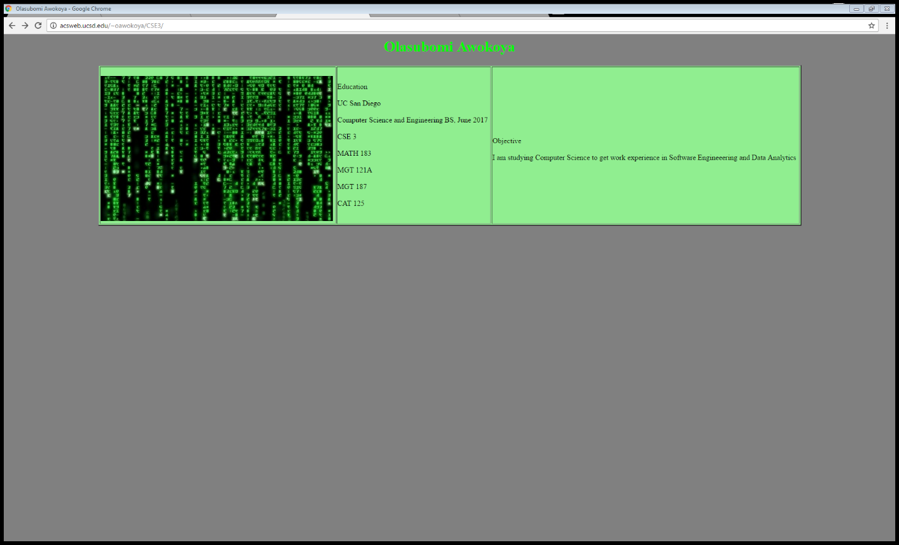

It’s incredible to think how much the world has changed since 1991, when the World Wide Web first started. The web has taken over our lives and it’s showing no sign of stopping.

Who knows where the web will take us in the future? Perhaps in another 10 years every person will have their own website. If one thing’s certain, it’s that a website is a very valuable thing to have these days.

Did You Know?

Guide to the High Tech GeekdomFirmBee

1/15

In 2012, a New York ad agency caused a stir by paying the homeless to be 4G wireless hotspots at the SXSW Festival as a "charitable experiment."

The year 2004 was the 160th anniversary of the first Morse telegraph transmission, so the Telecommunication Union decided to add the “@” symbol to Morse Code.

The baby diaper company, Huggies, created an application that alerts a parent when their baby pees by monitoring changes in diaper humidity.

In '11, a 75 year-old Georgian lady nabbed some unearthed fiber optic cables, leaving the country and southern neighbor Armenia, without internet access.

In 2004, MyDoom became the costliest and fastest spreading piece of malware worm ever. It caused a total of around $38 million in damage.

If you own a business, a web presence is a must. If you don’t, you still might want a personal blog or portfolio site to sell your skills to prospective employers. Of course, your ability to create and maintain a website is severely limited unless you learn HTML and CSS code, the code that all websites run on.

The following pages at Code Conquest will help you

Free HTML Tutorial

Free CSS Tutorial

HTML and CSS Training

How to Make Your First Website

# Become a Career Coder



Figure Puppy Coding

Looking for a career change? The humble computer programmer is quite possibly one of the most underrated professions out there. The demand for coders far exceeds the supply, so you’ll have no troubles finding a job. In fact, it’s projected to grow at a rate of 30% between 2010 and 2020. That’s twice as fast as most other jobs.

The world is practically crying out for more coders, as the below video explains…

And because the supply of coders around the world is so low, the pay is quite attractive too. Google and Facebook employees, for instance, are paid a base salary of ~$125K.

Here is a useful link to help you start your coding career:

Finding a Job in Coding

# Start a Business

Let’s say you’ve got an idea for a software product or web business. You want to create the next Facebook. But you’re short on cash, and being able to hire a team of coders is a pie in the sky. Why not learn code and build the product yourself?

It’s a path that many entrepreneurs are choosing to go down. They’ve started off with virtually no coding knowledge and have gone on to build their own small software businesses. For example, Nick D’Aloisio famously sold his iPhone app, Summly, to Yahoo! for $30m.

Some of the kinds of businesses you can start include…

* selling software
* selling mobile apps
* e-commerce
* selling your coding time.

If you do have a product idea, there’s no reason to sit twiddling your thumbs waiting for money to fall out of the sky. If you can learn code, you’ll not only be able to realize your product, but also know the source code of your software inside out. For more information, read this page:

Starting a Software Business

# Understand How Computers Work

noun

noun: software

1. the programs and other operating information used by a computer. Compare with hardware.

Source: Oxford dictionary

This is probably the biggest benefit of all, and the one that will apply to you no matter who you are or why you’re interested in learning code. After all, you use the Internet, mobile phones, computers and software in your daily life. Isn’t it a bit strange that you don’t fully understand how these technologies work?

Douglas Rushkoff explains the situation well in this video…

With any luck, you’ll be able to discover ways in which coding can help you in your everyday life or job. You may decide to write your own scripts, to perform routine tasks like sending emails, handling data, editing text or doing calculations

Understanding how software and coding works is definitely valuable for anyone, in any walk of life. On the next page, you’ll get a glimpse into how coding really works.

# Summary

* Benefits of learning to program
  + Make your own website
  + Career porpspects
  + More independence in business
  + Understanding the technology we use everyday

## Applying it to My Career

Learning to program is going to have a direct impact on the kind of job I will have. I plan on getting either a Data Analytics or Software Engineering roles in the near future. I think that exploring different programming languages can help me better understand the benefits of this skill, and will give me a better idea of what I want to invent or be a part of in the near future.

# Bibliography

Code Conquest. (2017, January 24). *Benefits of Learning Coding*. Retrieved from Code Conquest: http://www.codeconquest.com/what-is-coding/benefits/