**Robotic Lawn Mower**

A program was developed and embedded on an Arduino uno board for the processing of robotic lawn cutting. The following steps show procedure taken to develop a robotic lawn mower

**Component of Robotic Lawn Mower**

1. Arduino uno board
2. L293D motor driver shield
3. Ultrasonic sensor HCSR04
4. Ultrasonic sensor case holder
5. Dc gear motors
6. Robotic chassis
7. Lippo battery
8. BLDC motor 100kv
9. Servo motor SG90
10. ESC module
11. 3 pins slide switch
12. X type cross holder

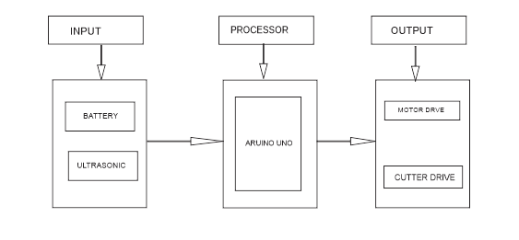

Input consists of the battery and ultrasonic sensor, giving surrounding information to the Arduino uno board, Arduino process the information and send signal to the output devices (Motor drive and Cutter drive) which eventually cut the grass intelligently. To control BLDC motor an ESC module servo tester is used.

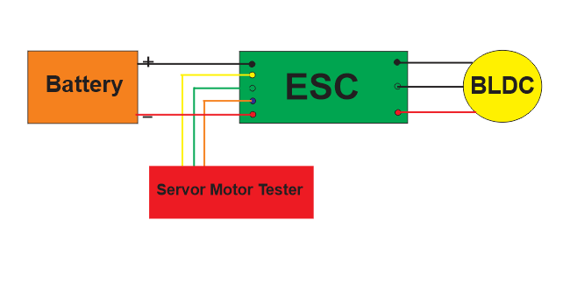

**Programming Language**

The programming language of the Arduino is in c plus plus and the code algorithm is explained in the following image below. While moving in different directions, the cutter cut the grass simultaneously. The coding is in lawn.cpp file.

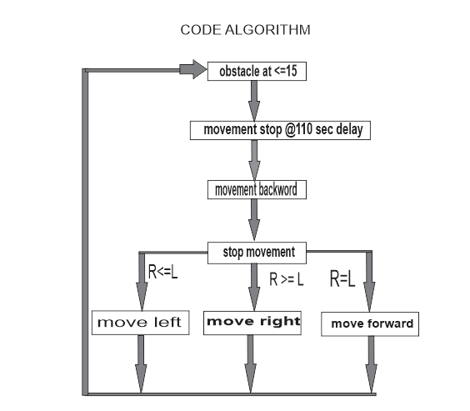

**Assembly of lawn mower components**

The image below shows the circuit diagram of robotic lawn mower assembly.

