**# mustard**

-

**=======================================================================**

Python library Imports

**=======================================================================**

-- sudo pip install flatten_json

-- sudo pip install json

-

**=======================================================================**

--Python script that will parse these files,

--and read them into a database with that schema

**=======================================================================**

-- dataLoad.py

-- db_config.py

-- db_info.ini  (This contains connection details to posgreSQL database)

Run time process

1. Clone the git repo or unzip the file in the attached email

<https://github.com/olat-dev-world/mustard.git>

1. install the following python libraries (if required)

-- sudo pip install flatten_json

-- sudo pip install json

1. create the schema and tables in PostgreSQL

see **DATA MODELLING** section below

1. from (1), change to mustard folder and run the following script

python3 dataLoad.py

1. Run the following script for the assessment reports

**See REPORT/Assessment QUERIES**

**=======================================================================**

-- DATA MODELLING

-- Mustard balls tables creation

-- SQL database schema for representing these balls.

**======================================================================**

create schema cricket;

--Drop tables if they already exists

drop table cricket.matches;

drop table cricket.teams;

drop table cricket.players;

CREATE TABLE cricket.matches (

    row_id INT GENERATED ALWAYS AS IDENTITY,

    match_id INT NOT null,

    is_out VARCHAR(100) not null,

    runs int not null,

    batting_team_id INT NOT null ,

    bowling_team_id INT NOT null ,

    batter_id int not null,

    non_facer_id INT NOT null ,

    bowler_id INT NOT null ,

    created_date timestamp default now(),

    PRIMARY KEY(match_id,batting_team_id,bowling_team_id,batter_id,non_facer_id,bowler_id)

);

CREATE TABLE cricket.teams (

    row_id INT GENERATED ALWAYS AS IDENTITY,

    team_id INT NOT null unique,

    name VARCHAR(100) not null,

    created_date timestamp default now(),

    PRIMARY KEY(team_id)

);

CREATE TABLE cricket.players (

    row_id INT GENERATED ALWAYS AS IDENTITY,

    player_id INT NOT null unique,

    hand VARCHAR(100) not null,

    name VARCHAR(100) not null,

    created_date timestamp default now(),

    PRIMARY KEY(player_id)

);

select * from cricket.matches;

select * from cricket.teams;

select * from cricket.players;

**============================================================================**

REPORT/Assessment QUERIES

**============================================================================**

**-- Question 1**

**-- Which team won each match? (i.e. who had the cumulative**

**-- highest number of runs in their innings)**

**-----------------------------------------------------------------**

with winning_team as

(

    select

        a.* ,rank() over (partition by a.match_id order by a.match_id,a.total desc)  rnk

    from (select  match_id , batting_team_id,bowling_team_id , sum(runs) as total

            from cricket.matches cm

            group by match_id, batting_team_id,bowling_team_id

        )  as a

)

select wt.match_id , t1.name as "Batting team" ,t2.name as "Bowling Team" , wt.total ,

    case when rnk = 1 then t1.name else '' end as WINNER

from winning_team wt

    left join teams t1

        on wt.batting_team_id = t1.team_id

    left join teams t2

        on wt.bowling_team_id = t2.team_id

--where rnk = 1

order by 1, 2 ;

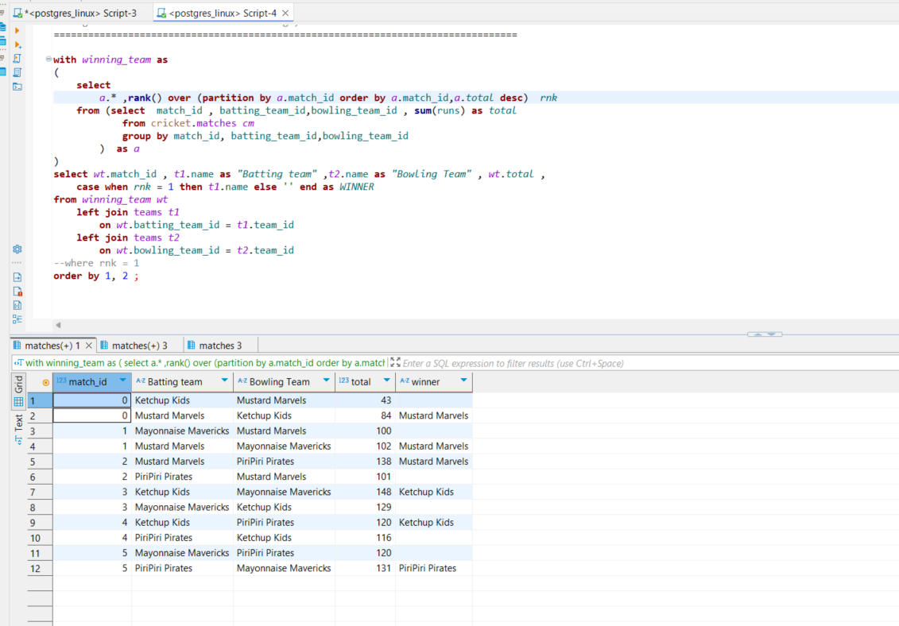

**-- Question 2**

**-- Which “over” had the highest score for each team for each match?**

**-- (i.e. for balls in this over number, which had the cumulative highest total)**

**--------------------------------------------------------------------------------**

with over_total as

(

    select  match_id, bowling_team_id, count(1) ball_total, count(1)/6 over_cnt

        ,rank() over (partition by match_id order by count(1) desc)  rnk

    from cricket.matches m

        left join teams t

            on bowling_team_id = t.team_id

    group by match_id,bowling_team_id

    order by 1

)

select

    ot.match_id , t.name as team, ball_total, over_cnt,

    case when rnk = 1 then t.name else '' end as "Highest Total"

from over_total ot

    left join teams t

        on ot.bowling_team_id = t.team_id

--where rnk = 1

order by ot.match_id, ball_total ;

**-- Question 3**

**-- The average number of runs scored by each batter**

**-- across all the matches they played in.**

**---------------------------------------------------------**

select

    batter_id , p.name , count(1) match_played_in, sum(runs) as total_runs ,

    sum(runs)/count(1) ave_no_of_runs

from cricket.matches cm

    inner join players p

        on cm.batter_id = p.player_id

group by  batter_id , p.name order by 1

