

Provincial Office Migration Architecture

**SARCS WC**

**MIGRATION ARCHITECTURE**

Table of Contents

MIGRATION ARCHITECTURE SUMMARY 3

ARCHITECTURE DIAGRAM 3

TIMELINES FOR THE PROJECT 5

# MIGRATION ARCHITECTURE SUMMARY

The Provincial Office of the South African Red Cross Society is comprised of the following functional units as distinguished by distinct duties and responsibilities. And these functions consist of: Admin/Management, Training, Disaster Management, Health and Care, Finance and House Keeping.

The approach that will be employed for the migration is to have a public subnet that holds static websites stored on S3 buckets that will be accessed AWS Route 53.

The different identified functionalities are hosted in individual private subnets and the various resources in these private subnets will be accessible via a NAT Gateway located in the public subnet.

Employees and all staff will be able to access the cloud platform via whatever workstation that they have (be it a laptop, a tablet or a smartphone) in order to be able to carry out their day to day activities based on their specific job descriptions and identified functionalities.

# ARCHITECTURE DIAGRAM

Illustrated below is the architecture diagram for the Provincial Office Migration Project:

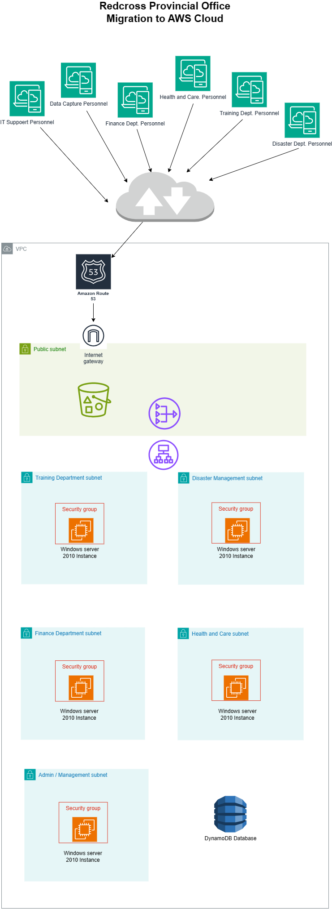

# TIMELINES FOR THE PROJECT

We can commence the project from the 2n week in May. And it will take about 2 – 3 weeks to complete it.

Meaning that we should be able to commission is by the 1st week of June 2024 once it is ready by the end of May.

And by the 2nd week of June we should have taken the whole staff of the Western Cape Provincial Office of the South African Red Cross Society through training and orientation on how to use the platform and also successfully taken care of onboarding of all staff.