INTRODUCTION

Superior quality well log data are essential for the high-quality seismic reservoir characterization because well log data are routinely used for wavelet estimation, low frequency model building, seismic velocity calibration, and time-to-depth conversion (Kumar et. Al 2018). Formation evaluation of a reservoir is done with the aid of petrophysical properties and parameters calculated and derived from well logs. Petrophysical These logs which are acquired through wireline logging are subjected to various conditions arising from the logging process. In most cases, these logs are recorded with missing values or missing sections arising from cost maintenance, geology of the environment or logging instrument malfunction. Petrophysical parameters calculated from well logs inform the final results of the formation evaluation of that reservoir. These petrophysical parameters are usually calculated with some degrees of uncertainties arising from a number of assumptions ranging from deposition environment, to fluid type, lithology, stress and strain conditions of the well bore. Missing values or sections in well logs further represent sections of no data which can introduce noise petrophysical softwares used in formation evaluation.

Several machine learning techniques have been proposed to deal with missing well sections ranging from linear models to tree models, artificial neural networks and recurrent neural networks. Sebtosheikh et. Al (2014) adopted Support Vector Machines for lithology prediction from petrophysical well logs based on core analysis data in an Iranian heterogeneous carbonate reservoir consisting of limestone, dolomite and anhydrite sequences. Silva et. Al (2013) used an Artificial Neural Network in predicting the lithology of carbonate-siliclastic rocks using elastic, mineralogical and petrographical properties of the rocks.

This study however goes to show the comparism between the single decision tree as an algorithm to predicting missing lithology properties to bagging algortihms in terms of performance accuracy. It also highlighten how each algorithm uses the information provided to find patterns that exists in the dataset. Accuracy and precision of machine learning techniques used in predicting well logs values to enhance the quality of petrophysical interpretation and consequently, formation and reservoir characterization.

Methods of Estimating Petrophysical Properties

Why Properties are estimated

Tree Based Models

Machine Learning Ensemble Methods
Ensemble method in machine learning allows for multiple weak (base) learners enhance improve the accuracy and reliability of machine learning models. Ensemble methods are learning algorithms that construct a set of classifiers and then classify new data points by taking a (weighted) vote of their predictions Based on the classical bias–variance decomposition of the error, and it shows that ensembles can reduce variance or both bias and variance (Matteo Re et. al 2012).

While there is no unified theory underlying ensemble methods (Matteo Re et. al 2012), ensemble techniques have been implemented and abstracted into algorithms to aid machine learning predictions and accuracy. Ensemble techniques could be as simple as averaging the prediction of two different regressor algorithms in an attempt to get a more generalised result or building several base models with different subsets of the training data to using multiple algorithms with different hyperparameters to get diverse but similar results which a meta learner can train on to get even more efficient results. This is referred to as stacking.

Bagging, known as bootstrap aggregation, is a machine learning ensemble method that averages the predictions of several tree based learners to produce a more accurate result.

DATA COLLECTION
Six different wells from the North Sea were used. Two of the wells served as the test data sets while the other four wells were used simultaneously to create the training and validation data sets. The Gamma Ray log, Neutron Porosity log, Density log, Resistivity log and Delta T (DT) logs were selected from the complete well logs suite to create the data sets. These logs were also chosen since they occurred in majority of the wells with relatively little amount of missing values compared to other logs. The two wells (15B and 15T2) were chosen as the test data sets due to the unlogged DT logs in the log suite. Four train data sets and validation data sets were created each from the other four wells (F1, F11A, F12, F15D). Each train data set was created by using three of the well logs data while the remaining well served as the validation data set in which the trained model will be evaluated upon.

Exxploratory Data Analysis
The primary aim with exploratory analysis is to examine the data for distribution, outliers and anomalies to direct specific testing of your hypothesis (Komorowski et. al 2016). During EDA, the data is simply visualized, plotted, manipulated, without any assumptions, in order to help assessing the quality of the data and building models (Komorowski et. al 2016). Exploratory data analysis helps to provide insights which can be useful during data modeling. When the distribution is skewed or the data structure obscures the pattern, the data could be rescaled in order to improve interpretability (Chong Ho Yu, 2010). The skewness of a data is the degree of distortion of the data from a normal distribution.

Bivariate Analysis
The bivariate analysis of the logs in respect to the target variable (DT log) is done to visualize the relationships and distributions between the feature logs and the target log. This as well help to capture information about outliers, unreal and spurious log values. The combined logs instead of the individual logs were rather used for the bivariate analysis since this will be fed directly into the model.

Training data used when Well F1 is used for validation

GR Against DT NPHI Against DT RHOB Against DT RT Against DT
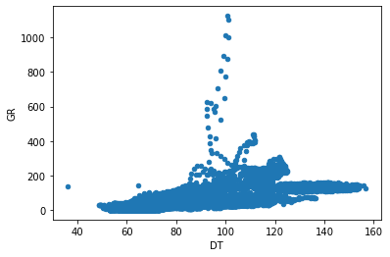
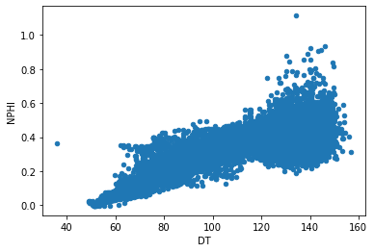
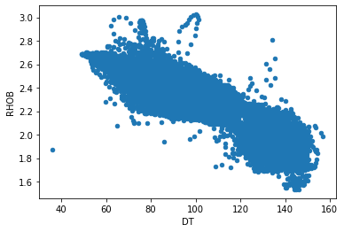
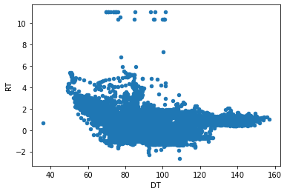

Training data used when Well F11A is used for validation

GR Against DT NPHI Against DT RHOB Against DT RT Against DT
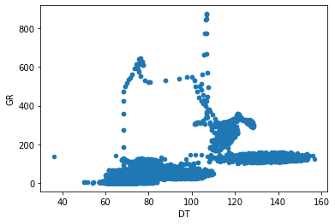
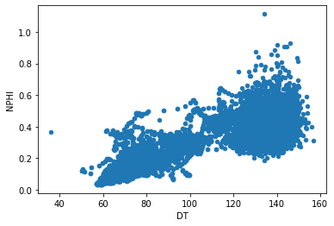
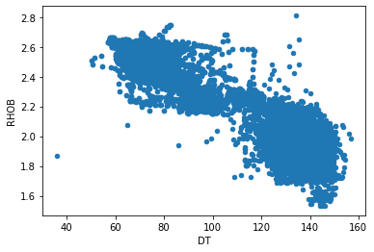
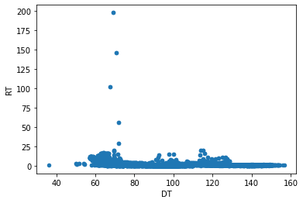

Training data used when Well FT2 is used for validation

GR Against DT NPHI Against DT RHOB Against DT RT Against DT
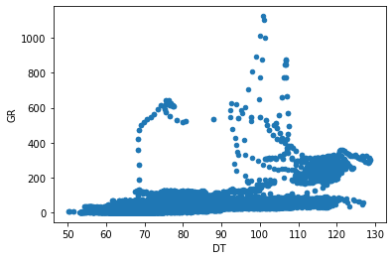
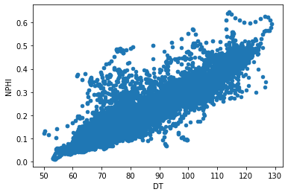
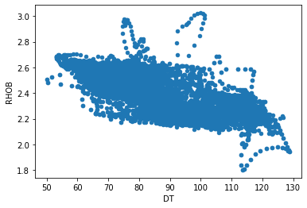
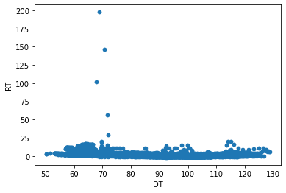

Training data used when Well F12 is used for validation

GR Against DT NPHI Against DT RHOB Against DT RT Against DT
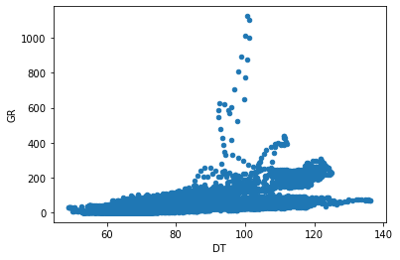
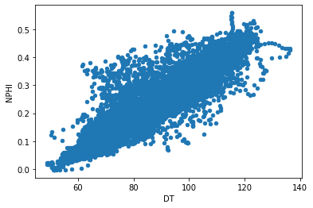
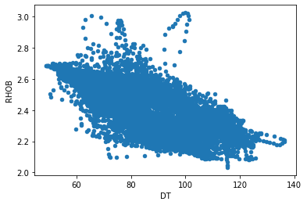
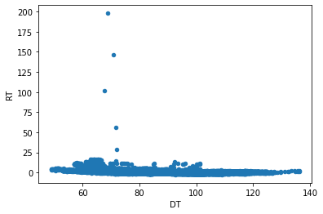

Skewness of target variable (DT log) in each well
How skewed the target variable is from a normal distribution affects the way the model is trained as this negates most models’ assumptions of a normal distribution for a regression problem (this is similar to class imbalance in the case of a classification problem). For a right skewed target distribution, he model will be trained more on the portion of data that falls under the right side part of the distribution. This can also impair features importance analysis.

WELL F1 WELL F11A
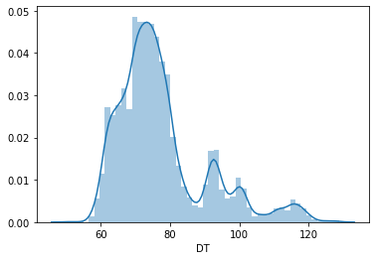
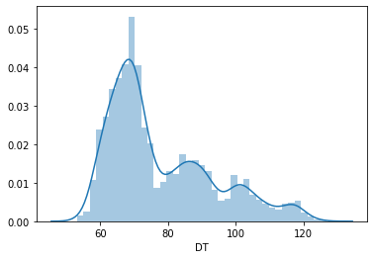

WELL FT2 WELL F12
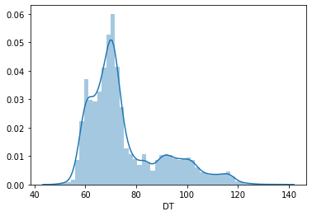
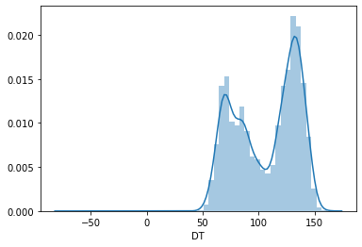

Training and Validation Logs

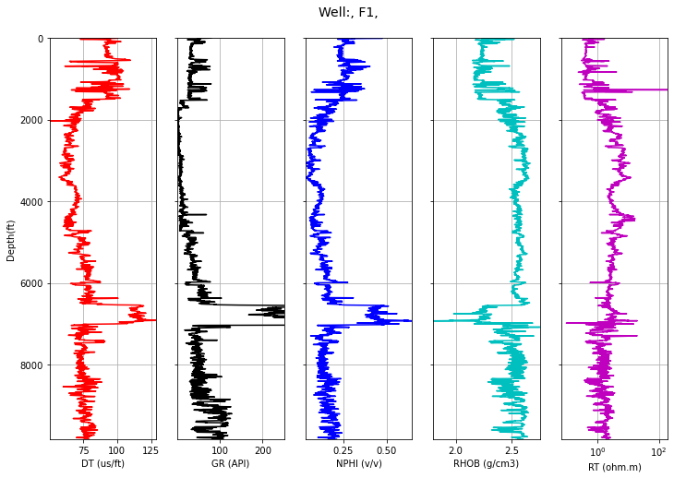

WELL F11A

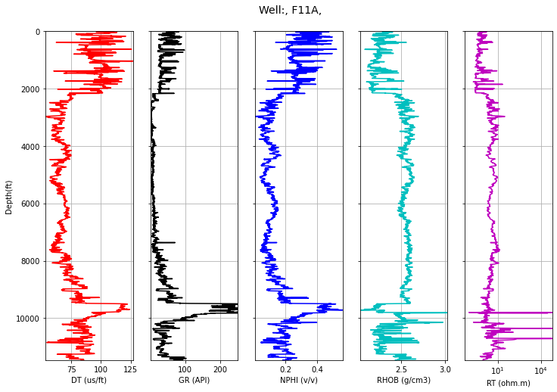

WELL T2

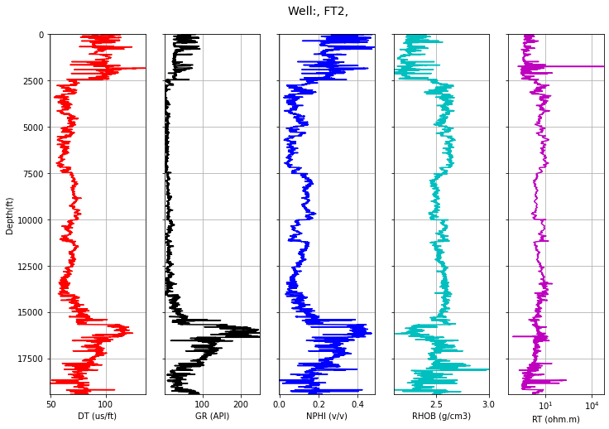

WELL F12

Test Wells
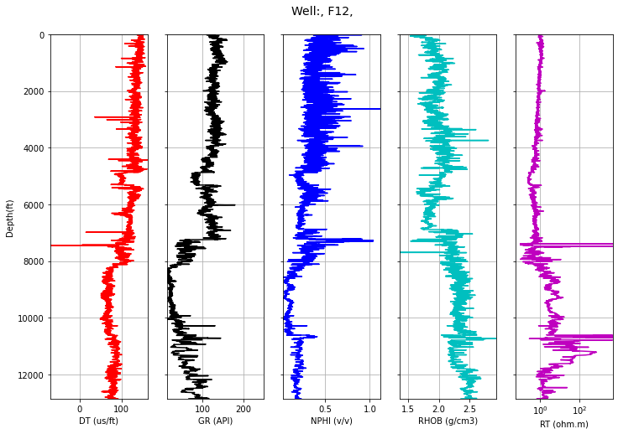
DATA PREPARATION
Missing values/sections in all data sets were removed to allow for a cleaner data set devoid of biases from using other methods of dealing with missing values. A larger amount of these missing values account for unlogged data starting from most of the wells tops.

Data Scaling and Normalization
The data was passed through a data scaling and normalization process. Normalization is scaling technique or a mapping technique or a pre processing stage. Where, we can find new range from an existing one range (Patro et. al 2015). Data normalization is the process of casting the data to the specific range, like between 0 and 1 or between -1 and +1 (Ali et. al 2014). This transform the data into a normal distribution with a standard deviation of zero and a mean value of 1. Normalization is required when there are big differences in the ranges of different features. (Ali et. al 2014).
The effects of data scaling and normalization are largely seen on linear models like linear regressors, Support Vector Machines. Tree based models like decision trees and forests have however been observed not to require scaling as the method of making predictions do not require any scaling. Neural networks on the other hand however require scaling and normalization of extreme values (outliers). Data scaling was done to reduce the magnitude of the petrophysical properties passing through the algorithms to speed up training time.
The StandardScaler module from sklearn preprocessing package was used. It standardizes features by removing the mean and scaling to unit variance. The standard score of a sample x is calculated as:

z = (x - u) / s
where u is the mean of the training samples scores and s is the standard deviation of the training samples.

METHODOLOGY

Two bagging algorithms; a Random Forest regressor and Extra Trees regressor and the conventional single decision tree regressor all from the Python scikit-learn library were used. Hyperparameter tuning with GridSearchCV was done to obtain optimal hyperparameters for each training each models. A ten-fold cross validation (CV) was used with each algorithm to get a more generalized result and how the models performed with different subsets of the datasets. A maximum depth of 16 was chosen for all three algorithms as the maximum depth (max_depth) tuning for each algorithm coukd not give the optimal value to be used.

RESULTS & DISCUSSION
Both bagging algorithms outperformed the single decision tree algorithm. In all validation cases on the validation datasets however, the Extra Trees regressor outperformed the Random Forest regressor both in RMSE scores and correlation coefficient scores. All three algorithms were used to make make predictions on the test logs to reproduce the delayed time log which were missing in wells F11B and F15D. RMSE and R2 validation scores serves as a guide into choosing the most accurate algorithm or model to use for replacing the missing logs. At depth interval 3050m-3100m in well F12, the NPHI, RHOB and RT logs record a missing sections al together. The Extra Trees regressor was used in reproducing the missing section of the well.

Machine learning models are not just dependent on how sophisticated the algorithms are but also how robust (qantity and quality) the training data fed into the model is. The model performances can be improved through the following ways;

- Using more logs from the wells
- Feeding the machine learning models with more data (feature generation and creation from existing data). Calculating more petrophysical properties like porosity, permeability etc.
- Feature selection: Checking for feature importance and dropping features likely to cause overfitting
- Feeding the models with better data (feature engineering). Carrying out log transformations,trigonometric transformations etc.
- Stacking is done by making an ensemble of weak (base) learners with a meta algorithm to improve the predictions of machine learning models.

REFERENCES
Mithilesh Kumar, R. Dasgupta, Dip Kumar Singha, N. P. Singh. Petrophysical evaluation of well log data and rock physics modeling for characterization of Eocene reservoir in Chandmari oil field of Assam-Arakan basin, India. J Petrol Explor Prod Technol (2018) 8:323–340.

Mohammad Ali Sebtosheikh, R. Motafakkerfard, Mohammad Ali Riahi, Siyamak Moradi, N. Sabety. Support vector machine method, a new technique for lithology prediction in an Iranian heterogeneous carbonate reservoir using petrophysical well logs. Carbonates and Evaporites 30(1):1-10 (2014).

L. Lam and C. Sue. Application of majority voting to pattern recognition:
an analysis of its behavior and performance. IEEE Transactions on Systems,
Man and Cybernetics, 27(5):553–568, 1997.

Matthieu Komorowski, Dominic C. Marshall, Justin D. Salciccioli and Yves Crutain. Exploratory Data Analysis. Chapter 15 2016.

Chon Ho, Yu. (2010). Exploratory data analysis in the context of data mining and
resampling. International Journal of Psychological Research, 3(1), 9-22.

Dietterich T.G. (2000). Ensemble Methods in Machine Learning. In: Multiple Classifier Systems. MCS 2000. Lecture Notes in Computer Science, vol 1857. Springer, Berlin, Heidelberg. https://doi.org/10.1007/3-540-45014-9_1

L. Breiman. Bagging predictors. Machine Learning, 24(2):123–140, 1996.

Matteo Re, Giorgio Valentini. Ensemble methods: A review. (2012). page 5

APPENDIX

WELL F1
 | DEPTH | DT | GR | NPHI | RHOB | RT | DEPTH.1
count | 9822.000000 | 9822.000000 | 9822.000000 | 9822.000000 | 9822.000000 | 9822.000000 | 9822.000000
mean | 3107.850000 | 77.410579 | 48.624734 | 0.166892 | 2.480931 | 2.797148 | 3107.850000
std | 283.551151 | 13.054261 | 66.332481 | 0.091949 | 0.135899 | 3.534284 | 283.551151
min | 2616.800000 | 50.178200 | 1.239300 | 0.033200 | 1.801200 | 0.093300 | 2616.800000
25% | 2862.325000 | 69.102175 | 11.147825 | 0.108100 | 2.425925 | 1.251000 | 2862.325000
50% | 3107.850000 | 74.336250 | 34.511900 | 0.144950 | 2.533200 | 2.254600 | 3107.850000
75% | 3353.375000 | 80.868700 | 53.705750 | 0.203475 | 2.575600 | 3.349675 | 3353.375000
max | 3598.900000 | 128.763000 | 873.719400 | 0.645400 | 2.748600 | 197.794000 | 3598.900000

WELL F15D

 | DEPTH | GR | NPHI | RHOB | RT | DEPTH.1
count | 13566.000000 | 13566.000000 | 13566.000000 | 13566.000000 | 13566.000000 | 13566.000000
mean | 3980.150000 | 36.761065 | 0.184821 | 2.376814 | 2275.353795 | 3980.150000
std | 391.631121 | 28.864315 | 0.054254 | 0.164828 | 11331.079560 | 391.631121
min | 3301.900000 | 5.977300 | 0.067900 | 2.131900 | 0.289800 | 3301.900000
25% | 3641.025000 | 20.283525 | 0.152100 | 2.229200 | 3.361225 | 3641.025000
50% | 3980.150000 | 28.145400 | 0.179900 | 2.329600 | 6.321500 | 3980.150000
75% | 4319.275000 | 46.779175 | 0.200575 | 2.531675 | 20.387425 | 4319.275000
max | 4658.400000 | 269.913900 | 0.484300 | 3.064400 | 62290.769500 | 4658.400000

WELL F11B

 | DEPTH | GR | NPHI | RHOB | RT | DEPTH.1
count | 15466.000000 | 15466.000000 | 15466.000000 | 15466.000000 | 15466.000000 | 15466.000000
mean | 3971.450000 | 33.940421 | 0.183350 | 2.397121 | 2255.365314 | 3971.450000
std | 446.479397 | 19.753302 | 0.059092 | 0.181271 | 11450.435089 | 446.479397
min | 3198.200000 | 2.687000 | 0.024000 | 1.627000 | 0.140000 | 3198.200000
25% | 3584.825000 | 17.955000 | 0.155000 | 2.230000 | 3.267250 | 3584.825000
50% | 3971.450000 | 28.723000 | 0.176000 | 2.374000 | 7.834000 | 3971.450000
75% | 4358.075000 | 43.585750 | 0.209000 | 2.560000 | 52.625750 | 4358.075000
max | 4744.700000 | 123.362000 | 0.541000 | 3.090000 | 62290.770000 | 4744.700000

WELL F11A

 | DEPTH | DT | GR | NPHI | RHOB | RT | DEPTH.1
count | 11464.000000 | 11464.000000 | 11464.000000 | 11464.000000 | 11464.000000 | 11464.000000 | 11464.000000
mean | 3150.150000 | 77.733619 | 32.902956 | 0.165742 | 2.468319 | 103.313883 | 3150.150000
std | 330.951608 | 15.549873 | 51.034425 | 0.099682 | 0.153289 | 2334.400108 | 330.951608
min | 2577.000000 | 53.165000 | 0.852000 | 0.010000 | 2.033000 | 0.103000 | 2577.000000
25% | 2863.575000 | 66.184000 | 8.589250 | 0.093000 | 2.337000 | 1.823000 | 2863.575000
50% | 3150.150000 | 71.579000 | 19.713500 | 0.130000 | 2.529000 | 3.081000 | 3150.150000
75% | 3436.725000 | 87.674750 | 38.340000 | 0.223000 | 2.581000 | 4.973250 | 3436.725000
max | 3723.300000 | 126.827000 | 1124.403000 | 0.559000 | 3.025000 | 62290.770000 | 3723.300000

WELL FT2

 | DEPTH | DT | GR | NPHI | RHOB | RT | DEPTH.1
count | 19433.000000 | 19433.000000 | 19433.000000 | 19433.000000 | 19433.000000 | 19433.000000 | 19433.000000
mean | 3549.879581 | 75.496268 | 32.947571 | 0.153316 | 2.495124 | 9.174699 | 3549.879581
std | 561.862966 | 14.901442 | 45.253300 | 0.098142 | 0.129956 | 502.010547 | 561.862966
min | 2577.000000 | 48.928000 | 0.838000 | -0.003000 | 2.090000 | 0.071000 | 2577.000000
25% | 3062.800000 | 65.402000 | 8.435000 | 0.078000 | 2.460000 | 1.927000 | 3062.800000
50% | 3550.700000 | 70.680000 | 13.159000 | 0.128000 | 2.529000 | 3.050000 | 3550.700000
75% | 4036.500000 | 82.827000 | 33.611000 | 0.203000 | 2.584000 | 5.778000 | 4036.500000
max | 4522.300000 | 136.253000 | 437.823000 | 0.486000 | 3.004000 | 62253.957000 | 4522.300000

WELL F12

 | DEPTH | DT | GR | NPHI | RHOB | RT | DEPTH.1
count | 12860.000000 | 12860.000000 | 12860.000000 | 12860.000000 | 12860.000000 | 12860.000000 | 12860.000000
mean | 2404.319272 | 106.749505 | 90.155106 | 0.278832 | 2.122411 | 33.496936 | 2404.319272
std | 604.841370 | 27.991450 | 42.289737 | 0.142013 | 0.227564 | 327.162094 | 604.841370
min | 1368.704400 | -68.827796 | 12.789500 | 0.028200 | 1.356800 | 0.100000 | 1368.704400
25% | 1869.147900 | 79.565697 | 49.477076 | 0.182700 | 1.938875 | 0.589850 | 1869.147900
50% | 2408.301000 | 115.402099 | 106.072700 | 0.263150 | 2.121150 | 0.891750 | 2408.301000
75% | 2919.869700 | 131.925292 | 126.951624 | 0.371600 | 2.297800 | 2.494900 | 2919.869700
max | 3442.563600 | 161.014801 | 179.878204 | 1.113800 | 2.939200 | 5000.000000 | 3442.563600

