Web Development Reflective Essay

## Roles and contributions

* 1. The roles were divided based on the technicality and individual ability. Adetola Ogundipe acted as the project manager. She assigns roles for each member of the team. I was assigned to work on the ride & facilities page (ride, facilities, food, and shopping section) of the website, both at the homepage (index.html) and the main page(ride.html).
  2. Other sections were assigned as follows:
* Header and Contact section was assigned to Chris Lianopoulos
* Tickets section was assigned to Chris Lianopoulos and Adetola Ogundipe
* FAQ section was assigned to Vlad
* Navbar and CTA(Call To Action) button was assigned to Adetola Ogundipe
* Park Introduction and Footer Section was assigned to Kostyantyn Nazarenko

I typed out the report for task 1 of the peer graded assignment, while we worked collectively on reviewing existing theme park websites. I reviewed <https://www.silverwoodthemepark.com/>while other members reviewed [https://www.knotts.com/,](https://www.knotts.com/) [https://www.ferrariworldabudhabi.com/,](https://www.ferrariworldabudhabi.com/) <https://www.disneylandparis.com>.

* 1. On technical aspects, we had issues selecting the right platform we can use to make our collaboration on the project quite easier, as we have different people with opinions of different platforms and software to use. Some suggest that we use notion, another suggest that we use G Suite shared folders, but I suggest using Git and GitHub as it’s designed solely for our use case.
  2. I set up the repository and GitHub pages on it.
  3. 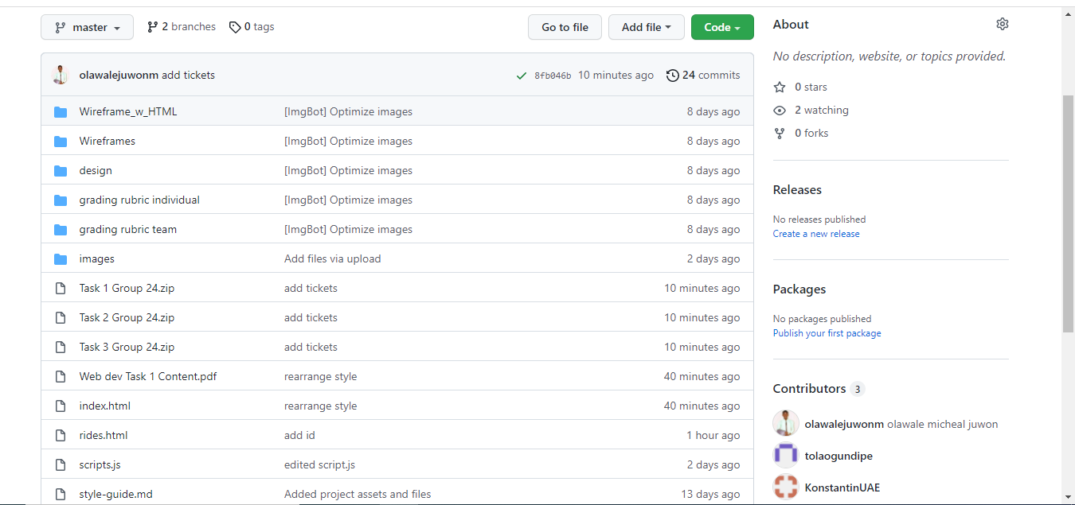
  4. Some team members find it challenging to understand it, so I guide them on how to use it.

## Your use of HTML and CSS

* 1. The project exposed me to learning about flex box in-depth. I created a flex box to serve as cards for the ride and facilities page, this card was set to have a maximum width of 45% (relative positioning) to ensure that the card is relative to any screen that’s viewed with.
  2. With CSS, I was able to alter the order of the HTML element when designing the rides and facilities section at the homepage of our website. I created an image tag and other elements next to it, by order the image ought to render to the right while other elements should also be next to it, with CSS float I totally reversed this order.
  3. Likewise, I used a diverse CSS selector like the children next to the already defined tag for selecting the DOM.
  4. The code implementation is attached below.
  5. .rides-left {
  6. margin-bottom: 8%;
  7. }
  8. .rides-left > div {
  9. display: inline;
  10. margin: 8%;
  11. }
  12. .rides-left > div > img {
  13. float: left;
  14. padding-right: 10%;
  15. }
  16. .rides-left > div > h4 {
  17. padding-top: 10%;
  18. }

<div class="rides-left">

<div>

<img class="rides-sect-grp-img" src="./images/home-ride-image-1.jpg" alt="ride-image">

<h4>We are happy to see you</h4>

<p>Prepare to immerse yourself into a world of fun and thrill. You can ride a real AT-AT from the Star

Wars movie. Maybe you should try to find your way to the volcano and destroy the Ring from the Lord

Of the Rings Movie.

If your faith is to save people, challenge your superhero skills in our Spiderman attraction.</p>

</div>

</div>

* 1. 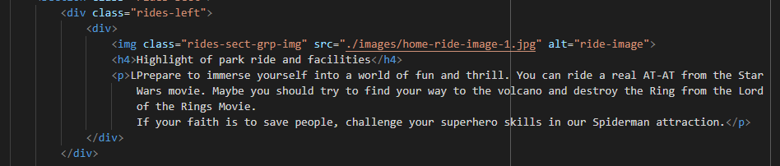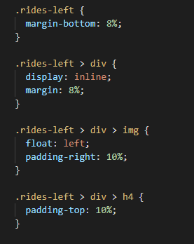

In my HTML code, I used semantic tags (*<section></section>)* for the section I worked on

* 1. I learned about some terminologies in web development: components, which implies that any repeated code should be a component. I applied this knowledge by only creating classes in CSS for any code repeated(component).

While working on the ride section for the homepage, it was very challenging for me to position the text as it was designed in the wireframe. The text is to align vertically and must be of the same length, using *text-align: center* solved the second issue, and I found the solution to the first problem by putting the text and image inside a container (an HTML tag that wraps them both) and then applying padding. 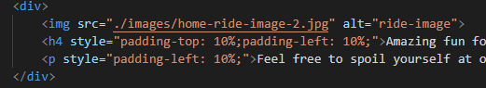

<div>

<img src="./images/home-ride-image-2.jpg" alt="ride-image">

<h4 style="padding-top: 10%;padding-left: 10%;">Amazing fun for everyone</h4>

<p style="padding-left: 10%;">Feel free to spoil yourself at our food court if you are afraid of speed and height</p>

</div>

Though the issues were resolved for large screens, it actually affects the interface outlook when checked on different screens. I still felt I needed more practice with understanding absolute and relative positioning thoroughly.

I tried out responsiveness by writing a media query for different screens (specified style rules being applied at a range or particular screen sizes) which makes the card responsive for different screens and I found it useful for developing agile websites.

## Positive aspects of your team work experience

* 1. “We go fast when we work alone, but we go far when we work together”.
  2. The best aspect of working in a team on this project is that we were able to build a simple but robust theme park website.
  3. Working together as a team taught me indirectly about being patient, understanding and accepting other people's opinions. It was fascinating to see how people from different countries and cultures reason and respond to problems.
  4. I enjoyed it because it makes the work seamless and easier because the little/minute section of the project is parted for everyone. This enabled me to patiently understand a concept in-depth. The teamwork enhances my productivity and balanced working conditions.

Generally, with the team work, I was able to acquire knowledge from my team members because some are good at aspects that I have issues understanding.

## Negative aspects of your team work experience

* 1. Time difference is the most annoying aspect of working together on this project. At the time when I'm available for meetings, other members of the team are planning to sleep. I only had a member of the team with one-hour time difference, this made things quite comfortable for collaboration. We scheduled a meeting together and dropped the report on the group chat for others with different time zones to contribute when they come online.

Some members of the team didn’t make valuable contributions to the project, which caused an overwork for the active members of the team.

Another aspect of the team work not enjoyed is managing all the team members / putting them to work quickly on their tasks.

We had something like a Gantt chart to keep track of all our timeline and submission dues, but this wasn’t followed because some team members couldn’t work according to given schedule, this makes it very frustrating because we couldn’t have a strictly followed timeline because some members aren’t responding swiftly to their task, which can never be enforced.

## Effects of teamwork on the quality of the work

Individual contributions play a greater role in the quality and effect of the project because we are a combination of people with different backgrounds, understanding and views about things.

According to the schedule prepared by our Project Manager (Adetola Ogundipe) testing and delivering of the completed website ought to be within January 9 and January 16th. But as a result of late response from some team members, their sections were uncompleted, and we couldn’t meet the set deadline. I believe this affected the quality of our work a little because we could have made some valuable edits after constructive criticism and summing up the peer review feedback if we’ve completed earlier than the stipulated deadline.

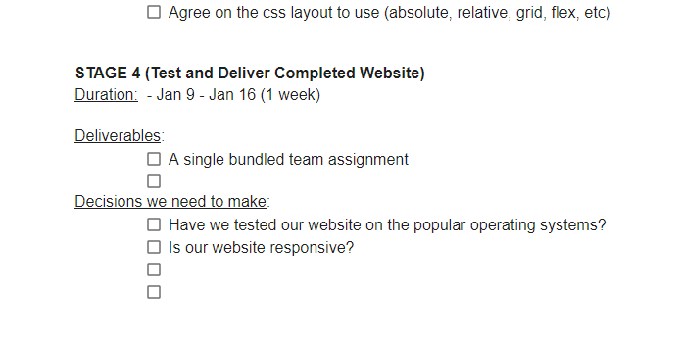

At finals, I thought about having a sliding image (called carousel in web development) at our homepage that displays different aspect of our theme park website at a glance, but we noticed that doing that might result into using script so as a result of this an animation was added to the images at the homepage, rides and facilities page which makes the website much more appealing.

## Tools you and your team used

* 1. We had different opinions on the tool to use for collaboration, sharing files and codes.
  2. Some suggest we use notion and another person suggests using google shared folders, but we later conclude on using Git and GitHub as a result of its advantages and because it’s used in reality for collaboration on big or small technology projects. It was our primary tool for code sharing and collaborative work on different sections of the website.

When working on the contents for the website, we use Google Docs for collaborating on the website content and website review. It offers us the ability to easily see different versions of the file at a particular time, real time working together on a document, and easy conversion to another file format.

Since communication is vital in team work, we noticed that most team members were not active on the Slack channel, so we created a WhatsApp group to aid communication.

We used Figma software for designing the wireframes, because of its ease of use and ability to edit again. Also, we used pexels for getting free images and pixlr for editing the pictures.

I personally use Visual Studio Code as my code editor and Chrome developer's tool for testing responsiveness across various screens.

I strongly believe that we used the tools that are right for us.