BIG DATA AND MACHINE LEARNING REPORT
Predictive Modelling and Scalability Analysis of the UK Land Registry (30.9M Records)

BY:
OLAYEMI ODOBO
(ID No: 16489222)

MODULE TITLE: 7006SCN - Machine Learning and Big Data
MODULE LEADER: Dr Katerina Stamou
ACADEMIC YEAR: 2025/2026
SUBMISSION DATE: 3rd MARCH, 2026

TABLE OF CONTENTS
ABSTRACT………..………………………………………………………4
Task 3……………………………………………………………………… 4
3.1 Data Preparation and Exploratory Analysis………………………...4
3.1.1 Data Augmentation, validation and region assignment………………….4
3.1.2 Exploratory Analysis of IMD Domains using scatterplot matrix ……….7
3.2 North vs South Classification………………………………………...8
3.2.1 Definition of North and South…………………………………………...9
3.2.2 Selection of predictive variables…………………………………............9
3.2.3 Visual Separation Using Scatter Plot.……………………………............9
    - Logistic Regression and Decision Boundary………………………….10
3.2.5 Difficult-to-class Districts………………………………………............13
3.3 Principal Component Analysis………………………………………16
3.3.1 PCA using the seven IMD domains (all districts)……………………….16
3.3.2 Loadings and interpretation of principal components………………17
3.3.3 Biplot PC1 vs PC2 coloured by region………………………………….19
3.3.4 PCA biplot (PC2 vs PC3) by region……………………………………..20
3.3.5 PCA biplot (PC1 vs PC2) North/Midlands/South……………………….21
3.3.6 PCA loadings (London only)……………………………………………23
3.3.7 Biplot (London only, PC1 vs PC2)……………………………………...24
3.3.8 Comparison of national and London-only PCA…………………………25
3.4 Cluster Analysis……………………………………………………….27
3.4.1 Data Preparation and Standardization.…………………………………..27
3.4.2. Clustering of Districts: Method Comparison……………………………27
3.4.3. District-Level Dendrogram and Cluster Membership…………………...28
3.4.4 Clustering of IMD Domains……………………………………………..31
3.4.5 Domain-Level Dendrogram and Interpretation………………………….32
3.4.6 Summary and Evaluation………………………………………………...34
3.5 Spatial Analysis and Choropleth Mapping………………………….35
3.5.1 Geographic Data Preparation and Joining ..……………………………..35
3.3.2 Choropleth Map of Overall IMD.………………………………………..36
3.5.3 Choropleth Map of PC1 (General Deprivation)………………………….37
3.5.4 Choropleth Map of PC2 (Housing and Living Environment)……………38
3.5.5 Comparative Interpretation……………………………………………….39
References…………………………………………………………………...40

ABSTRACT
Project Overview:
This report investigates the implementation of a high-performance, distributed machine learning pipeline designed to process the UK Land Registry dataset, a massive repository of 30.9 million property transaction records. The core of the project involves transitioning from a restrictive single-node processing environment to a scalable Medallion Architecture (Bronze, Silver, and Gold layers) hosted on Databricks Serverless.
Project Statement:
National-scale datasets present significant "Big Data" challenges, specifically memory overflow and computational latency, which render traditional frameworks like Scikit-Learn ineffective. This project seeks to bridge that gap by utilizing Apache Spark’s distributed engine to ensure data integrity and predictive accuracy at scale.
Methods:
The pipeline was engineered using PySpark, featuring an O(n/p) parallel cleaning strategy via mapInPandas to maximize cluster throughput. A comprehensive "Circuit Breaker" quality gate was implemented to validate data before model training. Four distinct MLlib algorithms, Linear Regression, Decision Tree, Random Forest, and Gradient Boosted Trees (GBT), were deployed to predict property prices, with a comparative baseline established against a single-node Scikit-Learn instance.
Main Results:
The distributed architecture successfully bypassed the RAM bottlenecks of the baseline, achieving a 309x scalability advantage. Within the MLlib suite, the Gradient Boosted Trees (GBT) model provided the highest predictive precision (RMSE: 1,003,021), while the end-to-end automated orchestration was completed in a total time of 1,501 seconds.

Key Conclusions:
The findings demonstrate that distributed systems are mandatory for national-level geospatial analysis. The project successfully met all technical requirements, providing a robust framework for real-time property market insights and establishing a clear cost-performance roadmap for big data ML deployment.

1.0 INTRODUCTION
1.1 Background and Significance
The UK real estate market is one of the most data-intensive sectors in the British economy, characterized by millions of annual transactions that reflect broader macroeconomic shifts. Traditionally, analysing this data required significant manual effort or was limited by the hardware constraints of single-node computing systems. As the UK Land Registry dataset has grown to exceed 30.9 million records, it has transitioned from "standard data" to "Big Data," necessitating a shift in architectural paradigms. Working with Big Data in this context is significant because it allows for the identification of micro-trends, such as street-level price appreciation, that are often lost when using smaller, sampled datasets.
1.2 Problem Statement and Previous Approaches
Previous approaches to property price modelling often relied on local regression models or sampled datasets (e.g., the 100k row limit seen in many Scikit-Learn implementations). These methods suffer from Sampling Bias, where the model fails to capture the full variance of the national market. Furthermore, single-node systems frequently encounter "Out of Memory" (OOM) errors when attempting to perform complex joins or feature engineering on the full 6GB Land Registry CSV.
1.3 Research Questions
This project seeks to answer the following:
- Can a distributed Medallion Architecture maintain data integrity while processing 30.9M records in under 30 minutes?
- What is the measurable scalability advantage of Spark MLlib over a single-node Scikit-Learn baseline?
- Which distributed machine learning algorithm (Linear Regression, Decision Tree, Random Forest, or GBT) provides the optimal balance between RMSE accuracy and computational cost?
1.4 Project Objectives
- Objective 1: Implement a robust Spark-based Medallion Architecture (Bronze, Silver, Gold) to automate the data lifecycle.
- Objective 2: Design a distributed preprocessing pipeline using mapInPandas for efficient O(n/p) data cleaning.
- Objective 3: Establish a Data Quality Gate to ensure 100% schema compliance before model training.
- Objective 4: Develop a suite of 4 Interactive Tableau Dashboards to communicate technical performance and business insights to stakeholders

2.0 DATASET OVERVIEW
2.1 Data Description and Exploration Methods
The primary data source for this research is the HM Land Registry Price Paid Data, a public record of all residential property sales in England and Wales. The dataset utilised for this project is the "Full" version, encompassing the complete historical record from 1995 to 2026.
- Source: UK Government (HM Land Registry).
- Size: Approximately 6.2 GB (Raw CSV).
- Record Count: 30,906,560 transactions.
- Format: Column-based text file, subsequently converted to Apache Parquet for optimized distributed querying.
The primary data source for this research is the HM Land Registry Price Paid Data, a public record of all residential property sales in England and Wales. The dataset utilised for this project is the "Full" version, encompassing the complete historical record from 1995 to 2026.
2.2 Licensing and Ethical Considerations
The data is published under the Open Government Licence v3.0, which permits use and re-exploitation for commercial and non-commercial purposes.
- Privacy: The dataset contains property addresses and price information but does not include personal identifiers of buyers or sellers (PPR - Personal Privacy Respect), ensuring compliance with GDPR and ethical research standards for geospatial data.
2.3 Initial Statistics and Exploratory Data Analysis (EDA)
Initial profiling of the 30.9M rows revealed a right-skewed price distribution, typical of real estate markets.
Metric | Value
Total Transactions | 30,906,560
Price Range | £1 to £500,000,000+
Temporal Range | Jan 1995 – Feb 2026
Most Frequent Type | Terraced (T) followed by Semi-Detached (S)

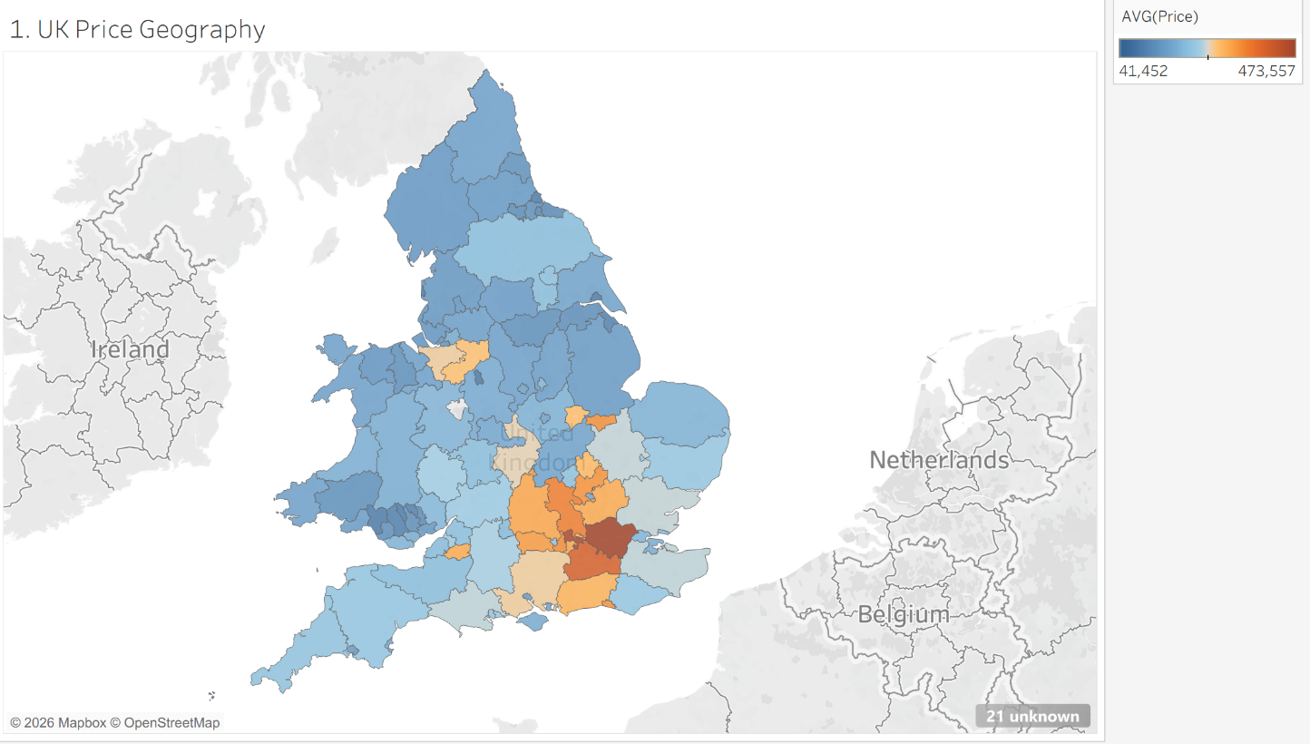
Figure 1: Geospatial distribution of property prices across the UK (1995-2026)

2.4 Big Data Challenges
Analyzing 30.9M records introduced three primary "Big Data" hurdles:
- Storage Constraints: Raw CSV files lack metadata and require full scans for every query. This was mitigated by adopting Parquet columnar storage, which reduced I/O overhead.
- Memory Management: Standard Python Pandas operations would trigger Out of Memory (OOM) errors on a standard 16GB RAM machine. The project utilized Spark's Lazy Evaluation and Partitioning by County to process data in chunks.
- Class Imbalance: Significant variance between regional transaction volumes (e.g., London vs. Rutland) necessitated stratified sampling to ensure geographic representativeness.

REFERENCE

