Website Availability Monitoring Documentation

The Website Availability Monitoring app lets you create availability monitoring tests for one or more web URLs and run these monitoring tests from anywhere the server is hosted. In addition to state views, you can display the status of these tests in a provided dashboard at the homepage route of the application. The website availability monitoring app is built in node.js with the express framework.

#### Monitoring Performed by the Website Availability Monitoring App

By default, the Website Availability Monitoring App configures the following monitoring by default. You can modify the monitor in the source code file.

| Monitor description | Default values |
| --- | --- |
| Website Monitor App | - The monitor is enabled by default once the node.js server has started. |
|  | - Test Frequency: 5 minutes |
|  | - Number of consecutive times a criteria should fail before an alert is generated: 1 |
|  | - HTTP version: HTTP/1.1 |
|  | - HTTP method: GET |
|  | - HTTP headers: accept "/" |
|  |  |
| Performance Data Collection | - response time: enabled |
|  | - Status boolean: enabled |

# Viewing monitoring data

All data collected by the Website Availability Monitoring appears in the home route of the express.js app, you can see the test state of the individual tests. The data is saved after each test to a supabase remote database.

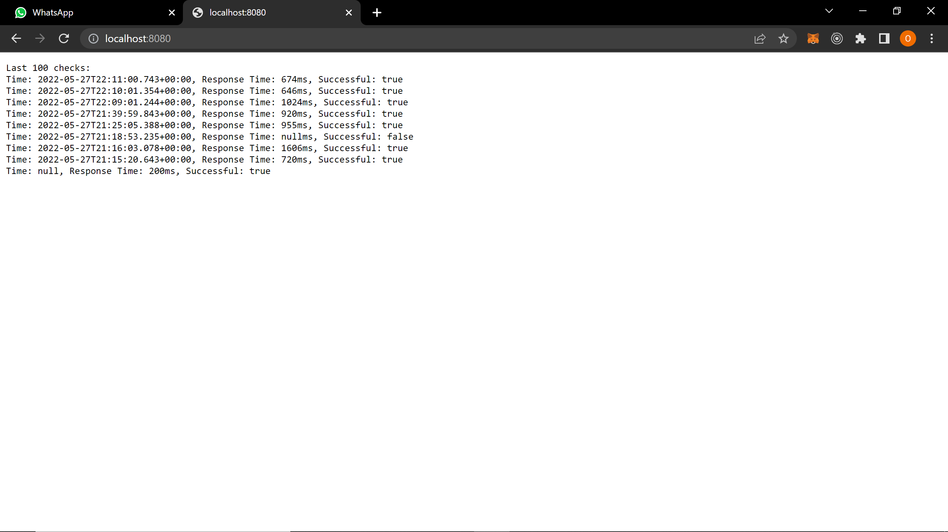

# DATABASE STRUCTURE FOR SAVED TESTS

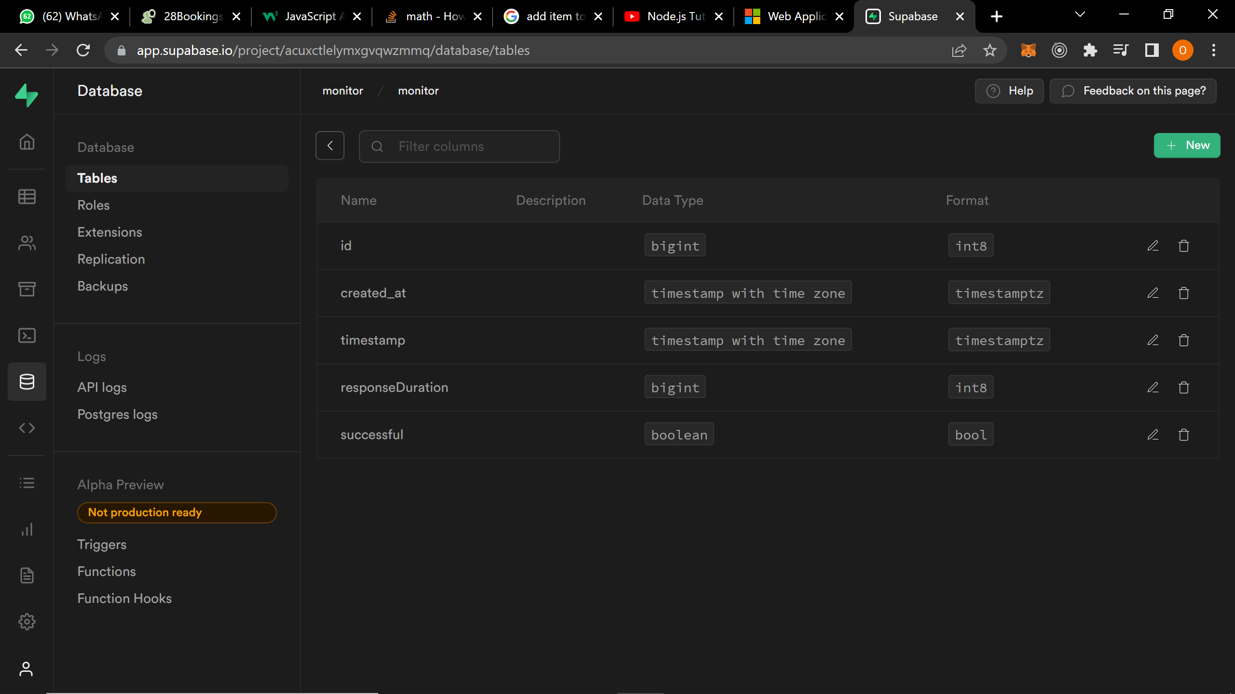 The tests responses are saved to a remote database as a service platform (Supabase). Only failed tests are sent to the users email using Mailgun’s email service.