Question-1a)

The maximum height of a red-black tree with n nodes is given by the formula 2 * log(**n**+1).

Question-1b)

Both the AVL Tree has less space complexity than red-black trees for the same number of nodes because each node in red-black tree has an additional property of being red or black thus each node in red-black tree takes up more space in memory than a node from an AVL Tree.

Question-2a)

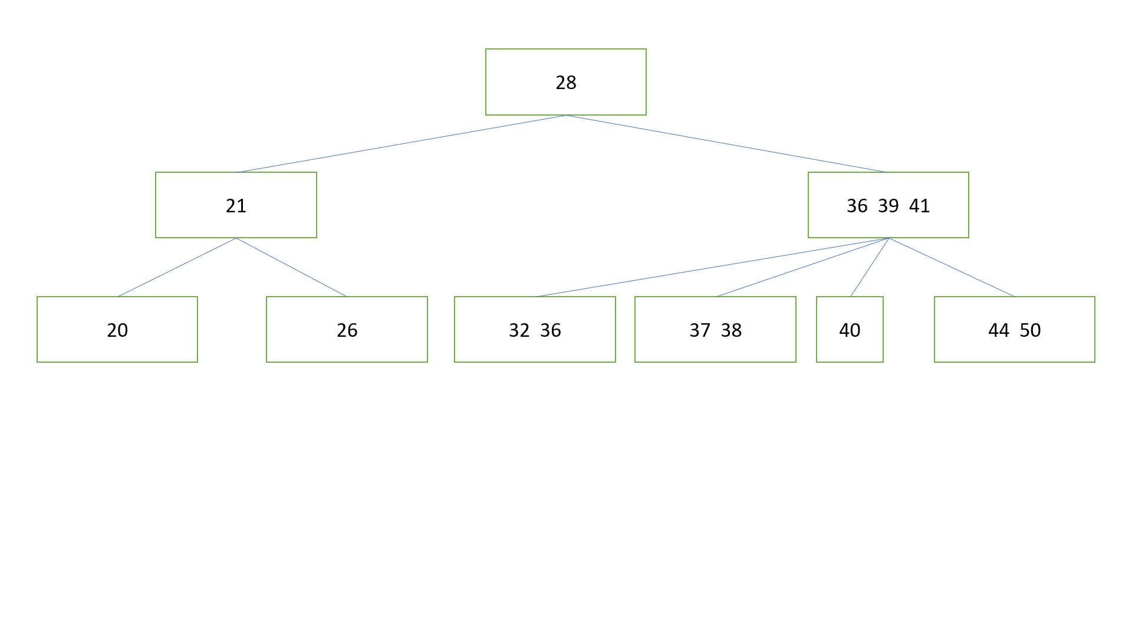

Question-2b)

