A Comparison of Discriminant Functions and Decision Tree Induction Techniques for Evaluation of Antenatal Fetal Risk Assessment

Nilgun Guler¹, Olcay Taner Yıldız², Fikret Gurgen², Fusun Varol³, Ethem Alpaydın²
¹ Math. Eng. Dept, Yıldız Technical University, Beşiktaş, İstanbul/TURKEY
² Comp. Eng. Dept, Bogazici University, Bebek, 80815, İstanbul/TURKEY
³ Gyn. and Obs. Dept, Trakya University, Edirne/TURKEY
{ gurgen@boun.edu.tr, guler@yildiz.edu.tr}

Abstract. In recent years, the family of methods suitable for classification problems has been extended to include a range of new techniques, such as discriminant functions and decision tree induction. Our purpose is to make a comparison of these classification techniques in antepartum fetal evaluation. The task is to investigate the doppler ultrasound measurements of umbilical artery (UA) to relate the health conditions of fetuses using discriminant functions such as linear discriminant analysis (LDA), multilayer perceptron (MLP) and decision trees (ID3, CART). We use the following UA blood flow velocity waveforms: pulsality index (PI), resistance index (RI) and systolic/diastolic ratio (S/D) in terms of weeks (week index: WI as a normalized value) to decide if there is hypoxia suspicion. With these indices, a specificity and sensitivity are 100% and 93%. It has also been demonstrated that MLP and CART are favorable medical aids to phycisians during intensive surveilance of fetuses.

1. Introduction
Several studies have already demonstrated the possibilities and limits of using umbilical doppler for the assessment of fetal growth [1-8]. The most commonly used indices are:
- Systolic/diastolic (S/D) ratio.
- Resistance index (RI).
- Pulsatility index (PI).
where PI=(S-D)/mean velocity and RI=(S-D)/D. These indices are defined by using the blood flow velocity waveform and are independent of the angle between the ultrasound beam and the direction of blood flow.
In these studies during pregnancy follow up of IUGR fetuses, it has been shown that increased impedance to flow in the UA is associated with fetal hypoxemia and acidemia [1-4]. Later, it has also been shown that indices of middle cerebral artery (MCA) and umbilical resistance index to cerebral resistance index ratio (URI/CRI) are important for fetal monitoring [1-8]. Even though, the effectiveness of the other indices such as middle cerebral artery (MCA) are known to be useful, we, in this study, only make use of UA indices for a comparison purpose of the discriminant functions and decision tree induction. The results can be extented for the other important indices of fetal monitoring.
Briefly, this study employs doppler ultrasound measurements of umbilical artery (UA), then, discusses the usage of discriminant functions and decision tree induction for the assessment of hypoxic conditions or for antepartum fetal evalution. Section 2 presents the proposed monitoring system for fetal health. Section 3 presents decision by discriminant functions such as linear discriminant analysis (LDA) and multilayer perceptron (MLP). Section 4 introduces decision tree induction techniques such as ID3 and CART. Section 5 introduces the experiments and the results. Finally, the discussion and conclusions are made in section 6.

2. Monitoring system of fetal health
The system receives weekly doppler ultrasound examinations [1] as input and produces an output correlated with clinical conditions. In the UA measurements case, feature vectors are weekly ultrasound values that are PI, RI, S/D and WI. The PI, RI and S/D are based on pulsatility which is defined as the difference between the peak systolic and end-diastolic components of the maximum frequency shift and the end-diastolic component itself [3-5]. The WI is the normalized gestational age in terms of weeks between 0 to 40 [9]. A part of the UA data that are the examinations of pregnant women in the range between 20 and 40 weeks are shown in Table1.

Table 1: PI, RI, S/D ratio for UA between 20 and 40 weeks [1]
Gestational age (Week) | Pulsality index | Resistence Index | S/D ratio
20 | 1.35 | 0.77 | 4.40
22 | 1.25 | 0.73 | 3.95
24 | 1.19 | 0.72 | 3.60
26 | 1.12 | 0.67 | 3.40
28 | 1.08 | 0.64 | 3.20
30 | 0.97 | 0.63 | 3.00
32 | 0.95 | 0.60 | 2.80
34 | 0.90 | 0.60 | 2.65
36 | 0.80 | 0.55 | 2.55
38 | 0.75 | 0.52 | 2.40
40 | 0.72 | 0.51 | 2.20

In the proposed system, we seperately use the UA indices to have an assessment about the risk of fetal hypoxia. We analyze the patterns of the data to see the effect of the specific measurements on the hypoxia. Furthermore, we use discriminant functions LDA and MLP and decision trees ID3 and CART to monitor the fetal conditions from these indices.

3. Decision by discriminant functions
Discriminant function analysis has been an important decision tool for various pattern recognition applications [11,12,13,14]. Discriminant functions generally transform input feature space on the directions of maximum separability. .Discriminant analysis is a technique for first identifying the "best" set of attributes or variables, known as the discriminator for an optimal decision. We can define the discriminant functions in various degrees.

3.1 Decision by LDA
The linear discriminant is the classifier that results from applying Bayes rule to the problem of classification, under the following assumptions:
- the data is normally distributed
- the covariances of every class are equal

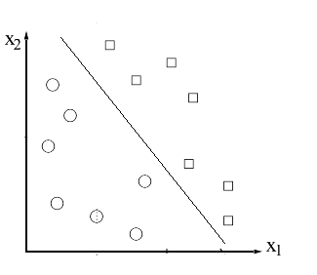(a)

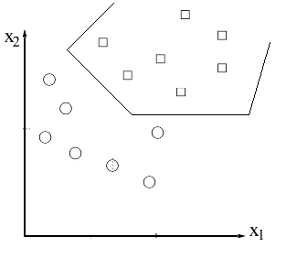.(b)

Fig 1: Decision produced by LDA (a) and MLP (b)
Despite these restrictions, the LDA still performs well on data which is only approximately normally distributed, and where the classes have different covariances. One of the purposes of this experiment is to see just how robust the linear discriminant is.
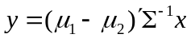
(1)

3.2 Decision by MLP:
Among the ANNs, the elementary multilayer perceptrons (MLP) with sigmoidal transfer function have been successfully applied to solve some difficult and diverse problems [15,16,17] as a nonlinear discriminant function (classifier). The feedforward network learns from the input data by the supervision of the output data creating single linear discriminant functions by each sigmoid hidden unit and combines them. Thus, this piecewise linear discriminant function works as a nonlinear discriminator.
Training them in a supervised manner with a highly popular algorithm known as the error back-propagation (BP) has become very popular. The back-propagation is an optimization technique for implementing gradient descent in weight space for multilayer feedforward networks.
The basic idea of the technique is to efficiently compute partial derivatives of an approximating function F(w;x) realized by the network with respect to all the elements of the adjustable weight vector w for a given value of input vector x and output vector y. The weights are adjusted to fit linear piecewise discriminant functions to feature space for the best class separability. The difference between the network’s output and the supervisor output is minimized according to a predefined error function (performance criterion) such as mean square error (MSE) (eqn.2) etc. The error function helps to place the discriminators to right location and positions:
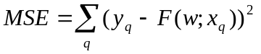
(2)

4. Decision by decision tree induction techniques
Decision trees test the attributes in order to make an optimal classification decision. ID3 and CART are the most commonly used ones. ID3 selects the best attribute for this purpose, but CART does the same task by choosing the best linear combination of the attributes.

4.1 Decision by ID3
ID3 algorithm [18] learns attributes by constructing them top-down manner starting with selecting the best attribute to test at the root of the tree. To find the best attribute, each instance attribute is put into a statistical test to determine how well it alone classifies the training examples. The best feature is selected and used as a test node of the tree. A child of the root node is then created for each possible value of the attribute namely two children for ordered features as x_{i}<a and x_{i}>a, and m children for unordered feature as
(3)
x_{i}=a₁, x_{i}=a₂ .. x_{i}=a_{m}
where m is the number of different possible values of the feature x_{i}. The entire process is then repeated recursively using the training examples associated with each child node to select the best attribute to test at that point in the tree. This form of ID3 algorithm never backtracks and is a greedy search algorithm.
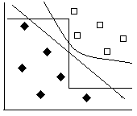
Fig. 2: Comparison of univariate and multivariate splits on the plane

4.2 Decision by CART
The multivariate decision tree-constructing algorithm CART selects not the best attribute but the best linear combination of the attributes. The linear combination consists of multiplication of weights with each feature x_{i.} The main operation in CART is determining the weights w_{i} of those features.
CART algorithm for finding the coefficients of the available features is a step-wise procedure, where in each step one cycles through the features x₁,x₂ .. x_{n} doing a search for an improved linear combination split. At the beginning of the L’th cycle, let the current linear combination split be v ≤ c. For fixed γ, CART searches for the best split of the form:
v - δ (x₁+ γ) ≤ c, such that
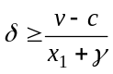 where x₁+ γ ≥ 0,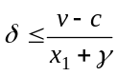 where x₁+ γ ≤ 0
(4)
The search for δ is carried out for γ = -0.25, 0.0, 0.25. The resulting three splits are compared, using the chosen partition-merit criterion, and the δ and γ corresponding to the best are used to update v, producing:
v’ = w₁’ x₁ + w₂’ x₂ … , where w₁’= w₁ - δ and c’ = c + δγ.
(5)
This search is repeated for other features x₂, x_{3…} x_{n} to obtain an updated split v_{l} < c_{l}. The final step of the cycle is to find the best c_{l}, and the system searches explicitly for the split that minimizes the impurity of the resulting partition. The cycles end when the reduction of impurity is below a constant say ε. [19].
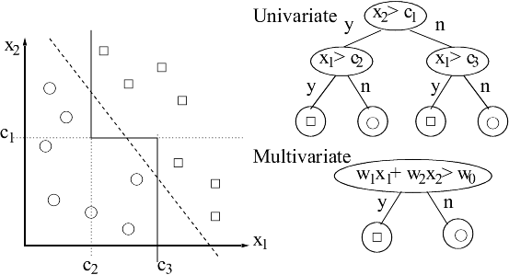
Fig. 3: The construction of multivariate decision trees

5. Experiments and Results
The set of data are used for the experiments: the PI, RI and S/D ratio values of UA [1] between 20 and 40 weeks. The data and experimental results are shown in Table 3, Table 4.

Table 3 : The number of training and test samples
 | Normal fetuses | Abnormal fetuses | Total
Data from UA
Training samples | 101(72%) | 46(28%) | 147
Test samples | 42(66%) | 21(44%) | 63

Table 4: Prevalence Data from UA
 | Sensitivity | Specificity | PPT | PNT
LDA | 100% | 76% | 68% | 100%
MLP | 100% | 93% | 88% | 100%
ID3 | 100% | 74% | 66% | 100%
CART | 100% | 93% | 88% | 100%

The sensitivity of the test is the probability that the test result will be abnormal when the disease is present.The specificity of the test is the probability that the test result will be normal when the disease is not present. The predictive value of an abnormal test (PNT) would be that fraction of fetus with an abnormal test result who have the abnormal condition, while the predictive value of a normal test (PPT) would be the fraction of fetus with a normal test result who are normal. Table 4 shows the results.
In this study, the highest specificity and sensitivity of the system is achieved by MLP and CART. The other techniques(expecially LDA and ID3) are poorer to specify the predicting normal cases while they are very good at the predicting abnormal cases.
Both, the discriminant functions and decision trees of pattern recognition are verified to be valuable tools for revealing adverse conditions in antenatal fetal risk assessment. As the nonlinearity of the discriminator increases, the accuracy of the assessment also improves. A MLP, as a nonlinear discriminator, outperforms the performances of the LDA and the ID3 induction, in the fetal risk assessment task. Also, in the case of CART, Linear combination of attributes (variables) are used for the decision induction. It is observed that there is a group of discriminators that is constructed with the techniques: the outcome of LDA is a linear discriminator, ID3 draws stairs according to the best induced features. The CART induces a linear combination of the best features for an optimal decision. The MLP, as a nonlinear discriminator, draws piecewise linear combinations, in each of them a local optimality is searched by training.

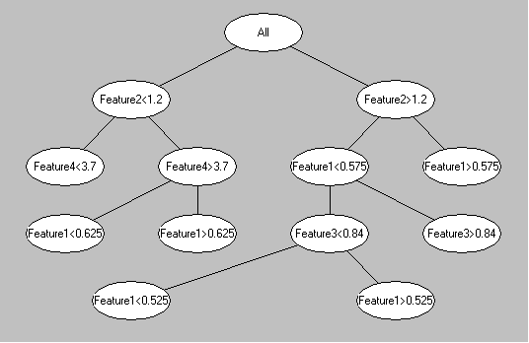
Fig. 4 : The results of ID3 (WI= Feature1, PI= Feature2, RI=Feature3 ,S/D=Feature4).
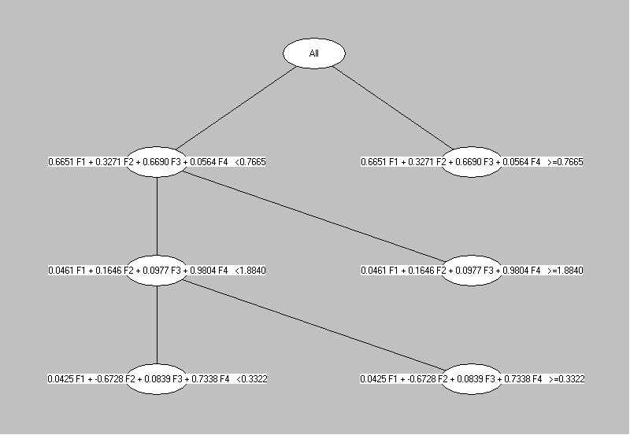
Fig. 5: The result of CART.

6. Discussion and Conclusions
The study points the following facts:
- The decision trees ID3 and CART are found to be applicable to the selection of the best attributes and/or the combination of them to make the best decision for antepartum fetal evaluation.
- The discriminant functions LDA and specifically MLP are also shown to be effective class discriminators for the same problem [20, 21].
- The discriminant functions and decision tree induction techniques produce discriminators. The first group obtains an optimal decision by the combination of attributes in the linear or piecewise linear form. The second group obtains similar decision by employing a tree that give the result by selection of the best attribute or the linear combination of the best attributes.
- The MLP and the CART techniques are found to be helpful to support the doctor’s decision.
- It is proven that the risk assessment by using the doppler ultrasound based indices PI, RI, S/D ratio of UA according to WI can be done with our system. The experiments that were performed here confirm the observations of the doctors. But the special cases also need special attention by the doctors: For example, it must be pointed out that the PI in the UA may even be raised several weeks or months before fetal hypoxia is clinically suspected.
- This study points a fruitful line of enquiry for helping doctors in the risk assessment of antenatal fetal evaluation.

7. References
- Giancarlo Mari, Joshua A. Copel : Doppler Ultrasound: Fetal Physiology and Clinical Application Chapter 13: Sonography in obstetrics and Gynecology: Principal and practice,1996.
- Creasy Resnik: Maternal-Fetal Medisine 4 th Edition: Chapter 15 Dopler ultrasound Assesment of Blood Flow, pp 216-229, 1999.
- Chervenak Frank, Kurcak Asım: “The Fetus as a Patient” 1996
- De Haan J: Pathophysiologic Back-grounds of changes in doppler flow indices. In Van Geijn HP, Copray FJA eds. A critical Appraised of fetal surveillance. Amsterdam: Elsevier,1994; 470-82.
- Maulik D, Yarlagadda P, Downing G: “Doppler velocimetry in obstetrics”: Obstet Gynecol Clin North Am 1990; 17:163-86.
- Campbell and Kyprus Nicolaides: “Fetal venous, intracardiac, and arterial blood flow measurements in intrauterine growth retardation”: Relationship with fetal blood gases. London, United Kingdom.
- M. Sinan Beksac, Funda Basaran, Selim Eskiizmirliler, Aydan M. Erkmen, Selma Yorukan: “A Computerized diagnostic system for the interpretation of umbilical artery blood follow velocity waveforms”: European Journal of Obstetrics & Gynecology and Reproductive Biology ,Vol 64 ,1996, 37-42.
- J.W. Wladimiroff, J. A. G. W. V. D. Wijngaard, S. Degani, M. J. Noordam, J. v. Eyck and H. M. Tonge: “Cerebral and Umbilical Arterial Blood Flow Velocity Waveforms in Normal and Growth Retarded Pregnancies”: European Journal of Obstetrics & Gynecology and Reproductive Biology, Vol 69, No.5, May 1987, page 705-709
- Fikret Gurgen: “Neural-Network-Based Decision Making in Diagnostic Applications”: IEEE Engineering in Medicine and Biology, pp 89-93, July/August, 1999.
- Fikret Gurgen, Emrah Onal, and Fusun G. Varol: “IUGR Detection by Ultrasonographic Examinations Using Neural Networks”: IEEE Engineering in Medicine and Biology magazine, Volume 16, Number 3, May/June, pp 55-58, 1997.
- Donald F. Morrison: Multivariate Statistical methods: McGraw-Hill Publishing Company.
- Joseph F. Hair, jr. Rolph E. Anderson, Ronald L. Tatham: Multivariate Data Analysis with Readings: Prentice Hall, 1995.
- Keinosuke Fukunaga: Introduction to Statistical Pattern Recognition:Academic Press, Inc, 1990.
- Subhash Sharma: Applied Multivariate Techniques: John Wiley & Sons, Inc. 1996.
- Haykin Simon: Neural Networks: Macmillan College Publishing Company, Inc. 1994.
- B.D. Ripley: Pattern Recognation and Neural Networks: Cambridge Press 1996.
- Padhraic Smyth,Wray Buntine: Probabilistic Machine Learning Putting Theory in to practice: Tutorial Notes: wray@Heuristicrat. pjs@galway.jpl.nasa.gov.
- J. R. Quinlan: Induction of Decision Trees: Machine Learning Vol. 1, pp. 81-106. 1986.
- Breiman, L. Friedman, J. H. Olshen, R.A. & Stone, C. J. (1984). Classification and Regression Trees.
- N. Guler, F. Gurgen, F. Varol : "Decision of Normal and Growth Retarded Pregnancies by Discriminant Functions Using Umbilical Arterial Blood Flows Velocity Waveforms": Advance in Intelligent Systems and Computer Science: World Scientific and Engineering Socity Press 1999 pp 186-190.
- N. Guler, F. Gurgen, F. Varol : "Ultrasound Blood Flow Waveform Discriminant Functions for Antenatal Fetal Risk Assessment": (in press) IEEE Engineering in Medicine and Biology magazine, 2000.

