Computational analysis and classification of type I restriction - modification systems reveals new families.

Ania Olchowik¹, Albertas Timinskas², Agnieszka Obarska-Kosińska¹, Krzysztof Szczepaniak¹, Ceslovas Venclovas^{2,*}, Janusz M. Bujnicki^{1,3,*}

1. Laboratory of Bioinformatics and Protein Engineering, International Institute of Molecular
and Cell Biology, ul. Ks. Trojdena 4, PL-02-109 Warsaw, Poland
2. Institute of Biotechnology, Vilnius University, LT-02241 Vilnius, Lithuania.
3. Faculty of Biology, Adam Mickiewicz University, ul. Umultowska 89, PL-61-614 Poznań, Poland

* To whom correspondence should be addressed. Tel: +48 22 597 0750; Fax: +48 22 597 0715; Email: iamb@genesilico.pl. Correspondence may be also sent to Ceslovas Venclovas, Tel: …; Fax: …; Email: venclovas@ibt.lt

The authors wish it to be known that, in their opinion, the first two authors (AO and AT) should be regarded as joint First Authors.

Keywords: DNA, type I restriction enzymes, nucleases

ABSTRACT

Type I Restriction-Modification Systems (TIRMS) are complex, multifunctional enzymes that commonly occur in prokaryotic cells. They comprise three types of subunits, which are required for recognition of specific target sequences in the substrate DNA (S for specificity), methylation of specific adenosines within the target sequence (M for modification), and ATP-dependent DNA translocation and cleavage at a variable distance from the unmodified target site (R for restriction). TIRMS have been originally grouped into four families (A, B, C, and D) based on experimental analyses; a fifth putative family (E) was postulated based on sequence analysis. Structures and functions of TIRMS have been extensively studied using various biochemical, biophysical, cellular and computational approaches. However, thus far no comprehensive phylogenetic analysis was performed for these proteins, and as a result their mutual evolutionary relations are unknown. We carried out an extensive computational analysis to identify TIRMS subunits encoded by completely sequenced prokaryotic genomes. Protein sequences were classified into families based on similarity-based clustering. This analysis confirmed the existence of TIRMS sequence families that agree with the previous classification and additionally revealed four new putative families (here named as F, G, H, J) comprising members thus far uncharacterized. Comparative analysis revealed common trends in the TIRMS genomic internal structure and external context. We identified only three out of six possible arrangements of TIRMS subunit-encoding genes (MSR, RMS, and RSM). Our study provides a comprehensive picture of sequence-structure-function relationships within TIRMS and will serve as a useful guide for future functional studies. The results of protein sequence comparative analyses as well as annotation of genomic structure and context are presented online in a publicly available database TIRMSdb.

INTRODUCTION
Type I Restriction-Modification Systems (TIRMS) were the first of restriction-modification systems to be discovered, detected in the late 1950s and then isolated in the early 1960s (historical review: ). They are sophisticated enzymes, composed of subunits encoded by three host specificity determinant (hsd) genes: S (for DNA sequence specificity), M (for DNA modification), and R (for DNA restriction). Subunits S and M form a DNA methyltransferase (MTase, typically with a stoichiometry of S₁M₂) that modifies specific adenosine residues in the target sequence to N6-methyladenosine (m⁶A), thereby marking the DNA as ‘self’. In the absence of that specific methylation, the target sequence is sensitive to the restriction endonuclease (REase) made of all three gene products (typically with a stoichiometry of S₁M₂R₂). REase binds to the unmodified sequences in the substrate DNA (e.g. a ‘non-self’ DNA of a phage or a plasmid entering a prokaryotic cell that encodes the TIRMS), triggers ATP-dependent pulling of that DNA, and degrades it by nucleolytic cleavage at a variable distance from the target sequence (review: ).

Recent structural studies provided insight into the TIRMS architecture and mechanism of action. Crystal structures have been determined for individual S, M, and R subunits from various systems , and structural models have been proposed for the functional MTase and REase complexes based on integration of crystallographic data with electron microscopy and small angle neutron and X-ray scattering experiments . The S subunit contains two DNA target recognition domains (TRDs), one for each part of the bipartite recognition sequence, joined by two α helices in an antiparallel arrangement. In three dimensions (3D) the S subunit displays pseudo-twofold symmetry , which is imposed on the structure of the whole TIRMS complex. The two M subunits are positioned on either side of the S subunit and contact the TRDs, to form the MTase core. The M subunit contains a Rossmann Fold Methyltransferase (RFM) catalytic domain in the center and additional terminal regions involved in interactions with other subunit. The two R subunits are located on either side of the MTase core. The R subunit contains an ATP-hydrolyzing DNA translocation “motor” domain from the AAA+ superfamily, a nuclease domain from the PD-(D/E)XK superfamily and additional regions involved primarily in interactions with other subunits .

RFM is an abundant domain found in MTases acting on many different substrates, including restriction-modification systems of other types, as well as enzymes acting on RNA, proteins, and various small molecules . The AAA+ module comprises two RecA-like domains and is found in many enzymes, including molecular machines involved in DNA repair, replication, recombination and chromosome remodeling . The PD-(D/E)XK domain is an abundant phosphodiesterase domain commonly found in all Types of restriction enzymes, in other nucleases and in proteins with many other functions . The TRD of TIRMS, on the other hand, is a unique domain, and outside of that class of enzymes it has been found only in some (but not all) Type II DNA:m⁶A MTases . TRD also shows the greatest amino acid sequence variability among all domains common to TIRMS. As the TRDs are responsible for specific recognition of DNA sequence, they accumulate most changes responsible for different substrate preferences. Indeed, TRDs can be exchanged between related S subunits or even moved between different positions within one subunit {furuta kobayashi} to generate enzymes with novel DNA specificities.

TIRMS are encoded in most of prokaryotic genomes, including many bacterial pathogens , and contribute to genome and strain stability by limiting horizontal gene transfer and genetic exchange between different bacteria . This is of special importance considering the spread of antibiotic resistance in pathogens, such as multidrug-resistant Staphylococcus aureus (MRSA), where the Sau1 TIRMS was found to regulate horizontal gene transfer, e.g. by blocking the transfer between S. aureus isolates of different lineages .

TIRMS were originally divided into three families based on complementation tests between subunits from different systems, as well as analyses of gene order, amino acid conservation and enzymatic properties of several representatives: Type IA e.g. EcoKI and EcoBI, Type IB e.g. EcoAI, Type IC e.g. EcoR124I, and Type ID e.g. StySBLI . Subsequently, Type IE (founding member: KpnBI) has been proposed based on comparative analyses that did not include complementation tests . Since that original classification established a decade ago, the flood of sequence data from whole-genome sequencing projects has resulted in accumulation of numerous TIRMS sequences in databases. However, thus far no comprehensive analyses of these sequences have been done to elucidate phylogenetic relationships between different members of TIRMS. As a consequence, it is unclear to which extent members of different families (defined experimentally) are related (in the evolutionary sense) to each other, and whether functionally uncharacterized new families may await discovery. Thus, we carried out a bioinformatics search for all proteins that based on their sequence similarities can be confidently classified as homologs of known R, M, or S subunits, and with the addition of genomic neighborhood analysis – predicted to form functional TIRMS. We aimed at developing a new classification scheme based on evolutionary relationships that will facilitate the planning of experimental analyses.

METHODS

Identification of individual subunits Very first draft by Albertas
Description of biological function has been realized through the library of representative sequence fragments. This library has been compiled taking proteins from functional groups from REBASE (etc.: “type I gamma class DNA methyltransferase”, “type II gamma class DNA methyltransferase”, “all DNA gamma MTases” …). Amino acid taken from REBASE protein sequence under analysis has been added to the representative region only in the case if it belonged to the sequence region what has been aligned with e-value better than 1e-04 to at least 5% of members of REBASE functional group of proteins. Identification of functional domains/regions (searching for individual components of R-M systems). For each representative fragment the PSSM has been built up using PSIBLAST and nr80 (ncbi). These PSSMs were used on searching bacterial proteomes for similar fragments. It has been assumed that bacterial protein possess functional domain confidently just in case if at least 10% of fragments of representative library are covered by fragments taken from protein under analysis sharing similarity higher than 1e-02. Functional groups where: 5-DNA m5C MTases, A-DNA alpha class MTases, B-DNA beta class MTases, G-DNA gamma class MTases, R1-proteins sharing similarity with type I hsdRs, R2- proteins sharing similarity with type II endonucleases, R3 -proteins sharing similarity with type III Res subunits, H- proteins similar to SN2 helicases, S- proteins sharing similarity with type I hsdS subunits).
The sets of hsdM, hsdS and hsdR subunit homologues were used in further analysis.

Identification of distance between type I subunit protein coding sequences in genomes.
Albertas did this

Identification of type I R-M systems
Something is missing here!!!! What about proteins exhibiting matches to one template (M or R or S only?) Protein sequences exhibiting matches to both M and S subunits (e.g. potential fusion proteins) were included in both M and S sets. The genomic location of each protein was determined using data on sequenced genomes available at (ncbi:ftp)[ref]. Genomes encoding at least one complete potential R-M system (at least one hsdR one hsdM and one hsdS subunit) were selected. Type I RM-related proteins from those genomes were assembled into groups of proteins with common genomic location - candidate type I R-M systems.
We classified subunits as a single candidate type I RM system if consecutive type I subunit coding sequences were not further than 5 ORFs apart.

Clustering of hsdM hsdR and hsdS subunits

Experimentally confirmed type I R-M subunits from rebase [ref] were added to the hsdM, hsdS and hsdR protein sets obtained from the genome sequence analysis. Obtained sets were clustered separately using clans clustering software [ref]. CLANS uses the P-values of highly-scoring segment pairs (HSPs) obtained from an N × N BLAST search, to compute attractive and repulsive forces between each sequence pair in a user- defined dataset. A two- or three-dimensional representation of sequence families is achieved by randomly seeding the sequences in the arbitrary distance space, then moving them within this environment according to the force vectors resulting from all pairwise interactions, and repeating the process until convergence. Clusters have been defined using a range of p-values, from 10⁻¹⁰ to 10⁻¹⁰⁰. Final clustering was performed manually based on computationally generated clusters. A set of canonical systems was selected. Those systems contained exactly 1 hsdM, 1 hsdR and 1 or more hsdS subunits and all subunits were successfully classified to one of the clusters.

Identification of type I families

All identified M, R and S clusters were represented as nodes in a Cytoscape [ref] generated graph. The common genomic location of two proteins was represented as a connection between graph nodes. The width of the connection between two clusters represents the number of times proteins from those clusters were encoded close to each other in a genome. Interconnected HsdM, hsdR and hsdM clusters were considered a family experimentally confirmed type I families were identified based on known representatives present in those clusters. Remaining sets of linked clusters were classified as potential new families.

Classification of subunits into families
HMMER was used to construct Hidden Markov models for each cluster based on proteins from candidate systems successfully classified into families. Proteins from the starting data sets were classified to one of the families using HMMER.
Systems were classified to a family only if all proteins within the system were classified to the same family. Systems containing more than 1hsdM or more than 1 hsdR subunit were excluded from analysis and analyzed separately.

Analysis of type I gene order
The distance in number of base pairs between coding sequences of two consecutive type I RM subunits located on the same DNA strand was calculated. Distance was measured from the last nucleotide of the upstream ORF to the first nucleotide of the downstream ORF. Positive distance indicates that genes are apart while negative distance indicates overlapping genes. The order of subunits was evaluated only for systems containing 3 subunits including hsdM, hsdS and hsdR located on the same DNA strand.

Type I R-M database
In order to make the results easily accessible the type I families database was constructed.
Database was implemented using Python, Django, and SQLite. Data retrieval and visualization was implemented using JavaScript, JQuery, HTML, and CSS.

RESULTS
The RESULTS have to start with the description on WHAT has been done (the “how” is in the METHODS, but “what” should be in RESULTS). So start with a general description of what we did first (not how, but what) – i.e. about the collection of sequences etc..
Albertas results on choosing protein sets and calculating distance go here...general statistics on number of candidate systems etc. ….
Clustering of R, M, and S subunits and definition of type I families according to sequence similarity

M, R and S subunits were clustered according to sequence similarity using CLANS. Nine clusters of M subunits and nine clusters of R subinits were determined by manual clustering. Seven clusters of S subunits were determined manually. Automated linkage clustering with default parameters in CLANS revealed a possible eighth cluster, while a ninth cluster included fusion proteins containing elements of both S and M subunits. XXXX of these clusters (X of R clusters, Z of M clusters, and Y of S clusters) contained sequences of experimentally characterized members of previously identified TIRMS families (A-E). It is worth emphasizing that no sequence-based cluster contained known members of different experimentally-defined families. At this stage the remaining YYY clusters (X of R clusters, Z of M clusters, and Y of S clusters) remained unassigned to any family.

Subsequently, we analyzed the genomic association of members of sequence clusters. Initially, we considered only sequences that occurred in loci comprising just one S, one M, and one R subunit (i.e. we ignored sequences of possibly incomplete TIRMS or those with more than three subunits encoded close to each other). This analysis (whose results are illustrated by a series of graphs in Figure 3) revealed that clusters of S, M, and R homologs formed six “triads” (each containing one cluster of S, M, and R subunits), one “tetrad” with two S clusters, one M cluster and one R cluster, and one “pentad” comprising two “dyads” of R/M clusters connected to one S cluster.

Clusters containing S, M, and R subunits assigned to one of the previously identified TIRMS families (A-E) were found to group together. Clusters without experimentally characterized members were found within three triplets, suggestive of three new families of TIRMS, which we have tentatively labeled F, G, and H. Additionally, one cluster of uncharacterized S subunits was found within the tetrad that already contained a triplet of Type IC subunits, and clusters of uncharacterized R and M subunits were found within a pentad, together with a triad of D subunits.

Experimentally confirmed enzymes from Rebase [ref] present in distinguished clusters were assigned to corresponding families. [Table 1]. One of experimentally characterized proteins S.SglORF2102a was assigned to a putative new family F.

Gene order in type I RM systems

We investigated the gene order of complete type I systems that contained exactly 3 subunits - all on the same DNA strand. From all six possible gene orders: MSR, RMS, RSM, SMR, MRS, MRS only the first three were significantly represented.

67% of systems had MSR gene order, 23% RMS and 9% RSM. [Fig 3a] The gene order was family dependent. MSR gene order was represented in 90% of D, E and F family systems, while MSR was frequent in families A, B and H. [Fig 3c]. Genes encoding type I RM subunits frequently overlapped.
Overlap is common particularly between hsdM and hsdS subunits in MS gene order. HsdM when followed by hsdS is over two times more likely to overlap than to be separated. Only 23% of hsdM subunits that were followed by hsdS subunits did not overlap, 7% was immediately after the upstream gene, 33% overlaped by 3bp , 13% by 7bp, 12% by 10bp [ fig 2b].

Type I RM subunits distribution in genomes - to be fused with albertas data
1) There are single hsdM, hsdS, hsdR subunits in genome. Also many MS subunits [supplementary Fig1] - solitary methylases
2) Solitary subunits within one genome CAN form a functional system (3 genomes)+ref.
3) There are potential systems, with all proteins classified to the same family that contain more than 3 subunits [supplementary Fig2]. Frequent S subunit multiplication - up to 20 S subunits associated with single RM system.

Type I RM families database http://www.typeii.evolveme.org/enzymes/base

Database containing results of analysis was implemented. Proteins in database were assigned to families based on HMM profile constructed from initial clusters using HMMER. Database contains data on candidate type I RM systems and proteins localized between putative type I subunits in the genome. Data on candidate Systems can be displayed using two alternative visualization modules. Schematic visualization includes shows location of proteins on DNA strand and assigned family, pFam textual description of each protein can be displayed on hover. Detailed visualization shows overlapping proteins and distances between proteins on DNA strand. Multiple candidate systems can be visualized and compared at one time.
Database can be queried using data on individual proteins or candidate systems. Individual proteins can be filtered by GI, Pfam id, type I RM subunit type if applicable, amino acid sequence, Genome, DNA element (as defined in sequence data), Pfam textual description, assigned family, distance from the preceding protein. Additional available data include position on the DNA strand and length of a protein product. Systems can be filtered by type of subunit (hdsM, hsdR, hsdS), number of subunits from particular type or Family.

Family | Enzymes previously not assigned to family | Enzymes previously assigned
A | StySJI, EcoR24I, EcoR12I | EcoBI, StySPI, StyLTIII, EcoR23I, EcoDI
B | StySKI, FtnUII, EcoAO83I | EcoAO83I, FtnUII, CfrAI,
C | Lla82I, Lla1403I, EcoR124I, MpuUI, TelBI, NgoAV,Lla2614I BliDI, LldI, NgoAV-1, MpuUI  C [S.Lla82I, S.Lla2614I S.LldI S.Lla103I S.Lla90I S.LlaW12I S.Lla90II, S.TelBI,S.Lla7I S.Lla1403I S.LlaCIS3I S.BliDI ]  C1[S.EcoR124I] | EcoR124II, EcoprrI  C1 [S.EcoR124II, S.EcoDXXI, S.EcoprrI]
D | HindI, PhaAI, EcoR13I | KpnAI,EcoR9I,StySBLI
E | FclI, BliDII, FtnUI | KpnBI, KpnBI
F | S.SglORF2102a
Table1. Experimentally Characterized enzymes classified to one of identified families. Family C hsdS subunits were classified to one of subclusters either C or C1.

FIGURES:

FIGURE 1: All putative type I subunits were identified. The average distance in genome between type I subunit coding sequences was determined. Subunits with common genomic location were identified as putative type I r-m systems. Sets of putative hsdM hsdR and hsdS subunits were clustered separately. Clusters of hsdM hsdR and hsdS subunit were linked based on common genomic location of proteins that belong to those clusters. Experimentally confirmed type I families were identified based on known representatives present in those clusters. Remaining linked clusters were classified as potential new families. Hidden Markov Model based profiles were constructed for identified families and all proteins were assigned to one of those families. Results were made available as a database typei.genesilico.pl
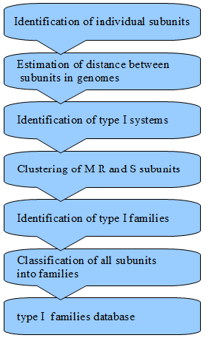

FIGURE2
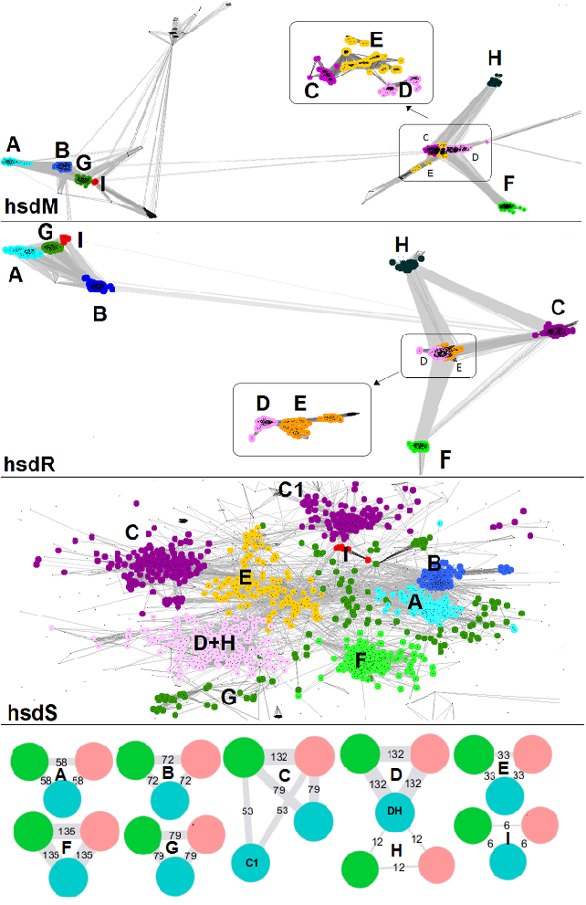
FIGURE3
with nodes representing clusters of similar sequences, and edges representing the presence in the same genomic locus

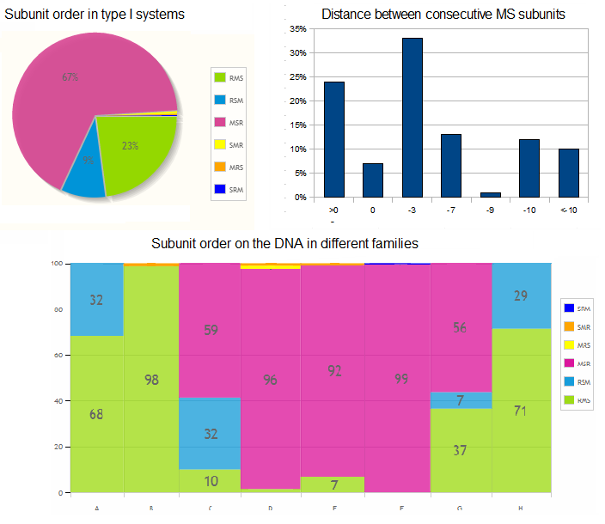

SUPPLEMENTARY FIGURE

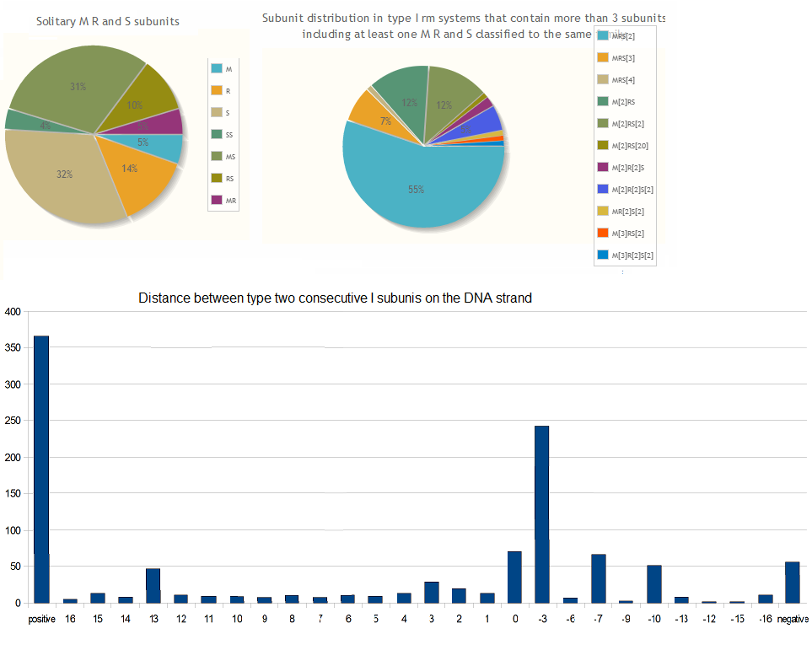

1. Murray, N.E. (2000) Type I restriction systems: sophisticated molecular machines (a legacy of Bertani and Weigle). Microbiol Mol Biol Rev, 64, 412-434.
2. Dryden, D.T. (2004) Reeling in the bases. Nat Struct Mol Biol, 11, 804-806.
3. Calisto, B.M., Pich, O.Q., Pinol, J., Fita, I., Querol, E. and Carpena, X. (2005) Crystal structure of a putative type I restriction-modification S subunit from Mycoplasma genitalium. J Mol Biol, 351, 749-762.
4. Kim, J.S., DeGiovanni, A., Jancarik, J., Adams, P.D., Yokota, H., Kim, R. and Kim, S.H. (2005) Crystal structure of DNA sequence specificity subunit of a type I restriction-modification enzyme and its functional implications. Proc Natl Acad Sci U S A, 102, 3248-3253.
5. Lapkouski, M., Panjikar, S., Janscak, P., Smatanova, I.K., Carey, J., Ettrich, R. and Csefalvay, E. (2009) Structure of the motor subunit of type I restriction-modification complex EcoR124I. Nat Struct Mol Biol, 16, 94-95.
6. Uyen, N.T., Park, S.Y., Choi, J.W., Lee, H.J., Nishi, K. and Kim, J.S. (2009) The fragment structure of a putative HsdR subunit of a type I restriction enzyme from Vibrio vulnificus YJ016: implications for DNA restriction and translocation activity. Nucleic Acids Res, 37, 6960-6969.
7. Gao, P., Tang, Q., An, X., Yan, X. and Liang, D. (2011) Structure of HsdS subunit from Thermoanaerobacter tengcongensis sheds lights on mechanism of dynamic opening and closing of type I methyltransferase. PLoS ONE, 6, e17346.
8. Park, S.Y., Lee, H.J., Song, J.M., Sun, J., Hwang, H.J., Nishi, K. and Kim, J.S. (2012) Structural characterization of a modification subunit of a putative type I restriction enzyme from Vibrio vulnificus YJ016. Acta Crystallogr D Biol Crystallogr, 68, 1570-1577.
9. Kennaway, C.K., Obarska-Kosinska, A., White, J.H., Tuszynska, I., Cooper, L.P., Bujnicki, J.M., Trinick, J. and Dryden, D.T. (2009) The structure of M.EcoKI Type I DNA methyltransferase with a DNA mimic antirestriction protein. Nucleic Acids Res, 37, 762-770.
10. Kennaway, C.K., Taylor, J.E., Song, C.F., Potrzebowski, W., Nicholson, W., White, J.H., Swiderska, A., Obarska-Kosinska, A., Callow, P., Cooper, L.P. et al. (2012) Structure and operation of the DNA-translocating type I DNA restriction enzymes. Genes Dev, 26, 92-104.
11. Davies, G.P., Martin, I., Sturrock, S.S., Cronshaw, A., Murray, N.E. and Dryden, D.T. (1999) On the structure and operation of type I DNA restriction enzymes. J Mol Biol, 290, 565-579.
12. Bujnicki, J.M. (1999) Comparison of protein structures reveals monophyletic origin of the AdoMet-dependent methyltransferase family and mechanistic convergence rather than recent differentiation of N4-cytosine and N6-adenine DNA methylation. In Silico Biol, 1, 175-182.
13. Kozbial, P.Z. and Mushegian, A.R. (2005) Natural history of S-adenosylmethionine-binding proteins. BMC Struct Biol, 5, 19.
14. Neuwald, A.F., Aravind, L., Spouge, J.L. and Koonin, E.V. (1999) AAA+: A class of chaperone-like ATPases associated with the assembly, operation, and disassembly of protein complexes. Genome Res, 9, 27-43.
15. Ammelburg, M., Frickey, T. and Lupas, A.N. (2006) Classification of AAA+ proteins. J Struct Biol, 156, 2-11.
16. Steczkiewicz, K., Muszewska, A., Knizewski, L., Rychlewski, L. and Ginalski, K. (2012) Sequence, structure and functional diversity of PD-(D/E)XK phosphodiesterase superfamily. Nucleic Acids Res, 40, 7016-7045.
17. Kosinski, J., Feder, M. and Bujnicki, J.M. (2005) The PD-(D/E)XK superfamily revisited: identification of new members among proteins involved in DNA metabolism and functional predictions for domains of (hitherto) unknown function. BMC Bioinformatics, 6, 172.
18. Laganeckas, M., Margelevicius, M. and Venclovas, C. (2011) Identification of new homologs of PD-(D/E)XK nucleases by support vector machines trained on data derived from profile-profile alignments. Nucleic Acids Res, 39, 1187-1196.
19. Goedecke, K., Pignot, M., Goody, R.S., Scheidig, A.J. and Weinhold, E. (2001) Structure of the N6-adenine DNA methyltransferase M.TaqI in complex with DNA and a cofactor analog. Nat Struct Biol, 8, 121-125.
20. Shen, B.W., Xu, D., Chan, S.H., Zheng, Y., Zhu, Z., Xu, S.Y. and Stoddard, B.L. (2011) Characterization and crystal structure of the type IIG restriction endonuclease RM.BpuSI. Nucleic Acids Res, 39, 8223-8236.
21. Gann, A.A., Campbell, A.J., Collins, J.F., Coulson, A.F. and Murray, N.E. (1987) Reassortment of DNA recognition domains and the evolution of new specificities. Mol Microbiol, 1, 13-22.
22. Roberts, R.J., Vincze, T., Posfai, J. and Macelis, D. (2010) REBASE--a database for DNA restriction and modification: enzymes, genes and genomes. Nucleic Acids Res, 38, D234-236.
23. Murray, N.E. (2002) Immigration control of DNA in bacteria: self versus non-self. Microbiology, 148, 3-20.
24. Waldron, D.E. and Lindsay, J.A. (2006) Sau1: a novel lineage-specific type I restriction-modification system that blocks horizontal gene transfer into Staphylococcus aureus and between S. aureus isolates of different lineages. J Bacteriol, 188, 5578-5585.
25. Titheradge, A.J., King, J., Ryu, J. and Murray, N.E. (2001) Families of restriction enzymes: an analysis prompted by molecular and genetic data for type ID restriction and modification systems. Nucleic Acids Res, 29, 4195-4205.
26. Chin, V., Valinluck, V., Magaki, S. and Ryu, J. (2004) KpnBI is the prototype of a new family (IE) of bacterial type I restriction-modification system. Nucleic Acids Res, 32, e138.

