int8

main-fsim.cc

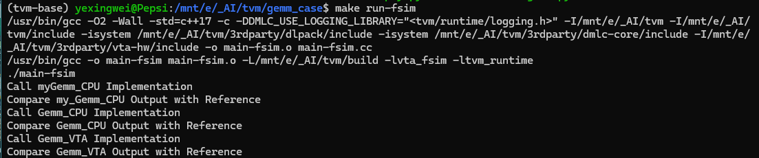

main-tsim.cc

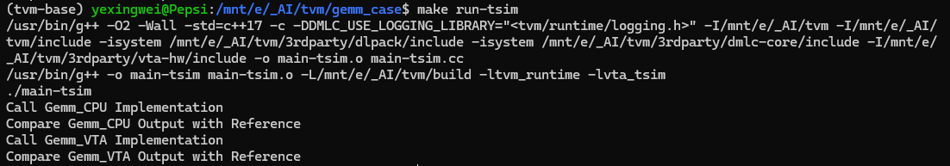

test_benchmark_topi_conv2d.py

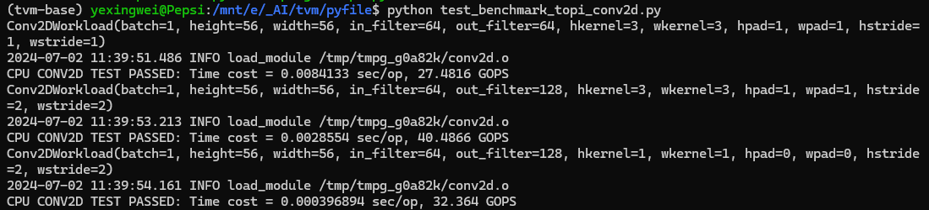

test_benchmark_gemm.py

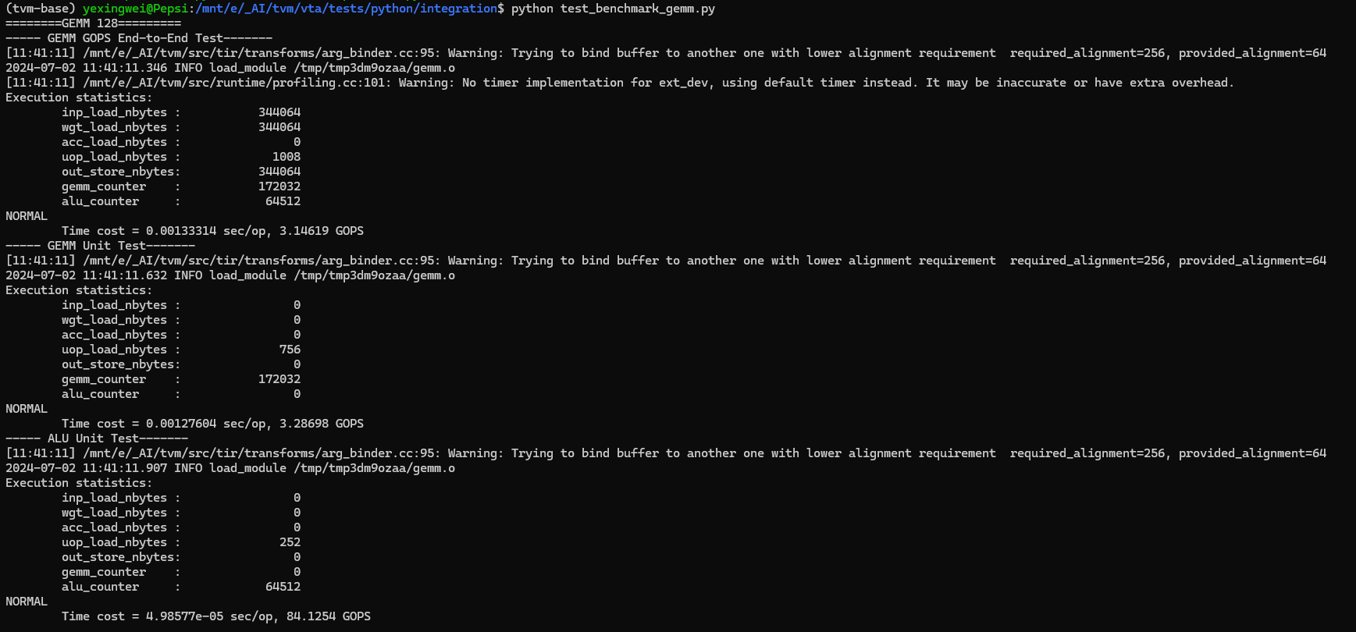

test_benchmark_topi_conv2d_transpose.py

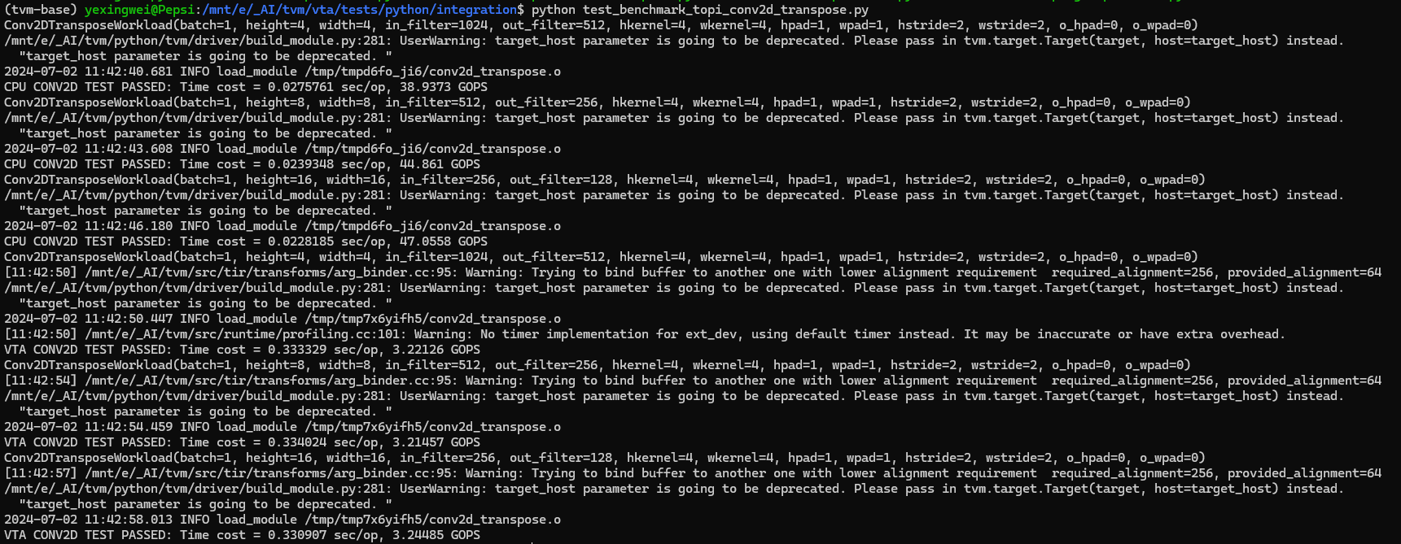

test_vta_insn.py

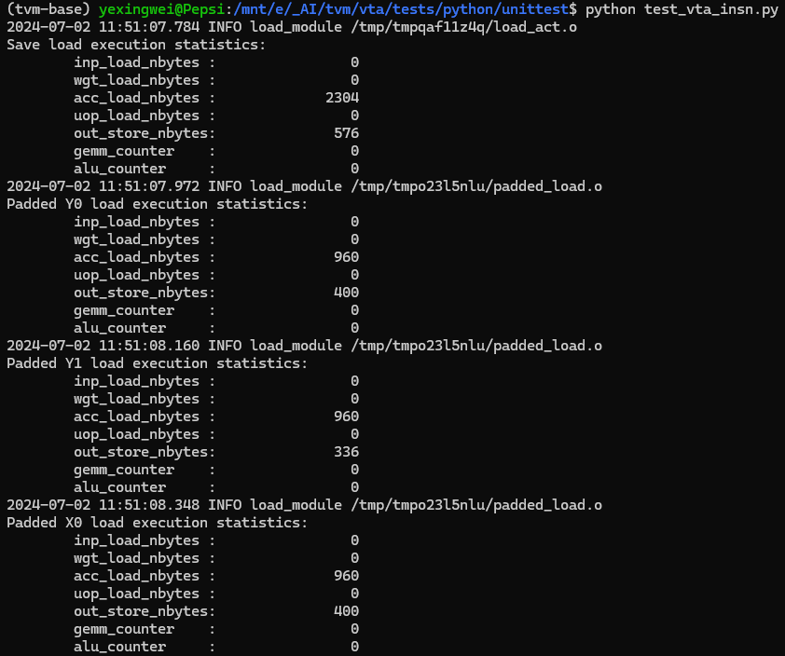

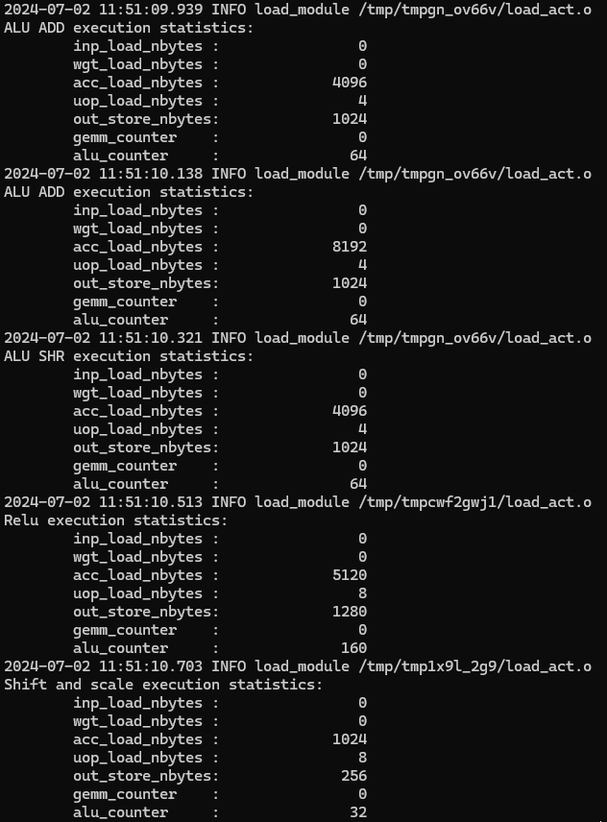

int16

main-tsim.cc

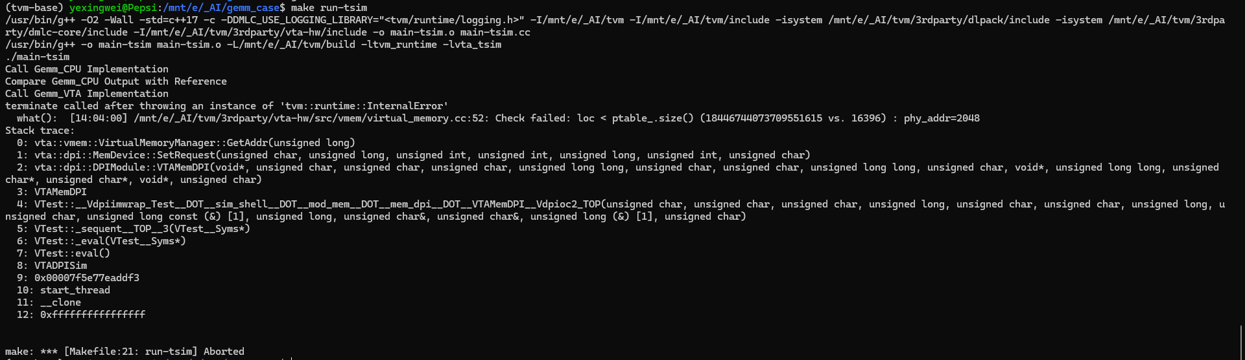

test_benchmark_topi_conv2d.py

