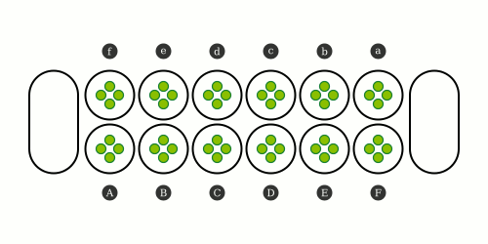
Oware Abapa - Mancala

Setup
- 2 Players - 48 seeds (all same color)
- Game board – 2 x 6 holes - 4 seeds each
- 2 empty storage holes

Goal
Capture more seeds than the opponent

Game ends
When one player captured 25 seeds or when both players captured 24 seeds

Playing the game
Players sit on opposite sides of the board, with a row of 6 holes in front of them. Players take turns. On each turn a player first collects, then sows and possibly captures seeds:

1 - Collect seeds
Pick up all seeds from one of the 6 holes on your side.

2- Sow the seeds
Counter-clockwise, drop one seed into each playing hole, until your hands are empty. Skip the storage holes. Also skip the empty hole that the seeds were collected from.

3 - Capture seeds
When the last sown seed is dropped in one of the holes belonging to the opponent, and after dropping the seed the hole contains exactly two or three seeds, the player will capture them. Taking all the seeds from the hole and saving them in his own store.

When the hole immediately to the right of the last pit from which seeds were captured contains also two or three seeds, the player will capture them too. And so on until the player cannot capture more seeds, always taking into account that players can only capture seeds from their opponents holes and never from their own holes.
Note that a player can never capture all the seeds of the adversary. If a player makes a move that would capture all the seeds on the opponent's side, that player will sow normally but will not capture any seeds.

Odd endings
It may also happen that a player cannot make any legal move on his turn, in such a case, each player captures the remaining seeds on their side of the board and the match ends.
A special situation is when the game enters a cycle, so that the same positions and movements would repeat indefinitely. If this happens, players may agree to end the game and each player will capture the remaining seeds on their side of the board.

