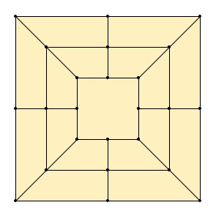
Morabaraba / 12 Men’s Morris

Setup
- 2 Players - 12 pieces each - black / white
- Empty game board as shown
- Board has 24 points (where lines meet)

Goal
Build “mills” to take away the opponent’s pieces, or lock them in

Game ends
When one player has only 2 pieces left or is locked in and cannot move anymore

Making a Mill
A “mill” is when a player has 3 pieces in a straight line. That player then removes one of the opponent's pieces from the board. Removed pieces are excluded from the game and cannot not be used again.
Note: Pieces that are part of a mill can only be removed if no other pieces are available.

Phase 1 - Placing pieces
Take turns placing your pieces on empty board positions,.
Try to make mills and try to prevent your opponent from making mills.
Continue until all pieces have been placed.

Phase 2 - Moving pieces
Now on each turn move one of your pieces along a line to an adjacent empty point.
Still try to make mills and try to prevent your opponent from making mills.

Flying
A player who has exactly 3 pieces left on the board, can “fly” them. That means on each turn, the player moves one of their pieces to an empty position anywhere on the board.
A player who has more than 3 pieces on the board must continue to move pieces as described above.

Strategy tip
A player can "open" one of their mills by moving one of its pieces, then on their next turn move it back to form the same mill again, this way repeatedly removing one of the opponent's pieces.
The other player can try to stop this by moving one of their pieces into the gap in the opened mill.

