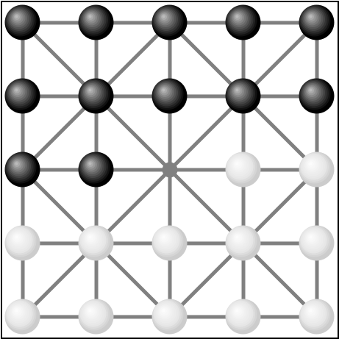
Alquerque (ancient checkers)

Origins
“El Qirkat” from Arabic: القرقات, first mentioned in 10th century, came to Europe via Spain. In France adapted to the chessboard, later leading to modern draughts/checkers.

Setup
- 2 Players - 12 pieces each - black / white
- Initial game board setup as shown
- Board has 25 points (where lines meet)

Goal
Capture or lock in all of the opponent’s pieces

Game ends
When a player has no more pieces left or cannot make any move

Game play
Players take turns, each time using only one of their pieces:
- If possible, you must capture an adjacent opposing piece: Jump over it along a line, land on the empty point right behind it.
- If possible, your piece must make successive jumps over opposing pieces, capturing them in the same turn. Successive jumps may “change direction” and do not all have to go along the same straight line.
The captured pieces are removed from the game and if no opposing pieces are left, you win.
- Alternatively, if no capturing is possible, just move one of your pieces one step along a line to an empty point.
- If you cannot jump or move any of your pieces, the game is over and the other player wins.

Differences to checkers
The rules described above
- Allow jumps and moves in all directions, including moving “backwards”.
- There are no “kings”, and no “crowning” when reaching the far end of the board.

Ending an inconclusive game
An evenly matched game can lead to situations where no player can gain a clear advantage to win.
The players can either agree to call it a tie or keep going until one player gives up.

