Assignment 1

Peng Gao 6151899

2019-12-02

Please also find the Class4DB I downloaded from my github.

Use the SSMS client app to connect to the Client4DB db.

1. Create a table-valued UDF that will accept an input parameter @age INT and will

return all the Student table records for that specific Age.

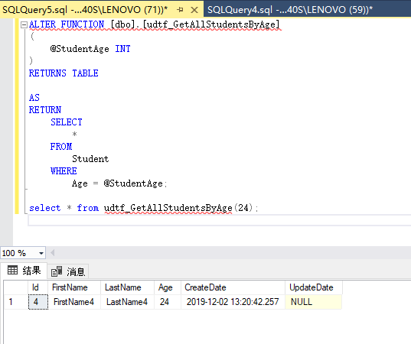

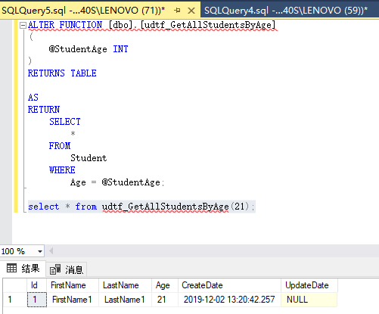

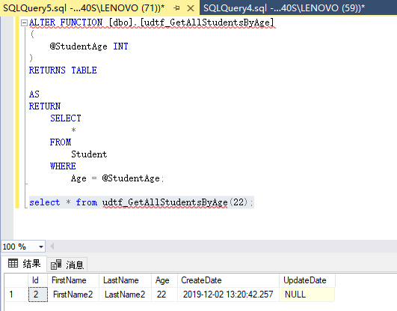

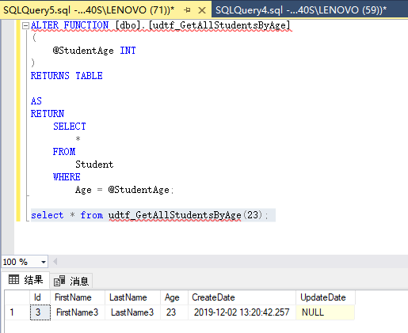

2. Create a stored procedure that will accept an input parameter @age INT and will

return the inner join of Class table and the result of the UDF function created at Ex 1.

Test the stored procedure with few age values!

