# Julian Augley – 2107012A

Assumptions made that affect, and how they have affected, the implementation of program AE2.

|  |  |
| --- | --- |
| **Assumption** | **Effects on implementation** |
| No checking that the text file to be encoded or decoded has any content at all. | No error checking for empty text files, frequency report returns NaN. |

# Functionality

Program meets all specifications, including vigenere cipher.

# Test data

All test data screenshots had to be full screen to show necessary data. Figure 1 shows invalid keyword and JOptionPane error message to let user try again.

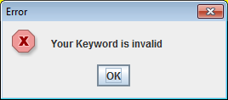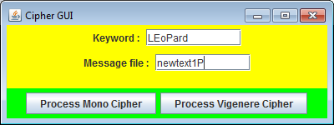

Figure 1: Invalid keyword input (lowercase letters) and error message

Figure 2: Invalid filename and associated error message

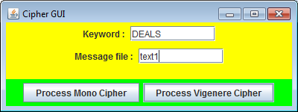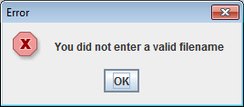

Figure 2 shows error message in the event of an invalid filename being entered by the user, in this case, a missing “P” or “C” at the end; these two characters are the only characters accepted by the program as the last characters in the filename.

Figure 3 demonstrates relevant output from an encryption using the monoalphabetic cipher with the keyword “VALID”, included are screenshots of the plain text file, the encrypted text file, the letter frequencies output and the cipher and alphabetic arrays produced as a result of this cycle of the program.

Figure 3: the results of one encryption using the monoalphabetic cipher with the keyword "VALID"

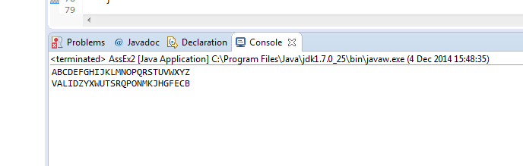

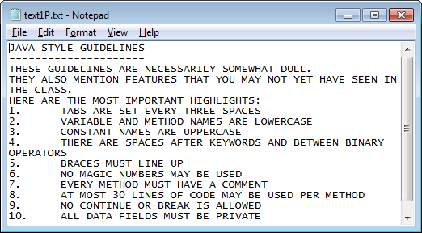

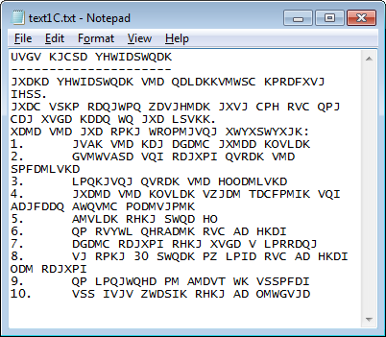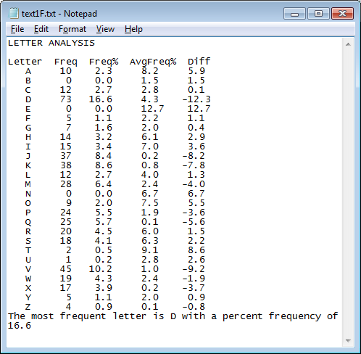

Figure 4 demonstrates the decryption of file text1C produced as a result of the encryption in figure 3, using the same keyword. Screenshots of the file “text1D.txt” and the letter frequencies are the only data shown here; the input file is “text1C.txt” in figure 3, and the cipher array is identical. This can be verified if you wish, using a manual encryption/decryption and comparing letter frequencies. E.g. D is most frequent in the encrypted file, while E is most frequent in the decrypted file; a check of the cipher array demonstrates the reason, i.e. E is encrypted as D using the keyword “VALID”.

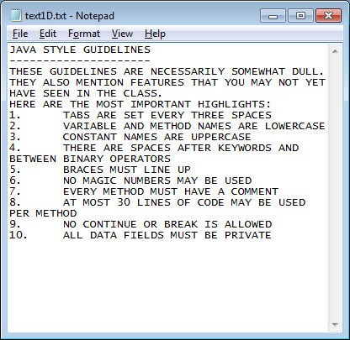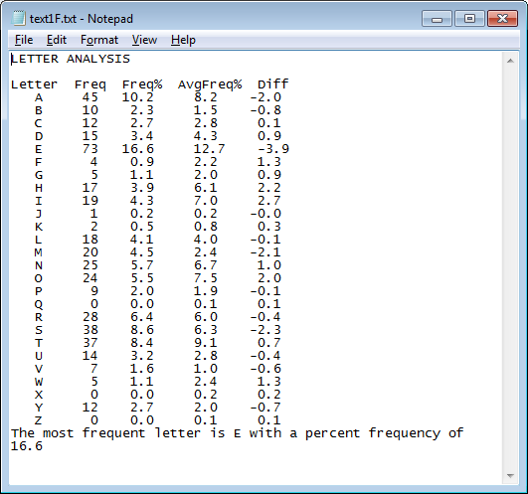

Figure 4: Results of a decryption cycle using the keyword VALID and the input file "text1C.txt", produced as a result of the encryption shown in figure 3.

## Vigenère cipher

Figure 5 contains the results of an encryption of “text1P.txt” using the vigenere cipher and the keyword TIGER. Again, the plain text file is the same as in figure 3, the encrypted file, the letter frequencies report and the alphabetic and cipher arrays are shown.

Figure 6 shows the results of a decryption using the vigenere cipher. File and keyword inputs are “text1C.txt” (produced as a result of a vigenere encryption) and “TIGER”, respectively.

Figure 5: The results of one encryption using the vigenère cipher, again using plain text file "text1P.txt" as input (i.e. contains the same text as shown in figure 3)

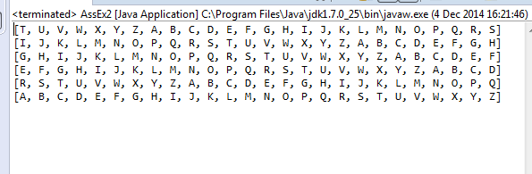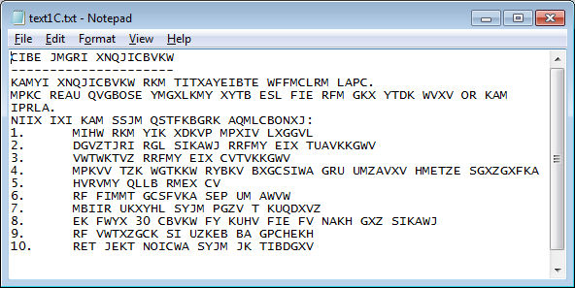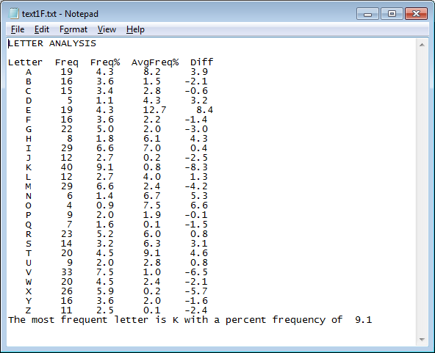

Figure 6: results from decryption using vigenere cipher, usingh "text1C.txt", the output from the vigenere encryption, as the input file. CIpher array is again identical to the array in figure 5.

