Julian Augley 2107012A

Assumptions affecting implementation

Several assumptions were made during the development of the AE1 programme. These are listed in table 1, along with the effects (if any) on the implementation of the programme functioning.
Assumption made | Effect on implementation
Main gui has readable fonts | Font size set to 20 for several GUI components
Wine name length no more than 20 characters, bottle quantity and price less than 10¹⁰ figures | JtextField for inputting wine name is 20 columns, and Jtextfields for price and quantity are 10 columns in length
Errors in double handling by the cpu are allowed in this assignment | BigDecimal has not been used, and therefore, some values for price have rounding errors, although the calculations are correct. One value that shows an example of this assumption is 2.30 (see screendump)
GUI does not have to look exactly like the specification example | A slightly different layout method was used in this programme, although all the components are the same. Also, I have placed all pound signs outside JtextFields.
No exceptions should be unhandled | Try-catch blocks for all the exceptions the programme threw during testing were added.
Table 1: Assumptions made that affected programme implementation

Functionality vs specification
The observed deficiencies in functionality were the way some doubles were handled by the compiler. The example observed was: 2.30 used as a bottle price was always stored as a little bit (i.e. at several decimal places) less than the input value. The second deviation from specification is, when one error is detected in a try catch block, the errors after it will also be thrown as well, resulting in multiple errors for the first error. It would be impossible to screen dump this deficiency, therefore it is not shown. These are the only deficiencies in functionality I could observe.

Proof of functionality
Screen dumps demonstrating aspects of functionality asked for in the specification are provided in this section. Image captions describe aspects of functionality shown in the screen dumps.

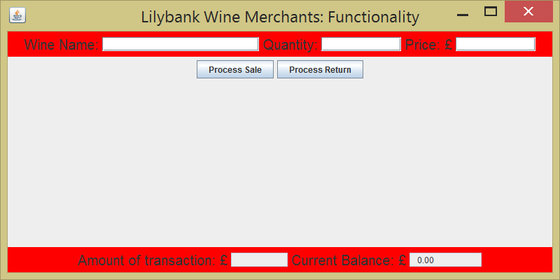
Figure 1 Program gets customer name and initial balance from input dialog boxes. No transactions have been carried out in this instance.

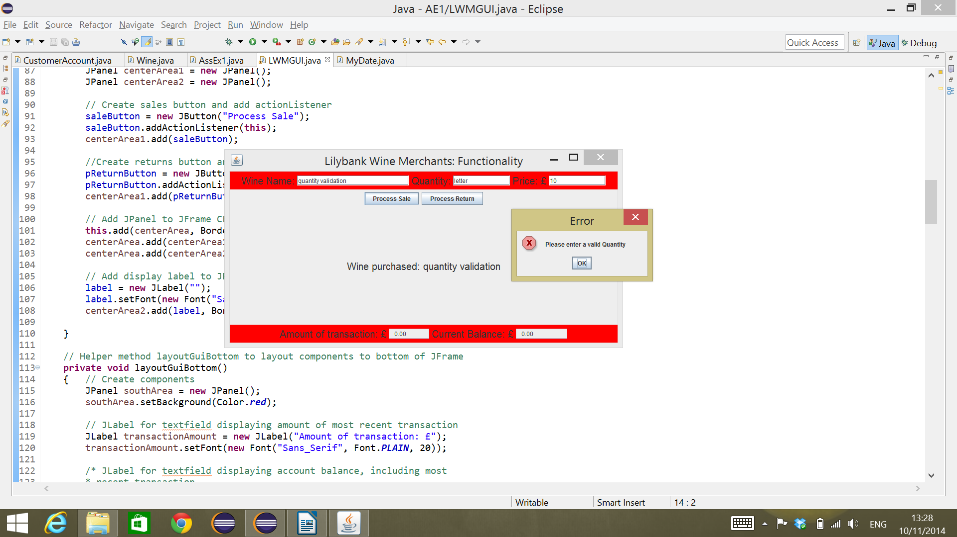Figure 1: Program validates number input from the GUI, in this instance, checking for an integer in the quantity field. Apologies for the image size, ALT+printscreen only captures the screen element in focus, and it wasnt possible to get the GUI and the JOptionPane error mesage in screen at the same time without capturing the whole screen.
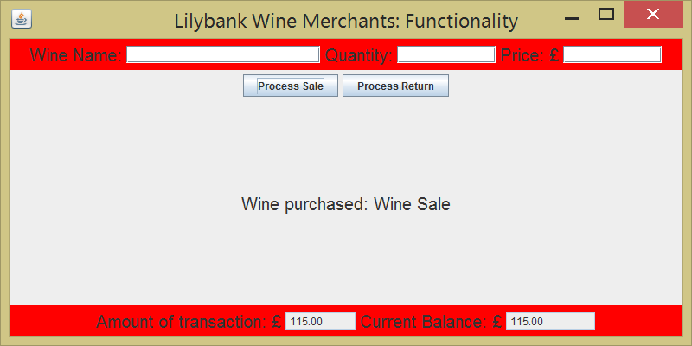Figure 2: Program calculates a sale correctly and shows normal balance, wine name and transaction amount

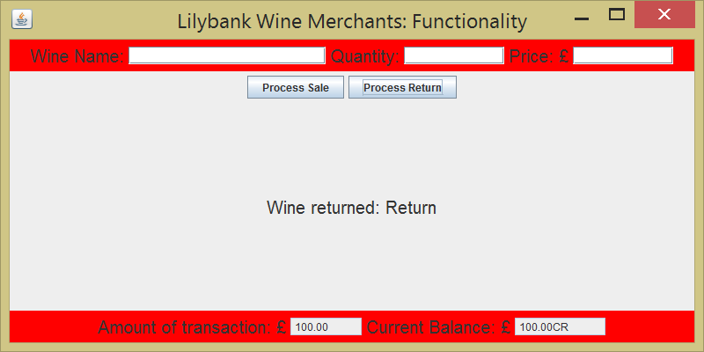
Figure 4: Program calculates a return normally, GUI shows transaction and credit balance.

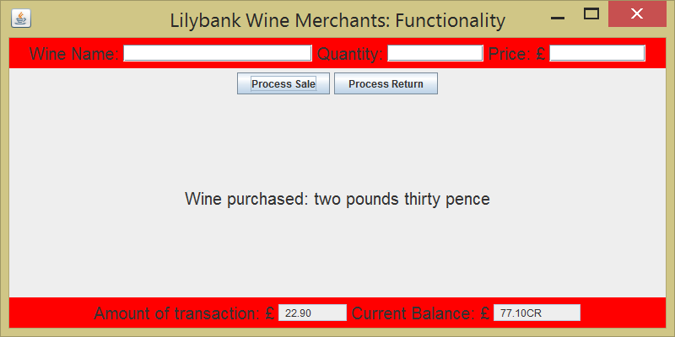Figure 3: This screen dump illustrates the issue with some doubles in the programme. In this case, a quantity of 10 bottles at a price of £2.30 were the input values in a sale; the transaction amount should show £23.00, but shows £22.90 instead. Additionally, as the customer had a credit balance of £100 prior to this transaction, the balance should have been £77, not £77.10 as shown.

