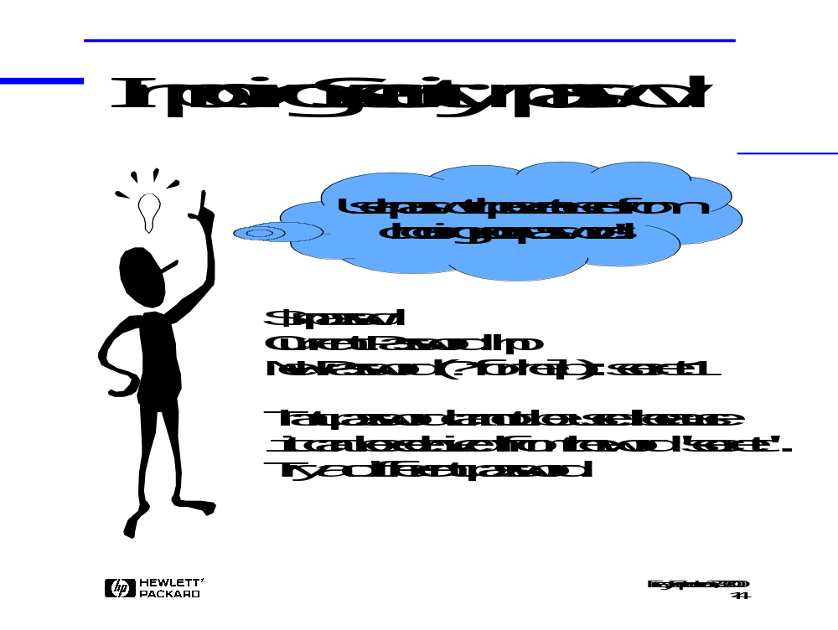
Although Crack provides a convenient mechanism for reporting insecure passwords, it provides no mechanism for enforcing a more secure password policy when your users change their passwords in the future. npasswd is the Unix public domain tool-of-choice for enforcing a more stringent password security policy.

npasswd supplements (or replaces!) the standard HP-UX passwd command, and provides the administrator with a flexible, robust mechanism for ensuring that users choose secure passwords that conform to the password guidelines discussed earlier in the presentation. The password checking mechanism in npasswd is much more robust than the standard password checks performed by /usr/bin/passwd.

At a minimum, npasswd compares every new password against the same set of dictionaries that are used by Crack. Passwords that contain any dictionary word, or any simple permutation of a dictionary word, are refused.

The administrator can add additional policies controlling:
• the minimum password length
• the list of valid password characters (ie: no control characters)
• whether or not all-alpha passwords will be allowed
• whether or not single-case passwords will be allowed

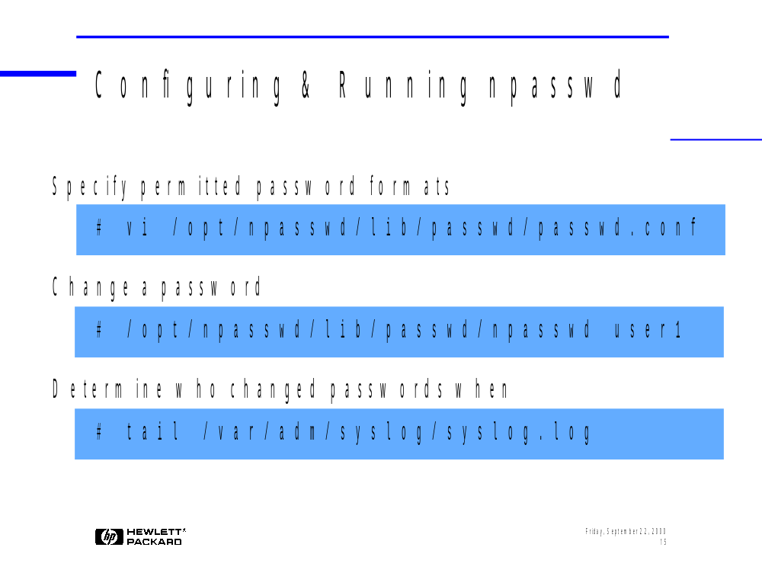
npasswd is a public domain software utility that may be obtained for free over the Internet. Note that HP provides no support for public domain software.
Downloading and Compiling the npasswd Executables
1. Create a directory for the npasswd source code and executables.
# mkdir -p /opt/npasswd/src /opt/npasswd/lib

2. Go to your new npasswd source code directory and download the npasswd tarball.
# cd /opt/npasswd/src
# netscape http://www.utexas.edu/cc/unix/software/npasswd/
go to the bottom of the window and select Npasswd download page
Click npasswd-2.X.tar.gz
3. Unzip and untar the source.
# gzip -d npasswd-2.05.tar.gz
# tar -xvf npasswd-2.05.tar

4. Go to the new npasswd directory.
# cd npasswd-2.05
5. npasswd doesn't compile properly with HP's ANSI-C compiler. Modify your PATH variable to ensure that you use the bundled C compiler instead.
# PATH=/usr/ccs/bin:$PATH

6. Run the Configure script.
# ./Configure
Accept the defaults for everything EXCEPT the following:
What Optimizer flags should be used? [-O] none
Installation prefix to use (~name ok) [/usr] /opt/npasswd
Any additional libraries? [-lnet -lnsl] -lnet -lnsl -lsec -lrpcsvc
Replace system programs? [y] n (optional)
7. Eventually, Configure will create a config.sh file for you. There is a bug in npasswd that requires a change to this file.
Press return or use a shell escape to edit config.sh: !vi config.sh
Go to line 189 in the file and change the value of the p_hpuxauth variable as follows:
p_hpuxauth='undef'
Save your changes to the file, then hit return to continue.
8. When asked if you want to run make to check dependencies, say yes.
Run make depend now? [y] y
9. When the dependencies are completed, run make two more times as follows (Note: This only works with the standard cc compiler, it does NOT work with C-ANSI-C).
# make
# make install

10. Create the npasswd password history file.
# cd /opt/npasswd/lib/passwd
# ./history_admin load </dev/null

11. Add the npasswd directory to your PATH.
# PATH=$PATH:/opt/npasswd/lib/passwd
Downloading and Compiling the npasswd Dictionaries
1. Go to the npasswd source code directory that you created previously and download the npasswd wordlist tarball.
# cd /opt/npasswd/src
# netscape http://www.utexas.edu/cc/unix/software/npasswd/
go to the bottom of the window and select Npasswd download page
Click npasswd-words.tar.gz

2. Unzip and untar the wordlist tarball.
# gzip -d npasswd-words.tar.gz
# tar -xvf npasswd-words.tar

3. Copy the word lists to the proper dictionary directory.
# cp npasswd-2.00/dict/* npasswd-2.05/dict
4. Go to the dictionary directory.
# cd npasswd-2.05/dict
5. There is a bug in the Makefile.SH file that must be fixed before proceeding. Edit this file.
# vi Makefile.SH
Replace the following lines (lines 149 thru 153):
if [ -n "$(WHAT)" ]; then\
files="$(WHAT)";\
else\
files=$(PICK);\
fi;\

With the following single line:
files=*.gz;\
Save your changes.

6. Use Makefile.SH to build a Makefile, then run make (Be patient!)
# sh Makefile.SH
# make install
Configuring npasswd
npasswd allows the administrator to specify exactly which types of passwords should be permitted and denied. You may accept the default configuration, or modify the passwd.conf configuration file if you wish. The sample file below shows just a few of the many parameters you can configure in passwd.conf.
# vi /opt/npasswd/lib/passwd/passwd.conf
passwd.AlphaOnly true Allows all-alphabetic passwords passwd.SingleCase true Allows all-single-case passwords
passwd.CharClasses 1 Allows passwords that contain just one char class
passwd.MaxRepeat 3 No character may be repeated more than 3 time
passwd.MinPassword 6 Passwords must have at least 6 chars
passwd.PrintableOnly false Don't allow non-printable characters
Running npasswd
After compiling and configuring npasswd, your users can run it by typing:
$ /opt/npasswd/lib/passwd/npasswd
Root can also use npasswd when changing other users' passwords. However, many of the other standard passwd command options (ie: -n, -m, -l and -f ) aren't included in the HP-UX implementation of npasswd.
# /opt/npasswd/lib/passwd/npasswd user1
If your users balk at typing such a long path, create an alias for them. If you want to force your users to use npasswd rather than the standard /usr/bin/passwd command, consider changing the permissions on /usr/bin/passwd to 700. This ensures that root can still use the standard passwd command's -n, -m, -l and -f options, while preventing regular users from bypassing the restrictions imposed by npasswd.

Each password change is logged in syslog.log, too, so you can determine who changed which passwords when.
# tail /var/adm/syslog/syslog.log
Jan 1 12:00:00 hosta passwd[5000]: Password changed on hosta for
user1 by root

WARNING! Running contributed software such as npasswd may violate your organization's security policy. Before downloading, compiling, or running this tool, be sure to obtain written permission from your Manager.

