SDU University
School of information Technology and Applied Mathematics
Computer Science Department

Project
Name of Topic
“Educational Project”

The work was completed:
B. Adi Group 03-P,
Check by: G.Tulemissova
Associate Professor, PhD

Kaskelen
2026
Content

- Introduction
1.1 Motivation and Problem Statment
1.2 Goals and Objectives
- Main Part
2.1 Company Description
2.2 Organizational Structure / infrastructure
2.3 Network Topology Overview
2.4 VLAN and IP Addressing Plan
2.5 VPN and IPsec
2.6 Firewall and ACL Security
2.7 Network Management Protocols: SNMP, LLDP, and EIGRP
2.8 Network Troubleshooting 2.9 SYSLOG Logging 2.10 Quality of Service
- Conclusion

Introduction
Modern educational institutions depend on stable, secure, and well-organized computer networks. A university network must support communication between departments, access to internal servers, internet connectivity, data exchange, online learning platforms, file sharing, monitoring, and administrative services. Because many users and departments work in the same infrastructure, the network must be divided logically, protected from unauthorized access, and managed efficiently.This project focuses on the design and implementation of a secure educational institution network infrastructure using Cisco Packet Tracer. The network is designed for a university environment and includes multiple departments such as Rectorate, Management, Business School, School of IT, Research and Library, Student Services, Finance, HR and Legal, IT Department, and Server Room.The project includes the use of VLANs, trunk links, inter-VLAN routing, dynamic routing, VPN with IPsec, firewall access control lists, SNMP, LLDP, SYSLOG, troubleshooting, and Quality of Service. These technologies are used to create a scalable, manageable, and secure network infrastructure. According to the project requirements, the work must include organizational structure, enterprise infrastructure, VLANs, VPN, firewall policy, routing protocol, monitoring, troubleshooting, and QoS implementation.The main purpose of this project is to show how a real enterprise-style university network can be planned, configured, tested, monitored, and protected. The final network should provide reliable communication between departments while keeping sensitive departments such as Finance, HR and Legal, IT Department, and Server Room properly secured.

1.1 Motivation and Problem Statement
In a university environment, many departments use the same physical network infrastructure, but they do not all require the same level of access. For example, students and general departments should not have direct access to Finance, HR, Legal, or server resources. If all devices are placed in one flat network, it can create security risks, broadcast traffic problems, poor management, and difficulty in troubleshooting.The main problem is to design a network that can support many users and services while maintaining security, scalability, and reliability. The network must separate departments, allow controlled communication, provide routing between required segments, protect sensitive resources, and support monitoring and troubleshooting.To solve this problem, the project uses VLAN-based segmentation, trunk links, inter-VLAN routing, dynamic routing protocol, firewall ACLs, VPN IPsec, SNMP monitoring, LLDP discovery, SYSLOG logging, and troubleshooting methods. VLANs are important because they separate devices into different broadcast domains, improving both control and security.

1.2 Goals and Objectives
The goal of this project is to design and configure a secure, reliable, and manageable educational institution network infrastructure in Cisco Packet Tracer.
The main objectives are:
- To create a department-based network structure for the educational institution.
- To build a physical and logical topology using routers, multilayer switch, access switches, PCs, and servers.
- To divide the network into VLANs based on departments.
- To configure trunk links between the core switch and access switches.
- To enable inter-VLAN routing for communication between required departments.
- To configure dynamic routing using EIGRP for communication between routers and network segments.
- To configure VPN with IPsec for secure site-to-site communication.
- To implement firewall rules using ACLs to restrict unauthorized access.
- To configure SNMP, LLDP, and SYSLOG for network management, device discovery, and event logging.
- To simulate and solve troubleshooting cases in the network.
- To describe the Quality of Service policy for important network traffic.
- To test the network using commands such as ping, tracert, show vlan brief, show interfaces trunk, show ip route, show ip eigrp neighbors, show access-lists, show lldp neighbors, and SYSLOG messages.

Main Part
2.1 Company Description
This project is based on the network infrastructure of an educational institution. The institution includes several departments that need stable communication, secure data exchange, access to internal servers, and centralized network management.The main departments in this project are Rectorate, Management, Business School, School of IT, Research and Library, Student Services, Finance, HR and Legal, IT Department, and Server Room. Each department has its own users, computers, and network requirements.Some departments require stronger protection than others. For example, Finance, HR and Legal, IT Department, and Server Room contain sensitive information and must be protected from unauthorized access. Other departments mainly require reliable access to internal resources, learning platforms, file sharing, and communication services.
The network was designed to support more than 50 PCs, multiple access switches, one core multilayer switch, routers, and servers. The Server Room contains important services such as DNS, DHCP, web portal, database, backup, mail, file server, Moodle, and monitoring/logging services.To make the infrastructure secure and manageable, the network was divided into VLANs according to departments. Trunk links were used between switches, inter-VLAN routing was configured on the core multilayer switch, and firewall ACL rules were applied to control access between departments. Dynamic routing, VPN IPsec, SNMP, LLDP, SYSLOG, troubleshooting, and QoS were also included to complete the enterprise-style network design.

2.2 Organizational Structure / infrastructure
The educational institution is organized into several departments, and each department has its own role in the university network. The organizational structure helps define how users, devices, and network resources should be separated and managed.the main departments are Rectorate, Management, Business School, School of IT, Research and Library, Student Services, Finance, HR and Legal, IT Department, and Server Room. Rectorate and Management are responsible for administration and decision-making. Business School and School of IT represent academic departments.
The network design follows this organizational structure. Each department is assigned to a separate VLAN and subnet. This makes the infrastructure easier to manage and improves security because access between departments can be controlled using routing and ACL firewall rules.

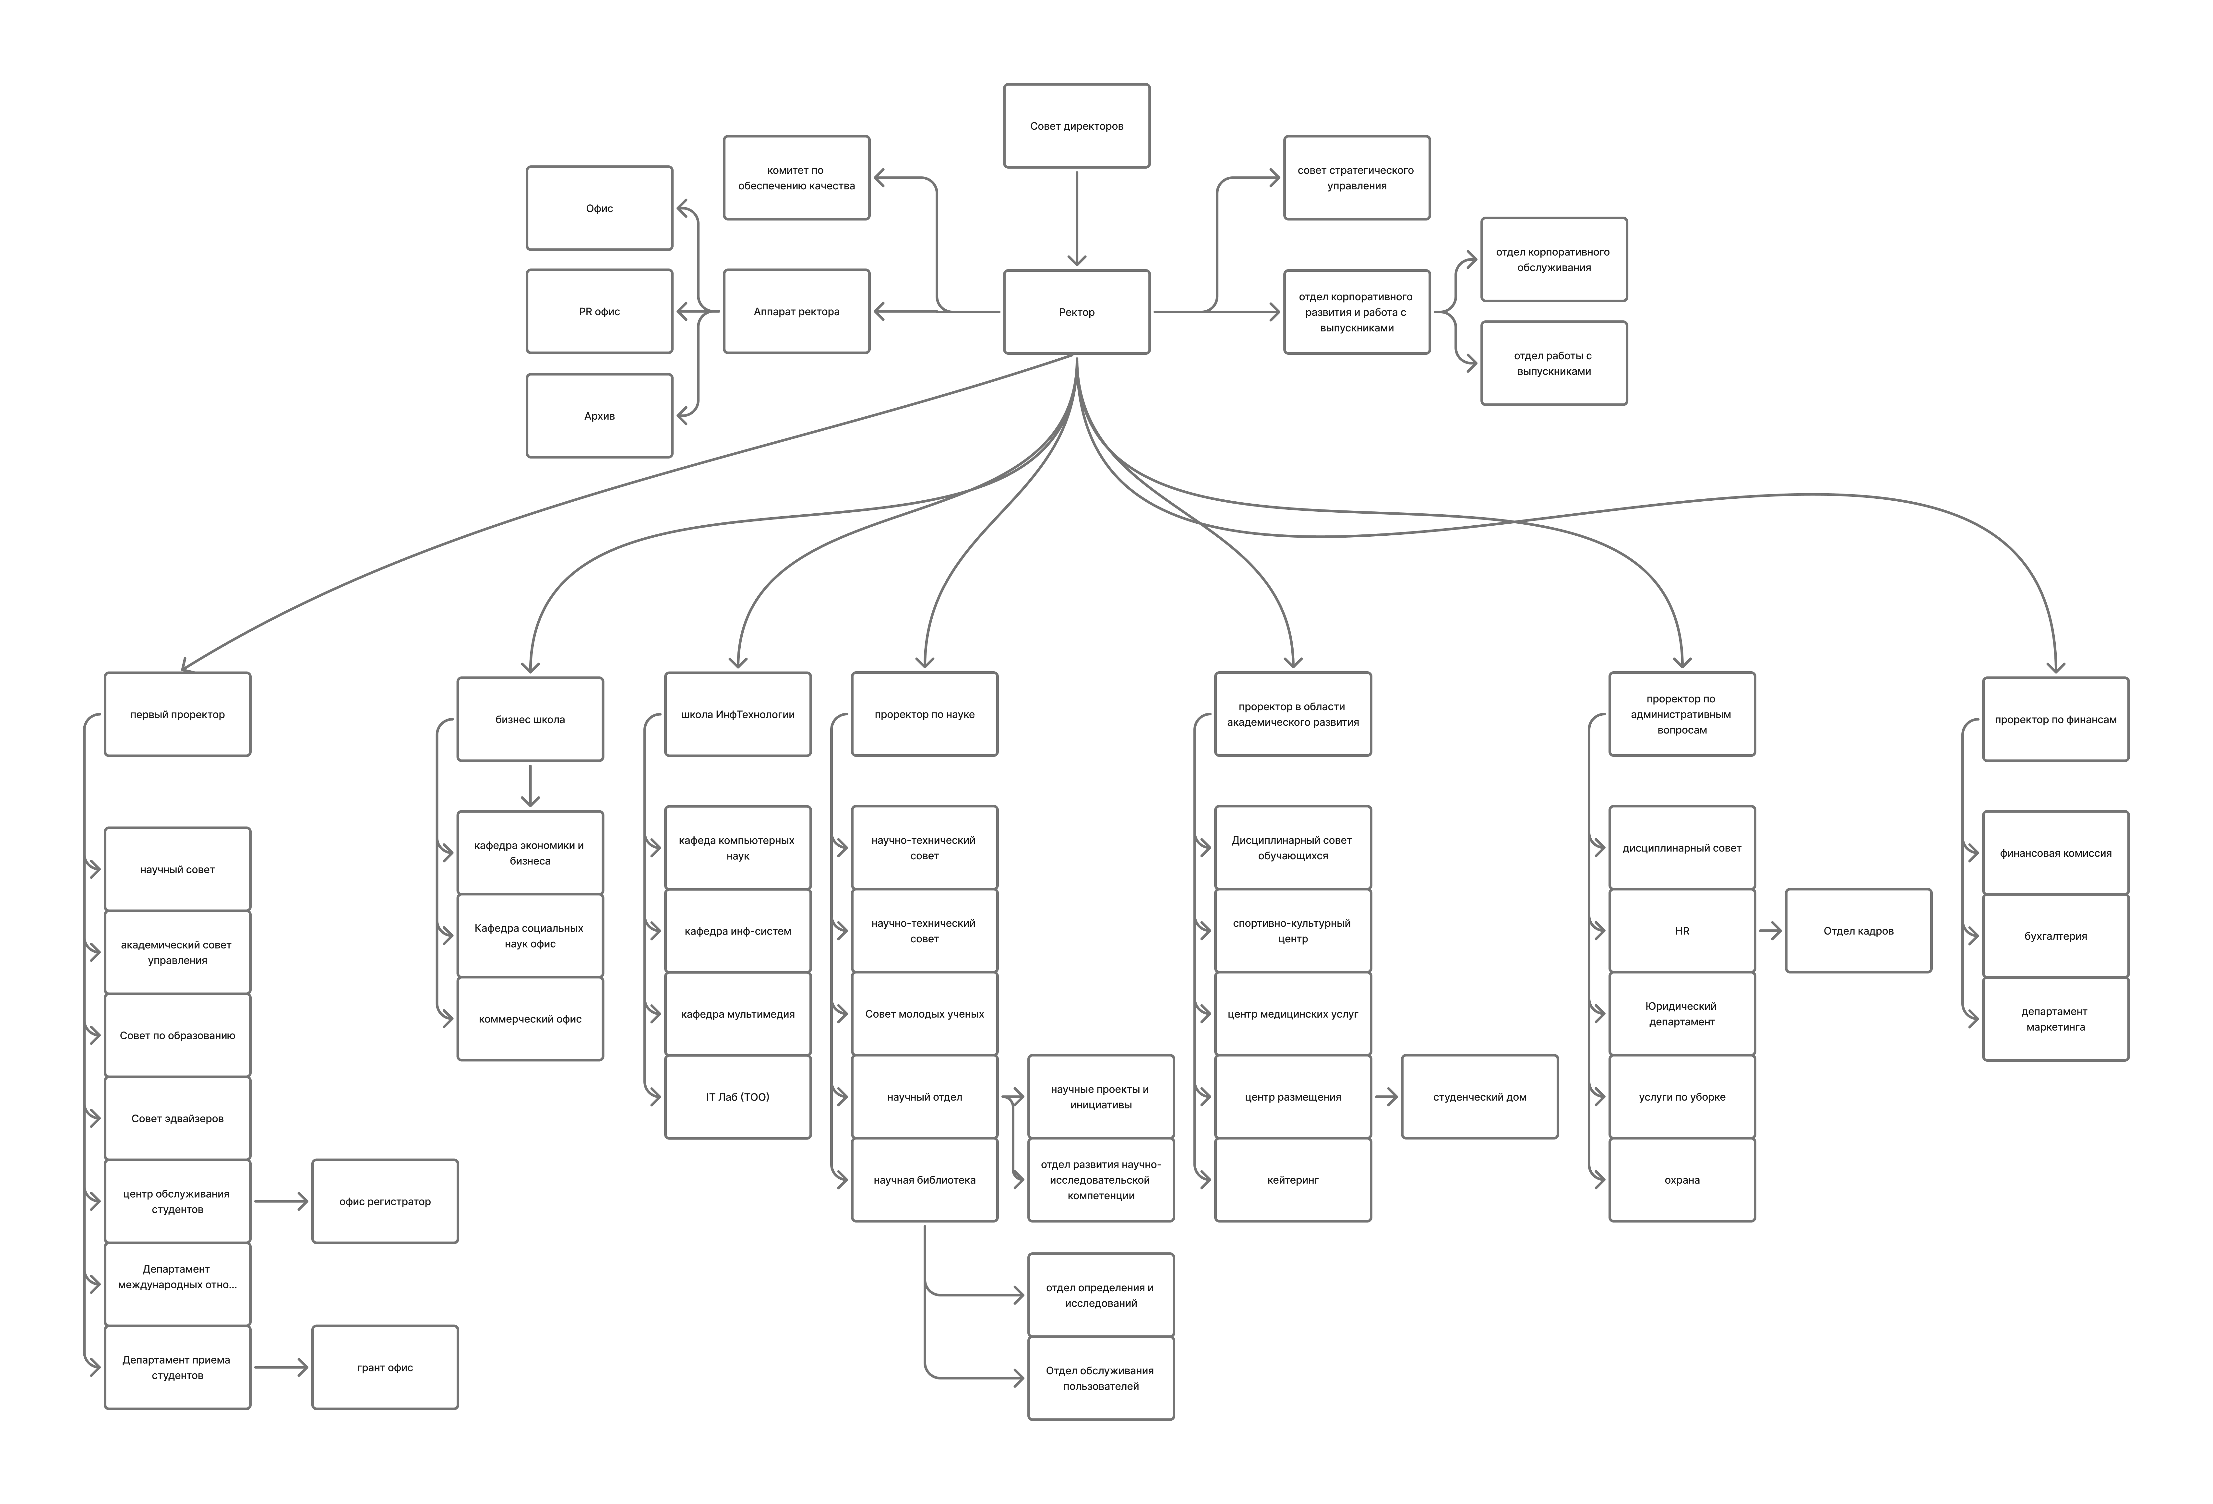
N | Number of computers to assign IP addresses to | Number of types of network devices | Number and name of servers | General software | Specific  software | Type of cloud | Lan Security- technology  and  protocols | Quality of Service | Network Troubleshouting
 | 35 Client PC’s | 14 Switche’s | Email Server | DHCP | Email Service | Private Cloud | VLAN 10,20,30,40 | VoIP priority | Ping
 | 5 Supporter PC’s | 3 Router’s | Web Server | DNS | CCTV Monitoring Software | Hybrid Cloud | VLAN 50,60,65,70 | bandwidth management | show ip route
 | 8 Department PC’s | 1 Firewall | Data Server | Windows 10/11 | Web Hosting Software |  | VLAN 80,90,100 | Server Security | show vlan brief
 | 3 Security PC’s |  | Security Server | Linux | Network Monitoring Tools |  | firewall filtering | Access Control  Lists | show running-  config
 | 3 CallCenter PC’s |  | Software Server | Firewall System | CRM System |  | ACL rules | Management and Support Systems | show interfaces
 | 1 Admin PC |  |  | Antivirus software | Access control system |  | port security

2.3 Network Topology Overview
The network topology was designed in Cisco Packet Tracer as a hierarchical educational institution network. The topology consists of one core multilayer switch, eight access switches, routers, end-user PCs, and servers. The core switch is the central device of the local network and connects all access switches together.The access switches are used to connect PCs from different departments. Each department is placed in a separate VLAN, and the access ports are assigned according to the department of the connected devices. The Server Room is connected through a separate switch and contains the main servers used by the institution.The core multilayer switch performs inter-VLAN routing using SVI interfaces.The topology also includes security and management technologies. ACLs are used as firewall rules to restrict access between departments, VPN IPsec is used for secure remote communication, and SNMP, LLDP, and SYSLOG are used for monitoring, neighbor discovery, and logging.
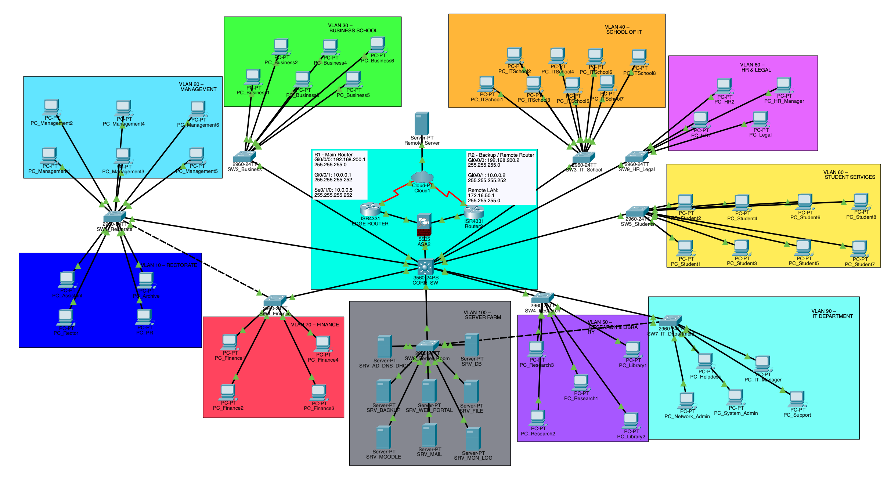
Backup Router / Redundancy
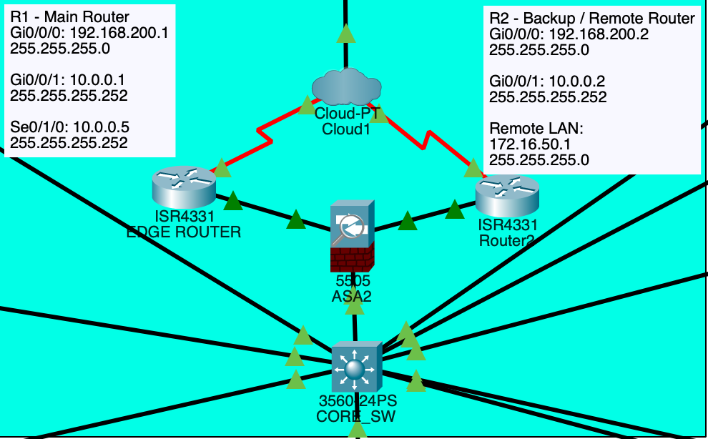
Backup routers were added to improve network reliability. In a real enterprise or university network, one router can become a single point of failure. If the main router fails, users may lose access to remote networks, external services, or VPN connections. For this reason, additional routers were included in the topology.

2.4 VLAN and IP Addressing Plan
VLANs were used to logically separate the educational institution network into different departments. Each VLAN represents one department and works as a separate broadcast domain. This design improves security, reduces unnecessary broadcast traffic, and makes the network easier to manage.
Each VLAN was assigned a unique IP subnet. The default gateway for each VLAN was configured on the core multilayer switch using SVI interfaces. End devices inside each department use the SVI IP address as their gateway.
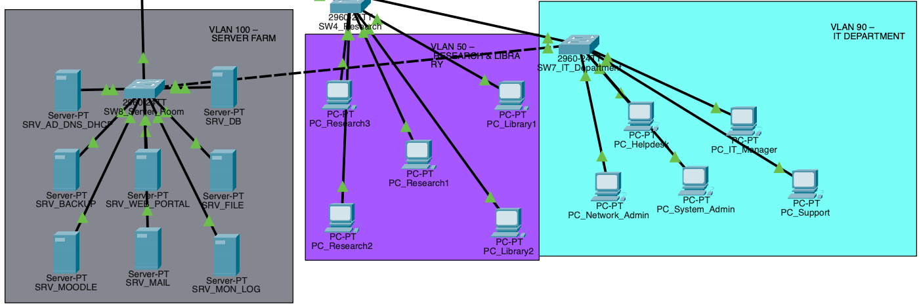

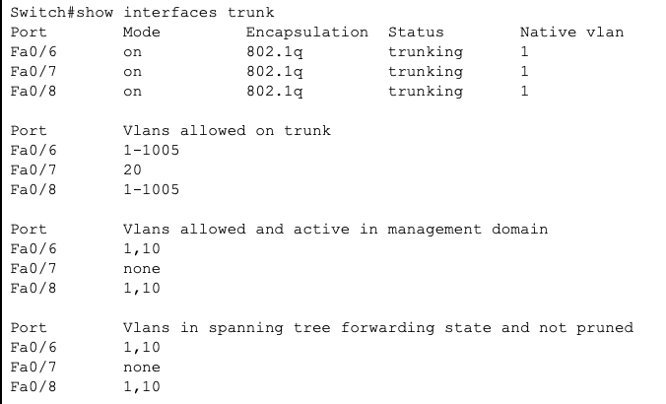
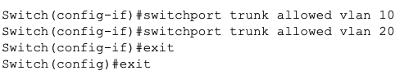

2.5 VPN and IPsec

A site-to-site VPN with IPsec was configured to provide secure communication between the main educational institution network and a remote network. The purpose of the VPN is to protect traffic that travels between two different network locations.
In this project, the VPN connection was configured between the main router and the remote router. The main protected network is the Server Room network, and the remote network is connected behind the second router. IPsec was used because it provides encryption, authentication, and secure tunneling between the two sites.
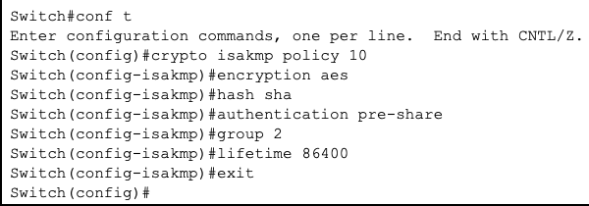
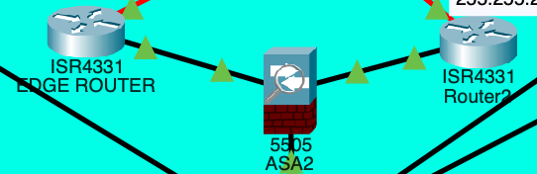
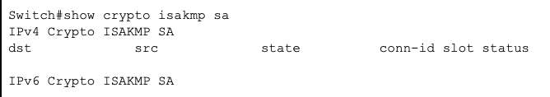

2.6 Firewall and ACL Security
Firewall security was implemented using extended Access Control Lists. ACLs were used to control traffic between departments and protect sensitive parts of the network. In this project, the most protected departments are Finance, HR and Legal, IT Department, and Server Room.
The security policy blocks general departments from accessing Finance and HR and Legal networks. At the same time, the IT Department is allowed to access all networks because it is responsible for administration and troubleshooting.
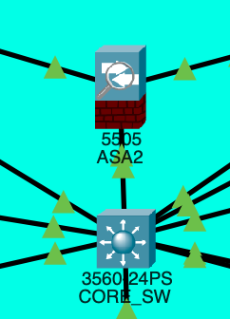
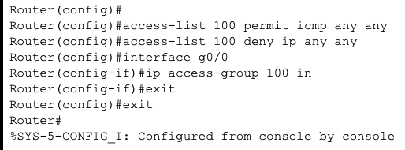
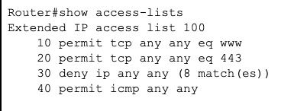

VLAN 30 Business School -> blocked from VLAN 70 and VLAN 80
VLAN 40 School of IT -> blocked from VLAN 70 and VLAN 80
VLAN 50 Research & Library -> blocked from VLAN 70 and VLAN 80
VLAN 60 Student Services -> blocked from VLAN 70 and VLAN 80
VLAN 90 IT Department -> full access

2.7 Network Management Protocols: SNMP, LLDP, and EIGRP
In this project, several network protocols were used to manage, monitor, and maintain the educational institution network. The main protocols used in this part are SNMP, LLDP, and EIGRP. Each protocol has a different role in the infrastructure.SNMP was used for network monitoring. It allows the administrator to monitor routers, switches, and other network devices. SNMP helps collect information about device status, interfaces, and performance. In this project, SNMP was configured with read-only and read-write community strings.
SNMP Operation
the configure SNMP:snmp-server community public ROsnmp-server community private RW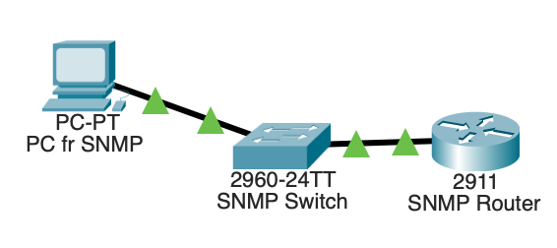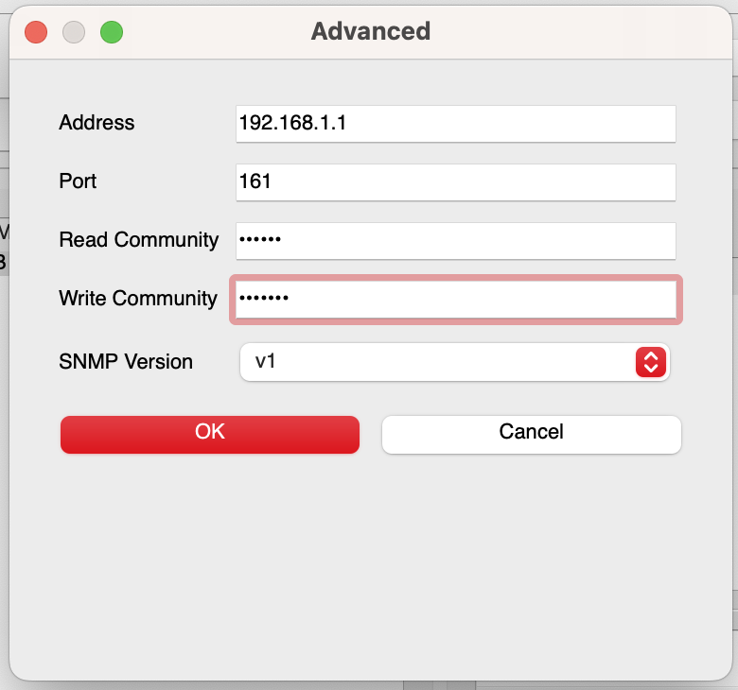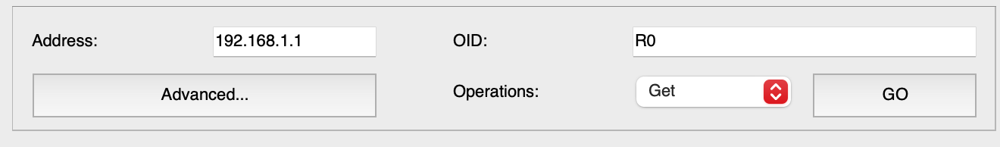
Configuring networks using LLDP
LLDP was used for device discovery. LLDP helps identify directly connected neighboring devices, such as routers and switches. It is useful for checking the physical topology and confirming that devices are connected to the correct ports.
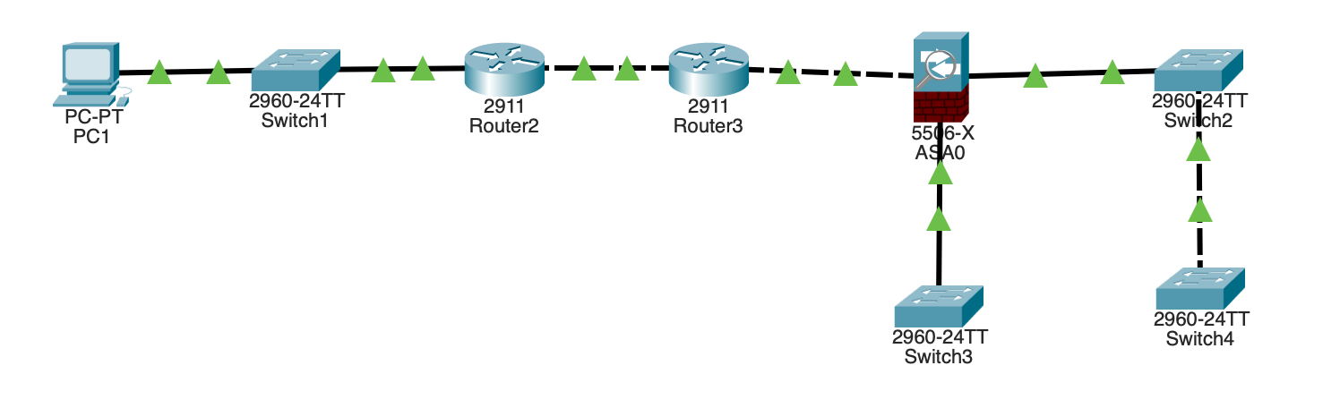
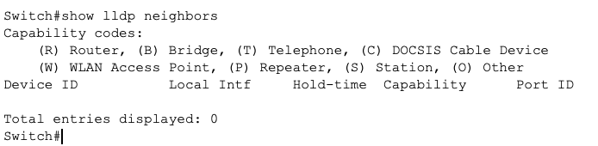

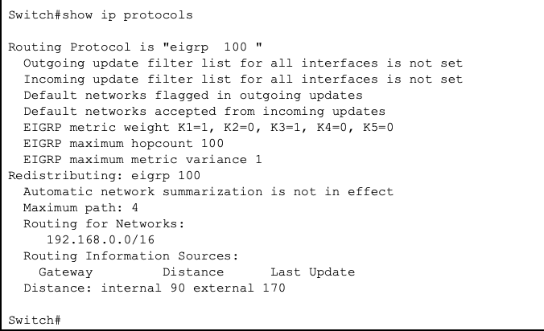
Configuring networks using EIGRP

EIGRP was used as the internal dynamic routing protocol. EIGRP allows routers and the core multilayer switch to automatically exchange route information. It helps the network learn VLAN networks, router links, and remote networks without configuring many static routes manually.

2.8 Network Troubleshooting
Network troubleshooting was performed to test the reliability of the infrastructure and to prove that possible network problems can be detected and fixed. Troubleshooting is an important part of network administration because even a correctly designed network can have issues such as wrong VLAN assignment, trunk problems, routing errors, ACL blocking, or incorrect IP configuration.In this project, troubleshooting was done by simulating network problems and then checking the cause step by step. The main troubleshooting method was to identify the problem, check physical connections, verify IP addresses, check VLANs and trunks, inspect routing tables, review ACL rules, and confirm the solution with connectivity tests.

Problem:
A PC from one department could not reach the Server Room.

Possible causes:
- Wrong IP address or default gateway on the PC
- Incorrect VLAN assignment on the access switch port
- Trunk link not allowing the required VLAN
- Missing route in the routing table
- ACL blocking the traffic

Solution:
The VLAN configuration, trunk status, IP addressing, and ACL rules were checked. After correcting the configuration, the connection was tested again using ping and tracert.

The troubleshooting results showed that the network problems could be identified and solved using standard Cisco verification commands. This confirmed that the infrastructure is manageable and that the administrator can maintain stable network operation.

2.9 SYSLOG Logging
SYSLOG was configured to collect and display network event messages from routers and switches. It is used for monitoring device activity, detecting configuration changes, and identifying network problems. In this project, SYSLOG helps prove that the network devices can send logs to a centralized monitoring server.The SYSLOG server was placed in the Server Room network. Network devices such as the main router and core switch were configured to send log messages to the SYSLOG server IP address.

Configure:
in the server turn on the SYSLOG protocol
then configuration for R1:
logging (ip address of Server)
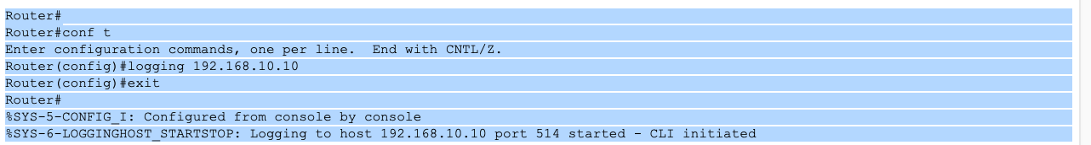
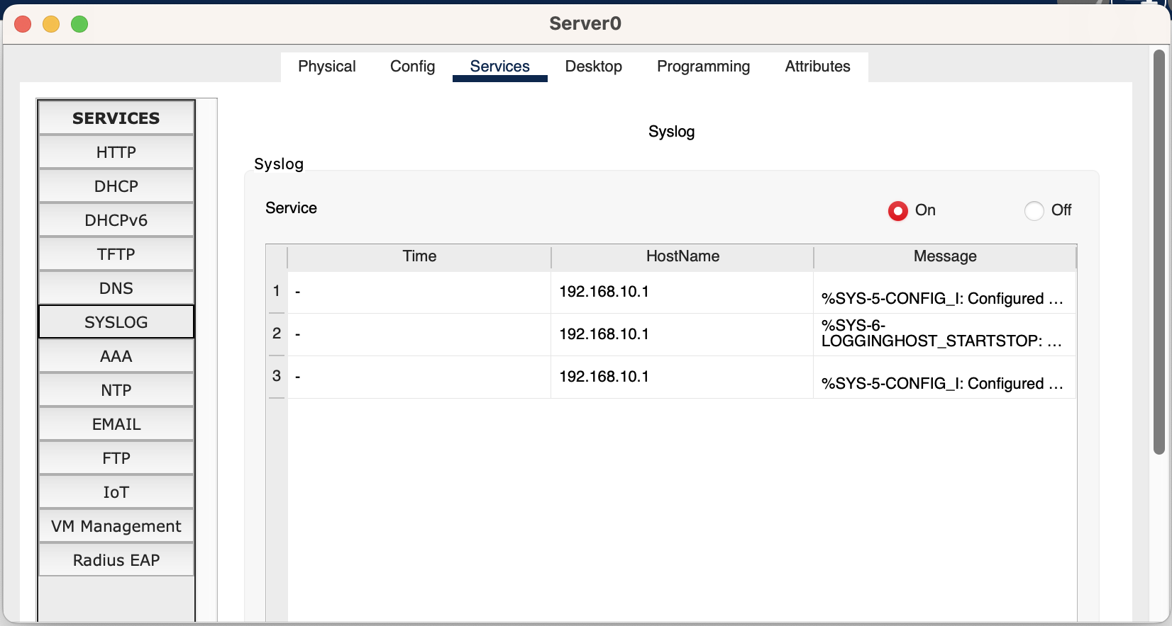

2.10 Quality of Service
Quality of Service was included to describe how important traffic should be prioritized and protected in the educational institution network. In a university environment, not all traffic has the same importance. For example, online classes, video conferencing, Moodle access, database communication, server traffic, monitoring traffic, and administrative services are more critical than normal web browsing or large file downloads.The main purpose of QoS is to reduce delay, packet loss, and jitter for important applications. At the same time, the QoS policy must work together with the security policy, because some types of traffic must be prioritized while other traffic must be restricted or monitored.
In this project, the QoS policy can be described as follows:
High priority:
- Online classes
- Video conferencing
- Voice communication
- Moodle / learning platform traffic
- SYSLOG and monitoring traffic

Medium priority:
- Database access
- Web portal access
- Email services
- File server access
- Backup server communication

Low priority:
- General web browsing
- Large downloads
- Non-critical student traffic
- Guest or unnecessary traffic

Conclusion
In this project, a secure and manageable network infrastructure for an educational institution was designed and implemented using Cisco Packet Tracer. The network was divided into departments using VLANs, which helped separate users, reduce broadcast traffic, and improve security. Trunk links were configured between the core multilayer switch and access switches to carry multiple VLANs through one physical connection.
Inter-VLAN routing was configured on the core multilayer switch, allowing communication between departments when permitted by the security policy. EIGRP was used as the internal dynamic routing protocol to automatically exchange routes between the core switch, main router, and remote routers. VPN with IPsec was configured to provide secure communication between the main university network and the remote network.
The security part of the project was implemented using ACLs. These access lists restricted general departments from accessing sensitive networks such as Finance and HR and Legal. The Server Room was placed in a separate VLAN and protected because it contains important services such as DNS, DHCP, web portal, database, backup, mail, file server, Moodle, and monitoring/logging servers.
Network management and monitoring were also included. SNMP was used for monitoring network devices, LLDP was used for device discovery, and SYSLOG was configured to collect network events from routers and switches. Troubleshooting was performed by simulating network issues and verifying solutions using commands such as ping, tracert, show vlan brief, show interfaces trunk, show ip route, show access-lists, and show logging.
As a result, the final network design is secure, scalable, reliable, and suitable for an educational institution. The project demonstrates how VLANs, routing, VPN, ACLs, monitoring tools, troubleshooting, and QoS policies can work together to support stable university network infrastructure.

